**PRACTICAL NO-8**

**Aim:** Writing your first Django app, part 1

**Code:**

***Mysite/urls.py***

from django.contrib import admin

from django.urls import include, path

urlpatterns = [

path('admin/', admin.site.urls),

path('polls/', include('polls.urls')),

]

***polls/urls.py***

from django.urls import path

from . import views

urlpatterns = [

path('', views.index, name='index'),

]

***polls/Views.py***

#from django.shortcuts import render

# Create your views here.

from django.http import HttpResponse

def index(request):

return HttpResponse("Hello, world. You're at the polls index.")

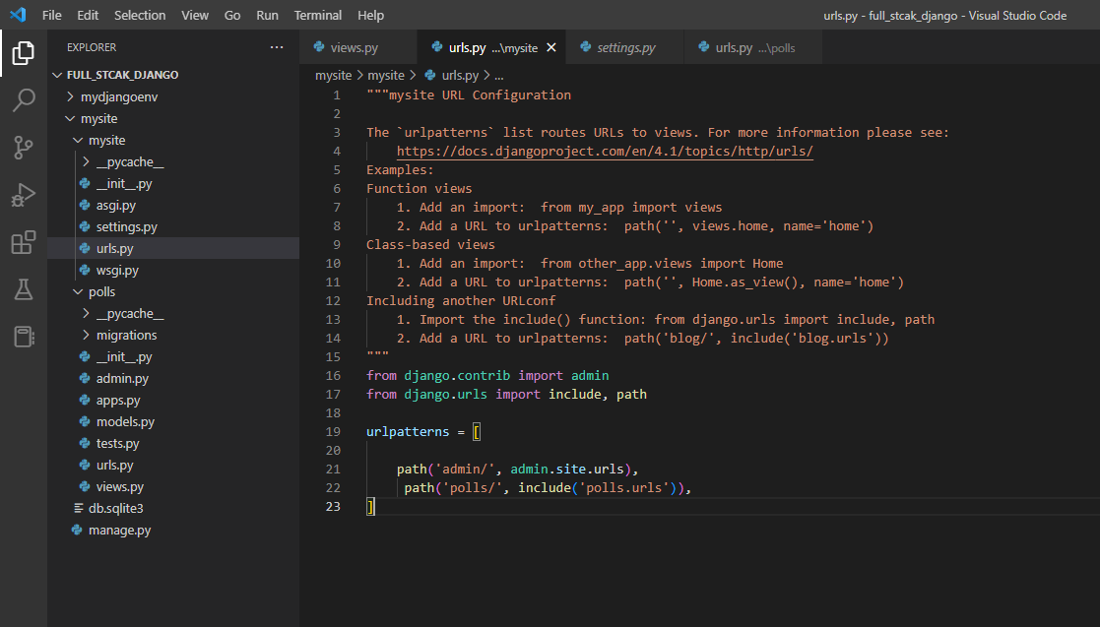

**Output:**

