Week:05-01

Rool no:241801317

Name-Vishal V

Q1)Problem Statement:

Write a program that prints a simple chessboard.

Input format:

The first line contains the number of inputs T.

The lines after that contain a different value for size of the chessboard.

Output format:

Print a chessboard of dimensions size \* size.

Print W for white spaces and B for black spaces.

Sample Input:

2

3

5

Sample Output:

WBW

BWB

WBW

WBWBW

BWBWB

WBWBW

BWBWB

WBWBW

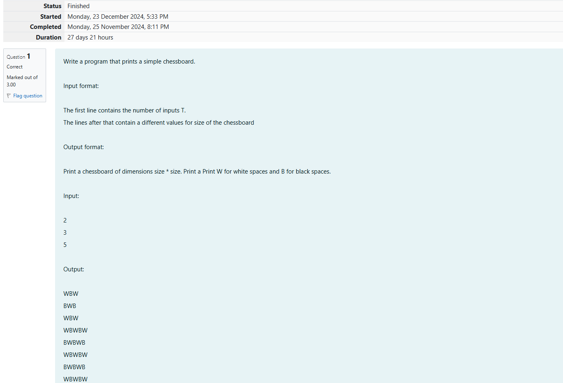

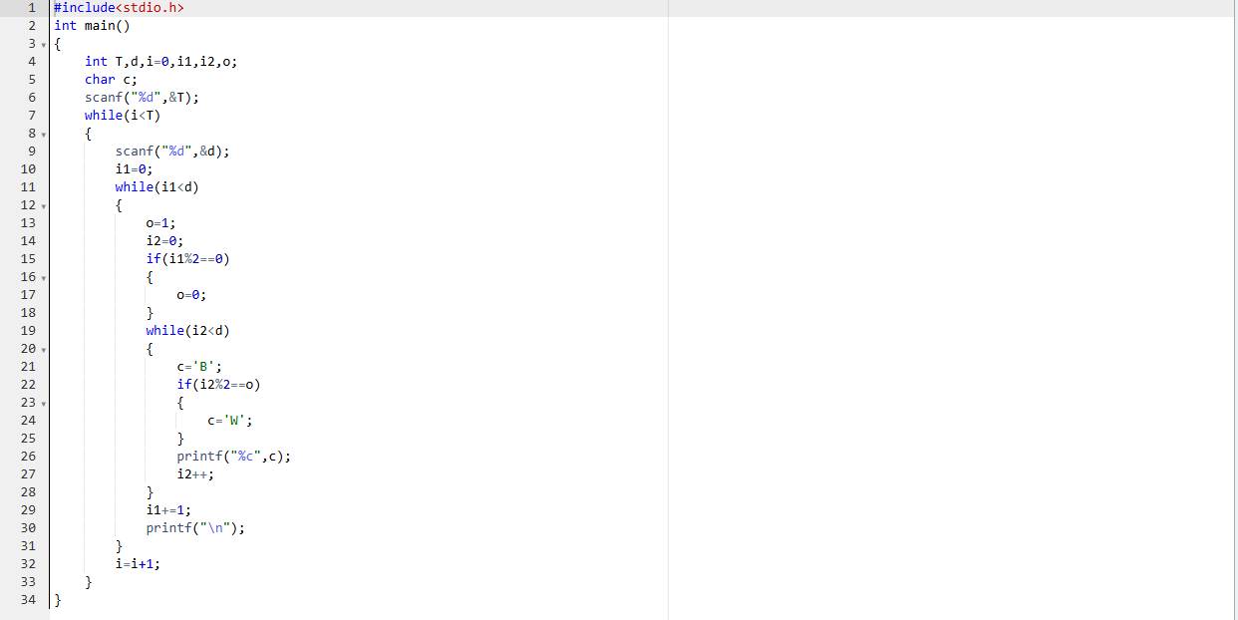

OUTPUT:

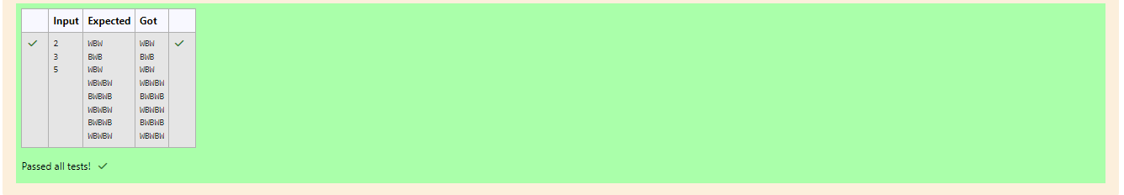

Q2)Problem Statement:

Let's print a chessboard!

Write a program that takes input:

The first line contains T, the number of test cases.

Each test case contains an integer N and also the starting character of the chessboard.

Output Format:

Print the chessboard as per the given examples.

Sample Input:

2

2 W

3 B

Sample Output:

WB

BW

BWB

WBW

BWB

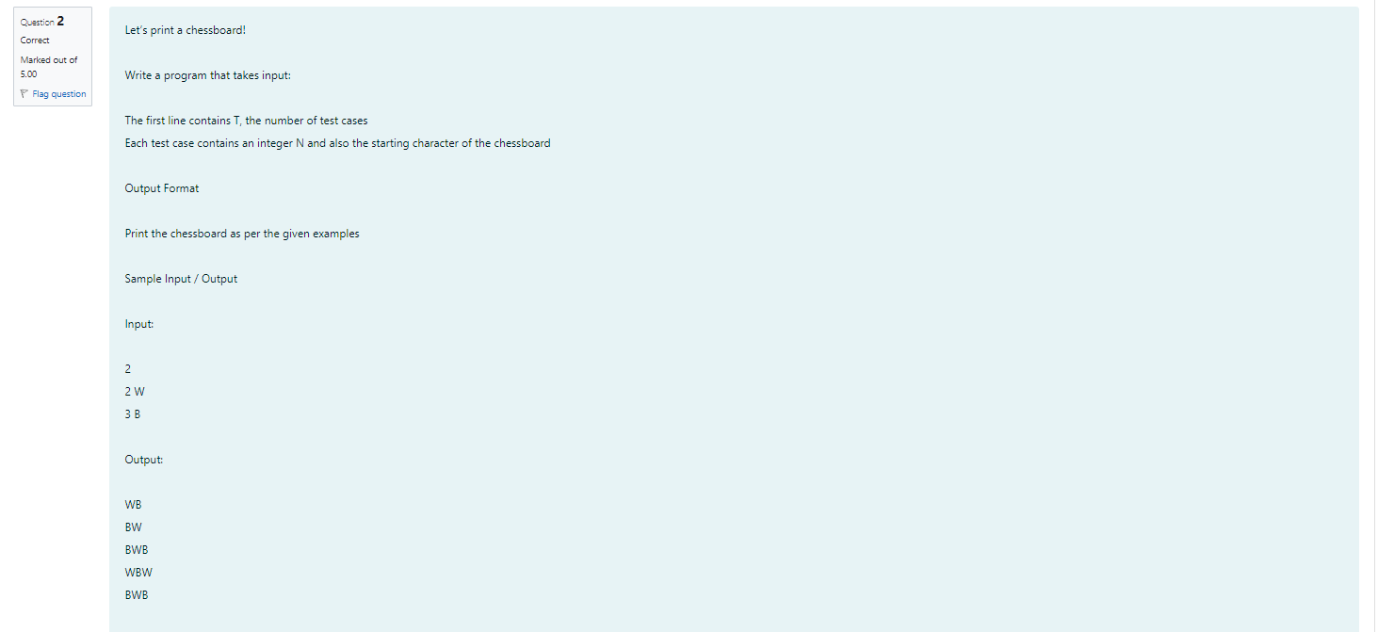

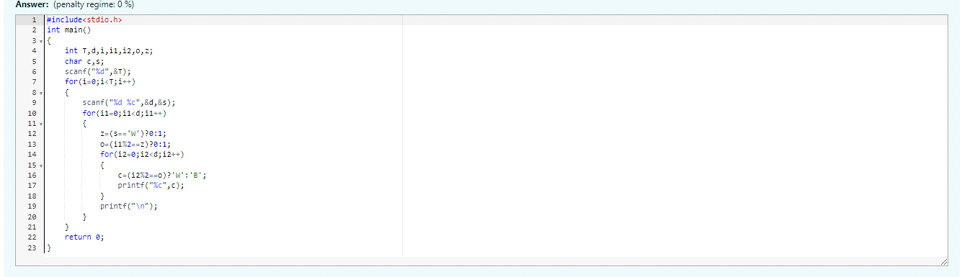

OUTPUT:

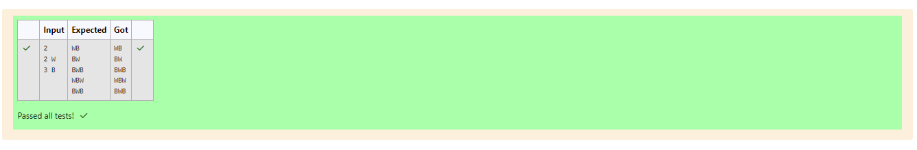

Q3)Problem Statement:

Decode the logic and print the pattern that corresponds to the given input.

If \( N = 3 \), then the pattern will be:

10203010011012

\*\*4050809

\*\*\*607

If \( N = 4 \), then the pattern will be:

1020304017018019020

\*\*50607014015016

\*\*\*809012013

\*\*\*\*10011

Constraints: ( 2 <= N<= 100 )

Input Format:

First line contains \( T \), the number of test cases. Each test case contains a single integer \( N \).

Output Format:

First line print Case #i where \( i \) is the test case number. In the subsequent line, print the pattern.

Sample Input:

3

3

4

5

Sample Output:

Case #1

10203010011012

\*\*4050809

\*\*\*607

Case #2

1020304017018019020

\*\*50607014015016

\*\*\*809012013

\*\*\*\*10011

Case #3

1020304050206027028029030

\*\*6070809022030204025

\*\*\*10011012019020021

\*\*\*\*13014017018

\*\*\*\*\*15016

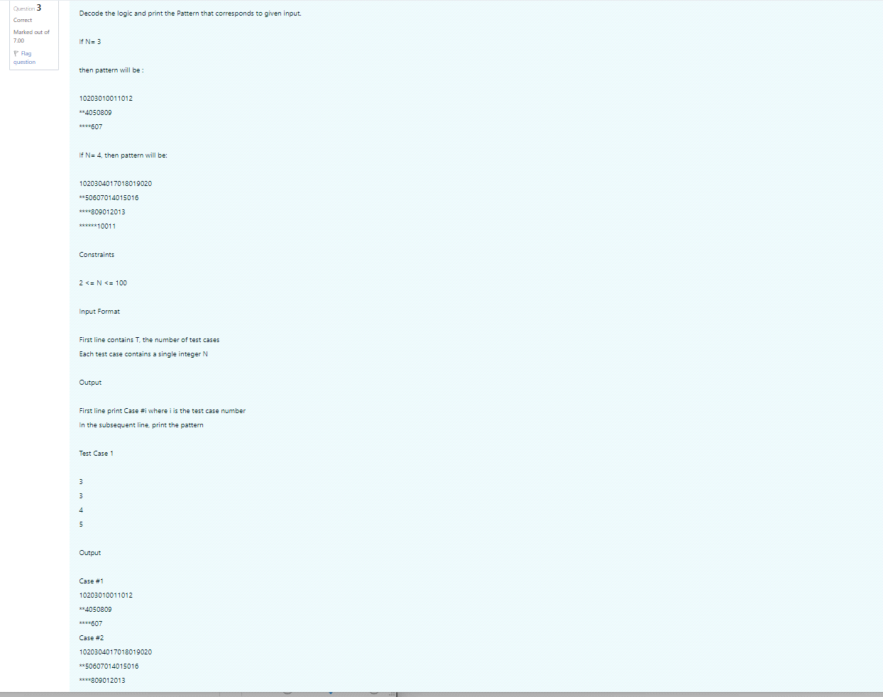

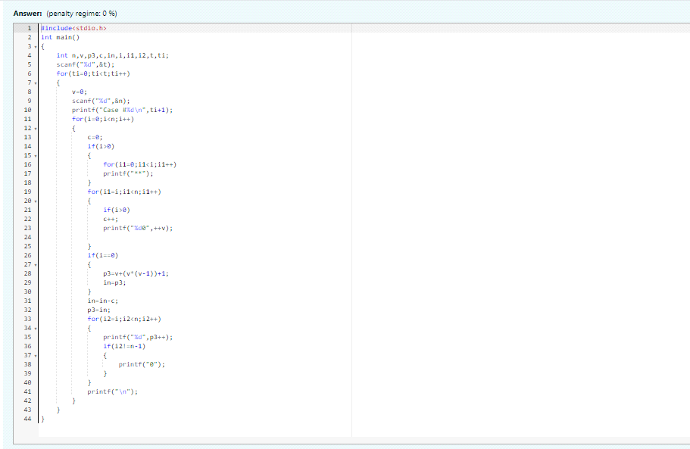

OUTPUT:

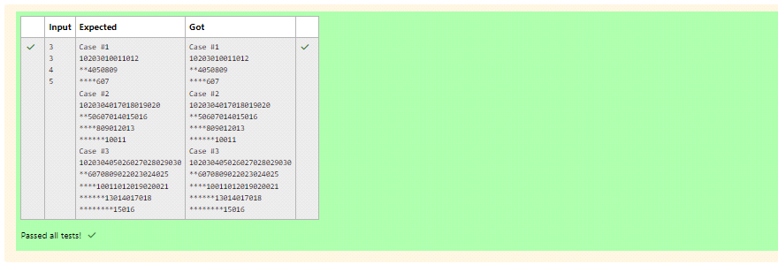

week:05-02

Roll No:241801317

Name: Vishal V

Q1)Problem Statement:

The k-digit number N is an Armstrong number if and only if the k-th power of each digit sums to N.

Given a positive integer N, return true if and only if it is an Armstrong number.

Note: 1 <= N <= 10^8

Hint:153 is a 3-digit number, and 153 = 1^3 + 5^3 + 3^3.

Sample Input:

153

Sample Output:

true

Sample Input:

123

Sample Output:

false

Sample Input:

1634

Sample Output:

true

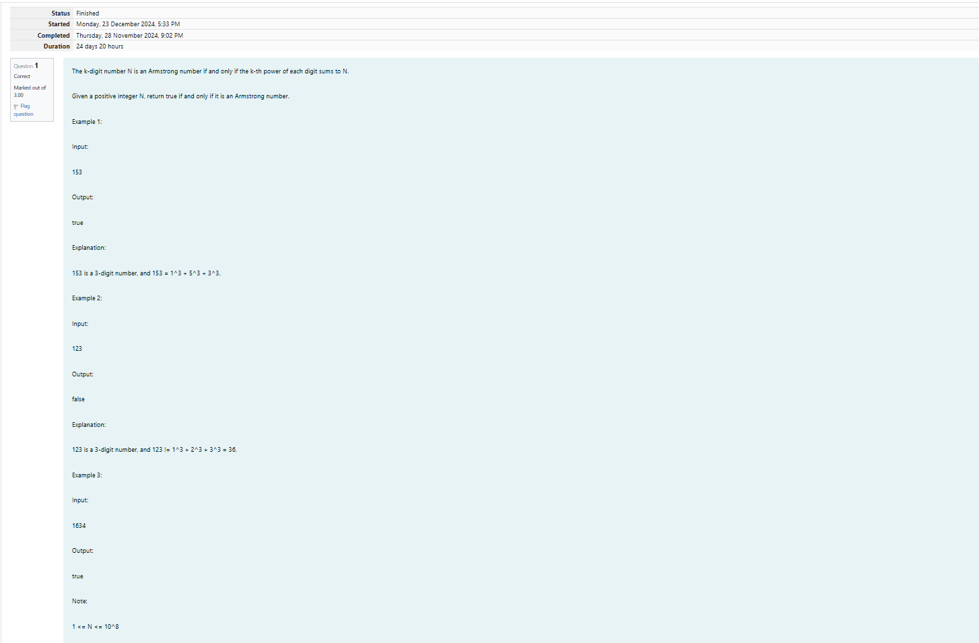

OUTPUT:

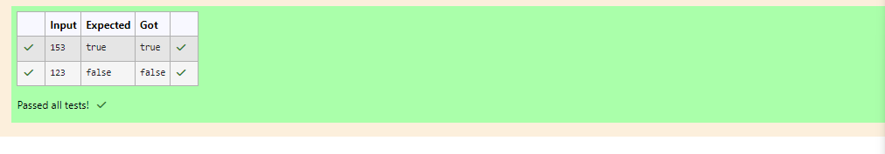

Q2)Problem statement:

Take a number, reverse it and add it to the original number until the obtained number is a palindrome.

Constraints: (1<=num<=999999999)

Sample Input 1:

32

Sample Output 1:

55

Sample Input 2:

789

Sample Output 2:

66866

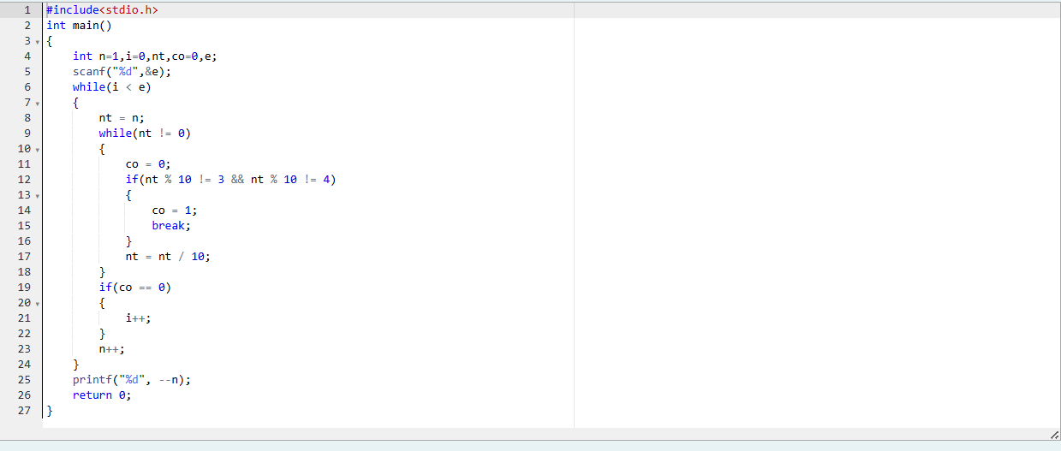

OUTPUT:

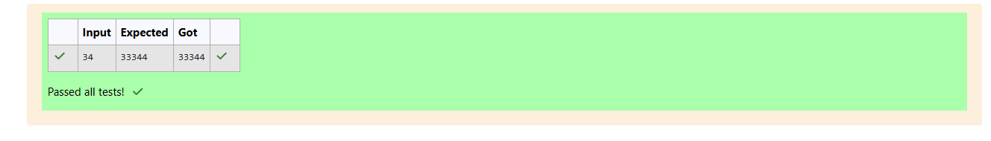

Q3)problem statement:

A number is considered lucky if it contains either 3 or 4 or both in it. Write a program to print the nth lucky number. For example, the 1st lucky number is 3, the 2nd lucky number is 4, the 3rd lucky number is 33, the 4th lucky number is 34, and so on. Note that numbers like 13, 40, etc., are not considered lucky as they contain other digits.

The program should accept a number 'n' as input and display the nth lucky number as output

Sample Input 1:

3

Sample Output 1:

33

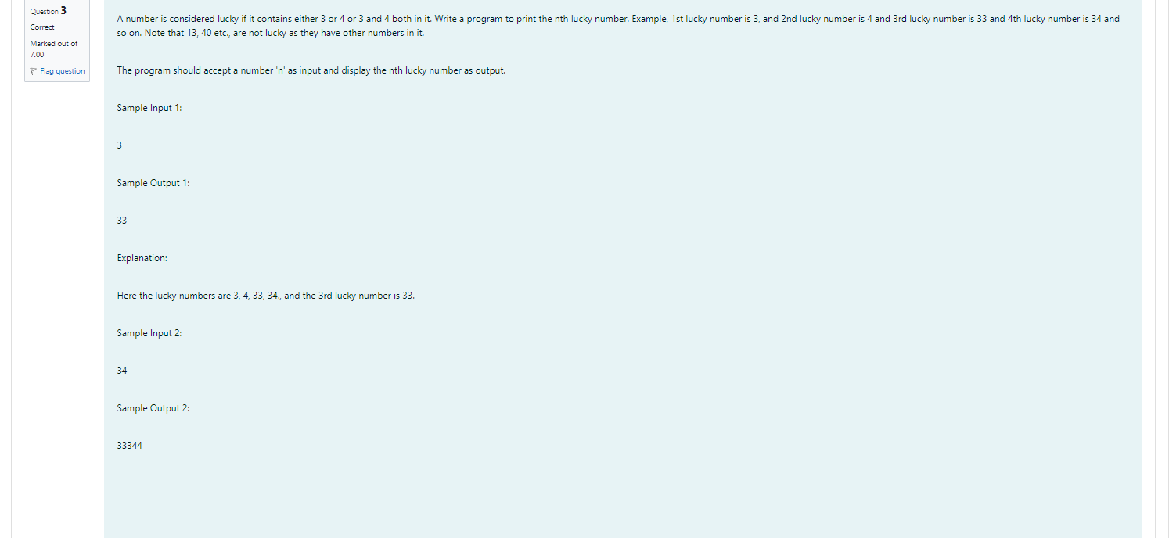

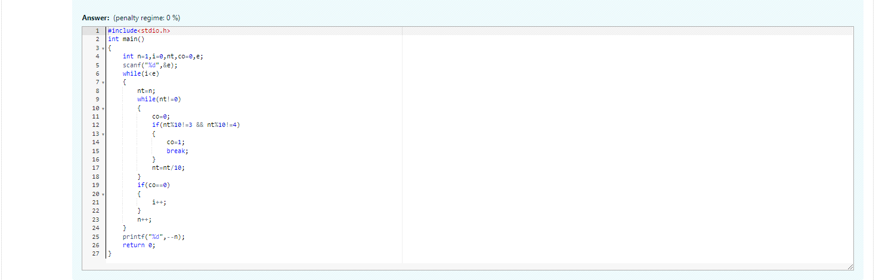

OUTPUT:

