resume-forge Project Showcase
LLM-tailored resumes that clear ATS filters — with a mechanical no-fabrication guarantee.
Status: 🟢 Complete | Date: July 2026 | Project Lead: Vishal Poornima | Quick Links: GitHub Repo
1. The Big Picture
The Problem
ATS software rejects strong candidates for mechanical reasons — mismatched keywords, broken layouts — and manually re-tailoring for every posting does not scale.
The Solution
resume-forge parses a resume once, tailors it per posting, renders a one-page LaTeX PDF, and scores it locally — while a guard blocks any invented fact.
🔥 Key Impact Metric: One-page, ATS-optimized resume scoring 80+/100 in ~70 seconds.
2. Core Features & Capabilities
- No-Fabrication Guarantee: Every fact is matched to the verified resume — nothing is invented.
- Provider-Agnostic Inference: Picks the best of 7 LLM backends — free cloud or fully offline.
- One-Page ATS-Safe Rendering: Single-column PDF, scored by 6 deterministic ATS checks.
3. Technical Implementation
Layer | Technology Selection | Strategic Rationale
Frontend | React, Vite, Tailwind CSS | Animated progress UI, no framework overhead.
Backend / API | Python, FastAPI | Background jobs with live progress polling.
LLM Inference | Ollama + 6 free/paid cloud presets | Runs unmodified: $0 budget to enterprise Claude.
Document Rendering | LaTeX (Tectonic), Jinja2 | Deterministic, ATS-safe PDF typesetting.
4. Key Results & Visual Assets
Measurable Metrics
- Test Coverage: 94 automated tests pass fully offline, enforced on every push via CI.
- Verified Performance: ~70s per run on free inference vs. 1–3 min local; scores of 80–88/100 achieved.
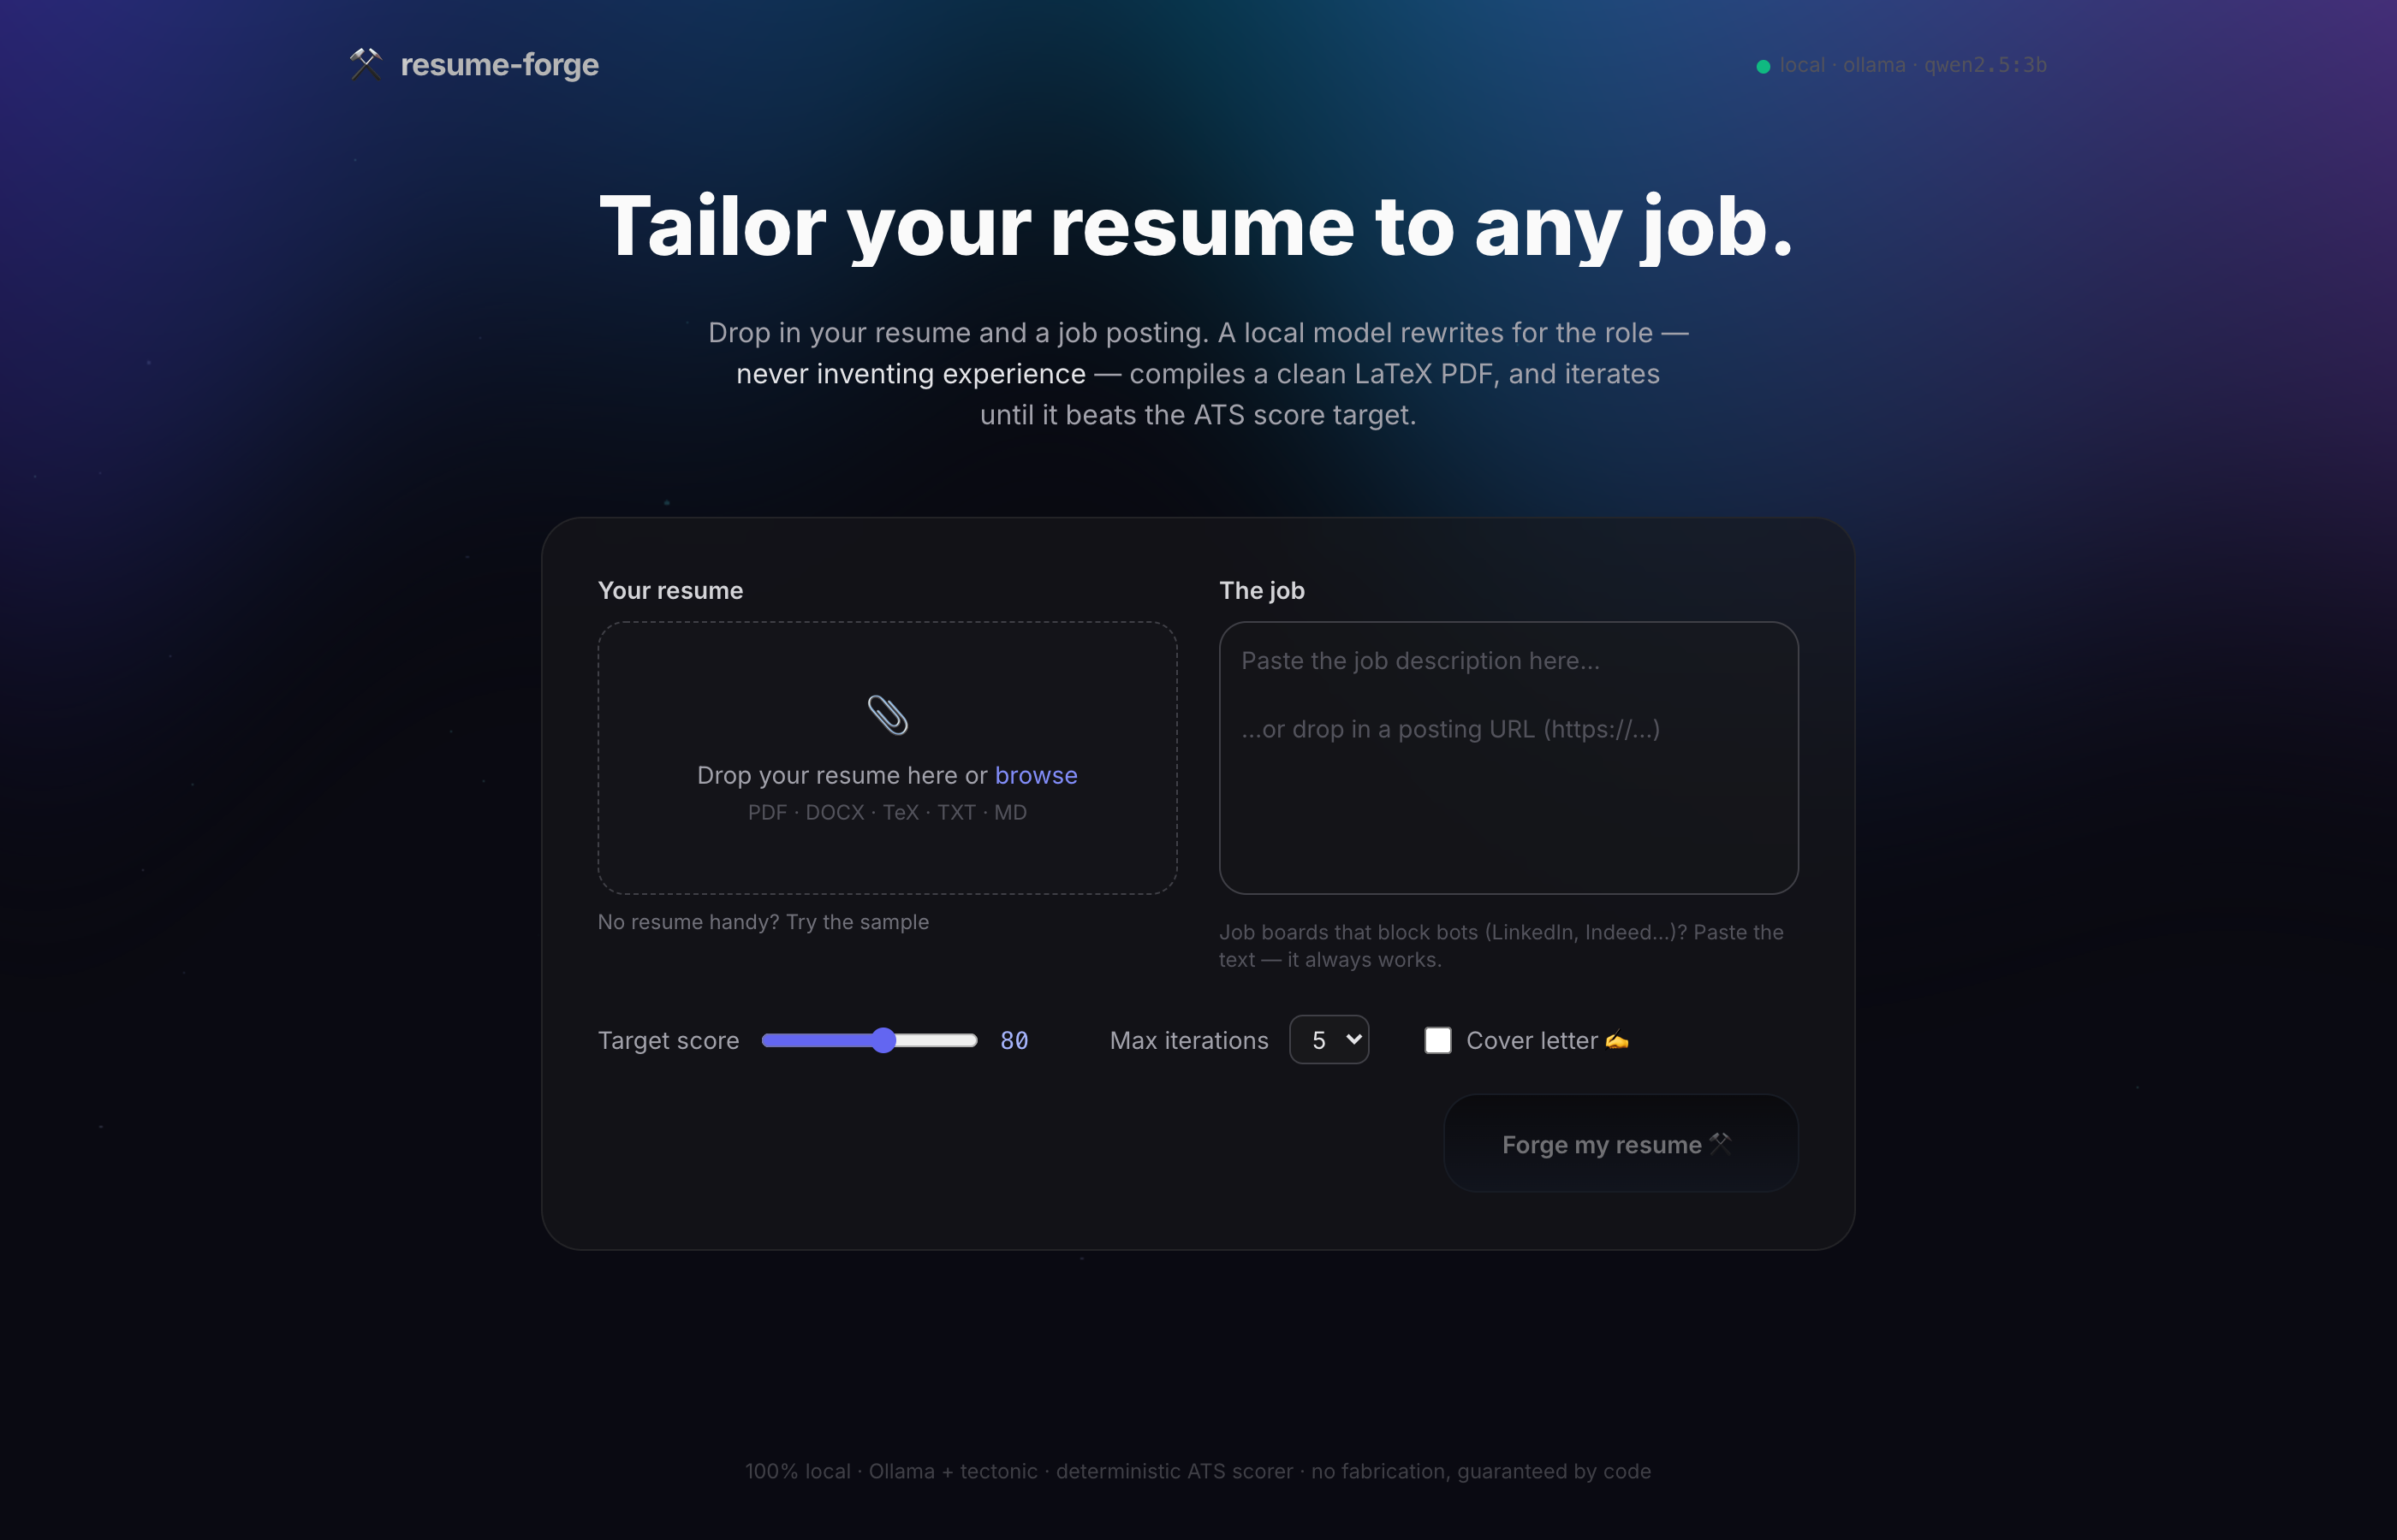
Figure 1: resume-forge web interface — intake form with live progress tracking.

