1. Write a simple poem and represent it as a web page. Give a title for the poem. Make rhyming words in the poem as bold.
2. Assume you have brought a new car. Write down the list of additional accessories you need for the car as an unordered list in HTML. Also, list the travel plans on the car as an ordered list.
3. Complete the following website name “Share your Winter Vacation Videos”. The required video files are located inside the compressed folder “Week 1 Assignment Files/Media/”.

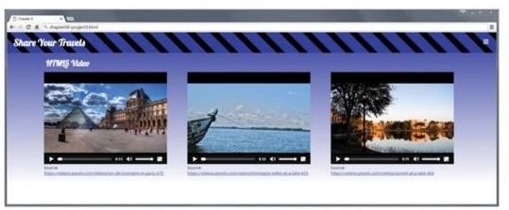

Hint: Add a <video> element to a <figure> element that will either play paris.mp4, paris.webm or paris.ogv in the element. Test in different browsers

1. Create the following output in HTML

