Example: By using Label, Entry and Button Control
Application: Addition Operation
XAML page(Design)
<?xml version="1.0" encoding="utf-8" ?>
<ContentPage xmlns="http://xamarin.com/schemas/2014/forms"
xmlns:x="http://schemas.microsoft.com/winfx/2009/xaml"
xmlns:local="clr-namespace:App7"
x:Class="App7.MainPage">

<StackLayout>

<Label
x:Name="valueLabel"
Text="Enter Value1"
Font="Large"
HorizontalOptions="Center"
VerticalOptions="CenterAndExpand"
/>
<Entry x:Name="txtVal1" Placeholder="Enter Value1"></Entry>
<Label
x:Name="valueLabel2"
Text="Enter Value2"
Font="Large"
HorizontalOptions="Center"
VerticalOptions="CenterAndExpand"
/>
<Entry x:Name="txtVal2" Placeholder="Enter Value2"></Entry>
<Button Text="Click Me!"
HorizontalOptions="Center"
VerticalOptions="CenterAndExpand"
Clicked="OnButtonClicked"
/>
</StackLayout>

</ContentPage>
XAML.cs Page (C# coding)
using System;
using System.Collections.Generic;
using System.Linq;
using System.Text;
using System.Threading.Tasks;
using Xamarin.Forms;

namespace App7
{
public partial class MainPage : ContentPage
{
public MainPage()
{
InitializeComponent();
}

async void OnButtonClicked(object sender, EventArgs args)
{
int val1 = int.Parse(txtVal1.Text);
int val2 = int.Parse(txtVal2.Text);
int res = val1 + val2;
await DisplayAlert("Addition",res.ToString(), "OK");
}
}
}
OutPut:
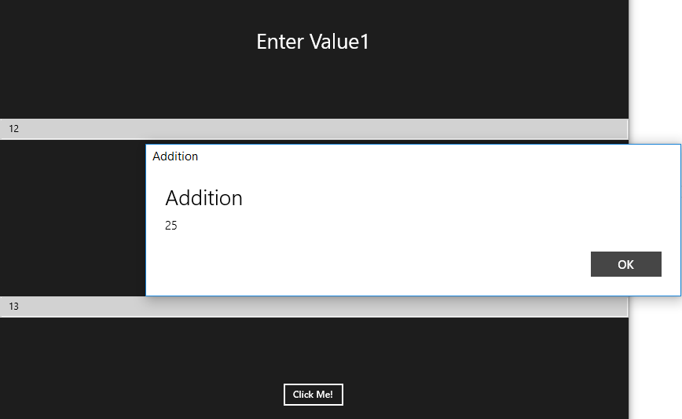

Example of DatePicker Control
Design Page:
<?xml version="1.0" encoding="utf-8" ?>
<ContentPage>
<StackLayout Orientation="Vertical" VerticalOptions="Center">
<DatePicker x:Name="mydatepicker" MinimumDate="01/01/1990" MaximumDate="12/31/2030" DateSelected="onDateSelected">
</DatePicker>

<Label x:Name="txtDate" Text="{Binding Date,Source={x:Reference mydatepicker}}" FontSize="30" HorizontalOptions="Center"></Label>
</StackLayout>

</ContentPage>

C# Coding Page
private void onDateSelected(object sender,DateChangedEventArgs e)
{

txtDate.Text = e.NewDate.ToString();
}
Output:
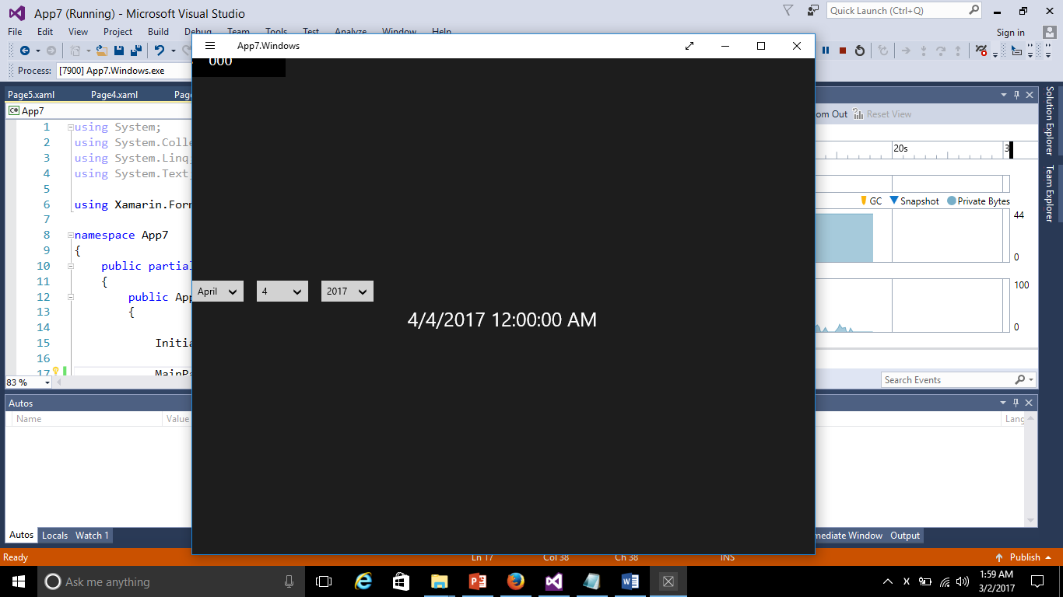

Example of TimePicker Control:
Design Page:
<ContentPage BackgroundColor="Green">
<StackLayout HorizontalOptions="Center" Padding="20">

<TimePicker x:Name="dttime"></TimePicker>

<Button x:Name="btnSubmit" Clicked="btnClick" Text="Submit"></Button>
<Label x:Name="lbltime" Text="{Binding Time, Source={x:Reference dttime}}"></Label>

</StackLayout>
</ContentPage>
C# Code:

public void btnClick(object sender,EventArgs args)
{

lbltime.Text = dttime.Time.ToString(@"hh\:mm");

}
Out Put:

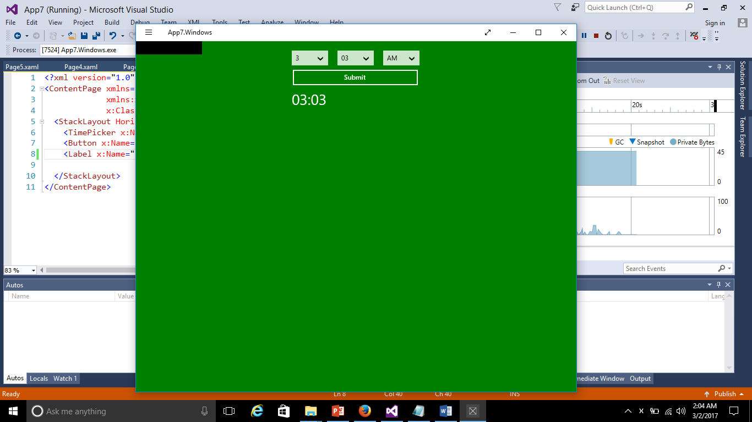

Example of BoxView and Slider Control:
Design Page:
<ContentPage>

<StackLayout Orientation="Vertical" Padding="40">

<BoxView Color="Blue" HeightRequest="100" WidthRequest="20">
<Label x:Name="lblValue" Font="Large" VerticalOptions="Center" HorizontalOptions="Center" />
</BoxView>

<Slider x:Name="sslider" Minimum="0" Maximum="50" ValueChanged="onSlidervalue"></Slider>

</StackLayout>
</ContentPage>
C# Coding:
public void onSlidervalue(object sender,ValueChangedEventArgs varg)
{
lblValue.Text = varg.NewValue.ToString();
}
Output:
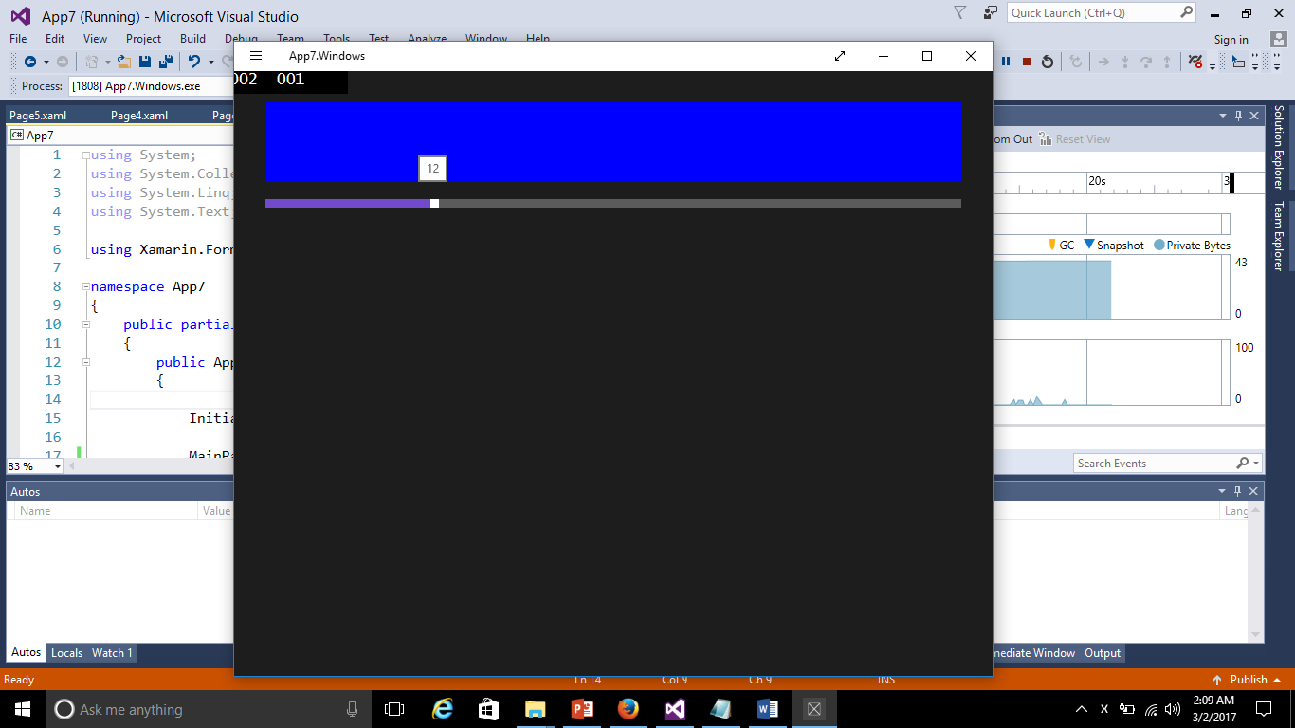

Example of Image Control:
Design Page:
<ContentPage>
<StackLayout Padding="10">
<Image HeightRequest="60" WidthRequest="100" VerticalOptions="Center" Aspect="AspectFit" Source="https://imagename.jpg" />

</StackLayout>
</ContentPage>
Example of Stepper Control:
Design Page:
<ContentPage>
<StackLayout Padding="10">
<Stepper x:Name="stpr" Value="5" Minimum="0" Maximum="10" ValueChanged="OnStepperValueChanged"></Stepper>

<Label x:Name="lblstpr" Font="Large"></Label>
</StackLayout>
</ContentPage>
C# Code:
void OnStepperValueChanged(object sender, ValueChangedEventArgs e)
{
lblstpr.Text = "Stepper value is "+ e.NewValue.ToString();
}

Output:

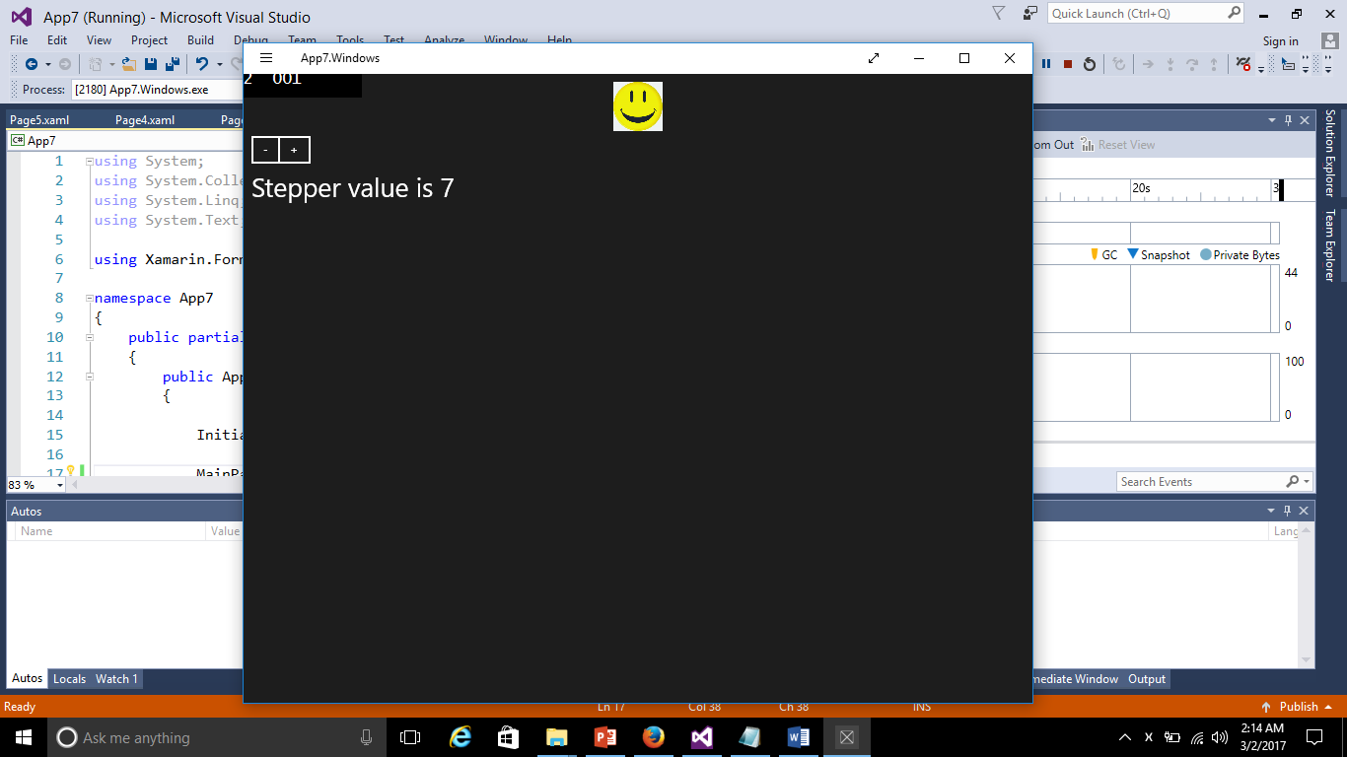

Example of Progress Bar
Design Page:
<ContentPage BackgroundColor="White">
<StackLayout Padding="10" VerticalOptions="Center">
<ProgressBar x:Name="progressBar1" HeightRequest="50" WidthRequest="100" Scale="0.5" BackgroundColor="Red"></ProgressBar>
<Label Text="{Binding Progress,Source={x:Reference progressBar1}}" VerticalOptions="Center" HorizontalOptions="Center" FontSize="20" TextColor="Navy" />
</StackLayout>

</ContentPage>
C# Coding:
protected override async void OnAppearing()
{
base.OnAppearing();
await progressBar1.ProgressTo(0.8, 10000, Easing.Linear);
}

Output:
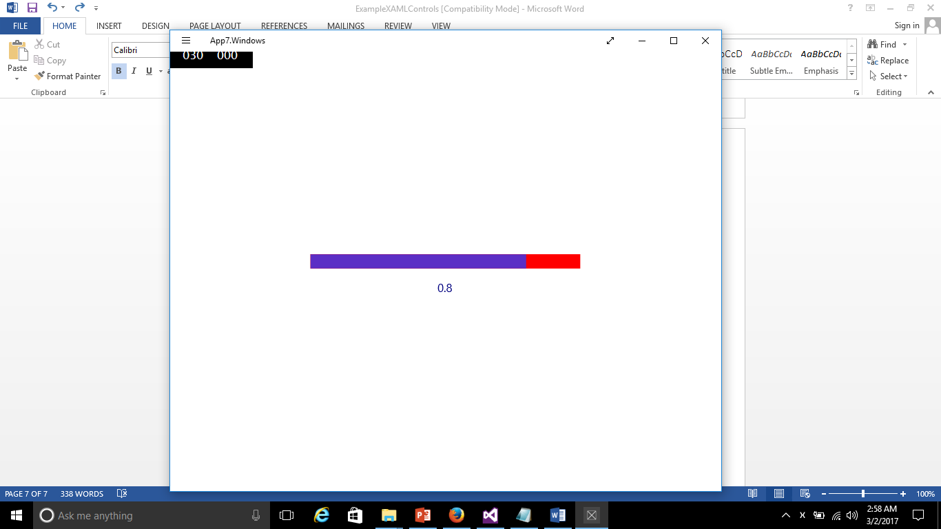

Example of Editor
The Editor control is used to accept multi-line input.
Design page:
<?xml version="1.0" encoding="utf-8" ?>
<ContentPage xmlns="http://xamarin.com/schemas/2014/forms"
xmlns:x="http://schemas.microsoft.com/winfx/2009/xaml"
x:Class="App11.Page6">
<StackLayout Padding="100">
<Editor x:Name="editor1" FontFamily="Arial" FontSize="14" TextColor="Green"></Editor>
<Button Text="Submit" Clicked="onbtn"></Button>
<Label x:Name="lbl"></Label>
</StackLayout>
</ContentPage>

C# Coding:
using System;

using Xamarin.Forms;

namespace App11
{
public partial class Page6 : ContentPage
{
public Page6()
{
InitializeComponent();
}
public void onbtn(object sender,EventArgs arg)
{
var txt = editor1.Text;
lbl.Text =txt;

}
}
}

Output:
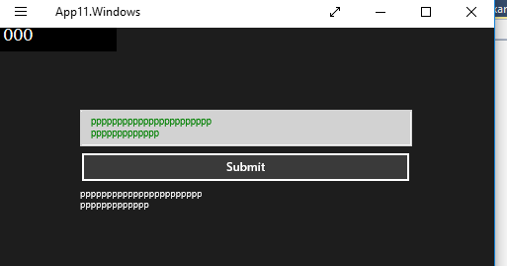

Example of searchBar:

Design Code:
<?xml version="1.0" encoding="utf-8" ?>
<ContentPage xmlns="http://xamarin.com/schemas/2014/forms"
xmlns:x="http://schemas.microsoft.com/winfx/2009/xaml"
x:Class="App8.Page3" BackgroundColor="Gray">
<StackLayout VerticalOptions="Center" Padding="50">
<SearchBar Placeholder="Enter Search key" x:Name="searchkey" SearchButtonPressed="onSearch"></SearchBar>
<ListView BackgroundColor="Maroon" x:Name="ddlist"></ListView>
</StackLayout>
</ContentPage>
C# Code:
using System;
using System.Collections.Generic;
using System.Linq;
using System.Text;
using System.Threading.Tasks;
using System.Xml.Linq;
using Xamarin.Forms;

namespace App8
{
public partial class Page3 : ContentPage
{
public Page3()
{
InitializeComponent();
ddlist.ItemsSource = _names;
}
private readonly List<string> _names = new List<string>
{
"","Gaurang","Deepak","Harshit"
};

private void onSearch(object sender, EventArgs ar)
{

string key= searchkey.Text;
IEnumerable<string> res=_names.Where(name =>name.Contains(key));
ddlist.ItemsSource = res;

}
}
}

