**ASSIGNMENT- 3**

1. Create a DynamoDB table with a partition key as ID.

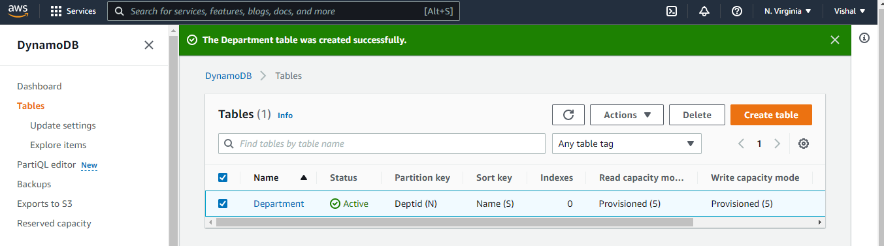

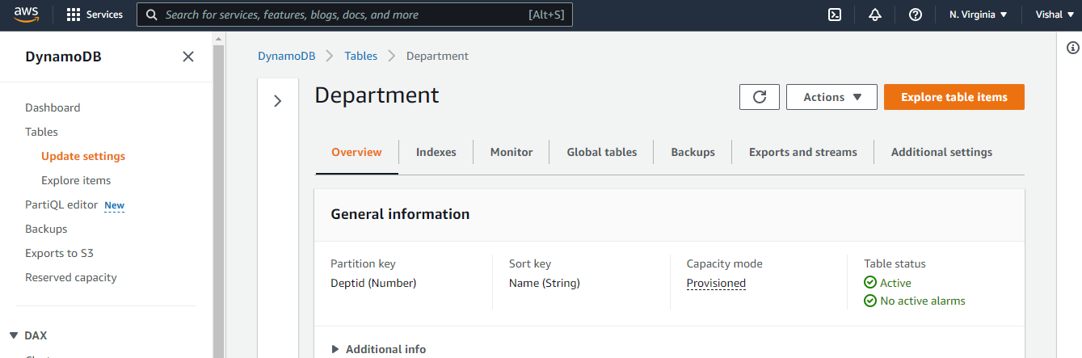

Add 3 items to the DynamoDB table.

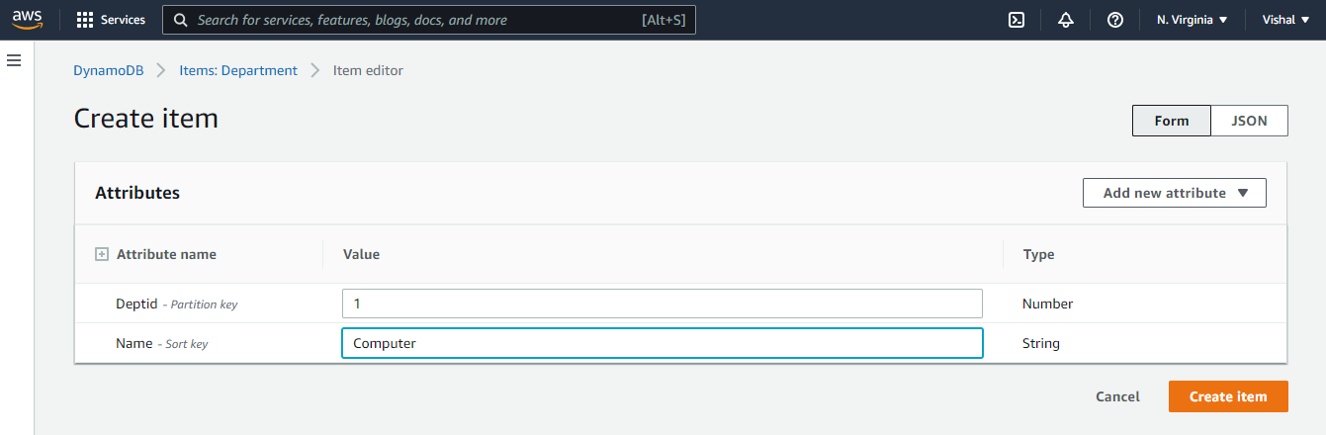

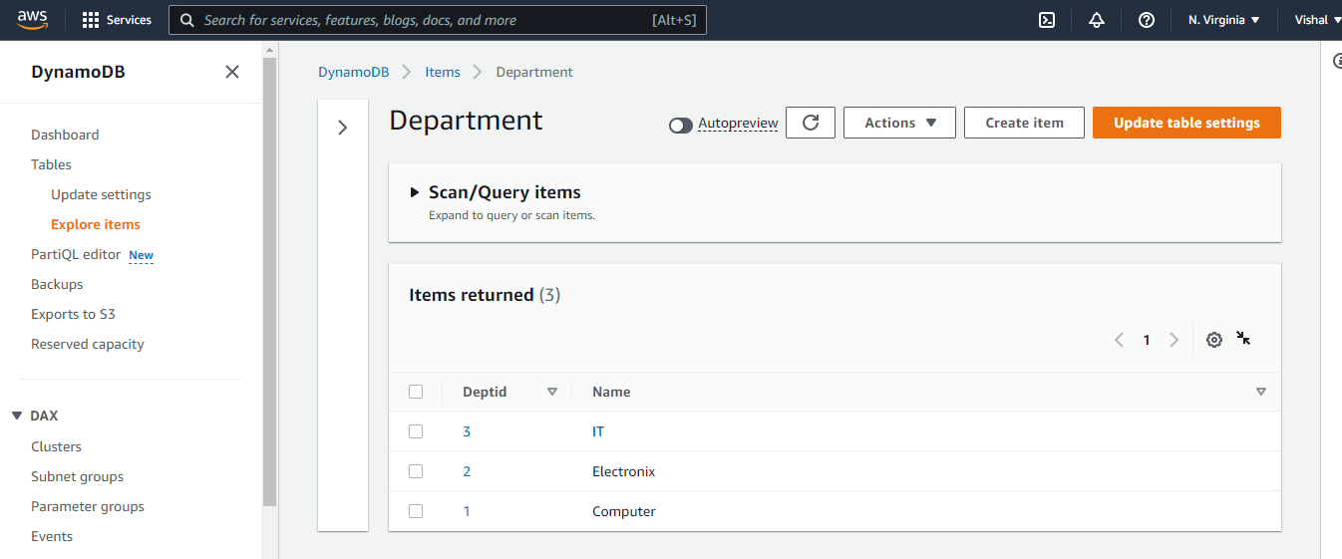

3) Take a backup of the table; delete the table, and then restore it.

