**ASSIGNMENT-2**

1. Create a policy number 1 which lets the users to:

a. Access S3 completely

b. Only create EC2 instances

c. And full access to RDS.

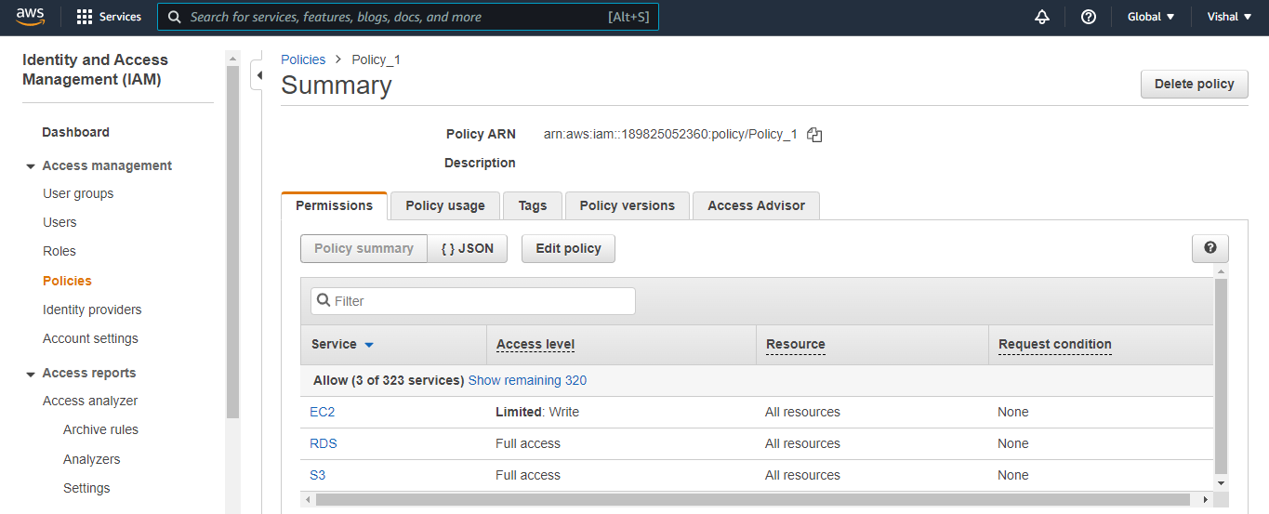

2. Create a policy number 2 which allows the users to:

a. Access CloudWatch and Billing completely

b. And can only list EC2 and S3 resources.

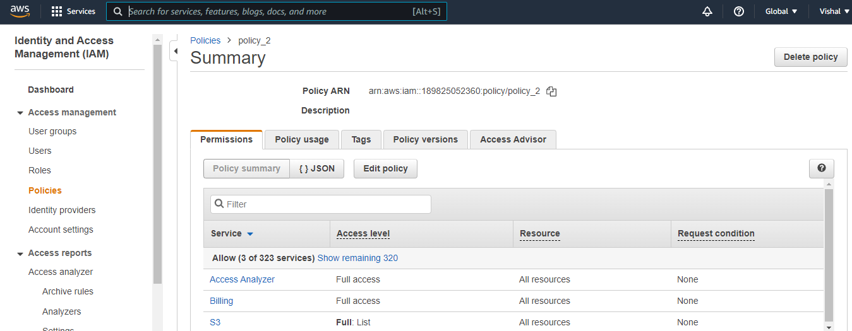

3. Attach policy number 1 to Dev Team from task 1

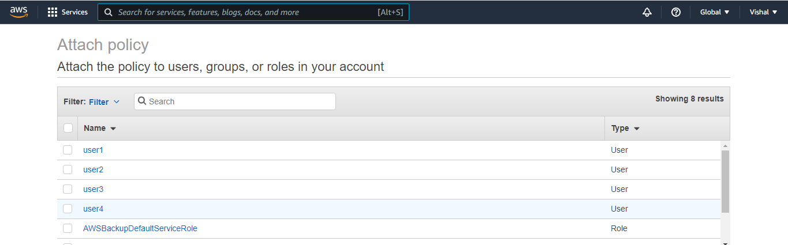

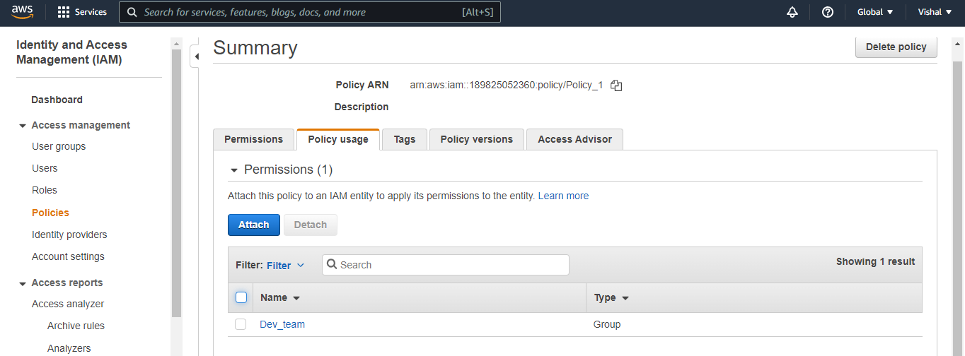

4. Attach policy number 2 to Ops Team form task 1

