**ASSIGNMENT-3**

1. Create a role which only let’s user1 and user 2 from assignment 1 to have complete access to VPC’s and DynamoDb.

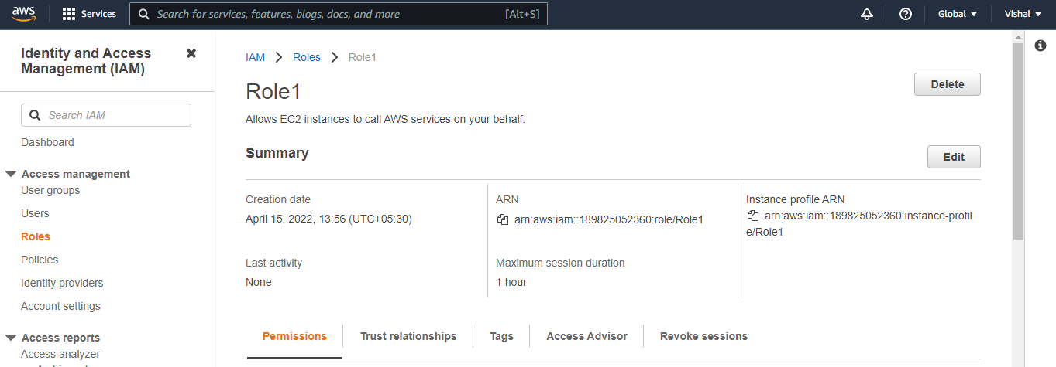

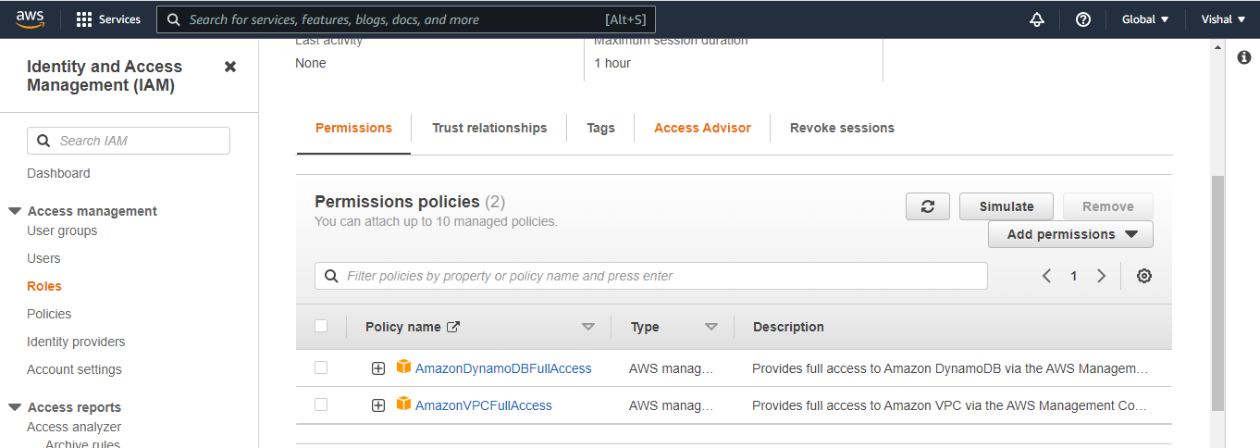

2. Login into user1 and shift to the role to test out the feature.

