**ASSIGNMENT – 1**

1. Create a 4 IAM users name “user1”, “user2”, “user3”, and “user4”.

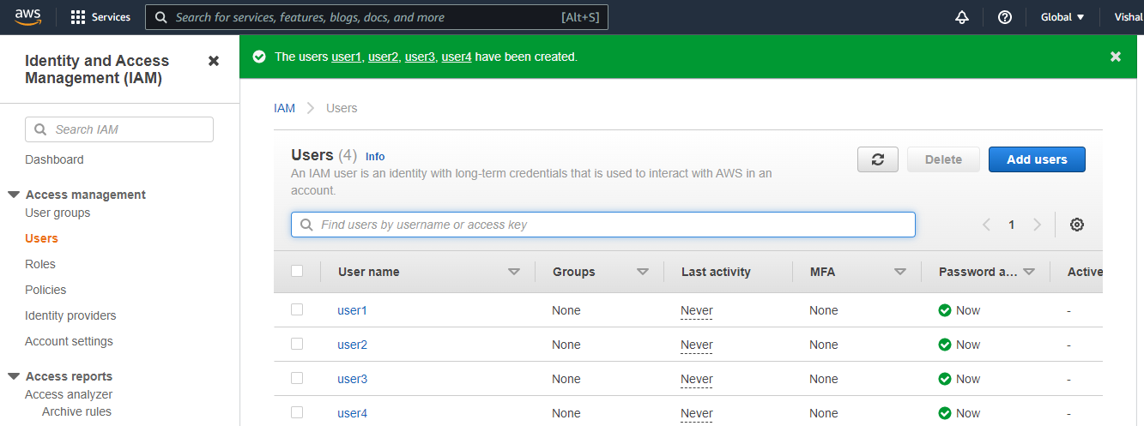

1. Create 2 Groups named “Dev Team” and “Ops Team”

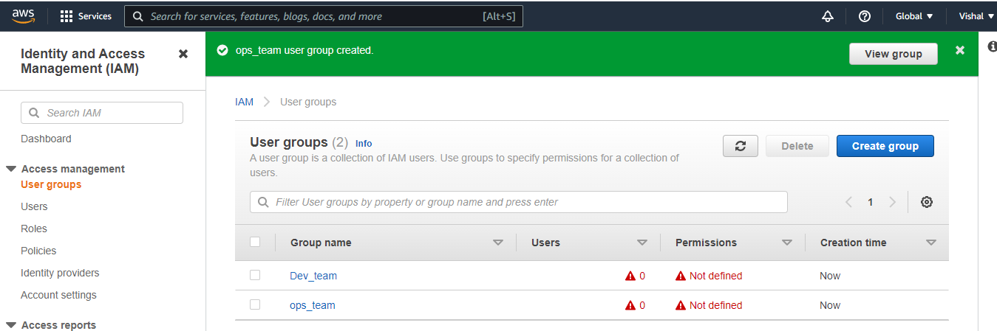

1. Add user1 and user2 to the Dev Team.

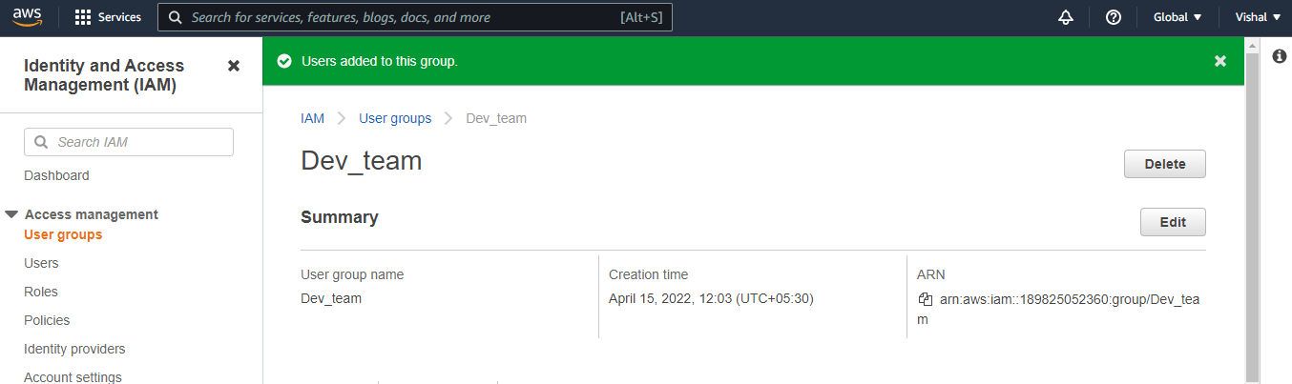

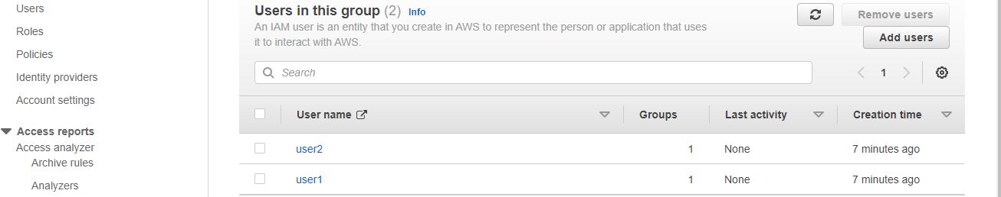

1. Add user1, user3 and user4 to the Ops team.

