Assignment – 1

1. Create an S3 bucket.

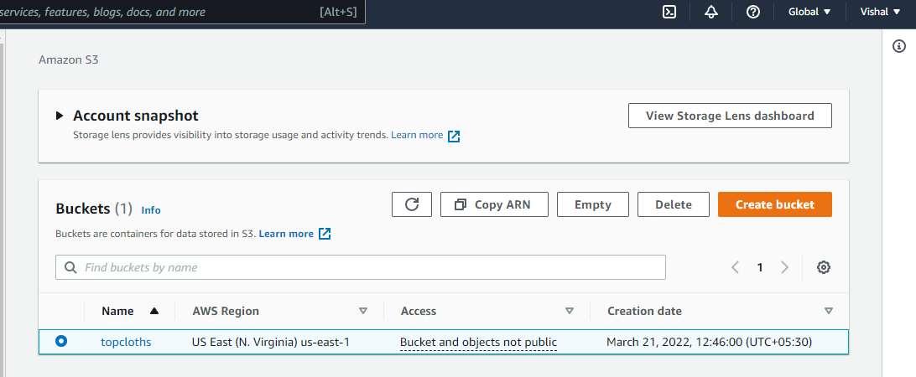

1. Upload 2 objects.

