Assignment – 2

1. Enable versioning for the bucket created in task 1.

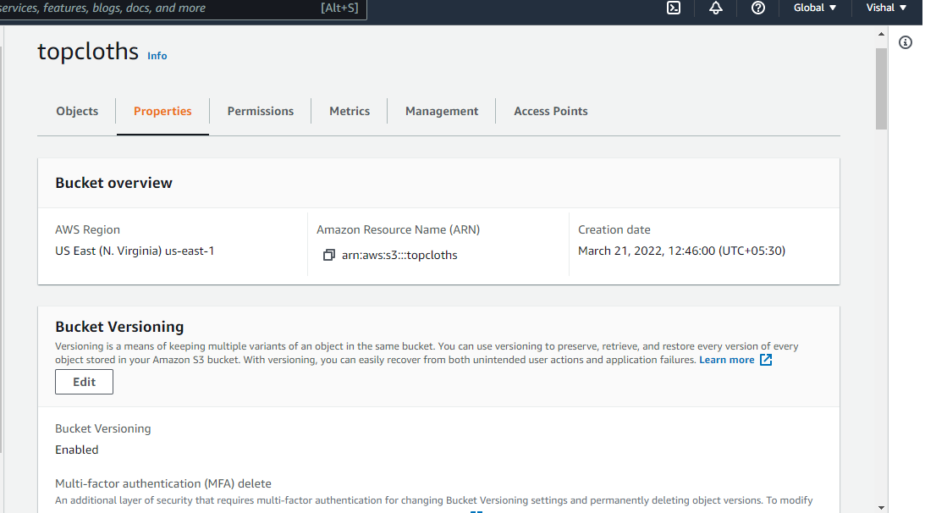

2. Now upload the same 2 objects and verify if the versioning works.

