**ASSIGNMENT -1**

1. **Create a VPC with 120.0.0.0/16 CIDR block.**

* **Default Vpc.**

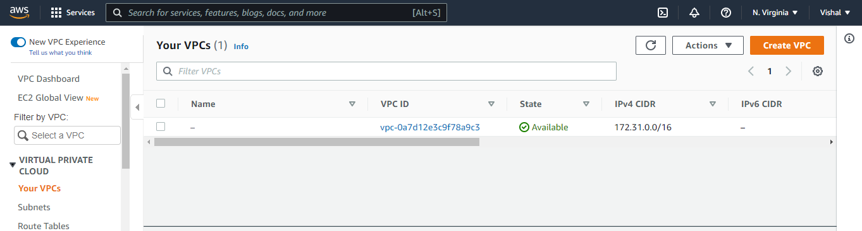

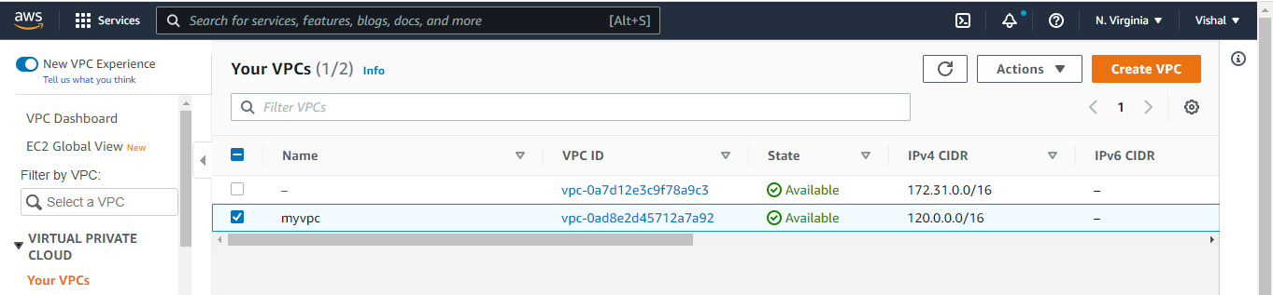

1. **Create 1 public subnet, 2 private subnets and make sure you connect a NAT gateway for internet connectivity to private subnet.**

