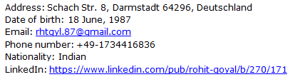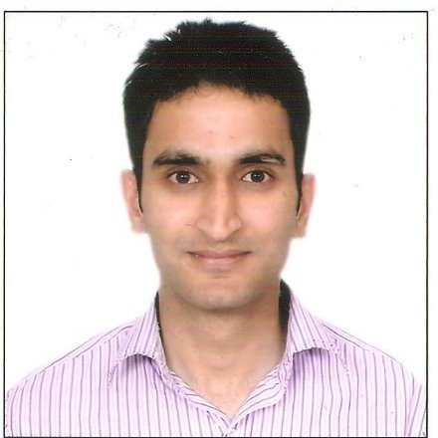

Objective
I wish to contribute my creativity as Database architect and excel in this field. I want to be a member of a team of great computer professionals who have been making top contributions to create and manage reliable infrastructures.

Summary & Profile Snapshot
- Total 4 years of experience in software development using C, C++,Java and Python.
- 1.5 years work experience as a Research assistant for developing tool unsing natural language text processing.
- 1.0 years work experience as a test automation engineer at Deutsche Telekom.
- Experience in platforms like Unix, Linux, HP-UX, IBM AIX.
- Experience in Installation, Configuration, Upgrades, migrations, Regular Database Management, Space monitoring, Cloning, UNIX Shell scripting and Documentation.
- Knowledge of oracle Advance Technologies like RMAN, Data Guard(logical and physical standby), Real application Cluster
- Well conversant in translating Business Requirements into Database activities.
- Working experience with IBM workload schedulers like Maestro for automation and scheduling.
- Working and internal source code knowledge of postgresql Database.
- Basic knowledge of MySql, Microsoft SQL Server Database.
- Strong Analytical, Interpersonal, Troubleshooting and Communication Skills.
- Fluent in English, strategic thinker, self-starter and an excellent team-player;

Education Qualifications
Masters | 1. Masters in Distributed software systemsOct-2012- Oct-2014)  Technical university of Darmstadt, Germany  - It is an international program focus on various domains like Databases, networking, software development, middleware, event processing and many more.  Master Thesis: Design, implementation and benchmarking of a new multi-version indexing algorithm for specially optimized for flash based databases systems
Bachelors | B. Tech in Computer Science and Engineering (2005 to 2009)  Maharaja Agrasen Institute of Technology (Guru Gobind Singh University),  Delhi, India

Work Experience
Experience 1: Database Consultant Deustche Bank, Frankfurt
Position Held | Database Administrator (Mar, 2015 –till present)
Employer | Avato Consulting
Responsibilities | Maintaining all build servers of Deutsche bank before going into production.  Failover test, space management, ASM based storage, cluster control, db refresh, installation, upgrade, import/export and rman for backup, daily incident, performance analysis .
Experience 2: Database operations for Numonyx Client
Position Held | Junior Database Administrator (Jan, 2009 –till Feb 2011)
Employer | Tata Consultancy Services (Delhi, India)
Responsibilities | Maintaining 180 DB which includes 64 production and 56 QA and 60 TI  Oracle database systems for European client.  DB Maintenance includes all regular Responsibilities like data, space, and  Performance management, backup, recovery, import, export and  Automation job scheduling using Shell scripting.
Experience 3: Database operations for Numonyx Client
Position Held | Senior Database Administrator (Feb, 2011–till August, 2012)
Employer | Tata Consultancy Services (Delhi, India)
Responsibilities | Installation, configuration, upgradation, migration, cloning, performance  of 178 databases which includes 42 production databases.  Working on year end maintenance activities  Handling priority 1, 2 tickets. Database backup, recovery, Sql query  tuning, db performance tuning and disaster recovery management in co-  ordination with other teams.
Experience 4: Team Management for Numonyx Client
Position Held | Shift manager(May,2012-till August, 2012)
Employer | Tata Consultancy Services (Delhi, India).
Responsibilities | Managing Night support teams, assigning of tickets as per skills, data  and tickets management using remedy, CA tools.  Mentoring new junior DBA’s for knowledge transfer and landscape  Understanding.
Experience 5: Research Assistant for DVS group in TU Darmstadt
Position Held | Research Assistant(March,2013-till Present)
Employer | TU Darmstadt, Darmstadt Germany
Responsibilities | Thinking of new ideas for index optimization.
Achievements | Designed, implemented and benchmarked a new multi-version indexing approach (MV-IDX) which gives a better, fast visibility check and direct access to the visible rows in the database.
Experience 6: Testing and DB Administration for Kobil Systems
Position Held | QA Engineer and internal Database Administator(March, 2013 – Now)
Employer | Kobil Systems, Eberstadt, Germany
Responsibilities | Designing and testing of server side components of a smart secure mobile  app for banking and secure transactions.  Major task is testing of installation and DB migration component of App.  I am also responsible for managing database (Oracle, Mysql, MSSql  server) QA databases on platforms like windows, linux and solaris.

Certifications / Training
Oracle Database 11g Certified Professional
Oracle Database 11g Certified Associate
Completed SQL Tuning(Query Optimization) Hands-on training from Oracle India Pvt. Ltd
Oracle Database 10g Certified Real Application Cluster(RAC) Expert
Certified ITIL v3 Foundation Expert
Attended Oracle 11g Data Guard training conducted by TCS Internal

Technical Skills
Programming Languages | C, Core Java, Pl/SQL, Shell Scripting
DB Systems | Oracle 9i, 10g, 11g, MS Sql server 2005,2007, Postgresql, Mysql
Platforms | Windows, Linux, Unix, HP-UX, AIX, Solaris
Others | MS Office, Redmine, remedy tool, HP quality Center, Test Link, Testing tools like  Jmeter, Selenium

Social Skills and interest
Hobbies | Stock and Investments, Listening Soft Music, badminton
Professional interest | Understanding ITIL process, IT Sales and request for proposals

References

Sushant Dash(sushant.dash@tcs.com)
Database Team Lead(Jagua & Land Rover Project), Tata Consultancy Services, Delhi, India

Varun Gupta(varunmast@gmail.com)
Database Lead and configuration manager, Tata Consultancy Services, U.S.A

