Qs1. How to change screen refresh interval?

Step1: Enter command ‘top’ on terminal.

Step2: While running press ‘d’.

Step3: Change the refresh interval as desired, type ‘10’ and press enter.

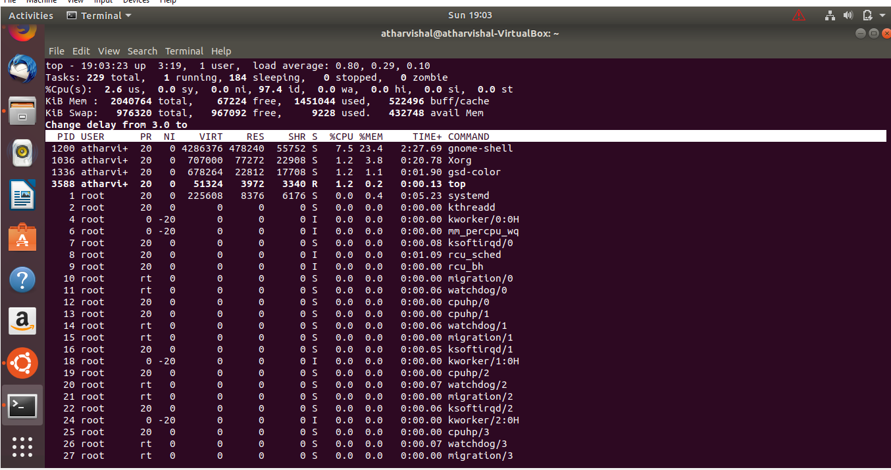

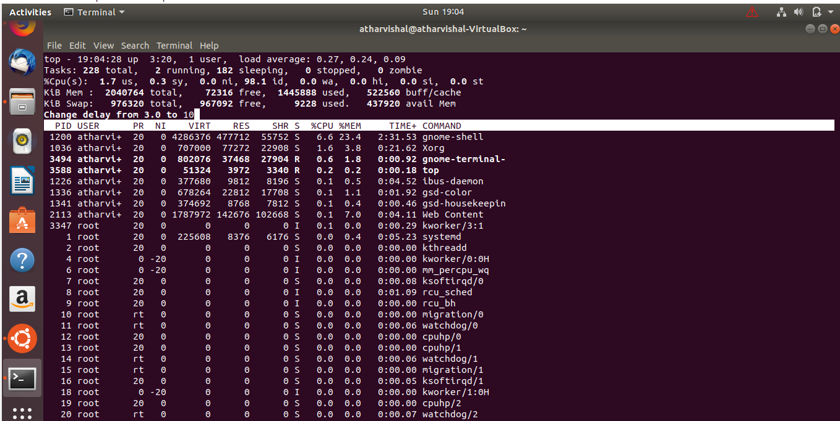

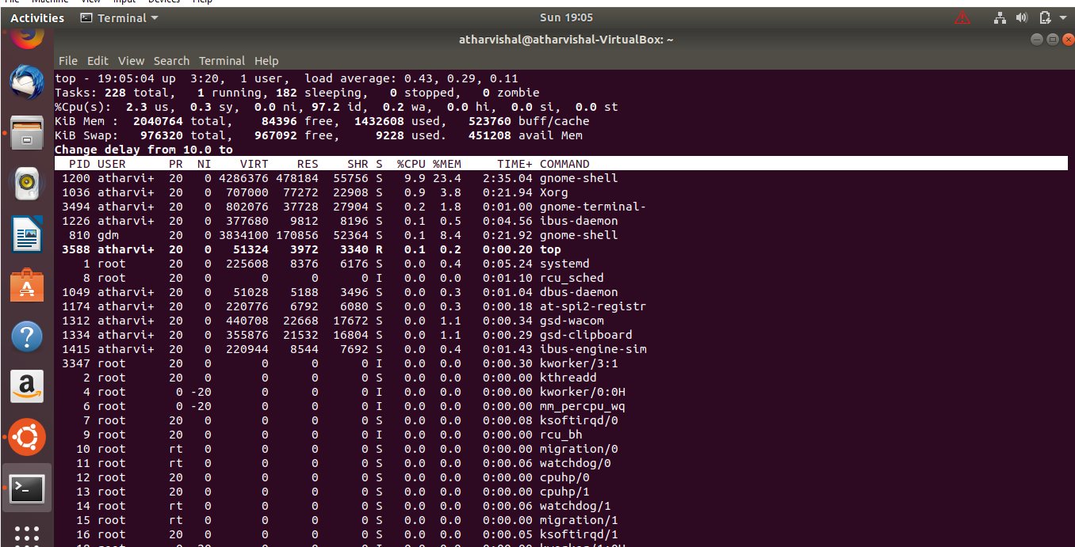

Qs2. Command to stop a background process?

Step1: Enter command ‘Top’ on terminal.

Step2: Locate the PID of the respective process you want to stop, e.g FireFox has a PID in this example as 2043.

Step3: Quit the top command.

Step4: Type command: kill -SIGSTOP [PID] i.e kill -SIGSTOP 2043, it would stop the process.

Step5: To continue the process, type command: kill -SIGCONT [PID].

