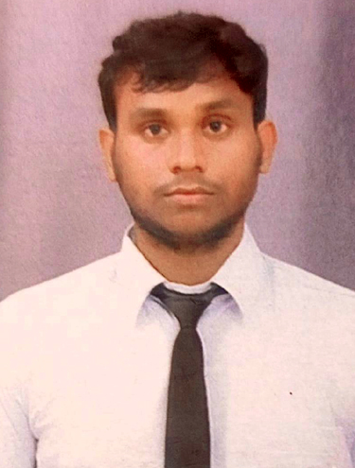
RESUME
VISHAL MAURYA
Address: A-84 vimal nagar kamta chinhat lucknow
Pincode: 226028
Contact No. +918381813449
Email Id:- vishalk21950@gmail.com

OBJECTIVE:-
"As in the field of literature with my good interpersonal and communication skills, I will be able to confidently deal with all the level of people working in the organization. I would put all efforts in my work."

EDUCATION OUALIFICATIONS
- Graduation (B.pharma) from Lucknow R.P.S college of pharmacy 2023
- Intermediate passed from U.P Board in 2023.
- High School passed from U.P. Board in 2021.

COMPUTER KNOWLEDGE:-
- Basic Knowledge in Computer Applications

STRENGTH
- Time punctual
- Ability to learn new things quickly Has strong attention to detail skills
- A loyal and supportive employee
- Self-motivated person with enthusiastic and consistent attitude

EXPERIENCE:-

- 2 years Teaching Experience in Home Tuition .

SKILLS:
- Fast learner
- Flexible in my work
- Available to work in required hours
- Basic knowledge of computer
- Language fluency - English, Hindi

PERSONAL PROFILE:-

Father's Name Mr. Ajay kumar maurya
Date of Birth 01-01-2005
Marital Status Unmarried
Nationality Indian
Religion Hindu
Gender male

DECLARATION:

I Solemnly here by information you that all above mentioned information is true information found to be incorrect I shall be held responsible for all that.

Date:
Place: Vishal maurya

