Online Examination System — Project Report
Nov 1, 2026 · @Vishal B

1. Problem Statement
Design and implement a simple online examination system in which an administrator maintains a repository of multiple-choice questions (MCQs), builds exams from that repository, and registers students; each student then takes an exam made of questions drawn at random from the exam's pool, and the system scores the attempt automatically and lists every student's result for the administrator.
The system must:
- authenticate two kinds of users, Admin and Student, and restrict each to their own functions;
- let the admin create, edit and delete exams and questions, and assign questions to an exam's pool;
- give each student a different random set of n questions from the pool, where n is set per exam;
- allow a student to answer, change answers, leave and resume an exam until they submit it, and only once;
- compute the score on submission and show results, including a per-question answer review, to the admin.

2. Motivation, Scope and Limitations

2.1 Motivation
Paper-based MCQ tests take time to set, print, invigilate and correct by hand, and the same paper for every student makes copying easy. An online system removes manual correction, gives instant and error-free scores, and keeps every attempt on record for later review.
- Fairness: each student gets a random subset of the pool, so neighbouring students rarely see the same questions in the same set.
- Reuse: questions live in one repository and can be reused across many exams.
- Speed: scoring is done by the database the moment a student submits.
- Transparency: the admin can open any attempt and see what the student chose against the correct answer.

2.2 Scope
- Two roles, Admin and Student, with token-based (JWT) login and role-based access to the REST API.
- Admin: CRUD for exams and questions, assigning/unassigning questions to an exam's pool, creating student accounts, viewing a rank list of results for each exam (with an exam filter and average score) and an answer-by-answer review.
- Student: list of available exams, start or resume an exam, navigate questions (Previous/Next), answer and change answers, submit once.
- Scoring: one mark per correct answer, no negative marking; unanswered questions score zero. Scores and ranks are shown only to the admin; the student sees an "Exam submitted" confirmation.
- A browser front end (HTML + JavaScript) that talks to the back end only through the REST API, so the two are fully separated.

3. Design of the Solution
The system is a three-tier web application: a browser front end, a Spring Boot REST back end secured with JWT, and a MySQL database (examdb) accessed through JDBC.

3.1 System architecture
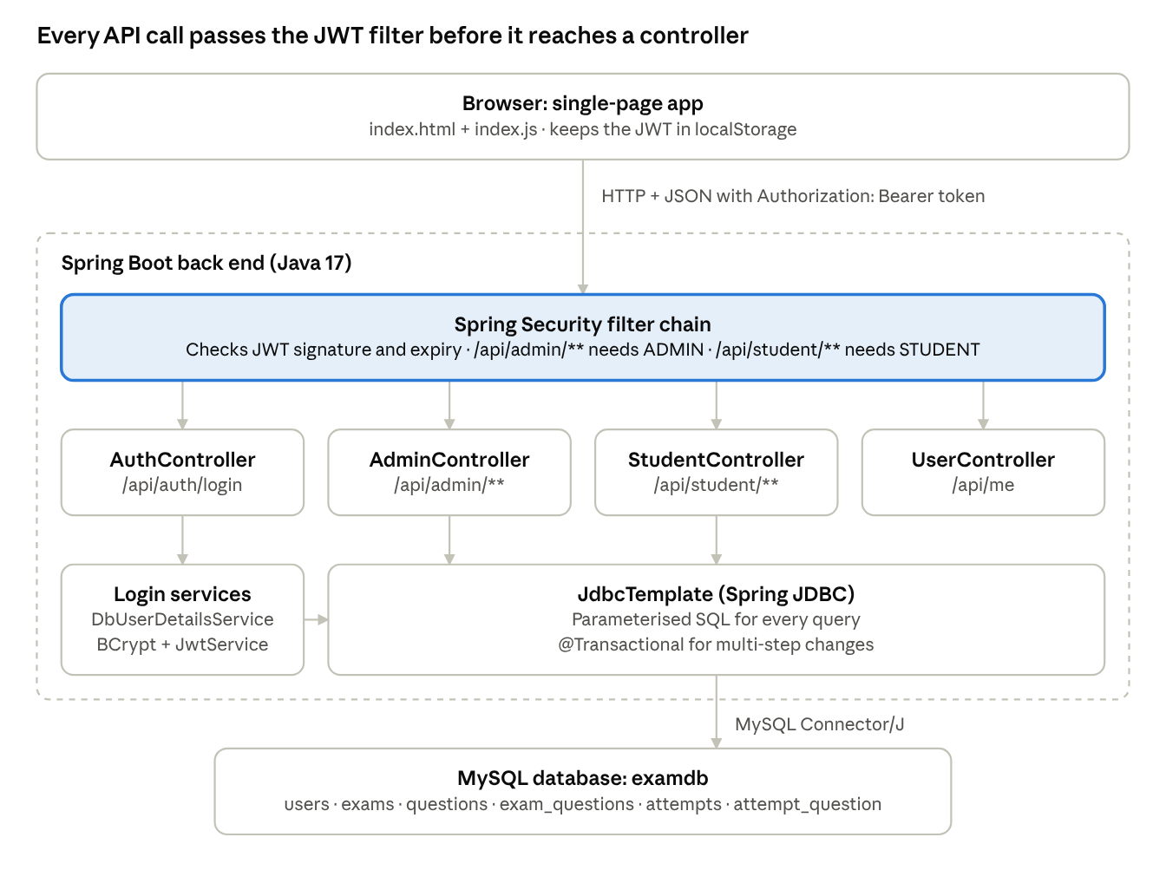
Figure A · system architecture
- Presentation tier: a single-page app (index.html, index.js) served from src/main/resources/static. It stores the JWT in localStorage and sends it as Authorization: Bearer <token> on every call.
- Application tier: Spring Boot with Spring Security. POST /api/auth/login checks the password against the BCrypt hash and returns a signed JWT (HS256, 60-minute expiry) carrying the user's role. Every other /api/** request is checked by the OAuth2 resource-server filter; /api/admin/** needs ROLE_ADMIN and /api/student/** needs ROLE_STUDENT.
- Data tier: MySQL 8, reached with Spring's JdbcTemplate using parameterised SQL (no ORM).

3.2 Exam attempt life cycle
An attempt has three states. Not started: no row in attempts. Open: a row with open = 1, created by Start, with n random questions copied into attempt_question. Closed: Submit computes the score and sets open = 0; the exam then disappears from the student's list and cannot be started again.

3.3 Database design
The database examdb has six tables: three hold master data (users, exams, questions) and three are link tables (exam_questions, attempts, attempt_question).
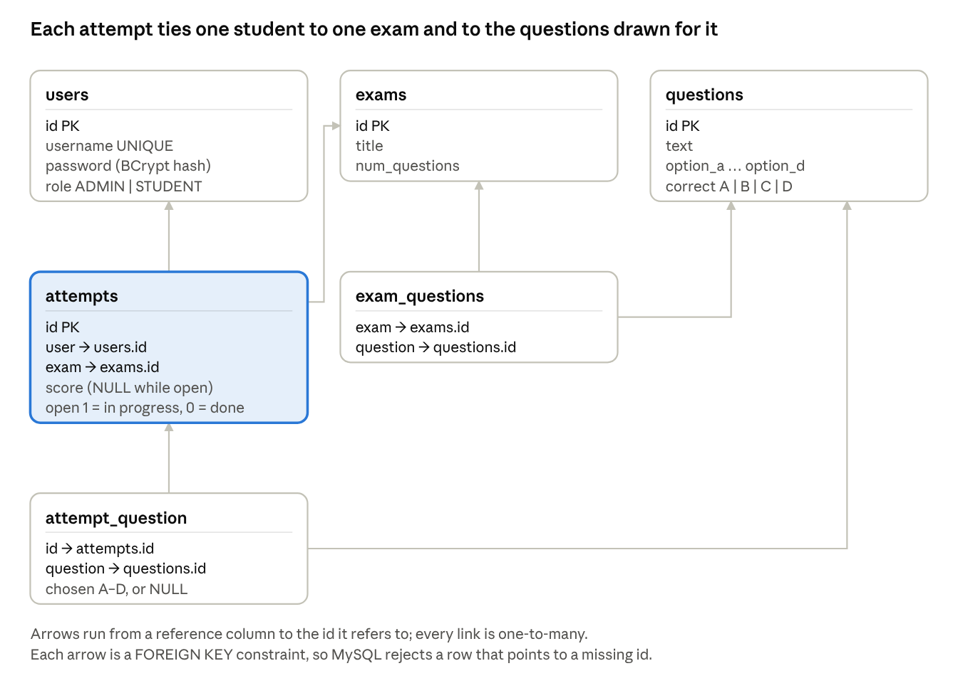
Figure B · entity-relationship diagram of examdb
Relationship | Type | Through
Exam – Question (pool) | Many-to-many | exam_questions (exam, question)
User (student) – Exam | Many-to-many, one attempt per pair | attempts (user, exam)
Attempt – Question (picked) | One-to-many | attempt_question (id = attempt id, question)

Table: users
Stores both admins and students; role decides which part of the API the user can reach.
Field | Type | Null | Key | Extra | Description
id | int | NO | PRI | auto_increment | User id
username | varchar(50) | NO | UNI |  | Login name, unique
password | varchar(100) | NO |  |  | BCrypt hash, never the plain password
role | enum('ADMIN','STUDENT') | NO |  |  | Access role

Table: exams
Field | Type | Null | Key | Extra | Description
id | int | NO | PRI | auto_increment | Exam id
title | varchar(100) | NO |  |  | Exam name
num_questions | int | NO |  |  | Questions each student receives

Table: questions
The question repository (bank).
Field | Type | Null | Key | Extra | Description
id | int | NO | PRI | auto_increment | Question id
text | varchar(1000) | NO |  |  | Question text
option_a | varchar(255) | NO |  |  | Option A
option_b | varchar(255) | NO |  |  | Option B
option_c | varchar(255) | NO |  |  | Option C
option_d | varchar(255) | NO |  |  | Option D
correct | enum('A','B','C','D') | NO |  |  | Correct option

Table: exam_questions
The question pool of each exam.
Field | Type | Null | Key | Extra | Description
exam | int | NO | MUL (FK) |  | Foreign key → exams.id
question | int | NO | MUL (FK) |  | Foreign key → questions.id

Table: attempts
One row per student per exam.
Field | Type | Null | Key | Extra | Description
id | int | NO | PRI | auto_increment | Attempt id
user | int | NO | MUL (FK) |  | Foreign key → users.id
exam | int | NO | MUL (FK) |  | Foreign key → exams.id
score | int | YES |  |  | NULL while open; marks after submit
open | tinyint(1) | YES |  |  | 1 = in progress, 0 = submitted

Table: attempt_question
The random questions picked for one attempt and the student's answer to each.
Field | Type | Null | Key | Extra | Description
id | int | NO | MUL (FK) |  | Attempt id; foreign key → attempts.id
question | int | NO | MUL (FK) |  | Foreign key → questions.id
chosen | enum('A','B','C','D') | YES |  |  | Student's answer; NULL if unanswered
Every reference column is a FOREIGN KEY, so MySQL itself rejects a row that points to a user, exam, question or attempt that does not exist. The controllers still delete dependent rows first (for example, deleting an exam removes its rows in exam_questions in the same transaction), so deletes do not violate these constraints.

SQL to create the schema
CREATE DATABASE examdb;
USE examdb;
CREATE TABLE users (
id INT AUTO_INCREMENT PRIMARY KEY,
username VARCHAR(50) NOT NULL UNIQUE,
password VARCHAR(100) NOT NULL,
role ENUM('ADMIN','STUDENT') NOT NULL
);
CREATE TABLE exams (
id INT AUTO_INCREMENT PRIMARY KEY,
title VARCHAR(100) NOT NULL,
num_questions INT NOT NULL
);
CREATE TABLE questions (
id INT AUTO_INCREMENT PRIMARY KEY,
text VARCHAR(1000) NOT NULL,
option_a VARCHAR(255) NOT NULL,
option_b VARCHAR(255) NOT NULL,
option_c VARCHAR(255) NOT NULL,
option_d VARCHAR(255) NOT NULL,
correct ENUM('A','B','C','D') NOT NULL
);
CREATE TABLE exam_questions (
exam INT NOT NULL,
question INT NOT NULL,
CONSTRAINT fk_eq_exam FOREIGN KEY (exam) REFERENCES exams(id),
CONSTRAINT fk_eq_question FOREIGN KEY (question) REFERENCES questions(id)
);
CREATE TABLE attempts (
id INT AUTO_INCREMENT PRIMARY KEY,
user INT NOT NULL,
exam INT NOT NULL,
score INT NULL,
open TINYINT(1) NULL,
CONSTRAINT fk_attempt_user FOREIGN KEY (user) REFERENCES users(id),
CONSTRAINT fk_attempt_exam FOREIGN KEY (exam) REFERENCES exams(id)
);
CREATE TABLE attempt_question (
id INT NOT NULL,
question INT NOT NULL,
chosen ENUM('A','B','C','D') NULL,
CONSTRAINT fk_aq_attempt FOREIGN KEY (id) REFERENCES attempts(id),
CONSTRAINT fk_aq_question FOREIGN KEY (question) REFERENCES questions(id)
);

4. Modules Split-up
The code is split into seven modules: four back-end Java packages under com.onlineexamsystem.onlineexamsystem and the browser front end.
# | Module | Package / files | Classes | Responsibility
1 | Security configuration | security | SecurityConfig, JwtConfig, DbUserDetailsService | Role-based access rules, BCrypt password encoder, JWT signing key, encoder/decoder, loading users from the users table
2 | Authentication | auth | AuthController, JwtService | Login endpoint; verifies username and password and issues a signed JWT with the user's roles
3 | Admin – exam & question bank | admin | AdminController, Exam, Question | CRUD for exams and questions; assigning and unassigning questions to an exam's pool
4 | Admin – students & results | admin | AdminController, Student, Result, AnswerDetail | Creating and listing student accounts; rank list of all attempts per exam, by score; reviewing one attempt question by question
5 | Student – exam attempt | student | StudentController, Attempt, AttemptQuestion | Listing available exams; starting/resuming an attempt with random questions; answering; submitting and scoring
6 | Current user | user | UserController | GET /api/me returns the logged-in username and roles so the front end can show the right screens
7 | Front end (UI) | static/ | index.html, index.js | Login page, admin dashboard (Exams, Questions, Students, Results tabs), student exam list, exam-taking screen and result screen
The entry point is OnlineExamSystemApplication, whose main method starts the embedded web server.

4.1 REST API by module
Method | Endpoint | Role | Purpose
POST | /api/auth/login | Anyone | Log in; returns { token }
GET | /api/me | Any logged-in user | Username and roles
GET / POST | /api/admin/exam | Admin | List exams / create exam
GET / PUT / DELETE | /api/admin/exam/{id} | Admin | View exam with its pool / edit / delete
POST / DELETE | /api/admin/exam/{examId}/question/{questionId} | Admin | Add / remove a question from an exam's pool
GET / POST | /api/admin/question | Admin | List questions / create question
GET / PUT / DELETE | /api/admin/question/{id} | Admin | View / edit / delete question
GET / POST | /api/admin/student | Admin | List students / create student
GET | /api/admin/result | Admin | Rank list: all attempts with score and rank
GET | /api/admin/result/{attemptId} | Admin | One attempt with its score, rank and every answer
GET | /api/student/exam | Student | Exams not yet submitted
POST | /api/student/exam/{examId}/start | Student | Start or resume; returns attempt and question ids
GET | /api/student/exam/{examId} | Student | Question ids of the open attempt
GET / POST | /api/student/exam/{examId}/{questionId} | Student | Read a question (no answer key) / save an answer
POST | /api/student/exam/{examId}/close | Student | Submit and score the attempt; returns 204 with no score

5. Implementation Specifics

5.1 Technology stack
Layer | Technology
Language | Java 17
Framework | Spring Boot 4.1.2 (Spring Web MVC)
Security | Spring Security, OAuth2 Resource Server (JWT, HMAC-SHA256), BCrypt
Database | MySQL, database examdb
Front end | HTML, CSS, JavaScript (Fetch API)
Build tool | Maven (Maven Wrapper mvnw)
Configuration lives in application.properties: the JDBC URL jdbc:mysql://localhost:3306/examdb, the Base64 JWT secret (app.jwt.secret) and token lifetime (app.jwt.expiry-minutes=60). spring.jackson.deserialization.accept-float-as-int=false makes the API reject a decimal such as 2.5 for whole-number fields instead of truncating it.

5.2 Login and authorisation
- The front end sends { username, password } to POST /api/auth/login.
- AuthController passes them to the AuthenticationManager, which uses DbUserDetailsService to load the user and BCryptPasswordEncoder to compare the password with the stored hash.
- On success JwtService.generateToken() builds a claim set (subject = username, roles = ROLE_ADMIN or ROLE_STUDENT, issued-at, expiry) and signs it with HS256. A wrong password returns 401 with "Invalid username or password".
- For every later request the resource-server filter verifies the signature and expiry, and JwtAuthenticationConverter turns the roles claim into Spring authorities. A missing, invalid or wrong-role token gets 403 Forbidden.
- The session is stateless (SessionCreationPolicy.STATELESS), so the server keeps no login state.

5.3 Random question selection
When a student presses Start, StudentController.startExam() runs inside one @Transactional method:
- If the student already has an open attempt, it is returned unchanged (resume). If it is closed, the request is refused with 409 Conflict.
- It checks that the exam exists (404 otherwise) and that its pool holds at least num_questions questions (409 "not ready yet" otherwise).
- It inserts a row in attempts with open = 1 and reads back the generated id with a KeyHolder.
- It picks the questions in a single query and stores each in attempt_question:
SELECT question FROM exam_questions WHERE exam = ? ORDER BY RAND() LIMIT ?
Because the selection is stored, the student sees the same questions when they come back to the exam.

5.4 Answering and hiding the answer key
GET /api/student/exam/{examId}/{questionId} joins attempt_question with questions and returns the text, the four options and the student's current choice, but never the correct column. POST to the same path saves { "chosen": "B" } after checking it is one of A–D (case-insensitive); answering again overwrites the earlier choice. A question that is not part of the student's own attempt returns 404.

5.5 Scoring
closeExam() scores the attempt and closes it in one SQL statement, so the database counts the correct answers:
UPDATE attempts SET open = 0, score = (
SELECT COUNT(*) FROM attempt_question aq
JOIN questions q ON q.id = aq.question
WHERE aq.id = ? AND aq.chosen = q.correct
) WHERE id = ?
Unanswered questions have chosen = NULL, which never equals correct, so they score zero. The endpoint returns 204 No Content: the score is not sent to the student and is visible only to the admin.

5.6 Admin functions
- Exams and questions: standard insert/update/delete with JdbcTemplate; a reusable insert(String sql, Object... args) helper returns the auto-generated key. Deleting an exam or a question first removes its rows from exam_questions in the same transaction.
- Pool assignment: refuses an unknown exam or question (404) and a duplicate assignment (409).
- Students: a new student's password is hashed with BCrypt before it is stored; a taken username returns 409; the student list never returns passwords.
- Results: joins attempts, users and exams, and counts the attempt's questions for the total. MySQL's RANK() window function (PARTITION BY exam, ORDER BY score DESC) ranks the submitted attempts of each exam; equal scores share a rank (1, 2, 2, 4) and open attempts get none. Rows come back grouped by exam, best rank first, with attempts still in progress at the end. The front end filters by exam and shows the number submitted, number in progress and the average score in percent. View answers shows the student's score and rank, then each question with the correct option and the student's choice; the rank is computed over all attempts first and then filtered, so it matches the list.

5.7 Front end
index.js is a single-page app with hash-based routing (for example #/exams/3, #/attempts/7). One api() helper attaches the token, sends JSON and, on a 403, logs the user out. After login it calls /api/me and shows the admin dashboard or the student view according to the role. The exam screen loads all picked questions at once, shows "x of n answered", lets the student jump between questions with Previous/Next or the question navigator, and saves each answer as soon as an option is clicked.

6. Validation Test Cases
The 27 cases below cover normal use, invalid input and access control; the expected results come from the checks in the controllers and security configuration. Run each one through the UI or Postman, then add a Status (Pass/Fail) column with what you observed.
TC | Module | Test input / action | Expected result
T01 | Authentication | Log in as admin with the correct password | 200 with a JWT; admin dashboard opens
T02 | Authentication | Log in with a wrong password | 401, "Invalid username or password"
T03 | Authentication | Log in with a username that does not exist | 401, "Invalid username or password"
T04 | Security | Call GET /api/admin/exam with no token | 403 Forbidden
T05 | Security | Call GET /api/admin/exam with a student's token | 403 Forbidden
T06 | Security | Call GET /api/student/exam with an admin's token | 403 Forbidden
T07 | Security | Use a token more than 60 minutes after login | 403; front end returns to the login page
T08 | Exam management | Create exam "Java Basics" with 5 questions per student | 201; exam appears in the list
T09 | Exam management | Create exam with numQuestions = 2.5 | 400 Bad Request; nothing saved
T10 | Exam management | Edit or delete exam id 999 (does not exist) | 404, "Exam 999 not found"
T11 | Question bank | Add a question with four options and correct = B | 201; question appears in the list
T12 | Question pool | Add question 3 to exam 1 twice | First 201; second 409, "already assigned"
T13 | Question pool | Add question 999 (does not exist) to exam 1 | 404, "Question 999 not found"
T14 | Student management | Create student with a username that is already taken | 409, "Username … is already taken"
T15 | Student management | List students | Ids and usernames only; no password field
T16 | Exam attempt | Start an exam whose pool has 3 questions but needs 5 | 409, "not ready yet: it has 3 of the 5 questions it needs"
T17 | Exam attempt | Start an exam with 10 questions in the pool and 5 per student | 201; 5 distinct question ids, all from that pool
T18 | Exam attempt | Two students start the same exam | Each gets 5 questions; the sets usually differ
T19 | Exam attempt | Leave an open exam and press Start / continue again | 200; same attempt and same questions, earlier answers kept
T20 | Answering | Answer with chosen = "b" | Saved as "B"
T21 | Answering | Answer with chosen = "E" | 400, "chosen must be one of A, B, C or D"
T22 | Answering | Fetch a question as a student | Text and four options returned; no correct field
T23 | Scoring | Submit with 3 correct, 1 wrong, 1 unanswered (of 5) | 204; student sees "Exam submitted" with no score; admin results show "3 / 5", Submitted
T24 | Re-attempt | After submitting, start, answer or submit the same exam again | 409 each time; exam no longer in the student's list
T25 | Rank list | Three students submit one exam with scores 4, 3 and 3 | Ranks #1, #2, #2 in that order
T26 | Rank list | A fourth student has started the same exam but not submitted | Listed after the ranked students with rank "—" and status In progress
T27 | Foreign keys | In MySQL, insert into attempts a user id that does not exist in users | Insert rejected with a foreign-key constraint error

7. Output Screenshots
Paste each screenshot below its caption. Fourteen figures follow one exam from setup to result; use the same exam (for example "Java Basics", 5 of 10 questions) throughout so the figures tell one story.
Figure 1 – Login page. The login form at http://localhost:8080.
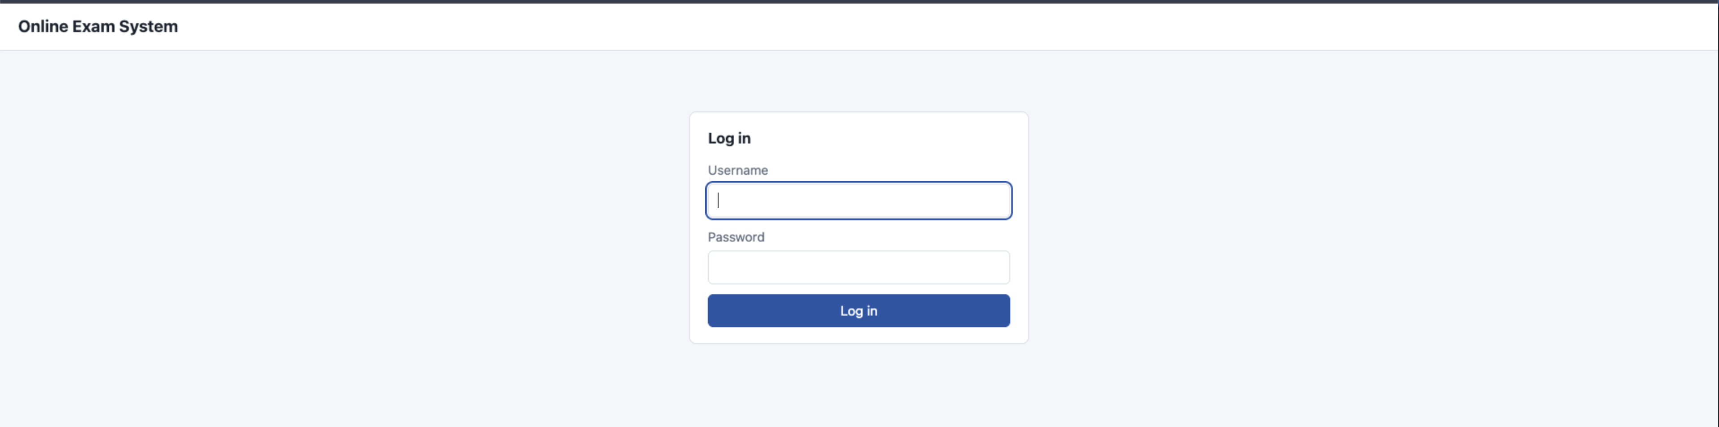
Figure 2 – Admin: Exams list. At least two exams with their questions-per-student value.
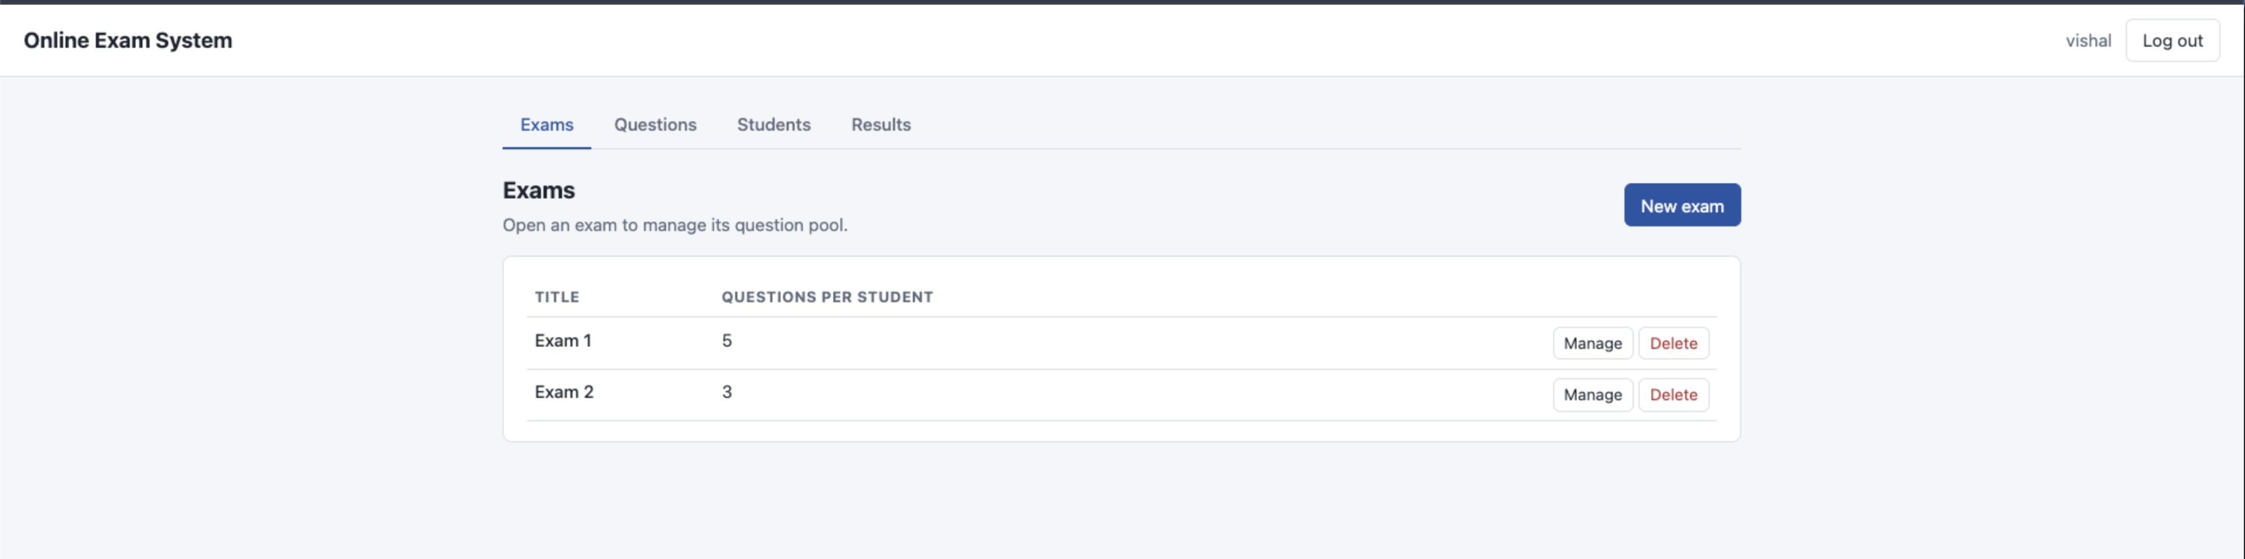
Figure 3 – Admin: New exam form. Filled in before pressing Save exam.
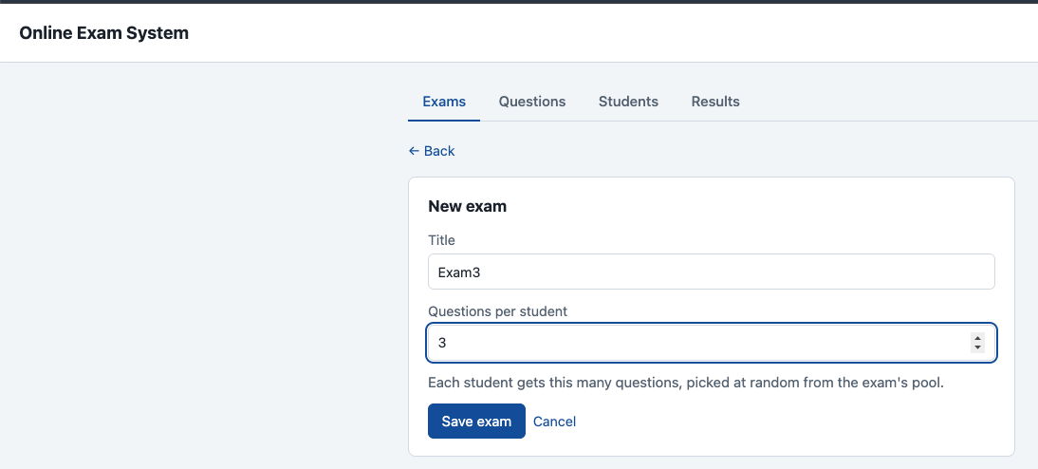
Figure 4 – Admin: Questions list. The question bank with several MCQs.
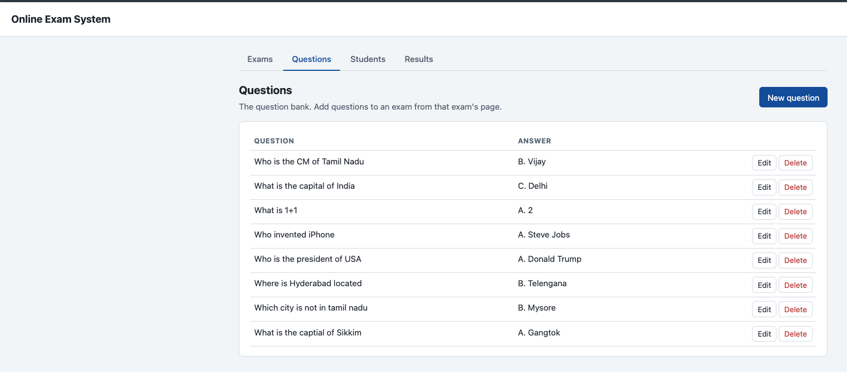
Figure 5 – Admin: New question form. Question, options A–D and the correct answer selected.
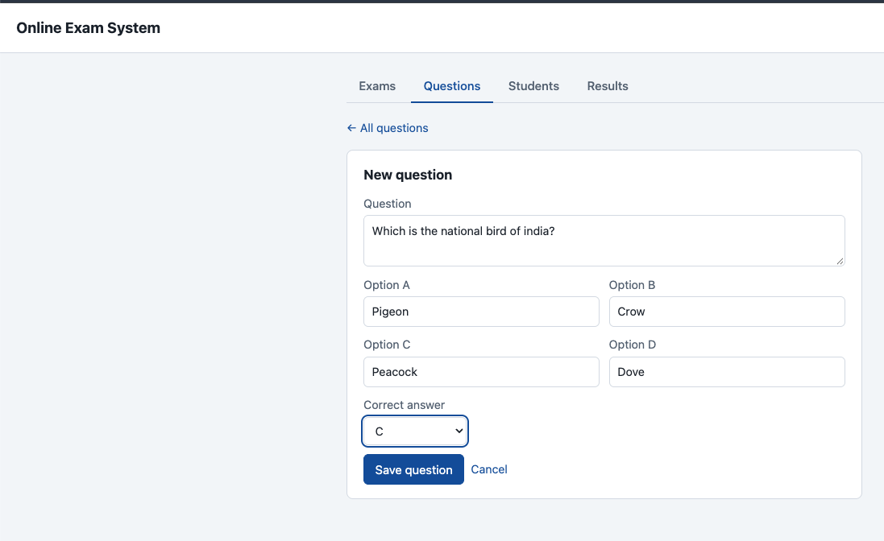
Figure 6 – Admin: Exam detail and question pool. The pool with the Add a question dropdown.
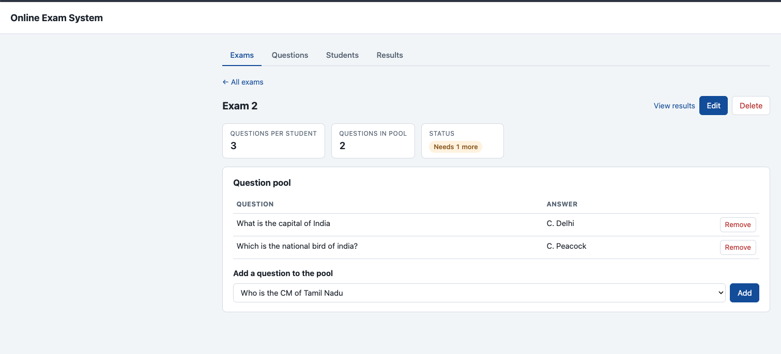
Figure 7 – Admin: Students. Student list and the Add student form.
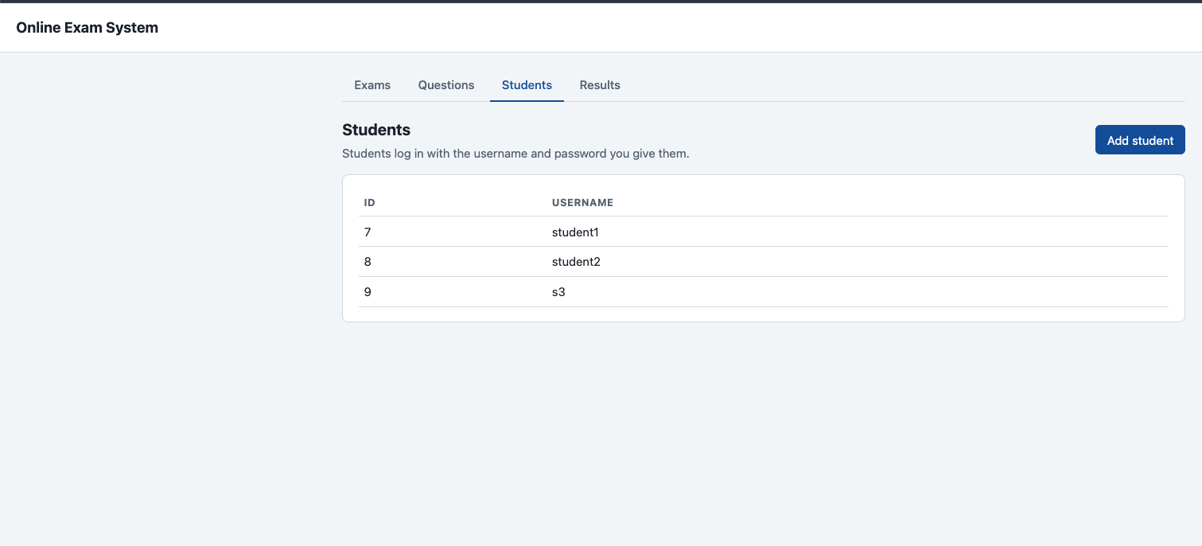
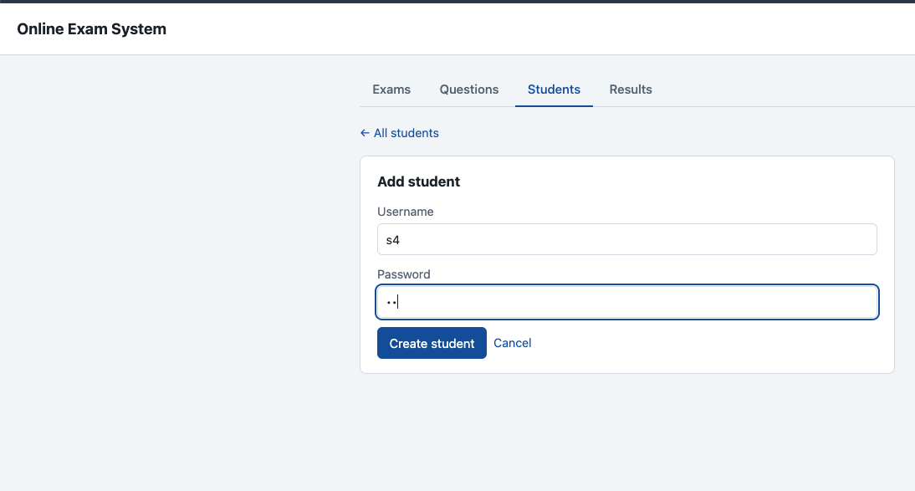
Figure 8 – Student: Your exams. The exam list with the Start / continue button.
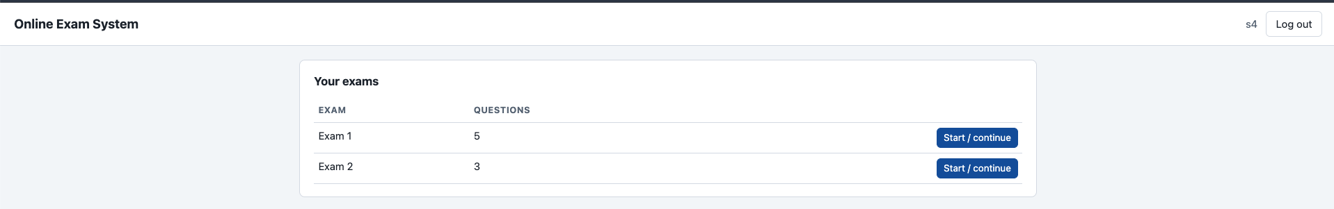
Figure 9 – Student: Taking an exam. A question with one option chosen and the "x of n answered" progress.
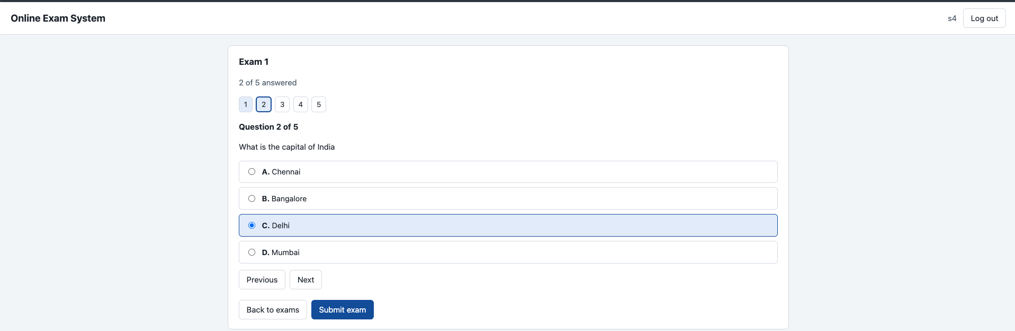
Figure 10 – Student: Exam submitted. The confirmation shown after Submit exam; students do not see their score.
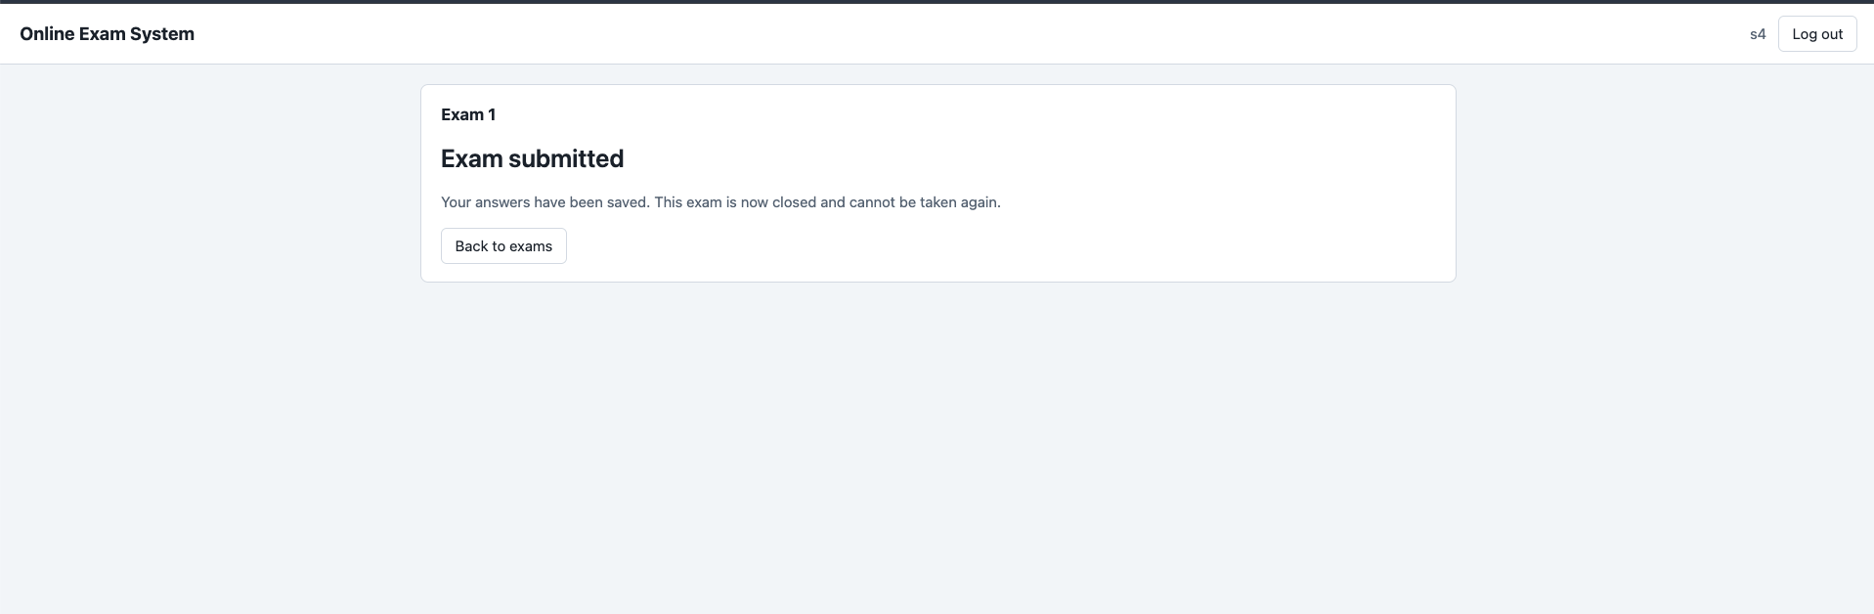
Figure 11 – Admin: Results. The rank list filtered to one exam: the Rank column (top three highlighted), the submitted / in-progress summary and the average score.
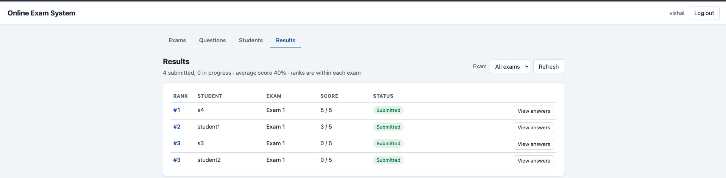
Figure 12 – Admin: Answer review. View answers for one attempt, showing its score and rank, and the correct and chosen options.
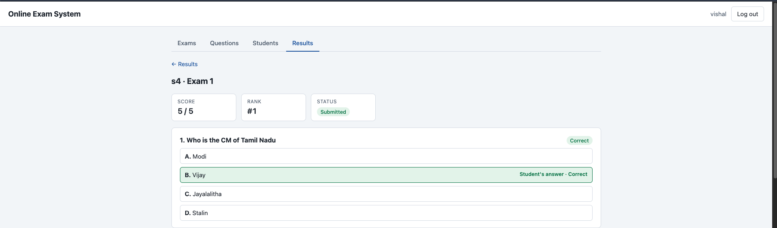

8. Object-Oriented Features Used
OOP feature | Where it is used | How
Classes and objects | Exam, Question, Attempt, AttemptQuestion, Student, Result, AnswerDetail | Each class models one real entity or one row of a table; a RowMapper lambda creates one object per database row
Encapsulation | All model classes | Fields are private; they are read only through public getters (getTitle(), getScore()), and there are no setters, so an object cannot be changed after it is built
Constructors | Model classes; JwtService, AuthController | Parameterised constructors initialise every field; controllers and services receive their dependencies through constructors
Abstraction through interfaces | UserDetailsService, PasswordEncoder, JwtEncoder, AuthenticationManager | Code depends on the interface, not the implementation; AdminController only knows a PasswordEncoder, not that it is BCrypt
Inheritance (interface implementation) | DbUserDetailsService implements UserDetailsService | The class inherits the contract of the Spring interface and supplies its own body
Runtime polymorphism (overriding) | DbUserDetailsService.loadUserByUsername() with @Override | Spring calls the interface method and our overridden version runs, loading users from MySQL
Composition (has-a) | AuthController has an AuthenticationManager and a JwtService; controllers have a JdbcTemplate | Objects are built from other objects instead of inheriting from them
Dependency injection | @Autowired fields, constructor injection, @Bean methods | Spring creates the objects and passes them in, keeping classes loosely coupled
Static members and constants | private static final String EXAM_COLUMNS, QUESTION_COLUMNS; static error(...) helpers | Shared values and helpers that belong to the class, not to an object
final fields | JwtService.jwtEncoder, expiryMinutes; AuthController fields | Set once in the constructor and never reassigned
Generics | List<Exam>, ResponseEntity<Map<String, String>>, ResponseEntity<?> | Type-safe collections and responses; ? lets one method return either data or an error body
Exception handling | AuthController.login() catches AuthenticationException; DbUserDetailsService throws UsernameNotFoundException | Errors are caught and turned into clear HTTP responses (401) instead of crashing
Collections and streams | List.of("A","B","C","D").contains(...); stream().map().filter().toList() in JwtService | Validation of answers and building the list of roles
Packages | auth, security, admin, student, user | Related classes are grouped, giving modularity and controlled visibility
Annotations | @RestController, @Service, @Configuration, @Transactional, @Override | Metadata that tells Spring how to treat each class and method

9. Inference and Future Extension

9.1 Inference
The project meets its goal: an admin can build a question bank and exams, each student receives a random, stored set of questions, answers are scored instantly by the database, and the admin can review every attempt.
- Separating the front end and back end through a REST API with JWT made the server stateless and let each role see only its own endpoints.
- Spring JDBC with parameterised ? queries kept the SQL visible and safe from SQL injection, while @Transactional kept multi-step changes (starting an exam, deleting an exam) all-or-nothing.
- Keeping the answer key on the server and scoring in SQL means a student cannot read or alter the correct answers from the browser.
- Object-oriented design (model classes, interfaces, dependency injection, packages) kept each module small and independent, so features could be added without touching unrelated code.
- Hashing passwords with BCrypt showed how real systems avoid storing plain passwords.

9.2 Future extensions
- Timed exams: store a start time and duration, show a countdown, and auto-submit when time runs out.
- Stricter keys: add a composite primary key on exam_questions and attempt_question, and a unique key on attempts (user, exam).
- Richer questions: multiple correct answers, images, negative marking, and difficulty levels or topics so an exam can draw, say, 3 easy and 2 hard questions.
- Shuffled options so the order of A–D also differs between students.
- Bulk import of questions and students from CSV or Excel.
- Analytics: per-question accuracy, score distribution charts and export of results to PDF or Excel.
- Account features: password change and reset, student self-registration with admin approval, admin-controlled re-attempts.
- Scheduling: exam start and end dates, so an exam is visible only within its window.
- Deployment: move secrets out of application.properties into environment variables, enable HTTPS and host the app online.

