LINUX ASSESSMENT SOLUTIONS:

Assignment 1: Considering the text file, Sample.txt which has multi-lines text, and outputting all the lines which has a specific word, “data” . Also outputting the total number of occurrences of that word, “data.

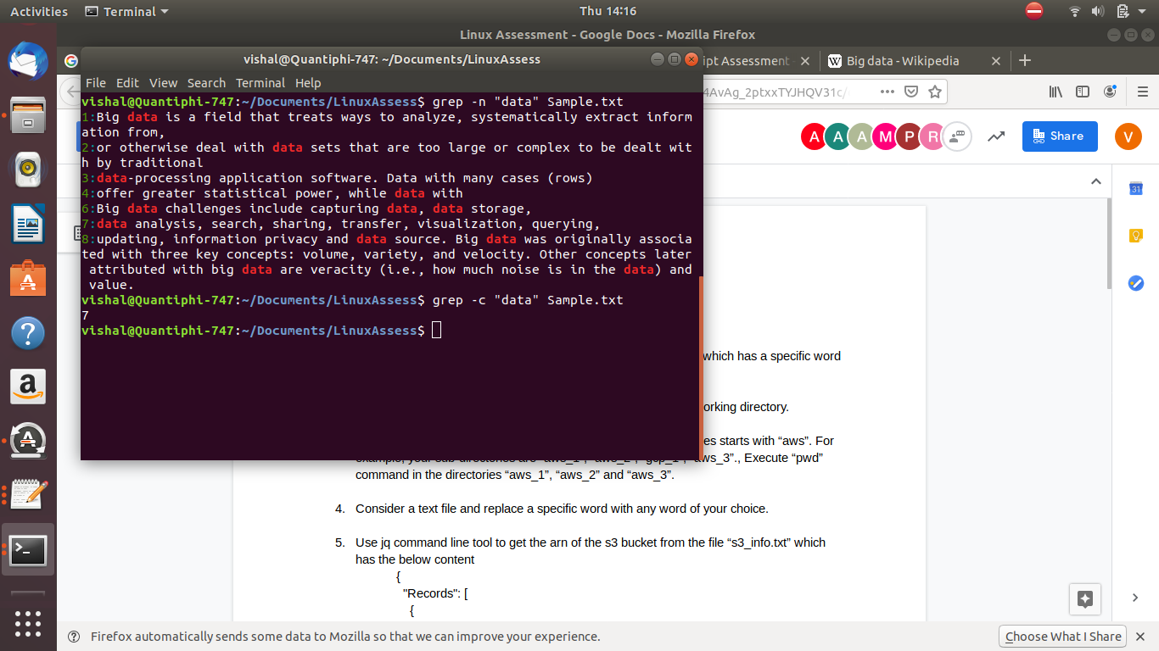

Assignment 2: Searching for all the files that have a ‘.txt’ extension in the current working directory.

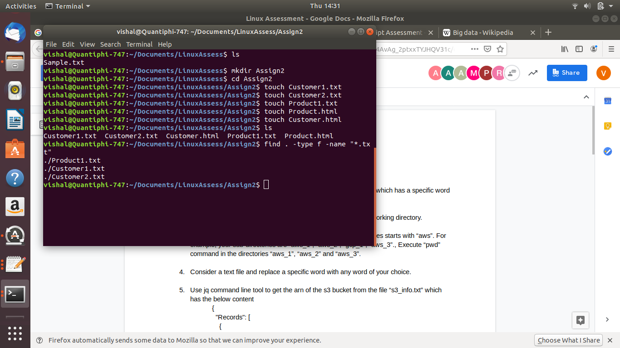

Assignment 3: Executing a specific command in all the subdirectories whose names starts with “aws”. For example, your sub-directories are “aws_1”, “aws_2”, “gcp_1”, “aws_3”., Execute “pwd” command in the directories “aws_1”, “aws_2” and “aws_3”.

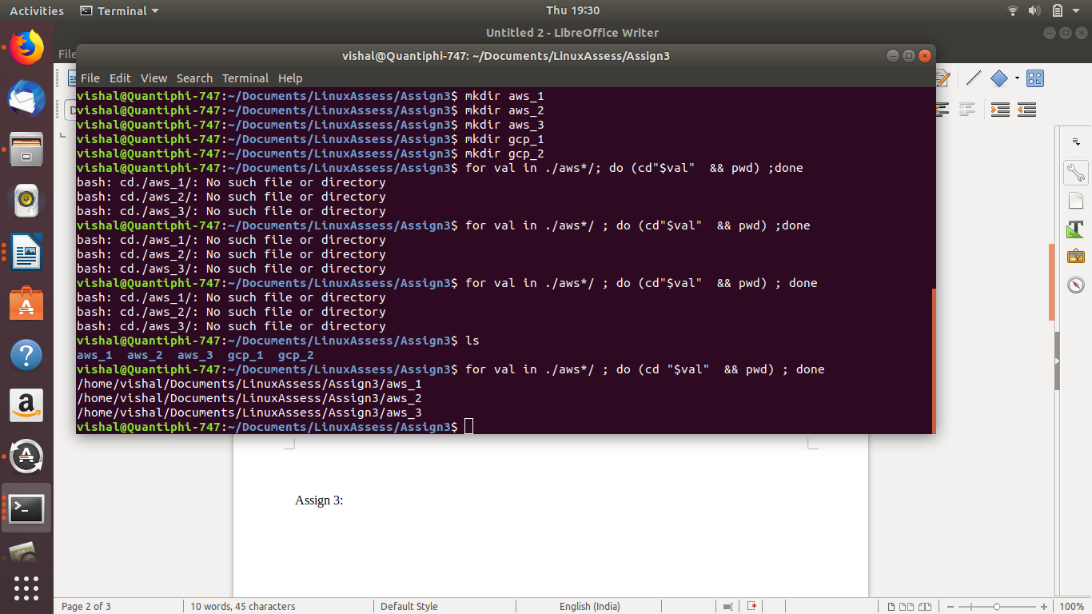

Assignment 4: Considering the text file, Sample.txt and replacing a specific word, “data” with any word, “money”.

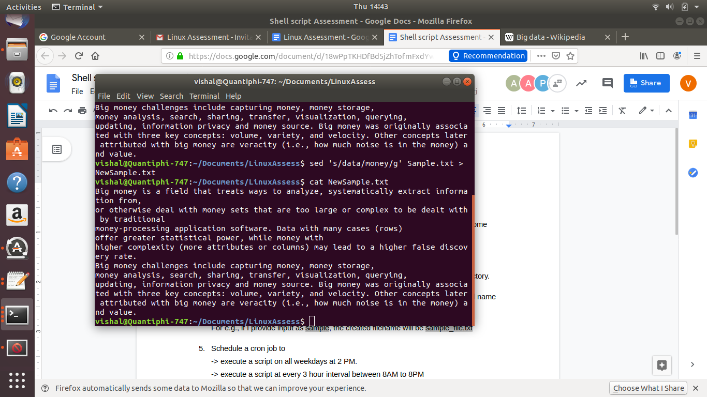

Assignment 5: Using jq command line tool to get the arn of the s3 bucket from the file “s3_info.txt” which has the below content.:

