SHELL SCRIPTING ASSESSMENT:

Asignment 1: Writing a Bash script which accepts name as input and displays a greeting: "Welcome (name)"

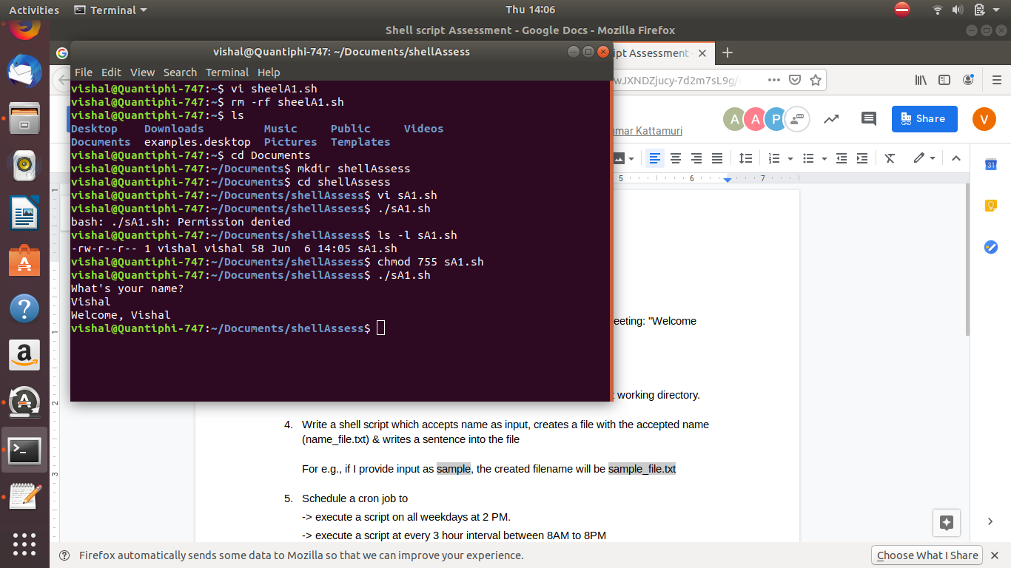

Assignment 2: Given two integers, x and y , find their sum and difference.

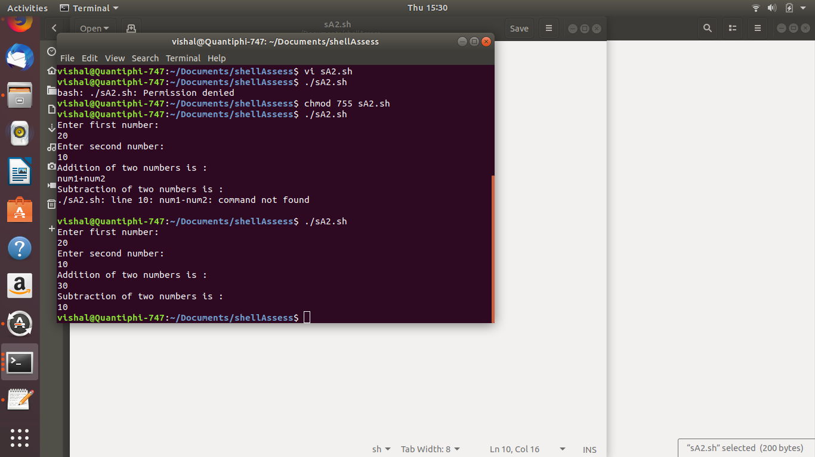

Assign3: Writing a shell script to get current date, time, username and current working directory.

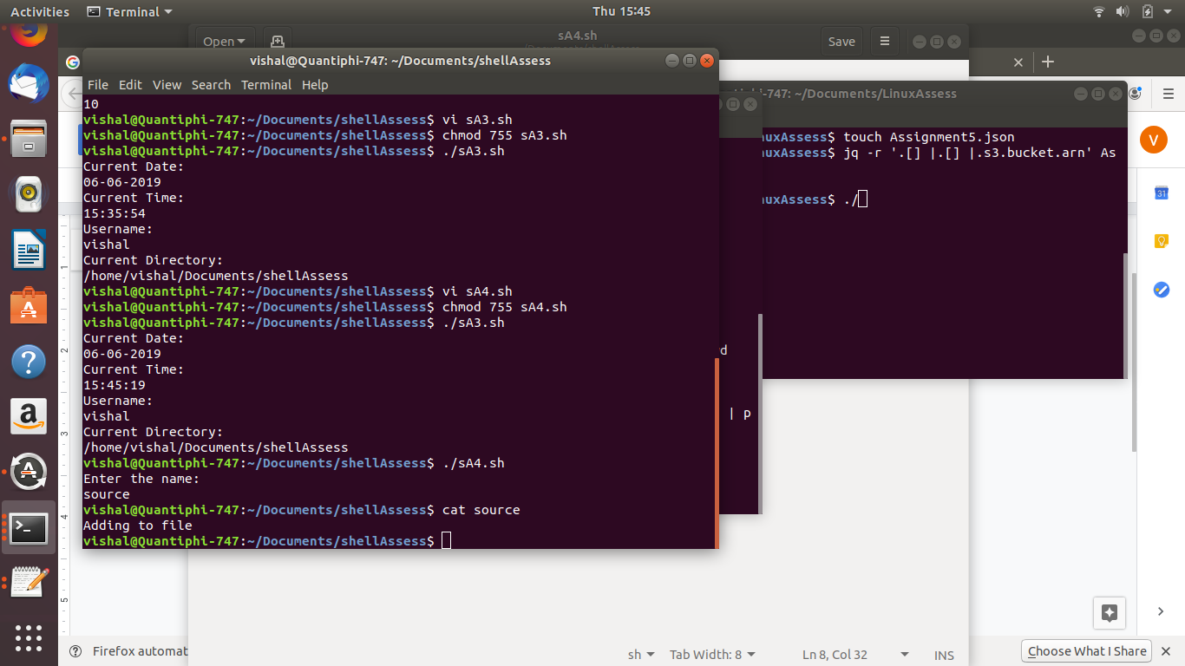

Assignment 4: Write a shell script which accepts name as input, creates a file with the accepted name (name_file.txt) & writes a sentence into the file.
Here, I have taken Spark as input and created a file, Spark.txt and written a sentence to that file, Spark.txt and displayed the contents on the screen.

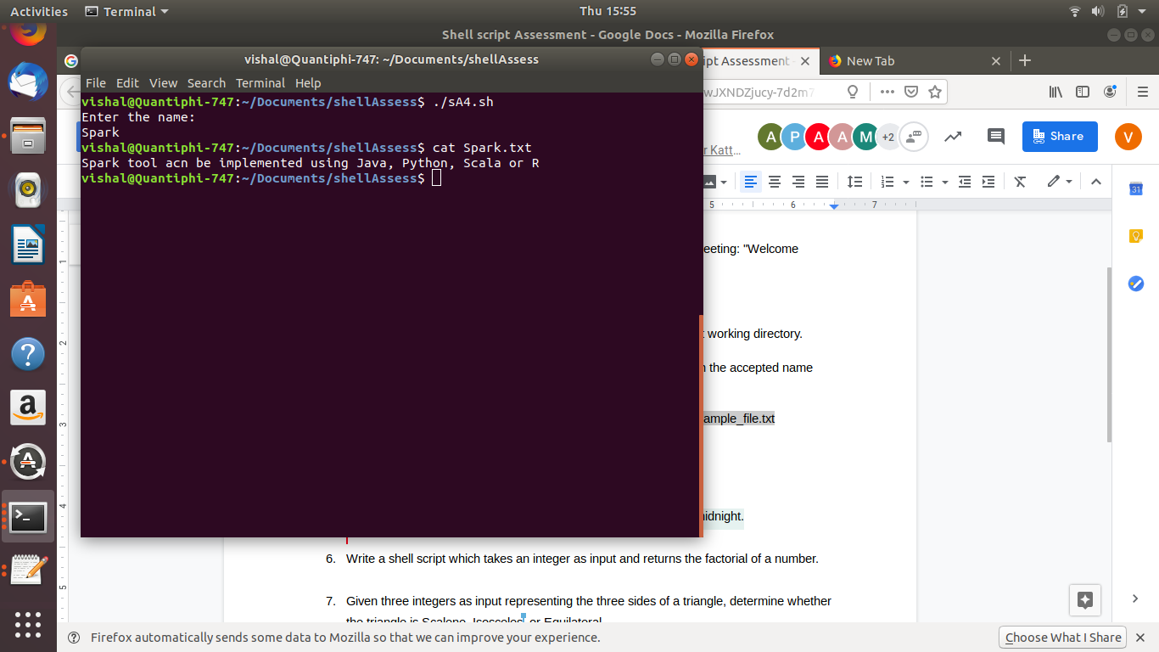

Assign 5:
Schedule a cron job to
-> execute a script on all weekdays at 2 PM.
-> execute a script at every 3 hour interval between 8AM to 8PM
-> execute a script on all the odd dates of all the even months at midnight.

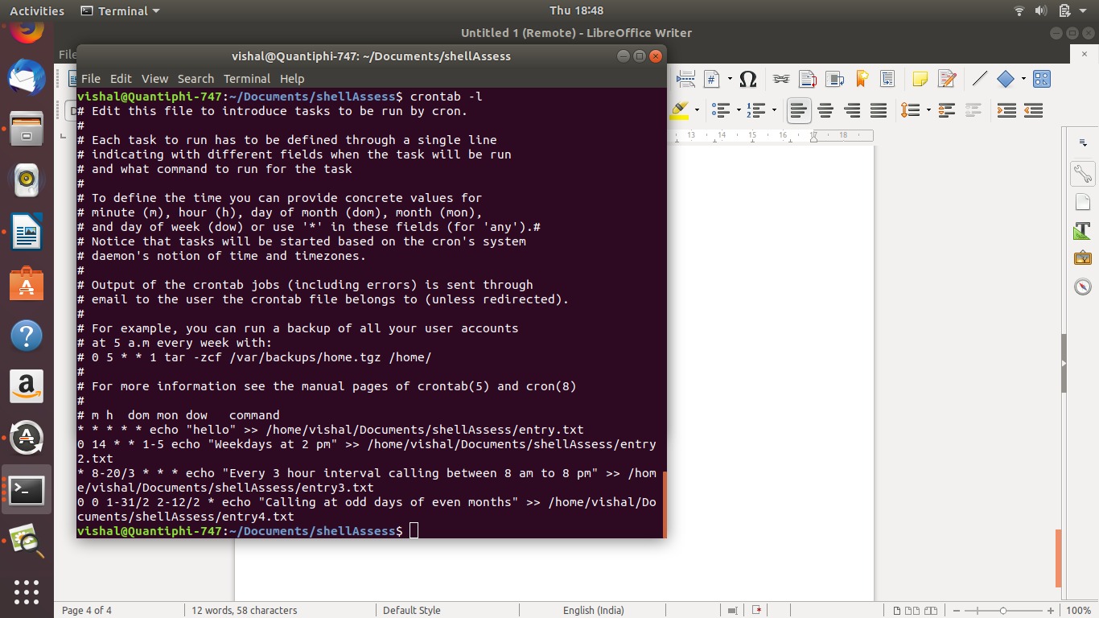

Assignment 6: Written a shell script which takes an integer as input and returns the factorial of a number.

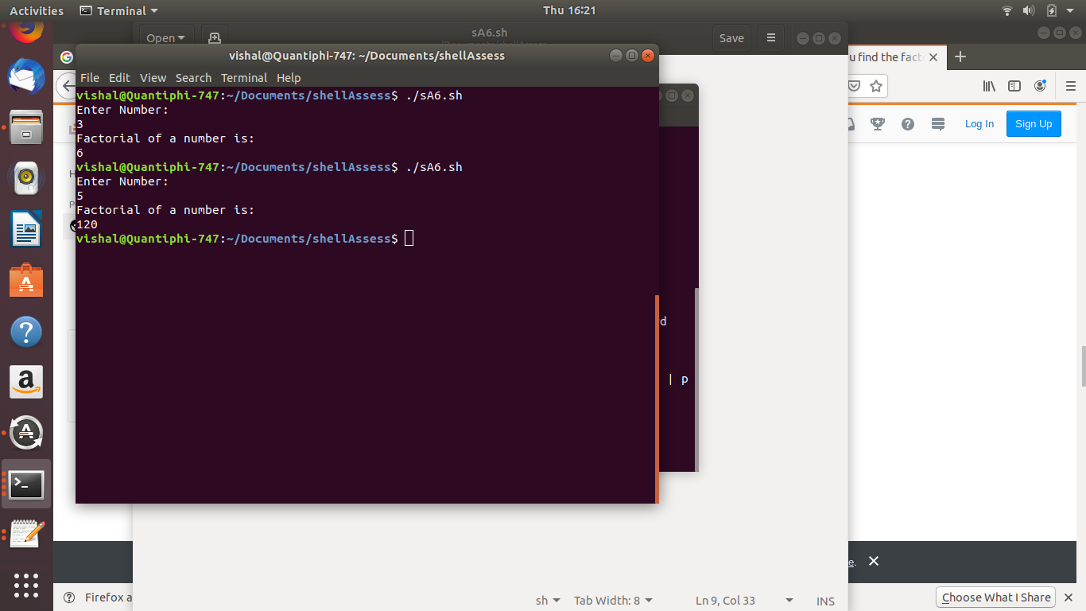

Assignment 7: Given three integers as input representing the three sides of a triangle, determine whether the triangle is Scalene, Isosceles, or Equilateral.

