FIT-FLEX DOCUMENTATION

Project Title

Fit-Flex

Introduction

• Project Title: Fit-Flex

• Team ID:

• Team Leader: M.VISHAL & vishalsharvan2507@gmail.com

• Team Members:

* A.AKASH & [akasharputham@gmail.com](mailto:akasharputham@gmail.com)
* G.ARAVINDH & [aravindhg2402@gmail.com](mailto:aravindhg2402@gmail.com)
* G.P.ABISHEK & cristoabicristoabi@gmail.com

Project Overview

Purpose: Fit-Flex is a fitness and wellness tracking platform that helps users plan, track, and

achieve their fitness goals through personalized workout routines and nutrition insights.

Features: ['User authentication and profiles', 'Workout plan management', 'Nutrition

tracking', 'Progress visualization', 'Responsive and user-friendly UI']

Architecture

Frontend: React.js with Tailwind CSS

Backend: Node.js with Express.js

Database: MongoDB for storing user, workout, and nutrition data

Setup Instructions

Prerequisites: ['Node.js', 'MongoDB', 'Git', 'React.js', 'Express.js', 'Visual Studio Code']

Steps: ['Clone the repository: git clone https://github.com/Dilli486/fit-flex.git', 'Install

client dependencies: cd client && npm install', 'Install server dependencies: cd ../server && npm install"] Folder Structure

• fit-flex/

• |-- client/ # React frontend

• | |-- components/

• | |-- pages/

• |-- server/ # Node.js backend

• | |-- routes/

• | |-- models/

• | |-- controllers/

Running the Application

• Frontend: cd client && npm start

• Backend: cd server && npm start

• Access: Visit http://localhost:3000

API Documentation

• User: /api/user/register, /api/user/login

• Workouts: /api/workouts/create, /api/workouts/:id

• Nutrition: /api/nutrition/log, /api/nutrition/:id

• Progress: /api/progress/user/:id

Authentication

• JWT-based authentication for secure login

• Middleware protects private routes

User Interface

• Landing Page

• Dashboard

• Workout Plan Page

Nutrition Tracking Page

• Progress Tracking Page

Testing

• Manual testing during milestones

• Tools: Postman, Chrome Dev Tools

Screenshots:

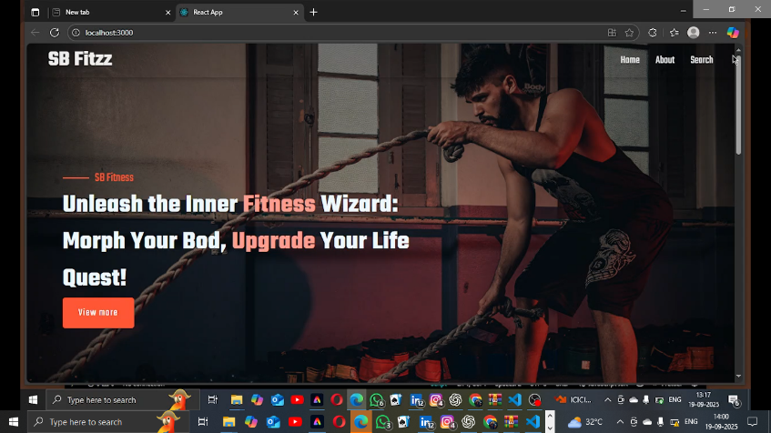

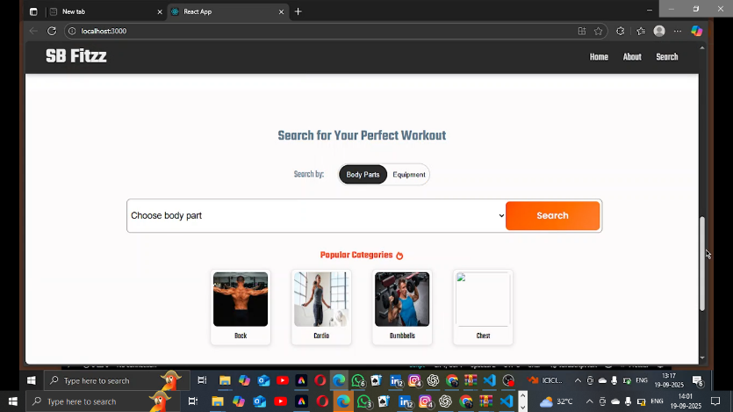

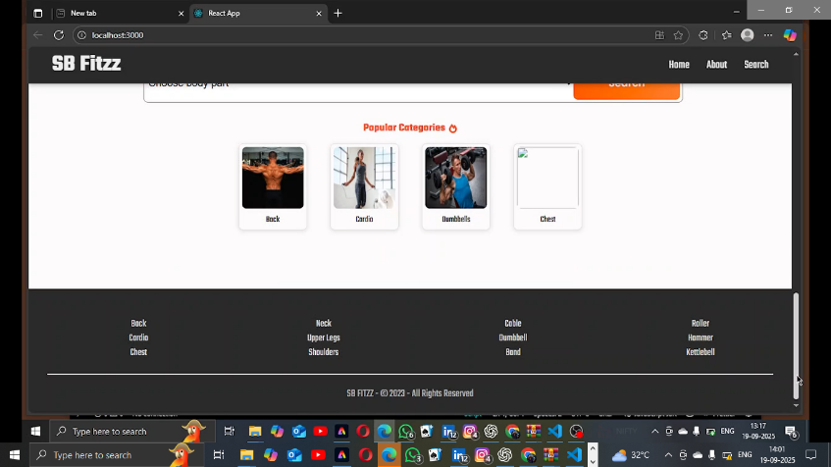

Demo link: https://drive.google.com/drive/folders/1Lo6fQXG_KS9S9X4RQumihUh9cpzm7hZF?usp=sharing

Known Issues

• Authentication token expiry causing unexpected logout Severity: High Description:

Users may be logged out unexpectedly when the JWT access token expires and the client

does not perform a silent refresh. Steps to reproduce

1. Log in to the application.

2. Wait until the access token expires (configured expiration time).

3. Attempt an authenticated action (e.g., update profile). Workaround / Fix: Short-term: Relogin when redirected to the login page. Long-term: Implement refresh tokens with silent

refresh or extend token lifetime and handle 401 responses to attempt token refresh

Future Enhancements

• Integration with wearable devices

• AI-based personalized fitness suggestions

Mobile app version