Architecture and Design Decisions

High-Level Architecture
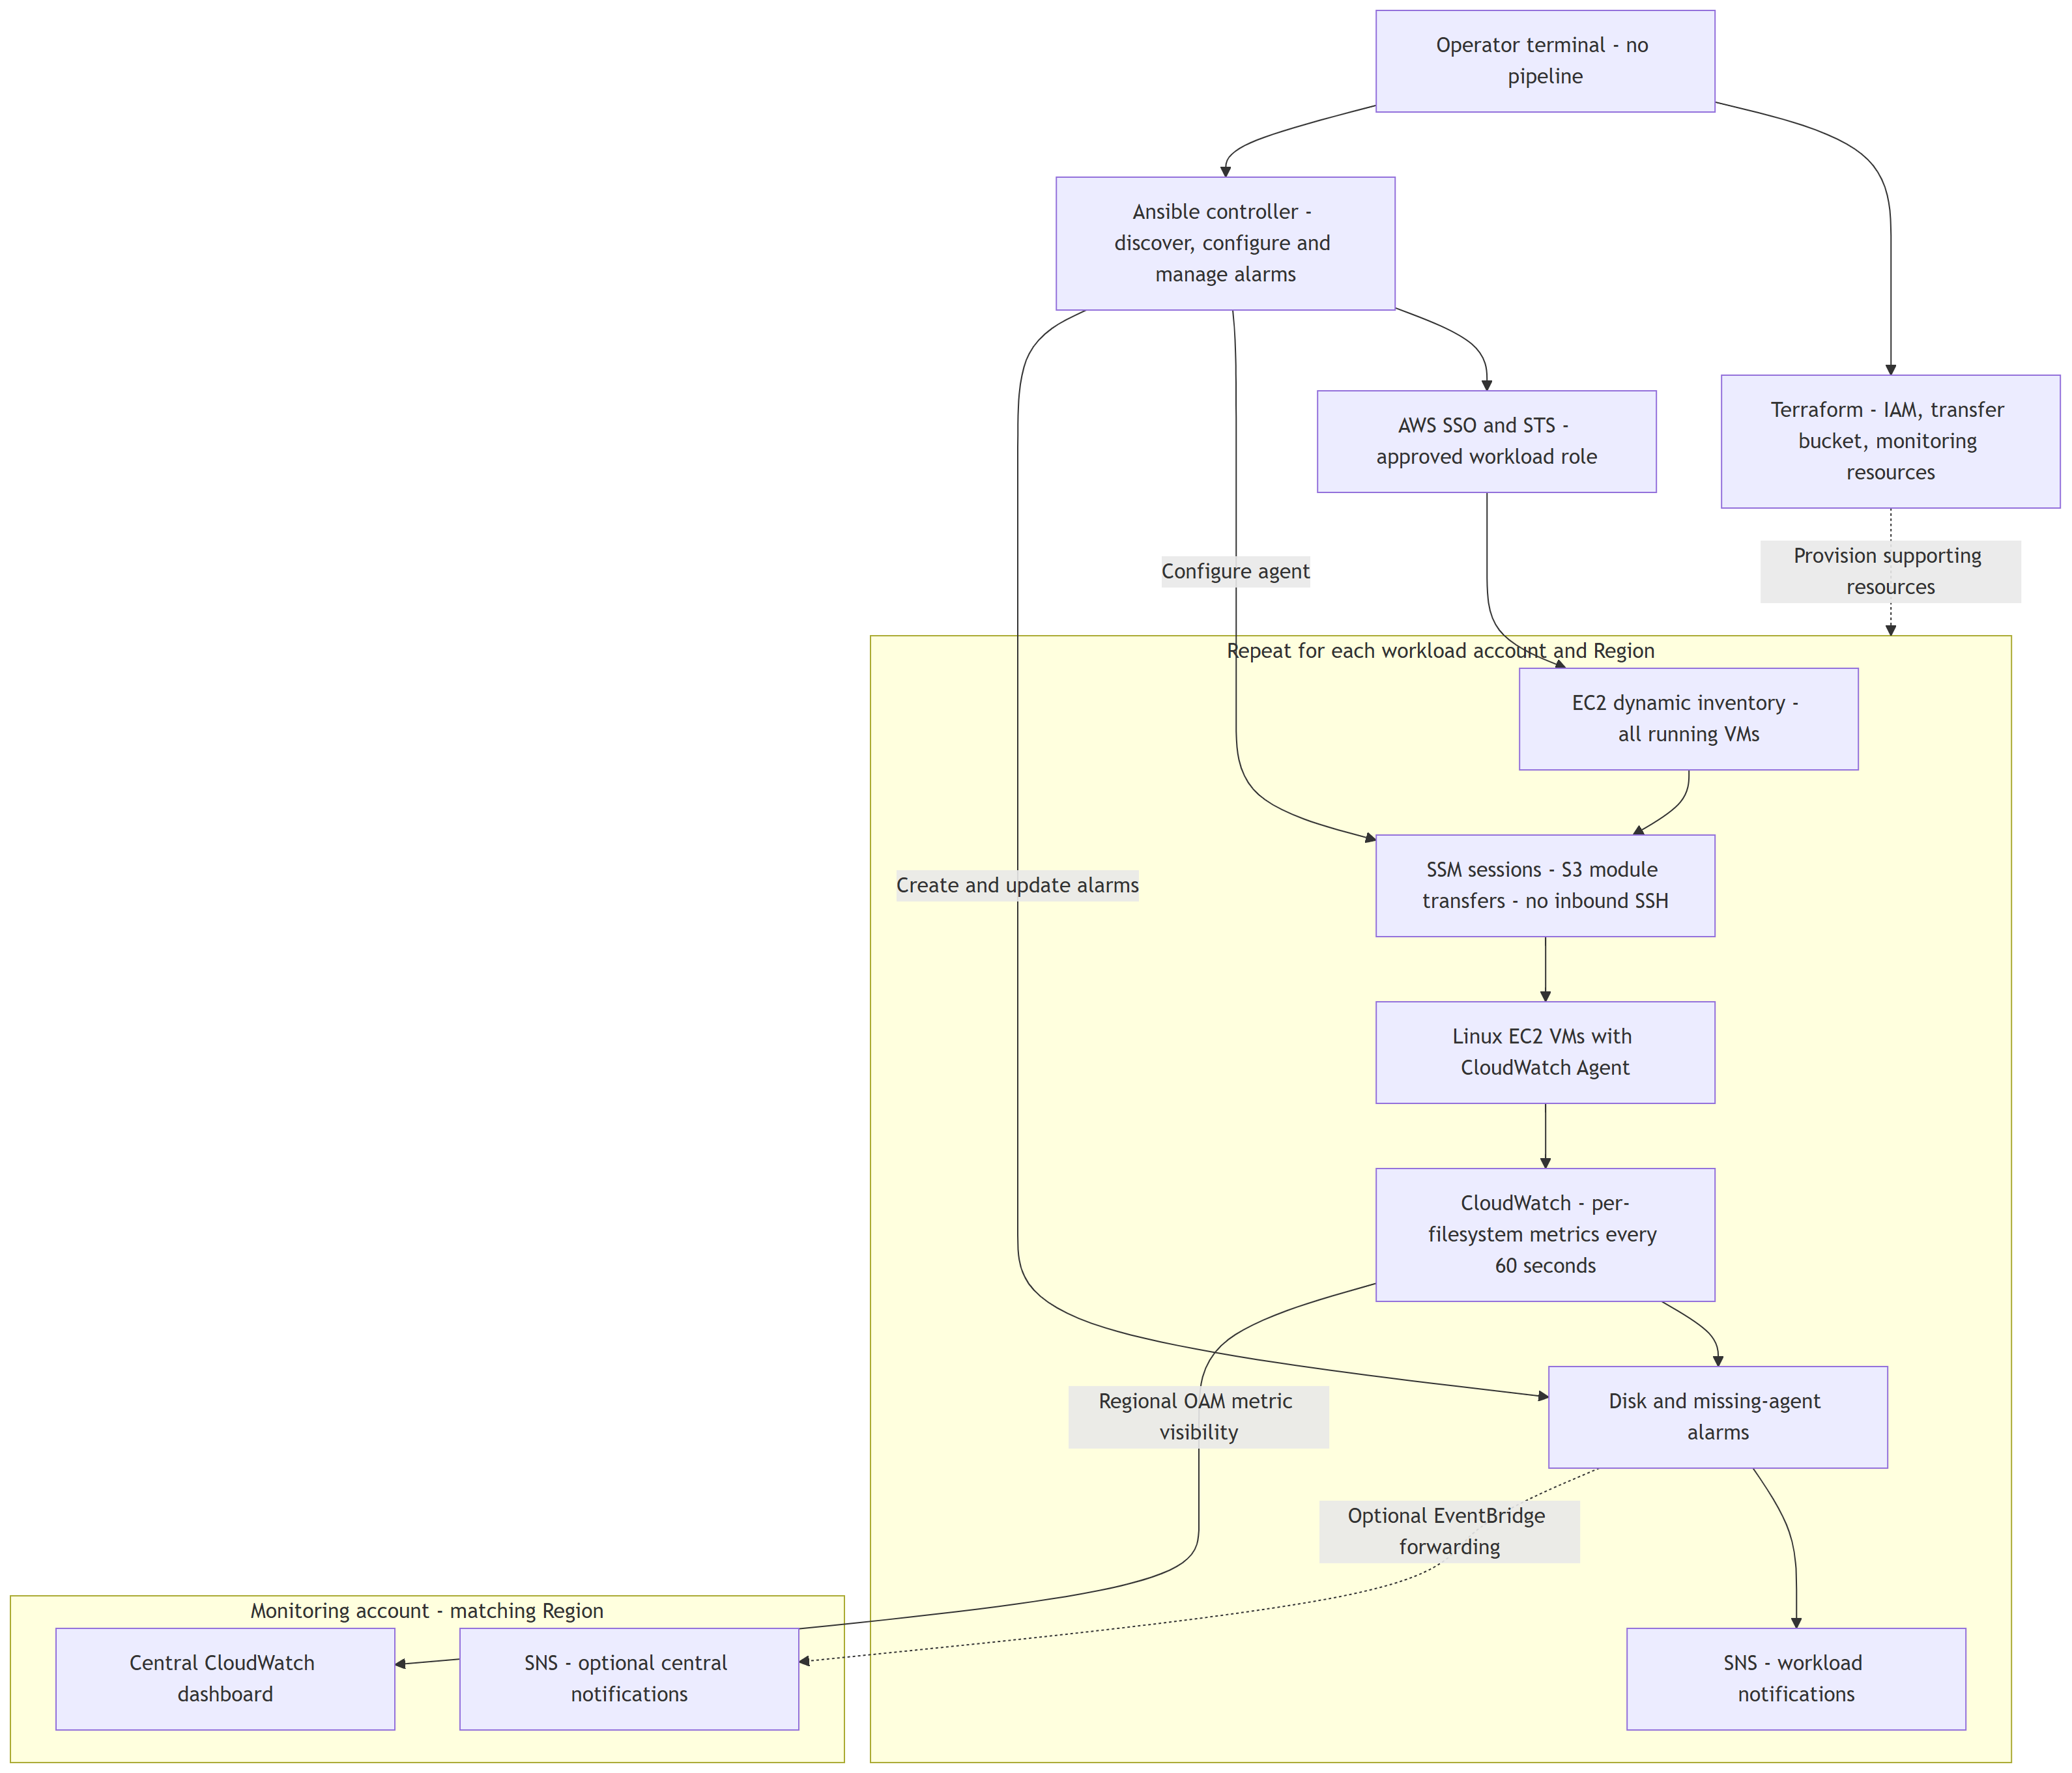
SSM/S3 provides secure guest access; CloudWatch provides continuous monitoring. OAM centralizes visibility across accounts without copying metrics. Workload SNS is the basic alert path; central event forwarding is optional. A single-account demo uses its local dashboard and needs neither OAM nor central forwarding.

Complete Execution Flow
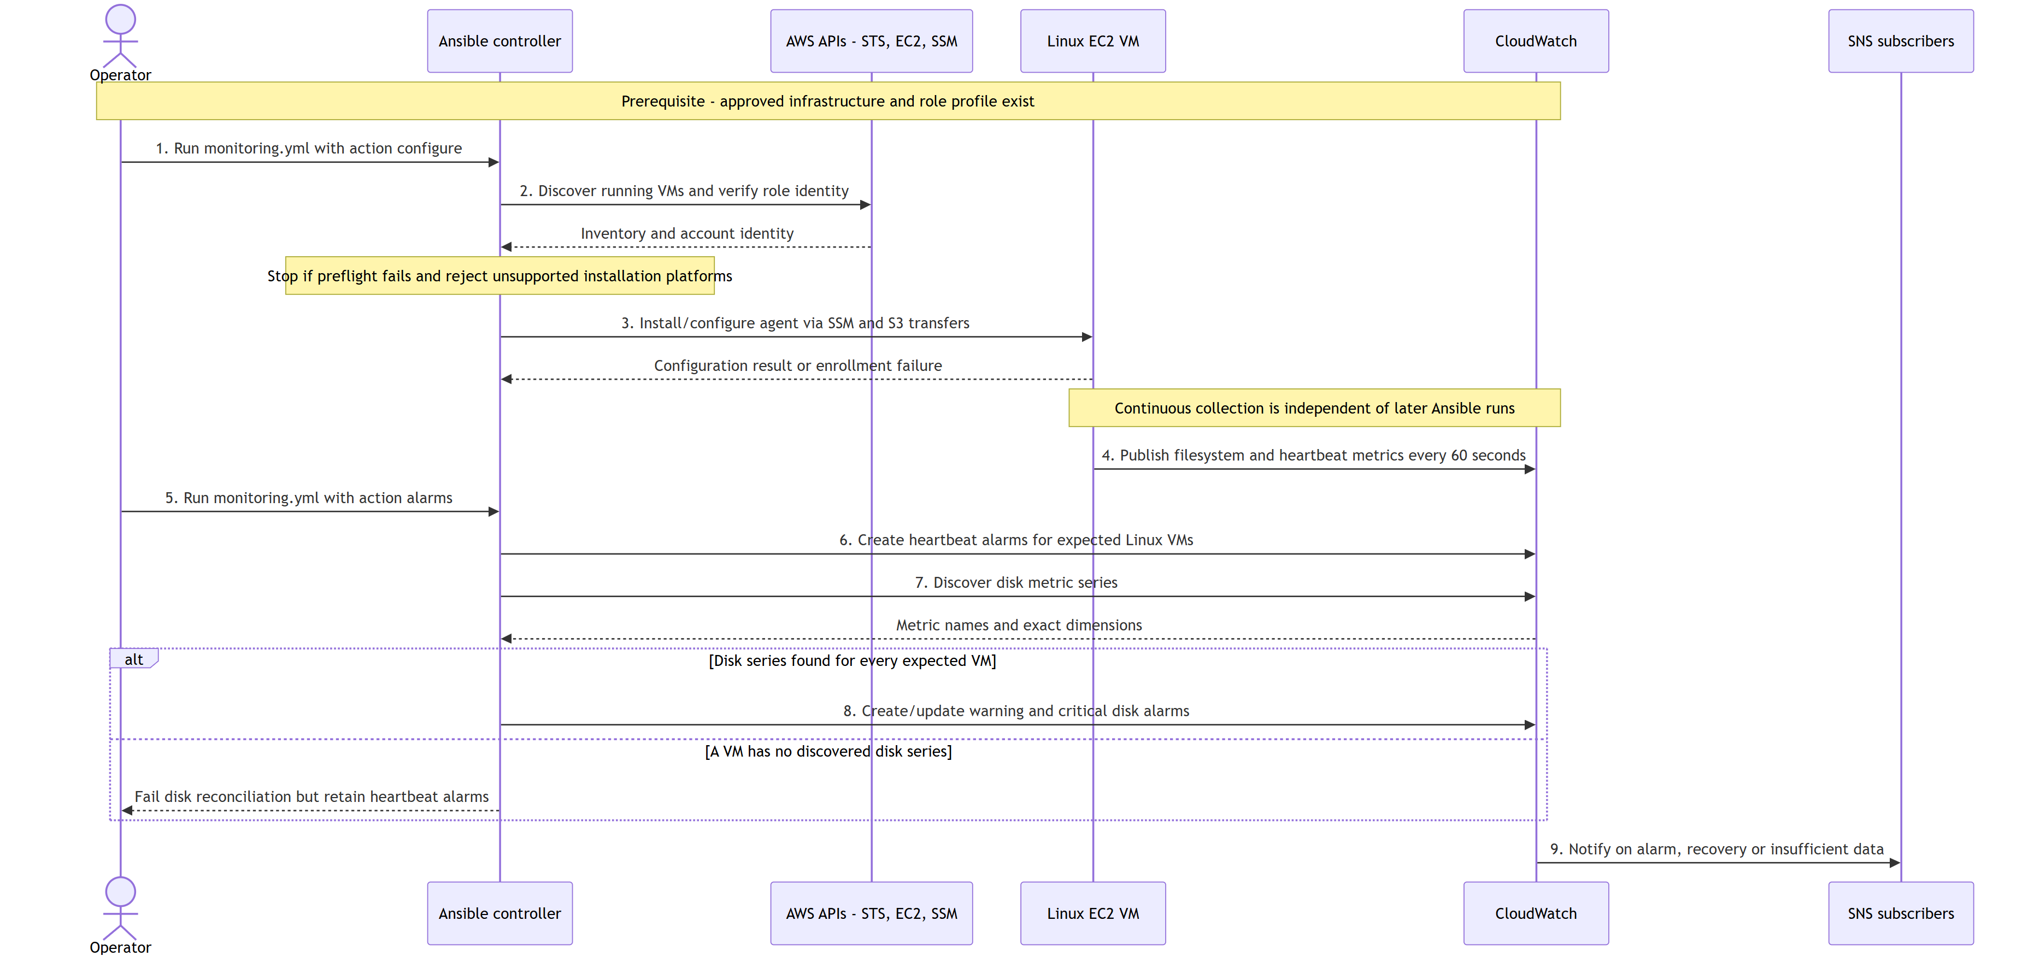

Numbered Walkthrough
These numbers match the main actions in the sequence diagram: enrollment (1-3) followed by continuous metric collection and alarm setup (4-9). Step 9 occurs when an alarm changes state, not on every playbook run.
1. Start enrollment: Select the approved account/Region and run monitoring.yml -e monitoring_action=configure with its named role profile. Supporting infrastructure must already exist.
2. Discover and validate: Dynamic inventory finds running VMs; preflight checks the account identity, profile, Region and Linux scope. Failed checks stop the run.
3. Configure the agent: Connect through SSM/S3 and install/configure CloudWatch Agent on supported AL2023 hosts. Enrollment failures require remediation.
4. Collect continuously: Each configured agent sends filesystem and heartbeat metrics to CloudWatch every 60 seconds, independently of Ansible.
5. Start alarm setup: Run monitoring.yml -e monitoring_action=alarms separately using the same workload profile and Region.
6. Create heartbeat alarms first: Add missing-telemetry alarms for expected Linux VMs, even if disk metrics have not appeared.
7. Discover disk metrics: Read published disk series and validate their exact instance/mount dimensions. Discovery alone does not prove freshness.
8. Create disk alarms: If every expected VM has a discovered series, create/update warning and critical alarms. Otherwise fail disk reconciliation while retaining heartbeat alarms.
9. Notify operators: CloudWatch sends alarm, recovery or insufficient-data notifications through SNS. Subscriptions must be configured and confirmed. The architecture diagram shows what is connected and where it lives. This sequence diagram shows who performs each action and in what order. Repeat discovery, configuration and alarm reconciliation to enroll new accounts or VMs.
Metrics continue after agent setup, independent of controller availability. Alarm reconciliation is a separate Ansible run. Missing agent samples trigger the heartbeat alarm. Failed preflight stops the run, and unsupported platforms fail enrollment explicitly. Cloning the repository does not deploy resources.

Components And Responsibilities
- Terraform provisions access roles, transfer storage, alarm topics, dashboards, and optional cross-account integrations.
- Ansible discovers EC2 instances, configures CloudWatch Agent, and creates or updates workload-local CloudWatch alarms.
- CloudWatch Agent publishes guest filesystem metrics every 60 seconds.
- CloudWatch stores and presents metrics, evaluates alarms, and supports account/Region dashboard views. OAM provides regional cross-account visibility; it does not copy metric data.
- SNS receives alarm state notifications. A human notification requires a separately configured and confirmed subscription.

Assignment Coverage
1. Access management: SSO/STS, dedicated workload roles, and SSM access are configured in Terraform and used by Ansible.
2. Collection and presentation: The agent publishes filesystem metrics; CloudWatch dashboards and alarms provide aggregation and monitoring.
3. Scalability: Dynamic EC2 inventory and repeatable per-account/Region runs support growth without a manually maintained VM list.

Measurement Contract
Disk metrics: disk_used_percent, disk_free, disk_total, 60-second resolution. Dimensions: InstanceId, path, fstype. drop_device and omit_hostname prevent additional identity dimensions. Alarm reconciliation refuses unexpected dimension sets, avoiding silent alarms on nonexistent series.
The heartbeat uses mem_used_percent with InstanceId: normal values cannot breach a negative threshold, but missing samples are treated as breaching. CloudWatch evaluation/backfill affects timing; this is not an exact outage timer. An alive heartbeat does not prove every expected mount is still reporting.

Scope and Extensions
Included in the proposed artifacts: AL2023 agent configuration, dynamic running-instance inventory, workload-local alarms, CloudWatch dashboards, regional OAM visibility and optional central event forwarding.
Designed extensions: other Linux distributions, Windows per-drive collection, inode/absolute-space alarms, event-driven enrollment, scheduled freshness and mount-expectation reconciliation, alarm retirement, DLQs and incident enrichment. These are not silently presented as implemented components.
For production, use the existing enterprise Ansible scheduler to refresh each account/Region at an agreed interval (for example, 15 minutes). Scheduling is an operating integration, not a deployment pipeline. This repository performs no automatic enrollment unless an operator or approved scheduler runs it.
References: CloudWatch Agent configuration, cross-account observability, SSM connection.

