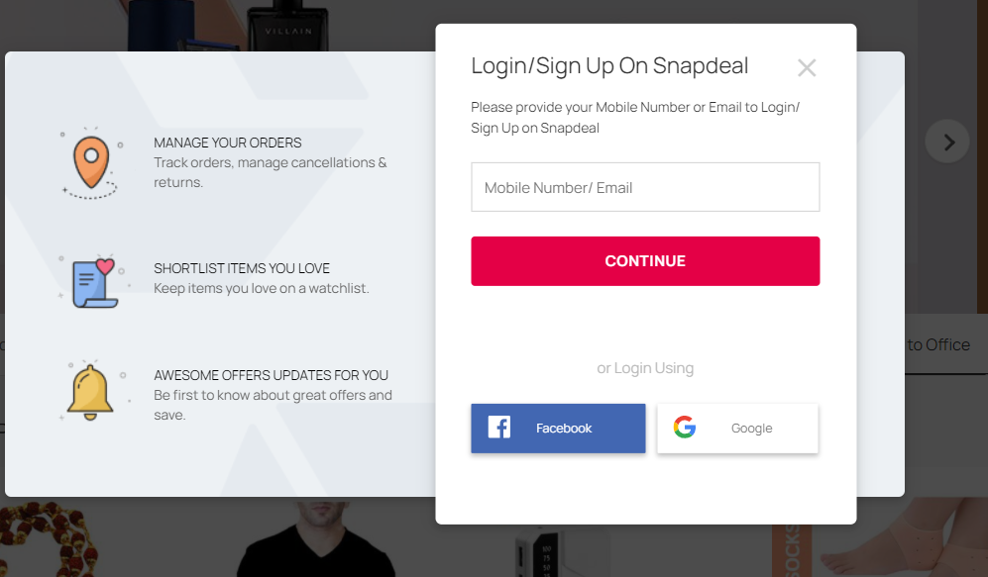
Pages- Register/Login page>Home page>product page>buying options >payment gateway.
Register/Sign up- To login Snapdeal website we must create account. Sign up
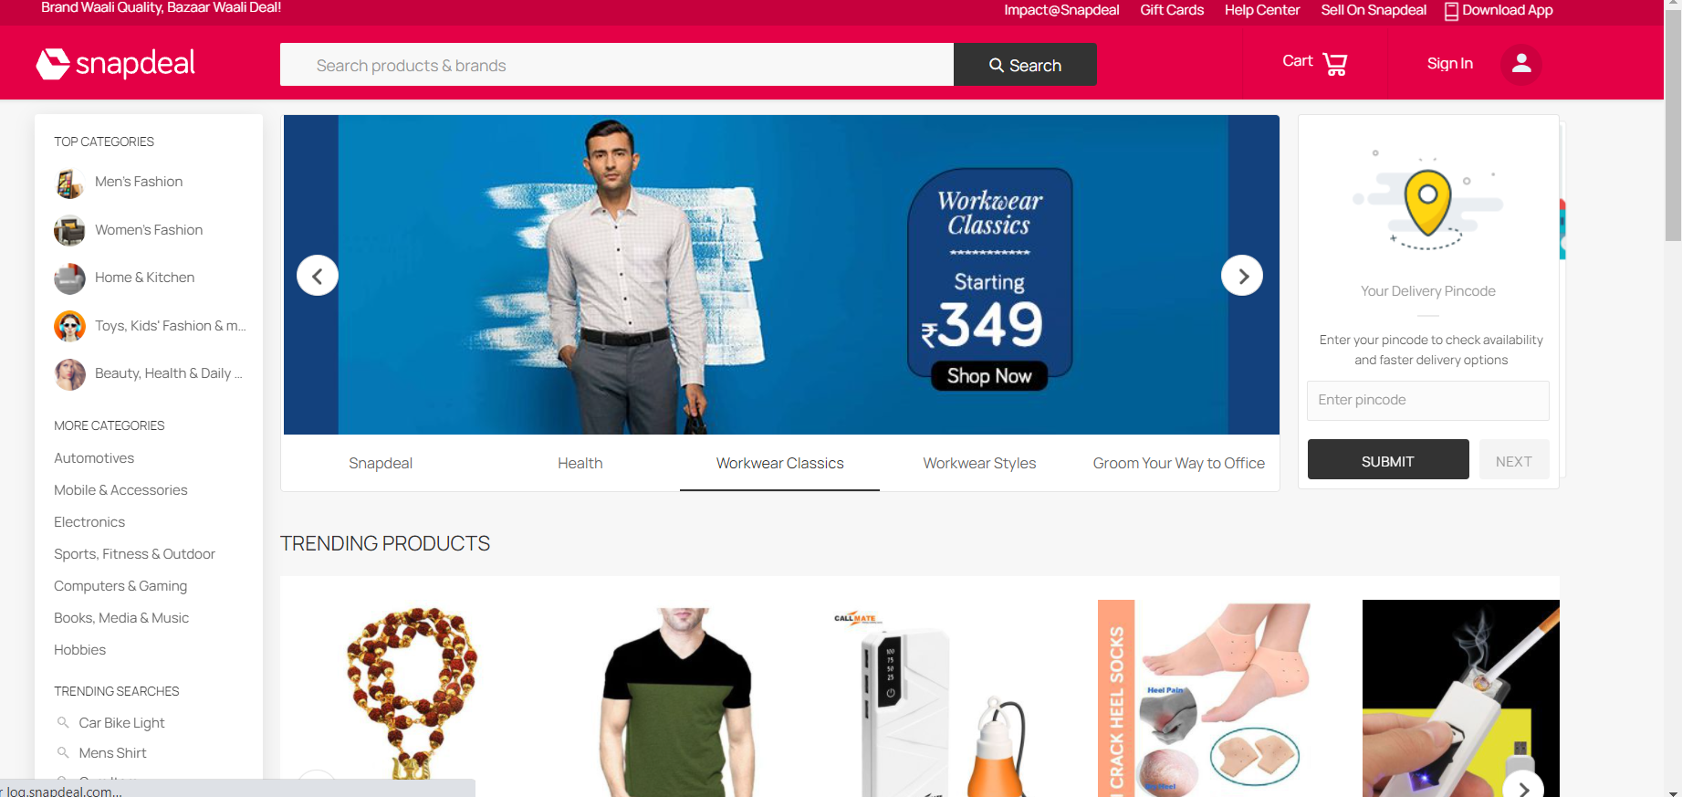

Login page – If you have already created an account. Just sign in with your mobile number.

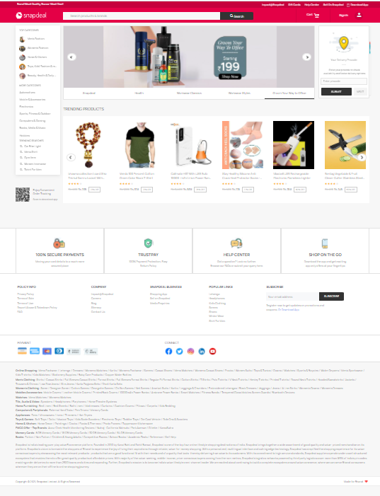

Home page- The home page offers various navigating features including shopping menu, find product, add to cart, payment etc. Shown in the image
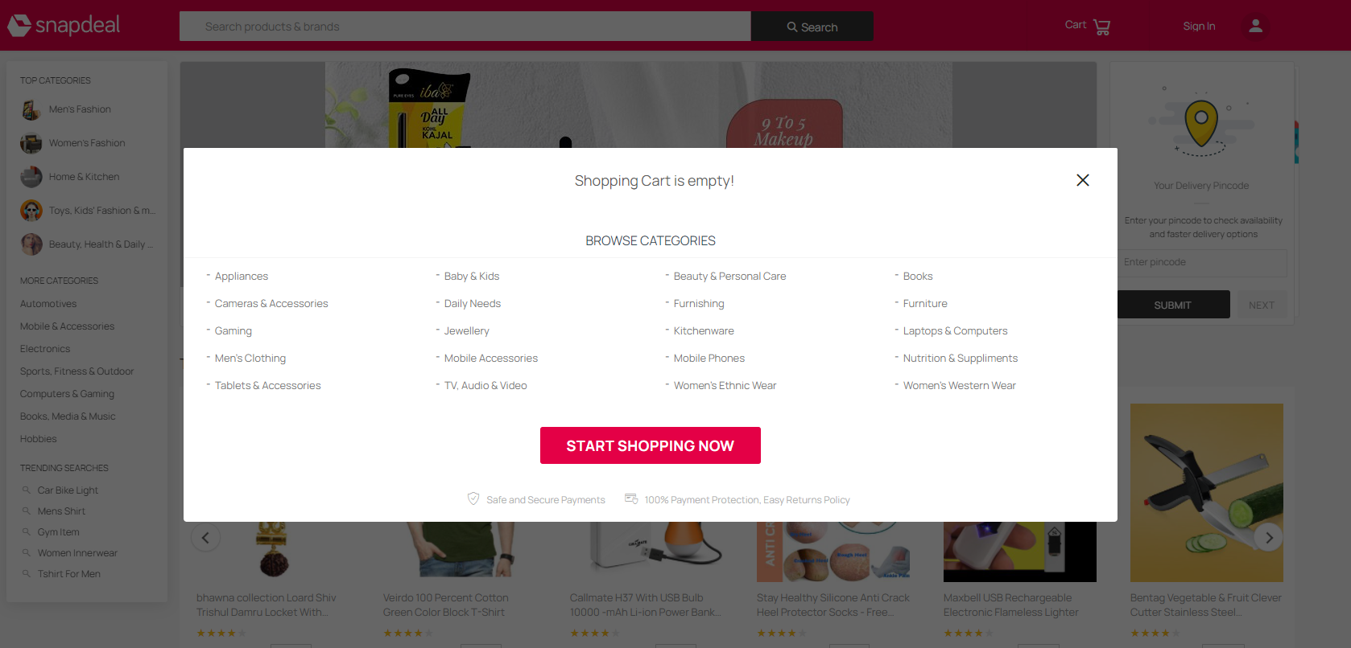

Cart- You can click add to cart for just liking the product or buying in future. It will show the items in the cart, it will be easy for shopping the liked products.

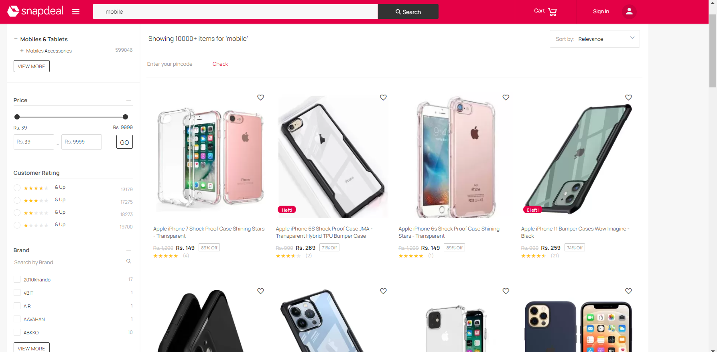

You can Browse the items that you want in search bar and select the items for further details.

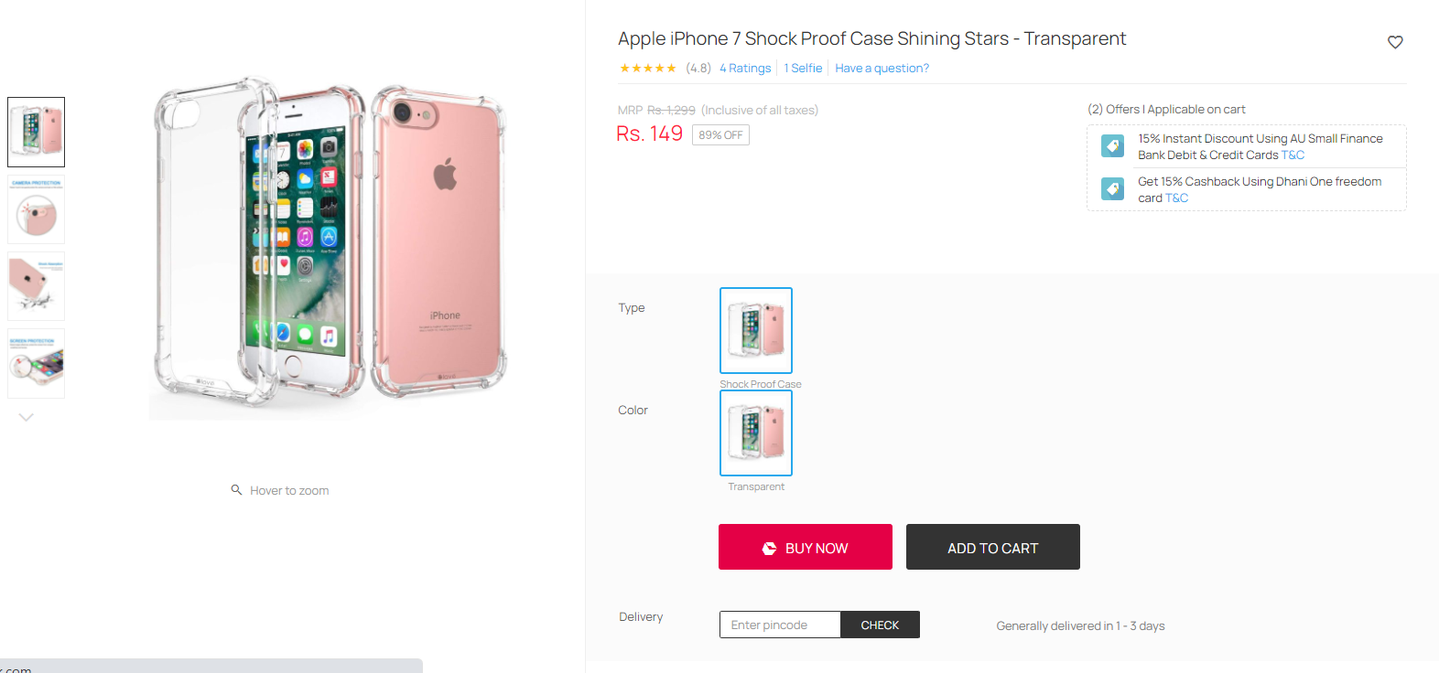

Buying Option with Payment gateway- The product with price and discount as well as offers with typical Cards. Buy now option as various features with the Delivery Address and the Review Order make payment.

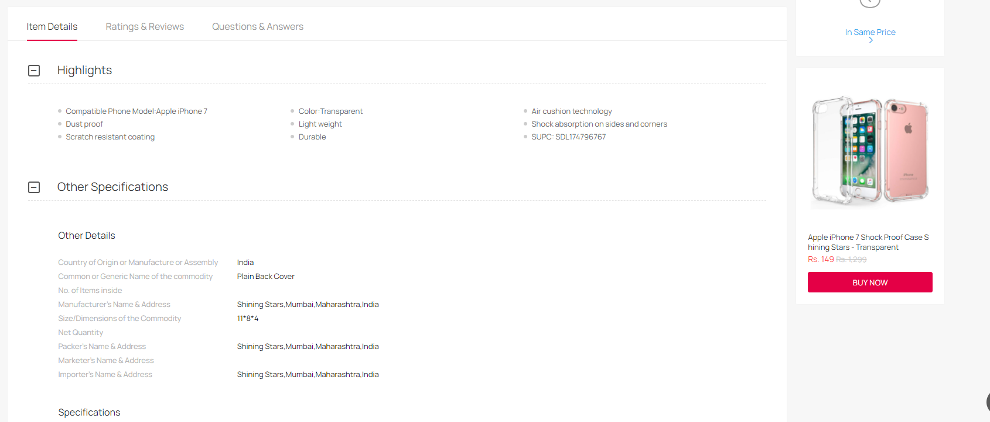
Highlights and specifications are shown below this and also the rating & review , Question and Answers .
Created by
-Vishal Chougule

