- Assignment:-9
Reset-Password
- Name:-
Vishal Bhambhana
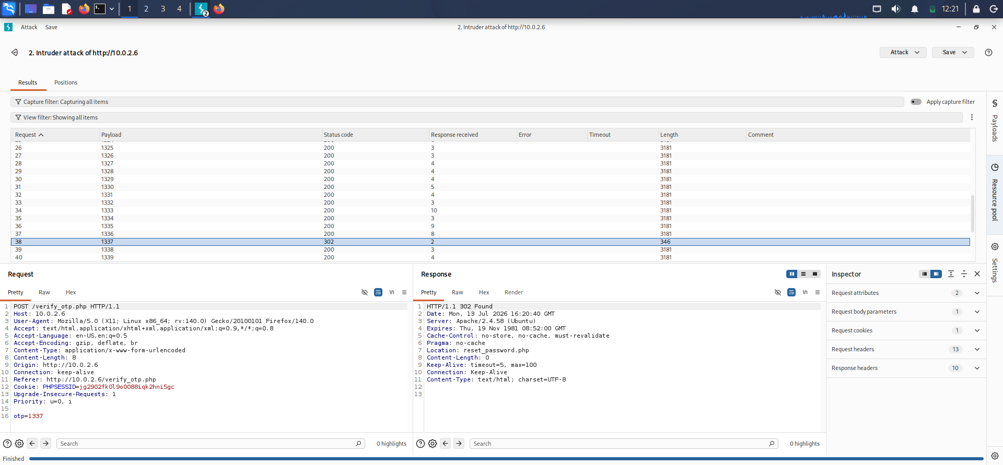
- Screenshots:-
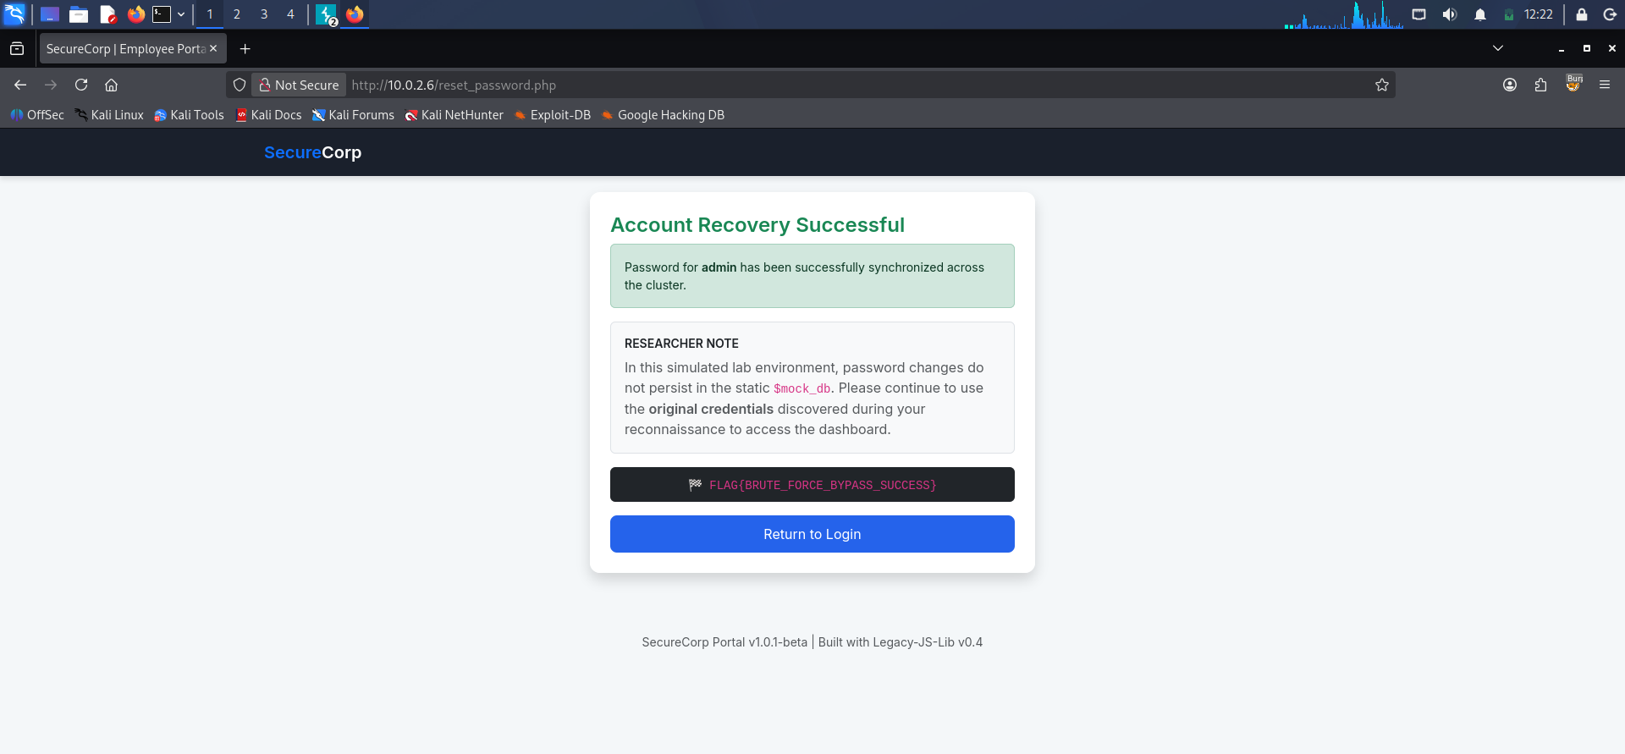
- Use burpsuit intruder for fetch OTP
- Flag:- FLAG{BRUTE_FORCE_BYPASS_SUCCESS}

