- Assignment:-8
IDOR
- Name:-
Vishal Bhambhana
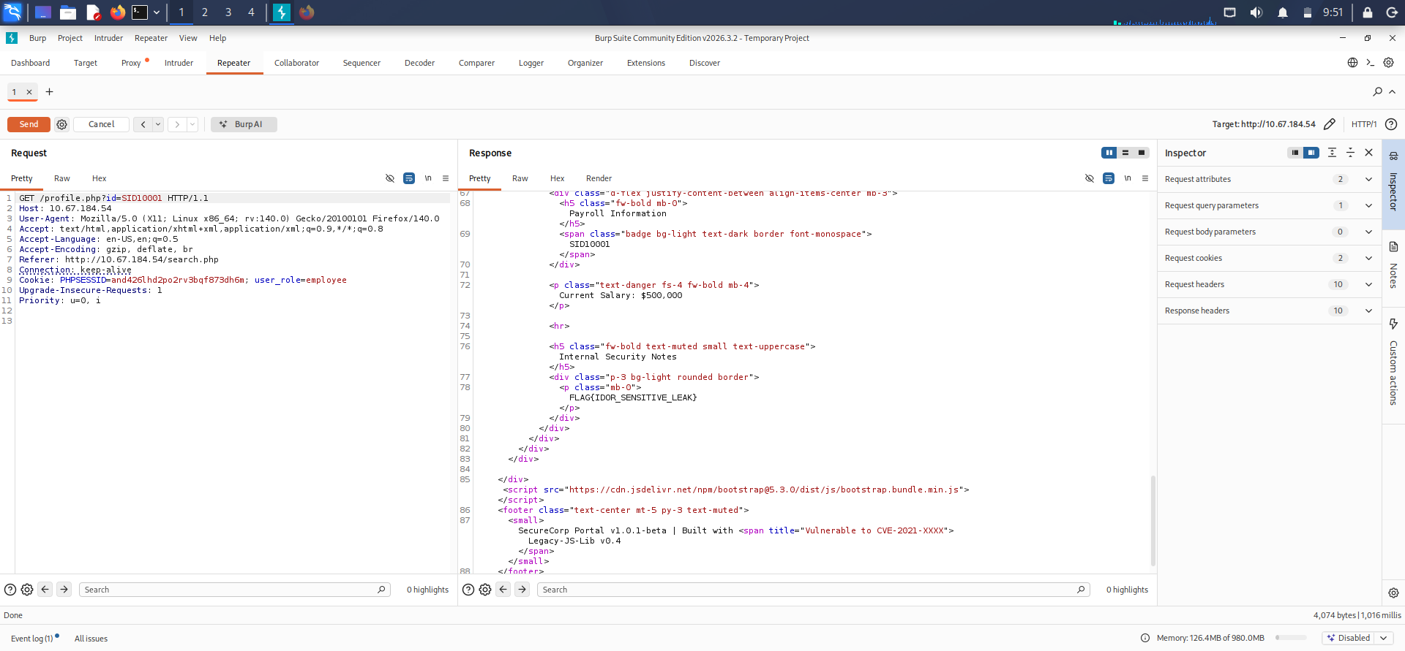
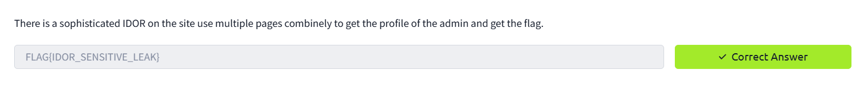
- Screenshots:-

- Change Profile ID
- Flag:- FLAG{IDOR_SENSITIVE_LEAK}

