Assignment-15 :-
Investigating an Attack
Name :- Vishal Bhambhana

Objective:-In this assignment I have to investigating the attack that is done by attacker.in this assignment ARP Spoofing attack was detected and I
Screenshot:-
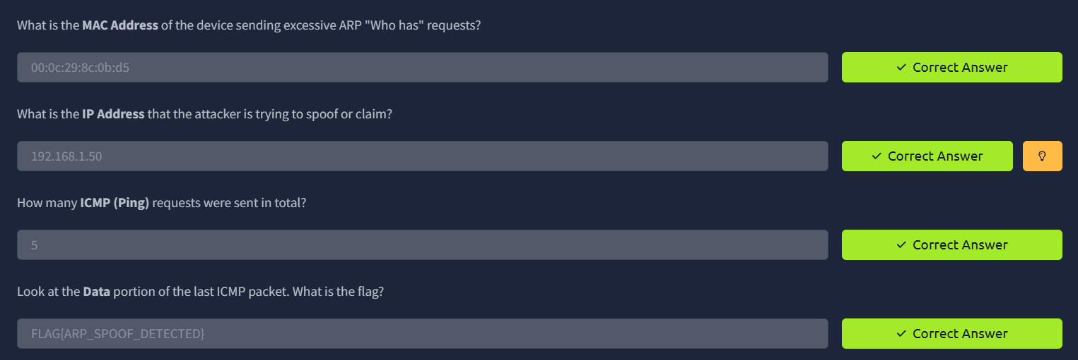
- This is the screenshots of tryhackme questions answers with flag.

- In this assignment I download the file and analysis packets in wireshark.

