Assignment-5:- Information Gathering
- Name:- Vishal Bhambhana
- Objective:-
The objective of this task was to perform passive and active information gathering using WHOIS and Nmap scanning techniques to identify open ports, services, versions, and hidden information on the target machine.
- Screenshot-1:- Whois Scan
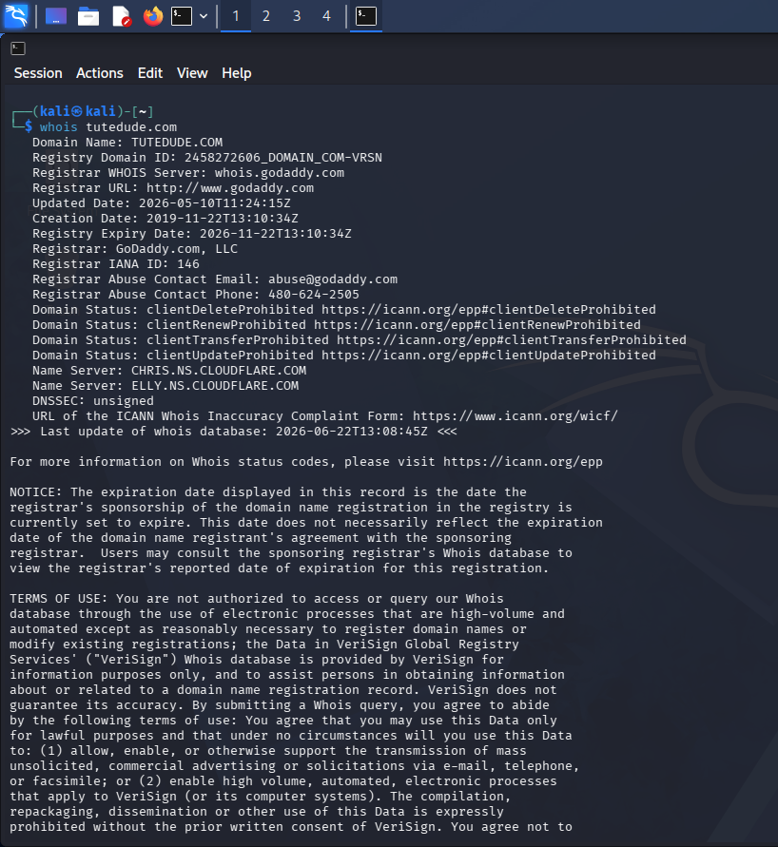
- A WHOIS lookup was performed on tutedude.com to determine the domain registration information.

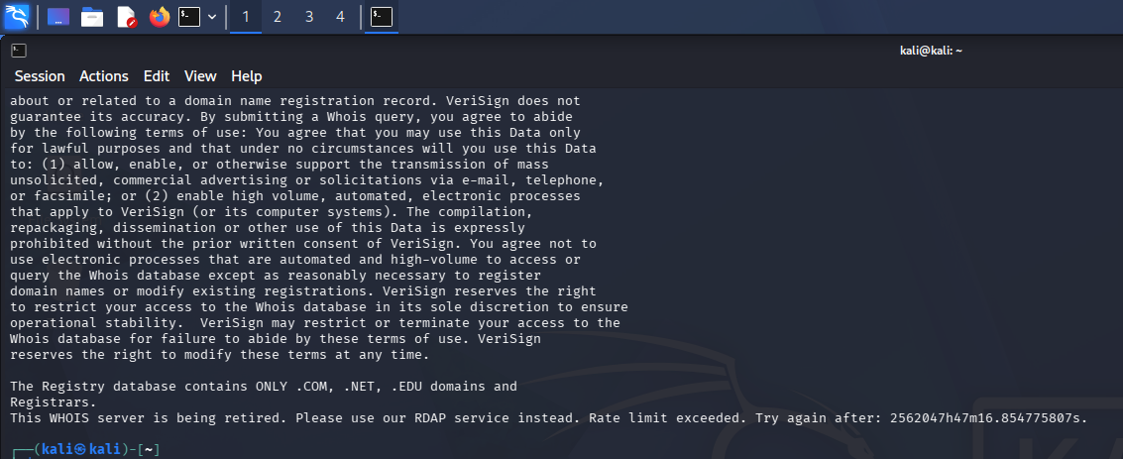
- Screenshot-2:-Basic Nmap Scan
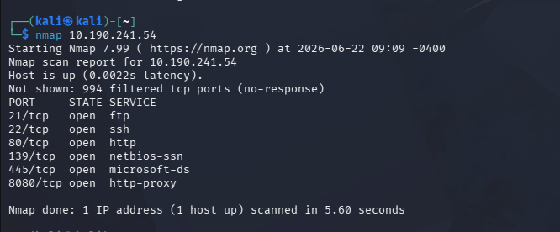
- A basic Nmap scan was performed to identify open ports on the target machine.

- Screenshot-3:-Advanced Nmap Scan
- An advanced Nmap scan using -sC and -sV options was performed to identify service versions and additional information. The scan revealed the required flag on a higher port.
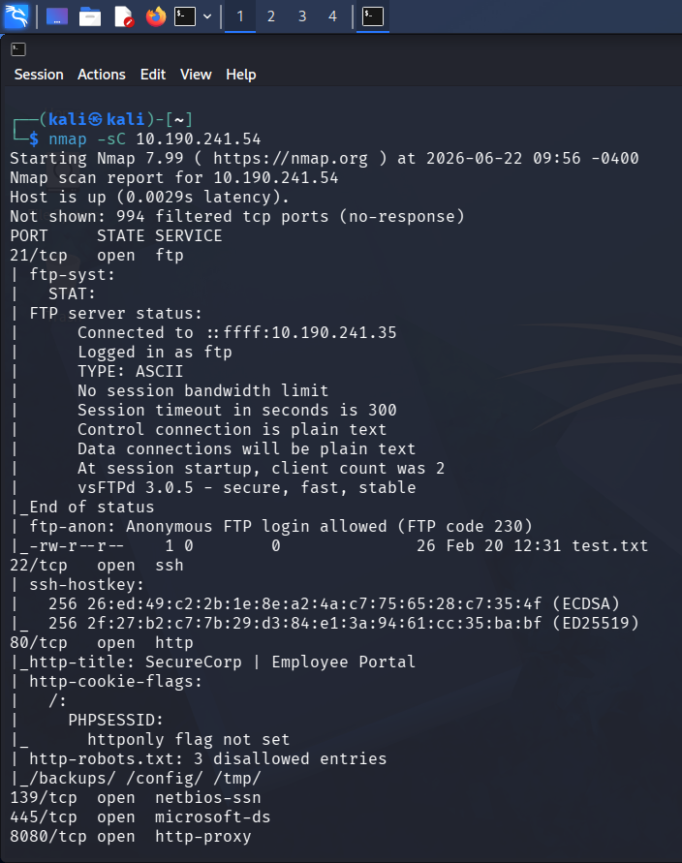
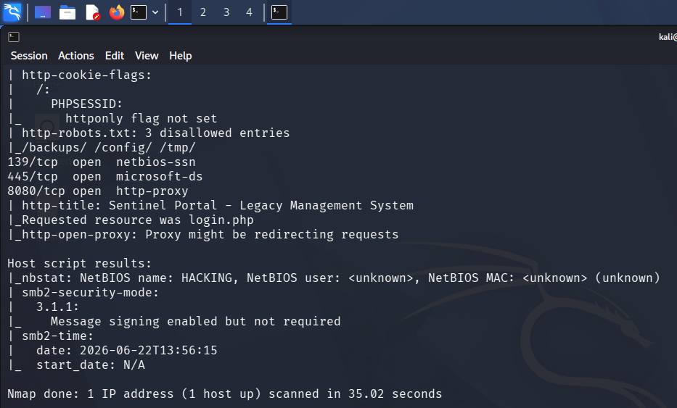

- Answers of the questions:-
- When was the domain tutedude.com registered?
ANS.=> 22/11/2019
- How many ports are open on the target?
ANS.=>7
- Which port is commonly used for SSH?
ANS.=>22
- Which service is running on port 80?
ANS.=>HTTP
- What is the Service Version running on port 21?
ANS.=> vsftpd 3.0.5

6)Flag:- FLAG{HIGH_PORT_RECON_SUCCESS}
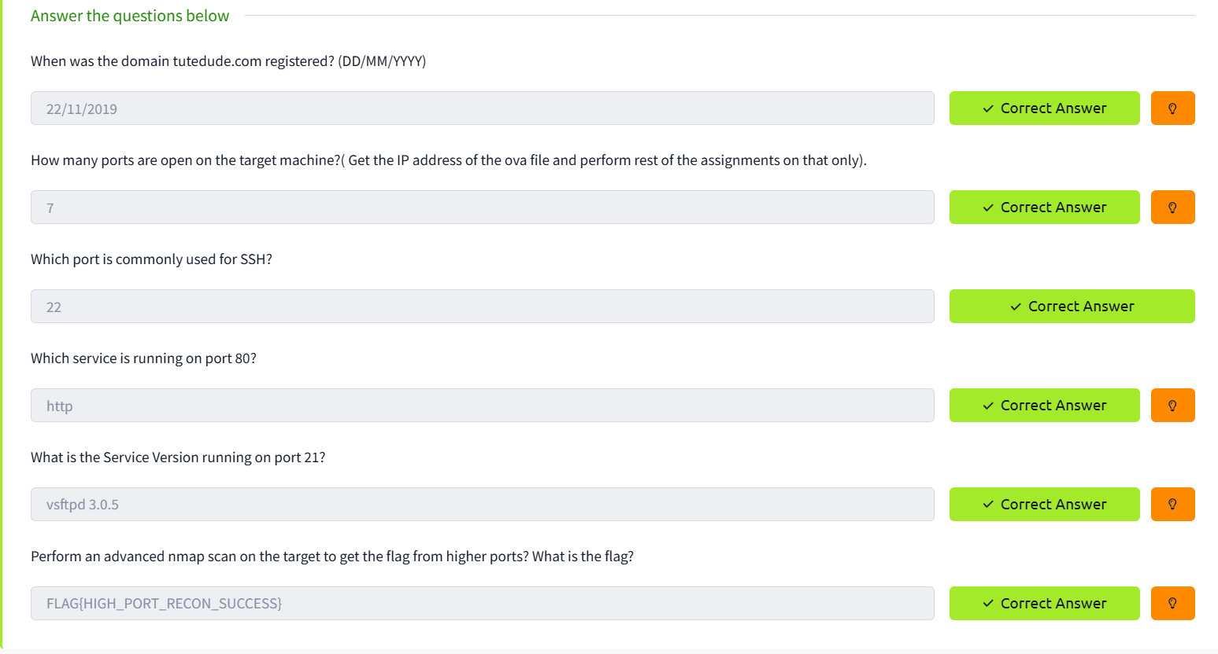
- Screenshot-4:- All questions were answered successfully and the room was completed.

End.

