- Assignment:-10
Cross-site Scripting
- Name:-
Vishal Bhambhana
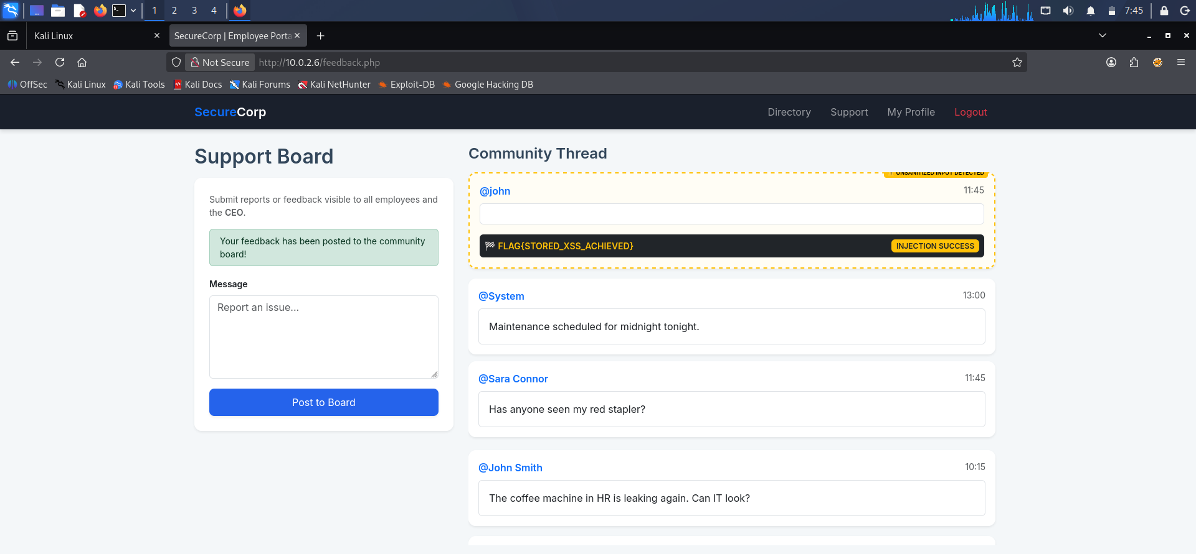
- Screenshots:-

- Write script on user support section
- Flag:- FLAG{STORED_XSS_ACHIEVED}

