Assignment 13:-
GreyBox VAPT
By Vishal Bhambhana

- Performed Nessus scan on the target and got the highest CVSS score as 7.5. 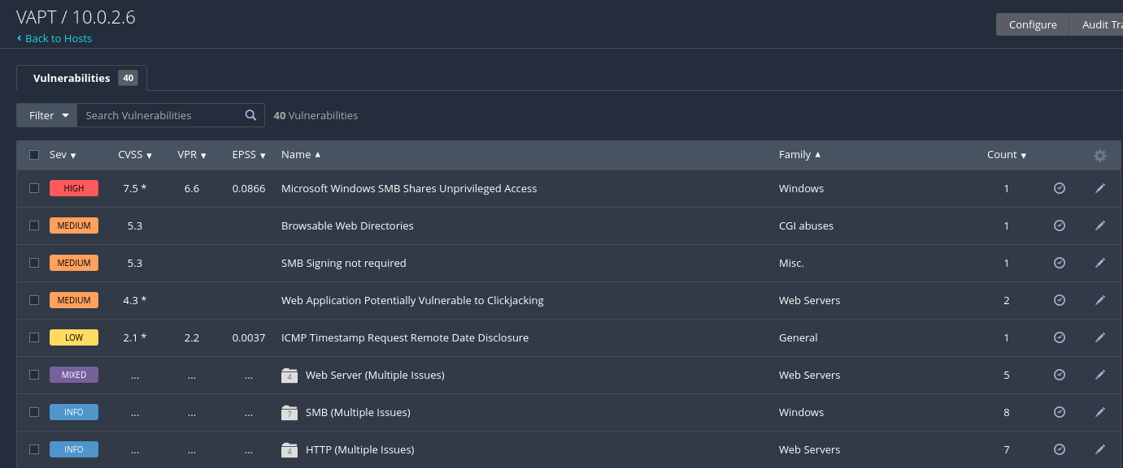
- Got the Vulnerability description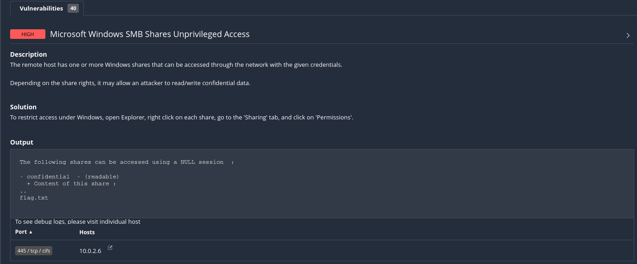
- Did some research from ChatGPT and google and learnt how to use SMB sharing in kali.
- First listing the available directories in SMB and then accessing that without the password using -N flag. After that, I downloaded the flag.txt into my kali machine using ‘get’ command in the SMB. This was possible due to the SMB vulnerability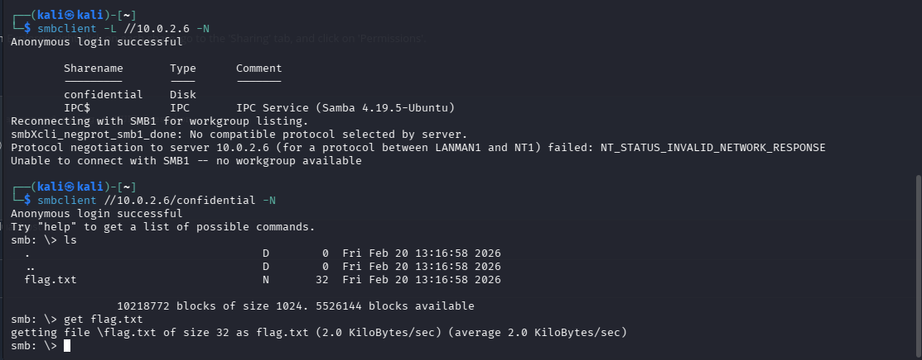
- Opening the flag.txt in the kali machine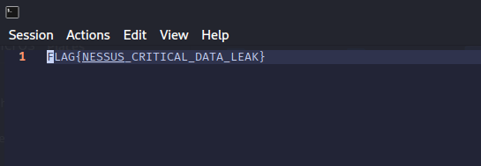
- TryHackMe Screenshot