Assignment 18:-
Log analysis
By Vishal Bhambhana

- Objective:-
The objective of this task was to Analyze Splunk logs to investigate the incident and identify the exfiltrated data.
- Methodology:-
- Loaded and Analyzed the log file in Splunk.
- Filtered events with severity=”CRITICAL”.
- Identified the exfil_data entries and compared the incidents.
- Decoded the exfil_data strings using Base64 decoding.
- Identified the decoy and the REAL flag.
- Answers:-
- CRITICAL events: 2
- REAL incident username: svs_admin_acc
- FLAG:FLAG{SPLUNK_ANALYSIS_PRO_2026}

- Conclusion:-
The real incident was associated with svc_admin_acc ,and the decoded exfiltrated data revealed the correct flag.
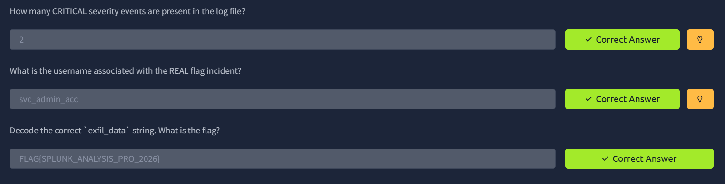
- Screenshot:-

