CAPSTONE PROJECT
Cobalt Shadow / SENTINEL Security Investigation
Prepared by: Vishal Bhambhana
Target: 10.0.2.6 • Web service: Port 8080

1. Objective and Reconnaissance
The task was to retrace the attacker's path through the SENTINEL portal, obtain elevated access, reach the development server shell, escalate privileges, analyze captured network traffic, investigate the resulting audit log, and recover the final flag.
- Port 8080 was enumerated with ffuf to identify exposed application files and useful entry points.
- The enumeration identified login.php, dashboard.php, access_logs.txt and phpinfo.php; the later authenticated dashboard exposed the administrative workflow.
- The access logs showed repeated Guest → Admin transitions for the test account, providing evidence of privilege escalation.
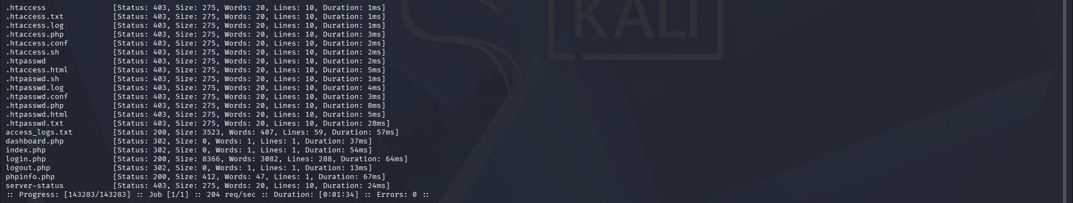
Figure 1. Initial ffuf enumeration of the SENTINEL web service on port 8080.
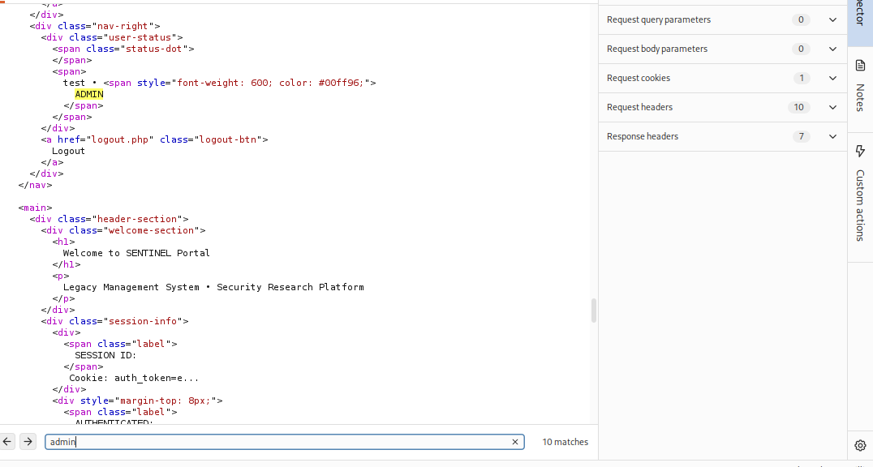
Figure 2. Burp evidence showing the authenticated test account with ADMIN role.
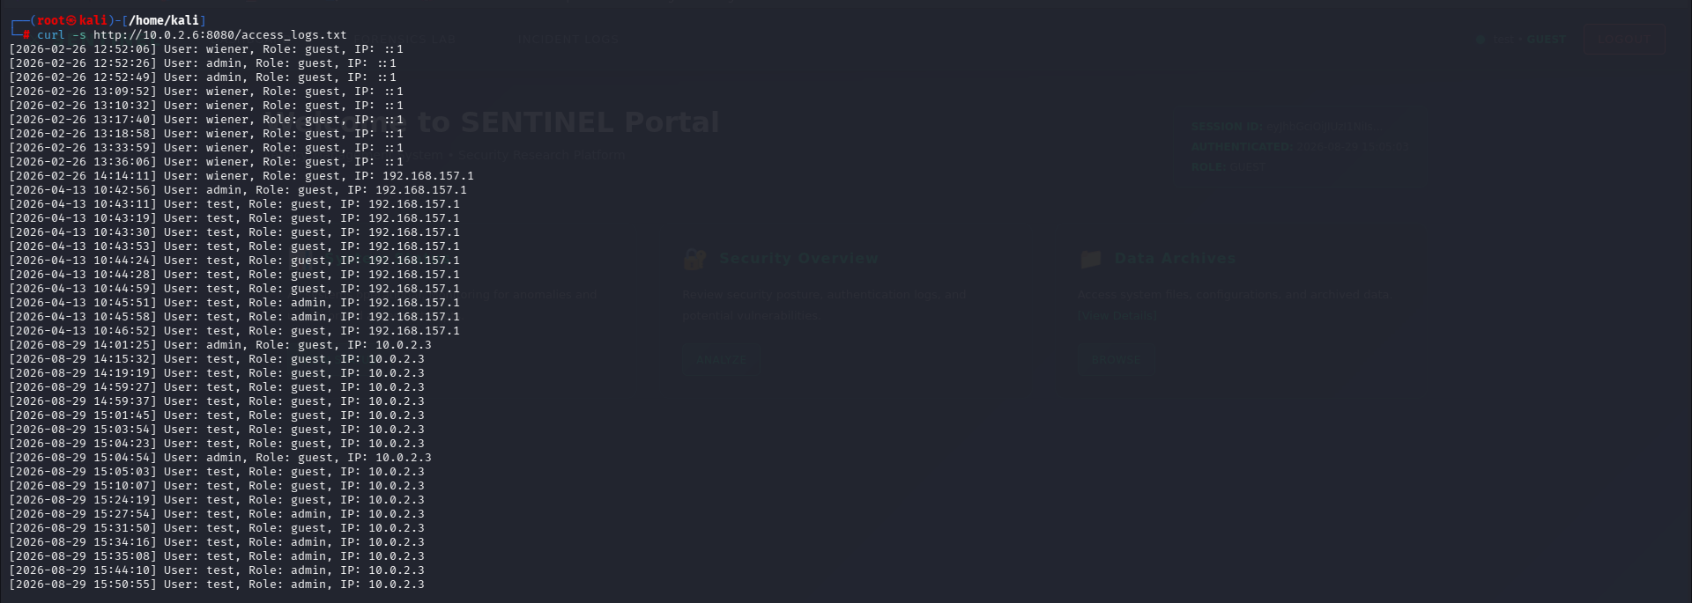
Figure 3. Incident and access logs showing repeated Guest to Admin transitions for the test account.

2. Access and Privilege Escalation
After the web investigation, SSH access to the same target host was established using the supplied student account. The shell access was then used to identify a writable script and a setuid-root executable that executed the script.
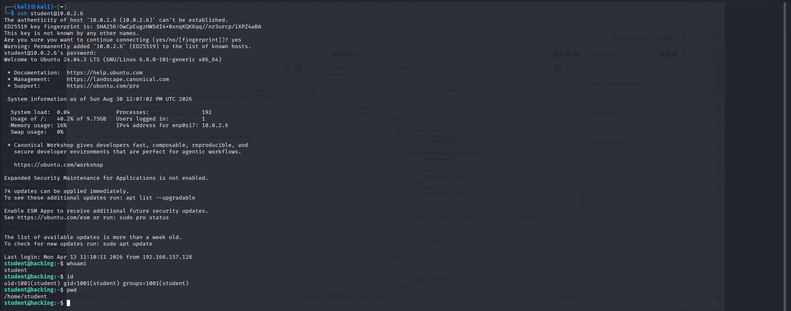
Figure 4. Successful SSH access to the target VM as the student account.
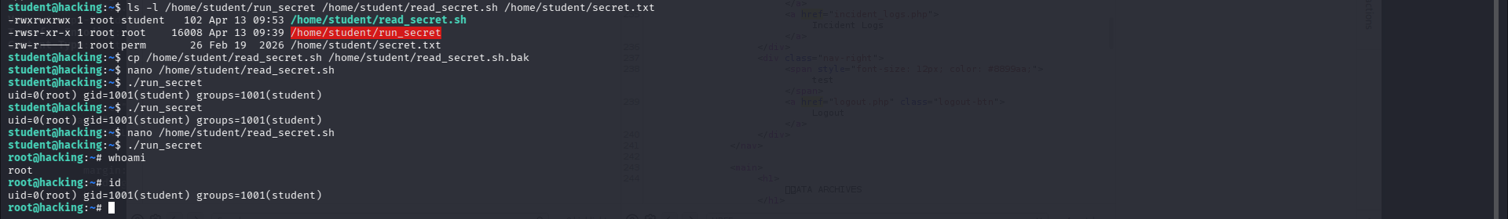
Figure 5. Shell-scripting privilege escalation: read_secret.sh is writable and run_secret is setuid-root; execution reaches uid=0.

Technical finding
Vulnerability: A root-owned setuid executable invoked /home/student/read_secret.sh, while the script was writable by the student user. Replacing the script content with /bin/bash -p allowed an interactive root shell.

- SSH shell access established on 10.0.2.6.
- The writable script was executed through the setuid binary.
- whoami returned root and id confirmed uid=0(root).

3. Traffic Analysis
With root access established, the investigation located the capture file /incident/response/team/Network_traffic.pcapng. The PCAP was copied to Kali and inspected with TShark/Wireshark. The analysis was deliberately restricted to the Sentinel service on port 8080.
Key artifact: Network_traffic.pcapng contained 1,727 frames. The 8080 conversation included an internal GET request to /login.php carrying an archive-password header.

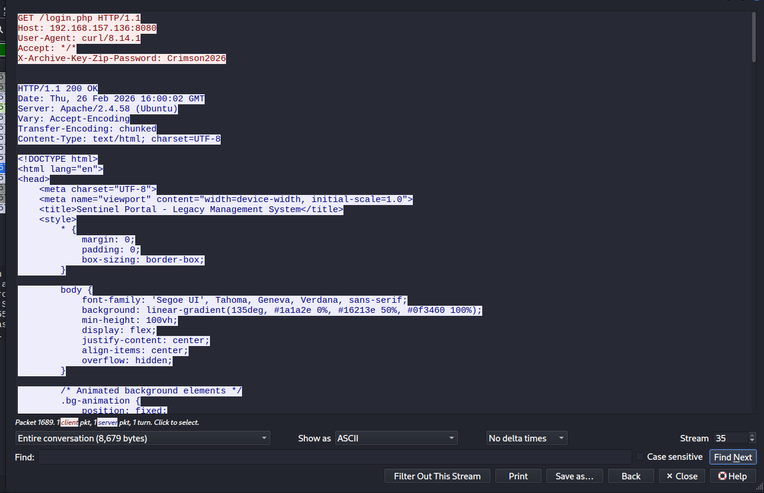
Figure 6. Wireshark stream analysis of port 8080 traffic revealing X-Archive-Key-Zip-Password: Crimson2026.

Traffic finding
Frame 1683 showed traffic from 192.168.157.128 to 192.168.157.136:8080. The request included the custom header X-Archive-Key-Zip-Password: Crimson2026. Testing the password against the vault archives identified svc_cron_42.zip as the matching encrypted archive.
- Archive matched: /home/capstone/vault/svc_cron_42.zip
- Archive contents: internal_audit.log
- The password was derived from the captured 8080 traffic rather than guessed from the archive names.

4. Log Analysis and Final Recovery
The matched archive contained internal_audit.log. The log contained routine service activity and one highly relevant authentication event: an AUTH_MODULE LOGIN_ATTEMPT for svc_admin with the message Access Granted: Provisioning Session and a Base64-encoded enc_data field.
Figure 7. Internal audit log showing the suspicious svc_admin provisioning-session event and encoded data.
Decoded result: RmxhZ3tZb3VfY29ucXVlcmVkX3RoZV9jYXBzdG9uZSF9 → Flag{You_conquered_the_capstone!}

5. Evidence Summary
Stage | Evidence | Result
Reconnaissance | ffuf | SENTINEL files and attack surface identified
Admin escalation | Burp / JWT | test account confirmed as ADMIN
SSH access | ssh + whoami/id | Shell access on 10.0.2.6
Shell scripting | setuid + writable script | uid=0 root execution and root shell
Traffic analysis | Wireshark/TShark | Crimson2026 recovered from 8080 traffic
Log analysis | internal_audit.log | svc_admin provisioning event identified
Final recovery | Base64 decode | Flag recovered successfully
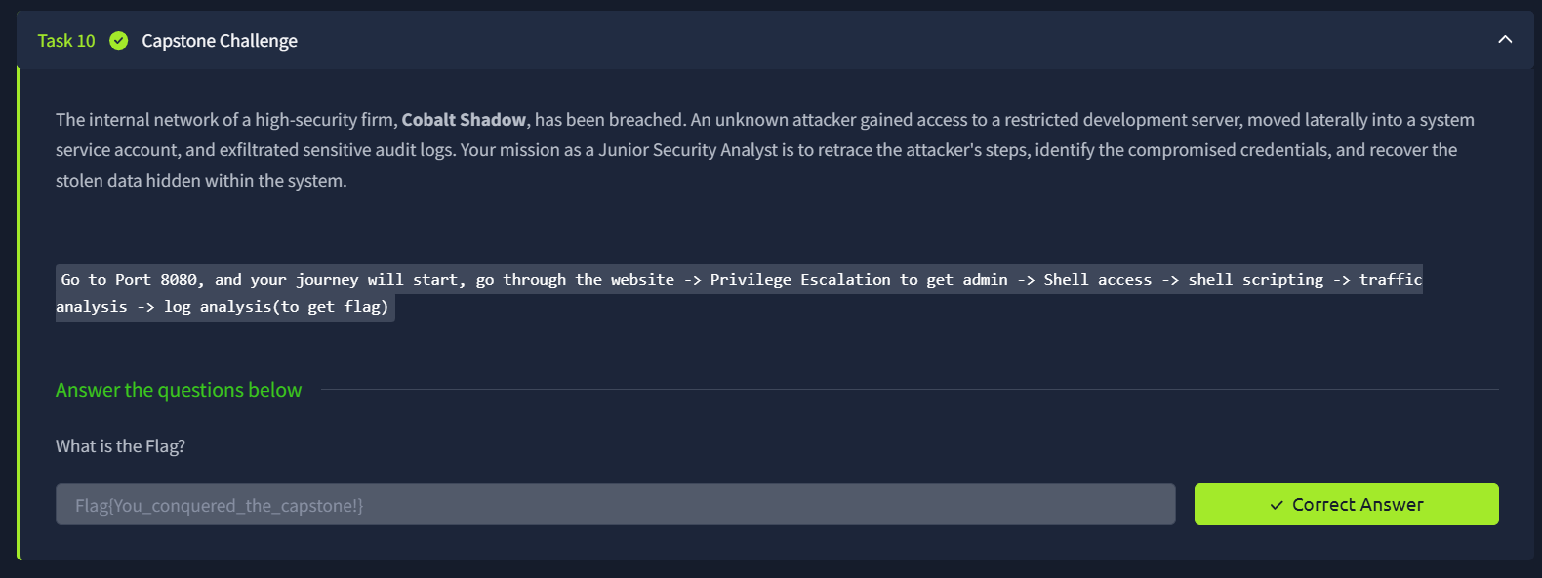
Figure 8. Capstone task showing the final flag entered and accepted as the correct answer.

