Assignment-14 :-
Network Traffic Analysis
Name :- Vishal Bhambhana

Objective:-objective of this assignment was do the detailed analysis on given file’s
Network traffic using wireshark.
Screenshot:-
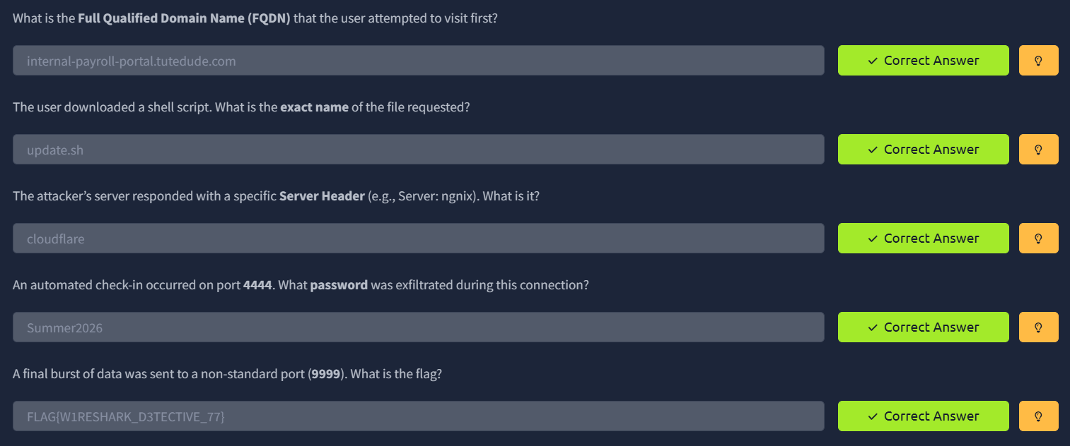
- This is the screenshots of tryhackme questions answers with flag.

