- Assignment:-12
Advanced Nmap
- Name:-
Vishal Bhambhana
- Objective:- Perform an advanced Nmap scan and retrieve the flag.

- Commands Used:-
  - nmap -p- 10.0.2.6
  - nmap -A -sV -sC -p- 10.0.2.6

- Flag Found:- FLAG{HIGH_PORT_RECON_SUCCESS}

- Screenshot-1:-
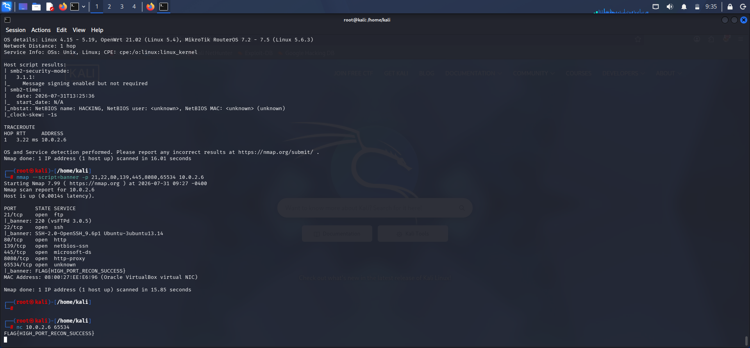
- Screenshot-2:-

