Assignment-3
1)What is the name of the file located inside the "loot" folder?
ANS.=> readme.txt
2)What are the contents of the file that was in the "loot" folder?
ANS.=> flag{you_know_cd_ls_cat_now}
3)What are the contents of the hidden file in the "loot" folder?
ANS.=> flag{you_found_the_hidden_file}

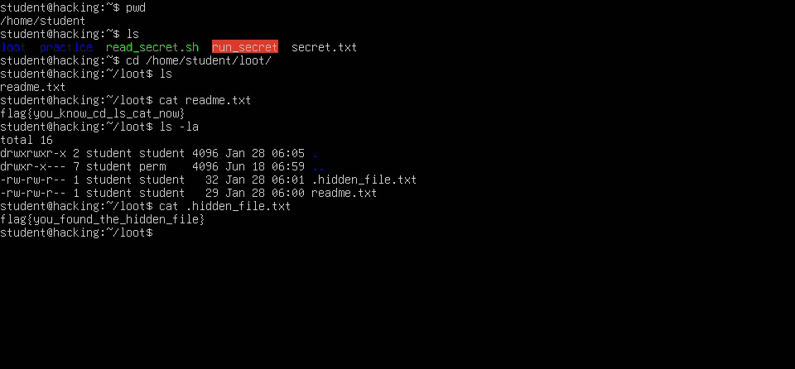
Screenshots:-
