Assignment 13:-
SSRF
By Vishal Bhambhana

- Objective:-
The objective of this task was to identify and exploit a Server-Side Request Forgery (SSRF) vulnerability in the SecureCorp employee portal and access an internal resource to retrieve the flag.
- Methodology:-
First, I connected to the TryHackMe target and logged into the SecureCorp portal using the credentials obtained from the previous fuzzing task.
After logging in, I navigated to the Avatar Sync (Legacy) page. The page allows users to enter an Asset URL and fetch assets from remote or internal endpoints.
I tested the URL-fetching functionality to determine whether the server could be forced to access internal resources.
The application provided a hint to fetch the /secret endpoint because it could only be accessed by the internal server.
- Flag:- FLAG{INTERNAL_SSRF_BYPASS_SUCCESS}
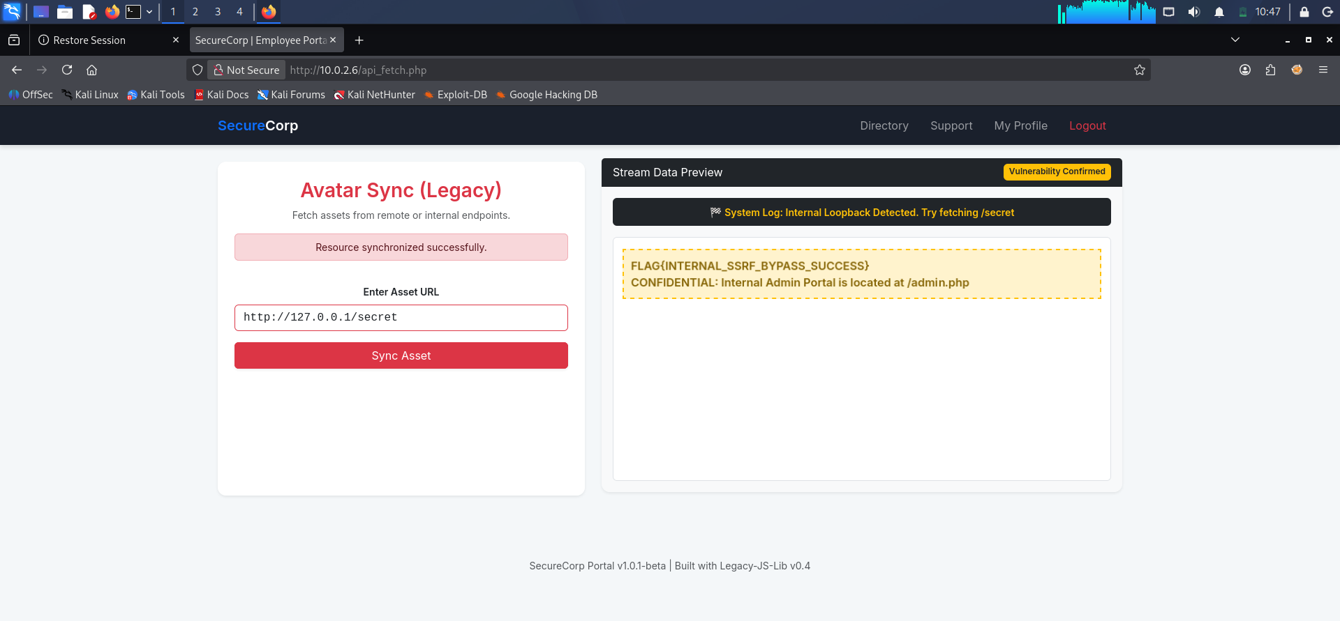
- Screenshots:-

