Assignment-4
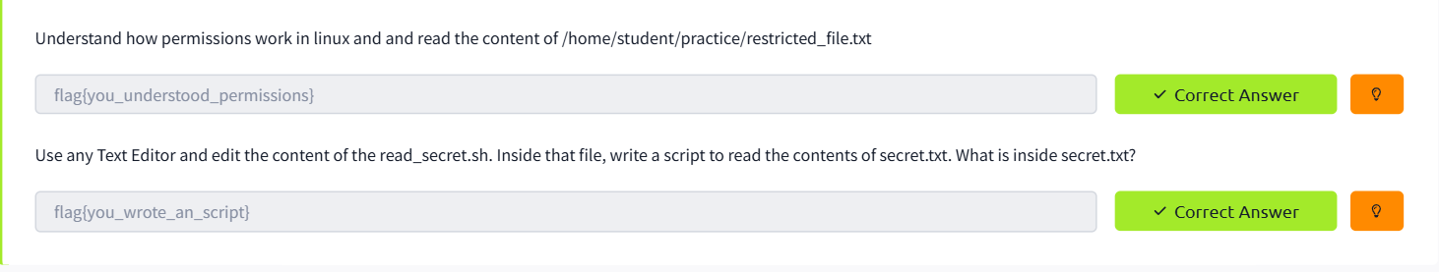
Screenshot-1:-

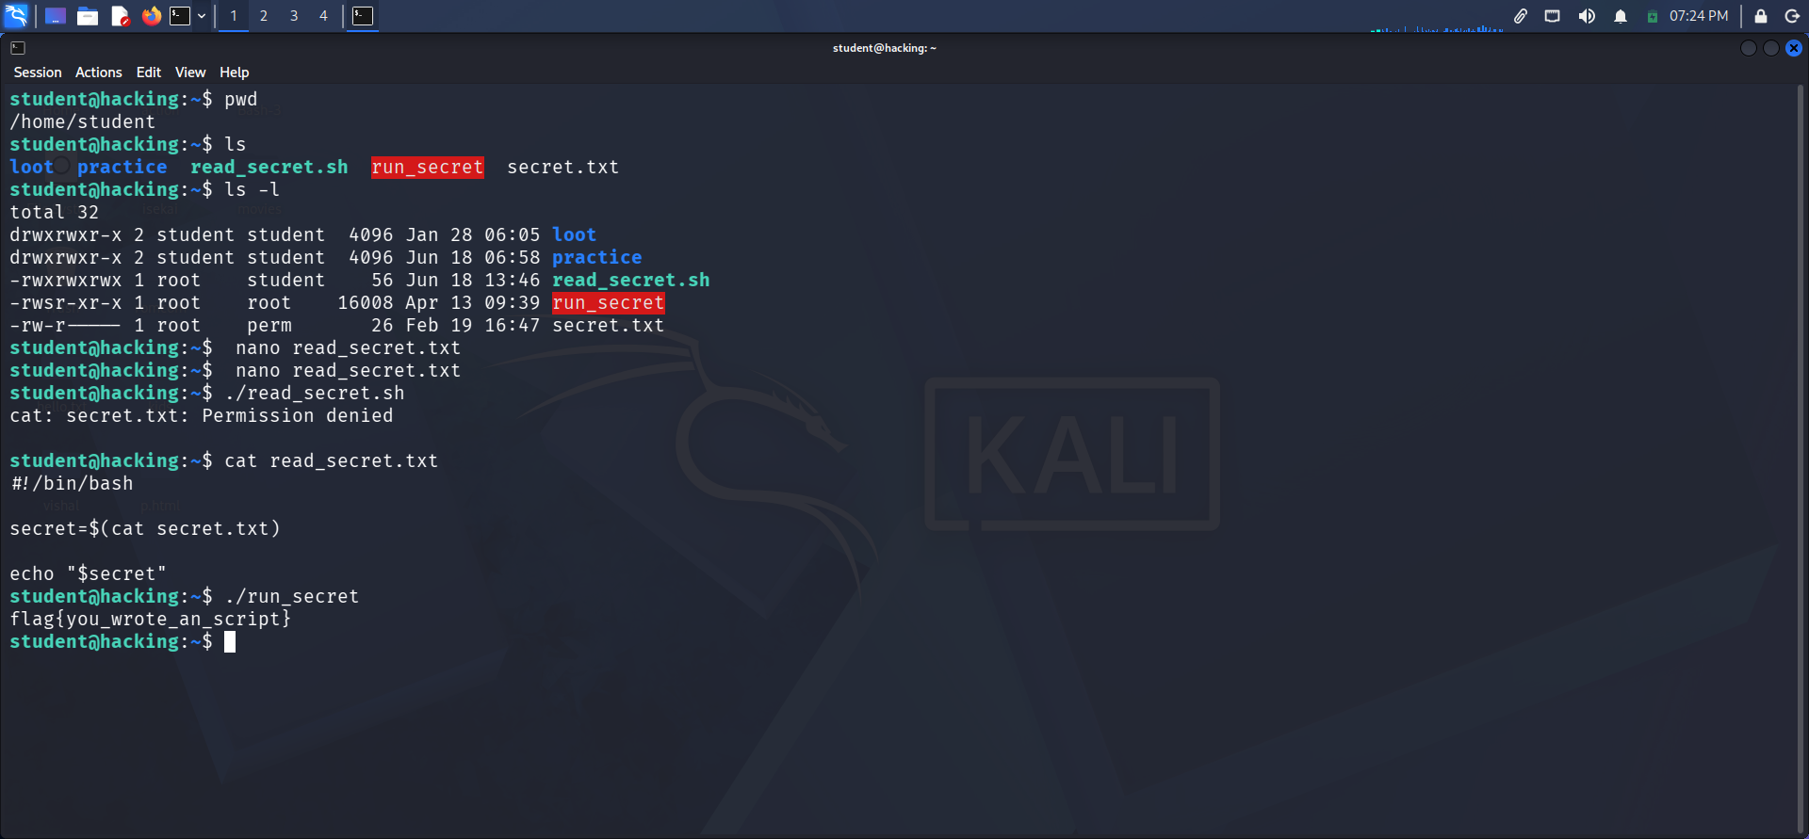
Screenshot-2:-

End.

