1. INTRODUCTION

As digital technology is reaching exponential heights, the distribution of digital media has become faster, easier, and requiring less effort to make exact copies. In recent times, Internet has emerged as the major platform for distribution of digital multimedia content. The inherent flexibility of Internet facilitates users to transact with one another to create, distribute, store, peruse, subscribe, enhance, modify and trade digital content in various forms like text documents, databases, ebooks, still images, audio, video, computer software and games. This gives rise to concerns about protection and enforcement of ‘Intellectual Property’ (IP) rights of the digital content involved in the transaction.

Digital Rights Management (DRM) systems address the issues related to ownership rights of digital content. DRM systems help in describing, identifying, trading, protecting, monitoring and tracking the IP rights of digital content to prevent unauthorized usage, replication and distribution of digital content. Various organizations like Moving Pictures Expert Group (MPEG), Internet Engineering Task Force (IETF) and World Wide Web Consortium (W3C) are working towards standardization of DRM systems. Though there has been considerable activity and interest in DRM, the issue of IP rights and content protection is fraught with legal complications and controversies. Different parties like content creators, music recording companies, movie production houses, book publishers, open-source software development community, consumer electronics industry, software companies, government organizations, legal fraternity and end-users have different views and opinions on protection and management of IP rights.

Digital watermarking is one of the key technologies that can be used for establishing ownership rights, tracking usage, ensuring authorized access, preventing illegal replication and facilitating content authentication, without restricting access to data. Even though encryption technologies are widely used to prevent unauthorized access of digital content, they do not prevent an authorized user from illegally replicating decrypted content.

SCOPE OF INVESTIGATIONS

Presently, we have understood the requirements of watermarking and have studied various existing methods for watermarking a still image. To gain insight into the transform domain watermarking, we studied various image transforms and implemented the same using the software MATLAB. Further, based on the method published in paper [1], we have watermarked a standard grayscale image with a binary image.

The scope of the topic involves studying the suitability of a particular method to different applications. In other words, the research of different algorithms used for a variety of applications e.g., copyright protection and concealed communication which may involve the use of either imperceptible watermarks or otherwise. In any method used, it must be ensured that the watermarked image is resistant to the various attacks to which it may be exposed to in the communication channel. Further, experimenting with a variety of image types for both the cover image and the watermark is possible and promises to be interesting.

METHODOLOGY

The report starts with an introduction to the topic. The current state of the project and the scope of the topic are stated briefly. Chapter2 gives an overview of what watermarking is, its feature, applications and the various attacks. Chapter3 outlines the various techniques of watermarking, furnishing in brief the various existing image transforms and their features.

Chapter4 contains the algorithms, which we have used to implement watermarking using a standard grayscale cover image and a binary watermark, based on [1]. Chapter5 discusses the results of our endeavors and the various observations made during implementation. Chapter6 winds up the report with conclusions and future scope. An appendix containing our program codes, a list of references, and the abstract follows this.

2. DIGITAL WATERMARKING

Watermarking is a variation of a technique known as ‘Steganography’, which is a technique for concealed communication. In contrast to Cryptography where the content of a communicated message is secret, in Steganography the very existence of the message that is communicated is a secret and only the parties involved in the communication know its presence. Here, a secret message is hidden within another unrelated message and then communicated to the other party. Some of the techniques of Steganography (like use of invisible ink, word spacing patterns in printed documents, coding messages in music compositions etc.) have been used by military intelligence since the times of ancient Greek civilization.

Watermarking can be considered as a special technique of Steganography where one message is embedded in another and the two messages are related to each other in some sense. The most common examples of watermarking are the presence of specific patterns in currency notes, which are visible only when the note is held against light, and logos in the background of printed text documents. The watermarking techniques prevent forgery and unauthorized replication of physical objects.

Digital watermarking is similar to watermarking physical objects, except that the watermarking technique is used for digital content instead of physical objects. In digital watermarking a low-energy signal is imperceptibly embedded in another signal. The low-energy signal is called ‘Watermark’ and it depicts some metadata, which can be the security or rights information about the main signal. The main signal in which the watermark is embedded is referred to as ‘Cover Signal’, since it covers the watermark. The cover signal is generally a still image, audio clip, video sequence or a text document in digital format.

2.1 BLOCK DIAGRAM
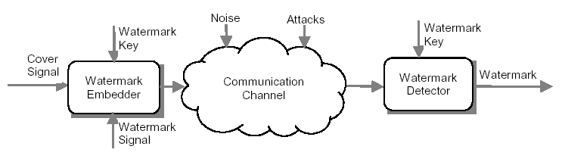

Figure 1: Basic block diagram of a digital watermarking System

The digital watermarking system essentially consists of a ‘Watermark Embedder’ and a ‘Watermark Detector’ (Figure 1). The watermark embedder inserts a watermark onto the cover signal and the watermark detector detects the presence of watermark signal. An entity called ‘Watermark Key’ is used during the process of embedding and detecting watermarks, which is of vital significance. A unique watermark key exists for every watermark signal, which is private and known to only authorized parties, and it ensures that only authorized parties can detect the watermark. Further, it should be noted that the communication channel can be noisy and hostile (i.e. prone to not only harsh climate, but also to intentional security attacks) and hence the digital watermarking techniques should be resilient to both noise and security attacks.
2.2 Features of Digital Watermarking

For inserting visible/invisible marks in images and video, and for adding information about audio at the beginning or end of the audio clip etc. the digital watermarking technique is appealing, since it provides following main features and does not require ‘out-of-band’ data as in other mechanisms.

- Imperceptibility: The embedded watermarks are imperceptible both perceptually as well as statistically and do not alter the aesthetics of the multimedia content that is watermarked. The watermarks do not create visible artefacts in still images, alter the bit rate of video or introduce audible frequencies in audio signals.

- Robustness: Depending on the application, the digital watermarking technique can support different levels of robustness against changes made to the watermarked content. The watermarks should not get degraded or destroyed as a result of unintentional or malicious signal and geometric distortions.

- Inseparability: After the digital content is embedded with watermark, separating the content from the watermark to retrieve the original content is not possible.

- Security: The digital watermarking techniques prevent unauthorized users from detecting and modifying the watermark embedded in the cover signal. Watermark keys ensure that only authorized users are able to detect/modify the watermark.

2.3 Classification of Digital Watermarking Techniques

Digital Watermarking techniques can be classified in a number of ways depending on different parameters. Various types of watermarking techniques are enlisted below. Each of the different types mentioned below have different applications:

- Robust And Fragile Watermarking: Robust watermarking is a technique in which modification to the watermarked content will not affect the watermark. As opposed to this, fragile watermarking is a technique in which watermark gets destroyed when watermarked content is modified or tampered with.

- Visible And Transparent Watermarking: Visible watermarks are ones which are embedded in visual content in such a way that they are visible when the content is viewed. Transparent watermarks are imperceptible and they cannot be detected by just viewing the digital content.

- Public And Private Watermarking: In public watermarking, users of the content are authorized to detect the watermark while in private watermarking the users are not authorized to detect the watermark.

- Asymmetric And Symmetric Watermarking: In asymmetric watermarking, different keys are used for embedding and detecting the watermark. In symmetric watermarking the same keys are used for embedding and detecting watermarks.

- Steganographic and Non-Steganographic Watermarking: Steganographic watermarking is the technique where content users are unaware of the presence of a watermark. In non-steganographic watermarking, the users are aware of the presence of a watermark.

2.4 Applications of Digital Watermarking

Digital watermarking techniques have wide ranging applications. Some of the applications are enlisted below:

- Copyright Protection: Digital watermarks can be used to identify and protect copyright ownership. Digital content can be watermarked to indicate that the content cannot be illegally replicated. Devices capable of replication can then detect such watermarks and prevent unauthorized replication of the content.

- Tracking: Digital watermarks can be used to track the usage of digital content. Each copy of digital content can be uniquely watermarked with metadata specifying the authorized users of the content. Such watermarks can be used to detect illegal replication of content by identifying the users who replicated the content illegally. The watermarking technique used for tracking is called as ‘Fingerprinting’.

- Tamper Proofing: Digital watermarks, which are fragile in nature, can be used for tamper proofing. Digital content can be embedded with fragile watermarks that get destroyed whenever any sort of modification is made to the content. Such watermarks can be used to authenticate the content.

- Broadcast Monitoring: Digital watermarks can be used to monitor broadcasted content like television and broadcast radio signals. Advertising companies can use systems that can detect the broadcast of advertisements for billing purposes by identifying the watermarks broadcast along with the content.

- Concealed Communication: Since watermarking is a special technique of Steganography, it can be used for concealed communication also.

2.5 COMMON ATTACKS

In most watermarking applications, the marked image is likely to be processed in some way before it reaches the watermark receiver. The process could be lossy compression, signal enhancement or digital to analog and analog to digital conversion. An embedded watermark may unintentionally or inadvertently be impaired by such processing. A few of the attacks are:

2.5.1 Removal attacks

Removal attacks aim at the complete removal of the watermark information from the watermarked data without the key used for watermark embedding, i.e., no processing can recover the watermark information from the attacked data

2.5.2 Geometric attacks

Geometric attacks do not actually remove the embedded watermark itself, but intend to distort the watermark detector synchronization with the embedded information. Some of the geometric attacks are Cropping, Rotation and Image Resizing

2.5.3 Cryptographic attacks

Cryptographic attacks aim at cracking the security methods in watermarking schemes and thus finding a way to remove the embedded watermark information or to embed misleading watermarks.

3. TECHNIQUES OF DIGITAL WATERMARKING

3.1 SPATIAL DOMAIN

Current Watermarking approaches in the literature can be grouped into two main classes. These are First Generation Watermarking and Second Generation Watermarking. Both approaches can be achieved via spatial or transformed techniques such as DCT and DWT. First Generation-Watermarking (1GW) methods have been mainly focused on applying the Watermarking on the entire image domain. However, this approach is not compatible with novel approaches for still images. JPEG 2000 standards are the new techniques for image compression. In contrast, Second Generation Watermarking (2GW) was developed in order to increase the robustness and invisibility and to overcome the 1GW weakness. The 2GW takes into account region, boundary and object characteristics. 2GW methods give additional advantages in terms of detection and recovery from geometric attacks (such as compression, filtering, rescaling, cropping, A/D and D/A conversion, geometric distortions, and additive noise).

There are several spatial-domain watermarking techniques for images. One technique consists of embedding a texture-based watermark into a portion of the image with similar texture. The idea here is that due to the similarity in texture, it will be difficult to perceive the watermark. The watermark is detected using a correlation detector. Another technique described as the ‘patchwork method’ divides the image into two subsets A and B where the brightness of one subset is incremented by a small amount and the brightness of the other set is decremented by the same amount. The incremental brightness level is chosen so that the change in intensity remains imperceptible. The location of the subsets is secret and assuming certain properties for image data, the watermark is easily located by averaging the difference between the values in the two subsets. In another spatial-domain technique for color images, the blue component of the image in RGB format is watermarked to ensure robustness while remaining fairly insensitive to human visual system (HVS) factors.
3.2 TRANSFORM DOMAIN

Transform domain techniques are used to create robust watermarks. In spatial domain robust watermarking can be achieved at the cost of explicitly modeling the local image characteristics. These characteristics can be more easily obtained in a transform domain.

The various transform domains that can be used are as follows:

3.2.1 DISCRETE FOURIER TRANSFORM (DFT)

The DFT is usually defined for a discrete function 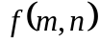 that is nonzero only over the finite region 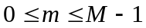 and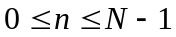. The two-dimensional M-by-N DFT and inverse M-by-N DFT relationships are given by

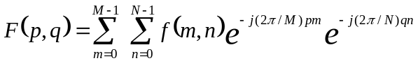 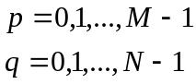 …(1)

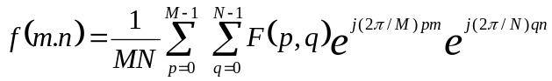 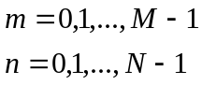 …(2)

The values 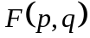are the DFT coefficients of. In particular, the value 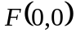is often called the DC coefficient. ^{[8]}

The magnitude of a given image's discrete Fourier transform determines the intensities of the sinusoids that combine to form the resulting image. Clearly, at any given frequency in the DFT of the image, a large magnitude implies a greater prevalence of a sinusoid at that frequency in the image while a small magnitude implies less of a sinusoid at that frequency is present in the image.

3.2.2 FAST FOURIER TRANSFORM (FFT)

The fast Fourier Transform (FFT) is an efficient algorithm for computing the DFT of a sequence. It is not a separate transform. It is particularly useful in areas such as signal and image processing, where its uses range from filtering, convolution, and frequency analysis to power spectrum estimation.

FFT transform is present in watermarking systems in one way or the other. Due to its invariance it is often used to implement fast cross-correlators. The watermark is added to the image as a band limited signal in a circular pattern around the center (DC) frequency. This makes this approach rotationally resilient.

3.2.3 DISCRETE COSINE TRANSFORM (DCT)

The DCT has the property that, for a typical image, most of the visually significant information about the image is concentrated in just a few coefficients of the DCT. For this reason, the DCT is often used in image compression applications. For example, the DCT is at the heart of the international standard lossy image compression algorithm known as JPEG. (Joint Photographic Experts Group.)

The two-dimensional DCT of an M-by-N matrix A is defined as follows :

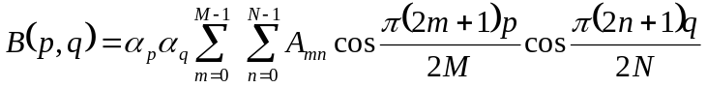 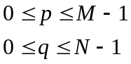 …(3)

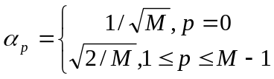 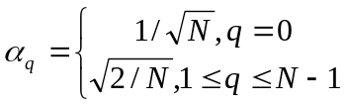 …(4)

The values 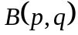are called the DCT coefficients of A.

The DCT is an invertible transform, and its inverse is given by

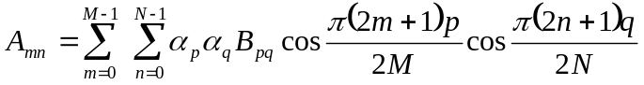 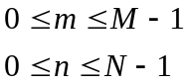 …(5)

where 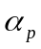 and 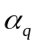remain the same.

The inverse DCT equation can be interpreted as meaning that any M-by-N matrix A can be written as a sum of  functions of the form

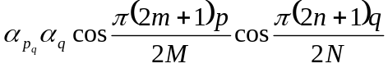 …(6)

These functions are called the basis functions of the DCT. The DCT coefficients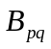, then, can be regarded as the weights applied to each basis function. Horizontal frequencies increase from left to right, and vertical frequencies increase from top to bottom. The constant-valued basis function at the upper left is often called the DC basis function, and the corresponding DCT coefficient 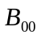 is often called the DC coefficient.

2.4.4 HAAR TRANSFORM

The Haar transform is a wavelet transform whoich uses a scale function φ(t) and a wavelet ψ(t) as shown to represent a large number of functions f(t).
1
φ(t)
1
1
1
ψ(t)
ψ(4t-k)

Figure 2: The Haar Basis Scale and Wavelet Functions

The representation is the infinite sum
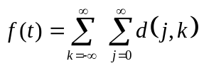ψ(2^{j}t-k) +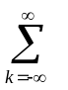c_{k}φ(t-k) …(7)

where c_{k} and d_{j,k} are coefficients to be calculated.

The basic scale function φ(t) is the unit pulse
φ(t)= 1, 0<=t<1,
= 0, otherwise …(8)

The basic Haar wavelet is a step function is

ψ(t) = 1, 0<=t<0.5,
= -1, 0.5<t<1 …(9)

2.4.5 DISCRETE WAVELET TRANSFORM (DWT)

The continuous wavelet transform is defined as follows

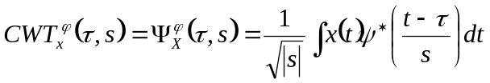 …(10)
As seen in the above equation, the transformed signal is a function of two variables, and s, the translation and scale parameters, respectively. 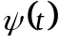 is the transforming function, and it is called the mother wavelet . The term mother wavelet gets its name due to two important properties of the wavelet analysis as explained below.
The mother wavelet can be any real or complex continuous function that satisfies the following properties
- The total area under the curve of the function is zero i.e.,
∫ ψ(t) dt = 0 …(11)
2. The total area of ⎜ψ(t) ⎜² is finite i.e.;
∫ ⎜ψ(t) ⎜² dt < ∞ …(12)
3. The admissibility condition
The term wavelet means a small wave. The smallness refers to the condition that this window function is of finite length. The wave refers to the condition that this function is oscillatory. The term mother implies that the functions with different region of support that are used in the transformation process are derived from one main function, or the mother wavelet. In other words, the mother wavelet is a prototype for generating the other window functions. The parameter scale in the wavelet analysis is similar to the scale used in maps. As in the case of maps, high scales correspond to a non-detailed global view, and low scales correspond to a detailed view. Similarly, in terms of frequency, low frequencies (high scales) correspond to global information of a signal (that usually spans the entire signal), whereas high frequencies (low scales) correspond to detailed information of a hidden pattern in the signal (that usually lasts a relatively short time).
The continuous wavelet transform is computed by changing the scale of the analysis window, shifting the window in time, multiplying by the signal, and integrating over all times. In the discrete case, filters of different cutoff frequencies are used to analyze the signal at different scales. The signal is passed through a series of high pass filters to analyze the high frequencies, and it is passed trough a series of low pass filters to analyze the low frequencies. The resolution of the signal, which is a measure of the amount of detail information in the signal, is changed by the filtering operations, and the scale is changed by upsampling and downsampling (subsampling) operations.
Various wavelet functions can be used to find this DWT. The different wavelet families make different trade-offs between how compactly the basis functions are localized in space and how smooth they are. The Daubechies wavelet family:
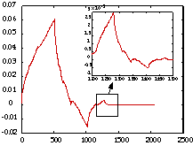
Figure 3: Daubechies mother wavelet
Other several different wavelet families are:
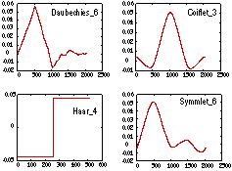

Figure 4: Several wavelet families

The Inverse CWT is given as:
Since wavelets are used to transform a function, the inverse is needed.
We denote ψ(ω) the Fourier transform of ψ(t).

ψ(ω) =∫ ψ(t) e ^{-iωt} dt …(13)

If W(a,b) is the CWT of a function f(t) with a wavelet ψ(t),then the inverse CWT is defined by,

f(t)= 1/C [∫ ∫ [(1/ ⎢a ⎢² W(a,b) ]1/√ ⎢a ⎢)ψ*((t-b)/a)] da db …(14)

where C =∫ ⎜ψ(t) ⎜²/ ⎜ω⎜ dω …(15)

The inverse CWT exists if C is positive and finite. Since C is defined by means ψ which itself is defined by means of the wavelet ψ(t), the requirement that C be positive and finite imposes another restriction, called the admissibility condition on choice of the wavelet.

4. IMPLEMENTATION

4.1 ALGORITHM 1 FOR WATERMARKING USING DCT

The objective of this algorithm is to watermark a grayscale image with a binary watermark and to extract the watermark from the watermarked image. The cover image used is the standard grayscale Lena image of size 512x512 pixels. The watermark is a binary image of size 16x16. the MATLAB program for the same is given in the appendix.

4.1.1 EMBEDDING ALGORITHM

- The first step in the watermarking process is to take the DCT (Direct Cosine Transform) of the cover image. The DCT processing is done block wise, i.e. 8x8 blocks of the image are processed at a time. The image was then broken into 16 blocks of size 128x128.
- Next the watermark image was converted from binary (1 and 0) to polar form (1 and -1) and expanded to a 128x128 matrix.
- The next step is to select a few coefficients from each of the 8x8 blocks for modification. This number is given by the formula
Number of coefficients=( 64* M1*M2)/(N1*N2)
=1
- Once selected, these coefficients are then scaled by a factor α (alpha) depending on the polarity of the watermark.

Coverimage (i,j)= Coverimage(i,j)+Watermark(i,j) * α ; Watermark(i,j)=1
= Coverimage (i,j)-Watermark (i,j) * α ; Watermark(i,j)=0

- The modified coefficients are re-incorporated into the DCT matrix and the IDCT (Inverse Discrete Cosine Transform) of the matrix is taken to get the watermarked image.
4.1.2 EXTRACTION ALGORITHM

- In order to extract the watermark, the user needs to have both the original as well as the watermarked image in his/her possession. We take the DCT of both the images and calculate the difference between them

DifferenceImage = DCT (WatermarkedImage) –DCT (OriginalImage)

- By subtracting the DCT of the original image from the DCT of the watermarked image we get the polar (positive or negative) values of α (alpha). We then split this difference matrix into blocks of 128x128 as each of these blocks contain one copy of the watermark.

- The next step is to extract the binary information from the reduced portion (size 128x128) . If α (alpha) is positive we assign 1 as the binary equivalent and if it is negative we assign 0 as its binary equivalent.

- Once the binary pattern is obtained (size128x128) it is mapped down to size 16x16 pixels to get the original watermark

4.2 ALGORITHM 2 FOR WATERMARKING USING DCT

The cover image is standard grayscale image ‘Lena.gif’ of size 512x512 pixels and
watermark is binary image ‘Watermark.gif’ of size 128x128. the MATLAB code is given in the appendix.

4.2.1 EMBEDDING METHODS

Let ‘X’ be the original gray-level image of size N1 by N2, and the digital watermark W be a binary image of size M1 by M2. In the watermark, the marked pixels are valued as one’s, and the others are zeros. Since only the middle-frequency range of the host image will be processed during the watermark embedding, the resolution of a watermark image W is assumed to be smaller than that of the original image X. For example, for each 8 by 8 image block, only (64*(M1*M2)/(N1*N2)) coefficients will be used for the watermark embedding. The ratio of M1 by M2 and N1 by N2 determines the amount of information to be embedded into the image.

The original image X and digital watermark W are represented as

X={x (i, j), 0<=i<N1, 0<=j<N2} …(16)

where, x( i, j)∈{0,…,2^{L}-1} is the intensity of pixel x( i, j) and L is the number of bits used in each pixel.

W={w (i, j), 0<=i<M1, 0<=j<M2} …(17)

where w(i, j)∈{0, 1}

In X, there are (N1*N2)/64 image blocks with size 8 by 8. To obtain the same number (N1*N2)/64 of blocks as the image X, the watermark W is decomposed into several blocks with size (M1*M2)*64/(N1*N2). For example, if M1=N1/2 and M2=N2/2 , the block size of the watermark block is 4 by 4, and if M1=N1/4and M2=N2/4 , the block size of the watermark block is 2 by 2. The extra columns and rows might be added to complete each image and watermark blocks.

Pseudorandom Permutation of the Watermark

In the approach, each watermark block is embedded into the middle-frequency range of each image block using block transform instead of full-frame transform. Therefore, each watermark block will only be dispersed over its corresponding image block, instead of the entire spatial image. Obviously, without appropriate adjustment for the spatial relationship of the watermark, a common picture-cropping operation may eliminate the watermark. To survive picture cropping, a fast two-dimensional (2-D) pseudorandom number traversing method is used to permute the watermark to disperse its spatial relationship. Here, the permutation is implemented as follows. First, number each pixel from 0 to M1 by M2. Second, generate each number in random order. Finally, generate the coordinate pairs by mapping the random sequence number into a 2-D sequence. For example, for a digital watermark of size 128 by 128, use a “linear feedback shift register” to generate a random sequence from 1 to 16383. Then, for each sequence element number M, compute (M div 128) and (M mod 128) as the permuted vertical and horizontal coordinates.

W_{p}=Permute (W) …(18)
Block Transformation of the Image
Since the discrete cosine transform (DCT) used by JPEG is performed on blocks of 8 by 8, the input image X is divided into blocks of 8 by 8, and each block is DCT transformed independently. That is,

Y=FDCT(X) …(19)

Where FDCT denotes the operation of forward DCT.

Choice of Middle-Frequency Coefficients
The human eye is more sensitive to noise in lower frequency components than in higher frequency ones. However, the energy of most natural images is concentrated in the lower frequency range, and the information hidden in the higher frequency components might be discarded after quantization operation of lossy compression. In order to invisibly embed the watermark that can survive lossy data compressions, a reasonable trade-off is to embed the watermark into the middle-frequency range of the image. To this end, for each 8 by 8 image block, only (64*(M1*M2)/(N1*N2)) coefficients are selected out of the 64 DCT coefficients. Those selected coefficients are then mapped into a reduced image block of size M1*M2*64/(N1*N2). That is, the middle-frequency coefficients selected from the image of size N1*N2 are collected to compose a reduced image of size M1*M2, which has the same resolution with the binary watermark.

Y_{r} = Reduce (Y) …(20)

For example, if M1=N1/2 and M2=N2/2, only 16 DCT coefficients are processed during the watermark embedding, and the other 48 DCT coefficients are left unchanged. Figure1 exemplifies the definition of the middle-frequency coefficients, which are mapped into a reduced block of size 4 by 4.
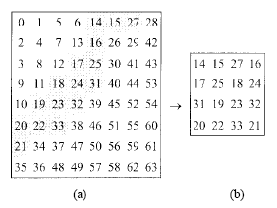

Figure 5: Defining Middle Frequency Coefficients

Modification of the DCT Coefficients
A permuted digital watermark and a reduced image (which contains only the middle-frequency components of the original image) both with M1*M2 size are obtained. For each watermark block of size (M1*8/N1)*(M2*8/N2), the reduced image block of size (M1*8/N1)*(M2*8/N2) at the corresponding spatial position will be modified adequately to embed the watermarked pixels. Each watermarked pixel is embedded by modifying the polarity between the corresponding pixels in neighbouring blocks.

P=Polarity (Y_{r} ) …(21)

After the binary polarity pattern is obtained, for each marked pixel of the permuted watermark, modify the DCT coefficients to reverse the corresponding polarity.

P^ =XOR (P,Wp) …(22)

Then, construct Y_{r}^ from P^ such that the differences between Y_{r}^ and Y_{r} are minimized or smaller than a user specified threshold.

Y_{r}^=Expand (P^) …(23)

Inverse Block Transform
Finally, map the modified middle-frequency coefficients Y_{r}^ into Y to get Y^. Then, inverse DCT (IDCT) of the associated result to obtained the embedded image.

X^=IDCT (Y^) …(24)

4.2.2 WATERMARK EXTRACTING METHOD

The extraction of watermark requires the original image, the watermarked image, and either the watermark or the permutation mapping used in image-dependent permutation during the embedding steps. The extraction steps are described as follows:

Block Transformation

Both the original image and the image in question are DCT transformed.

Y=FDCT (X) …(25)

Y~=FDCT (X~) …(26)

Generation of Polarity Patterns

Generate the reduced images which contain only the middle frequency coefficients and then use these middle-frequency DCT coefficients to produce the polarity patterns. That is,
Yr = Reduce (Y) …(27)

Yr~ = Reduce (Y~) …(28)

P=Polarity (Yr) …(29)

P~ = Polarity (Yr~) …(30)

Extract the Permuted Data

Perform exclusive-or (XOR) operation on these two polarity patterns to obtain a permuted binary data, i.e.,

Wp~ =XOR (P, P~) -(31)

Reverse Pseudorandom Permutation

Reverse-permute W_{p}~ to get the watermark W~.

5. RESULTS AND DISCUSSIONS

The two algorithms were implemented and the following observations and results were obtained after analyzing the methods.

5.1 METHOD 1
A watermark was embedded into the host image of ‘Lena’. The reduction of the picture quality was studied as a function of the scaling factor.

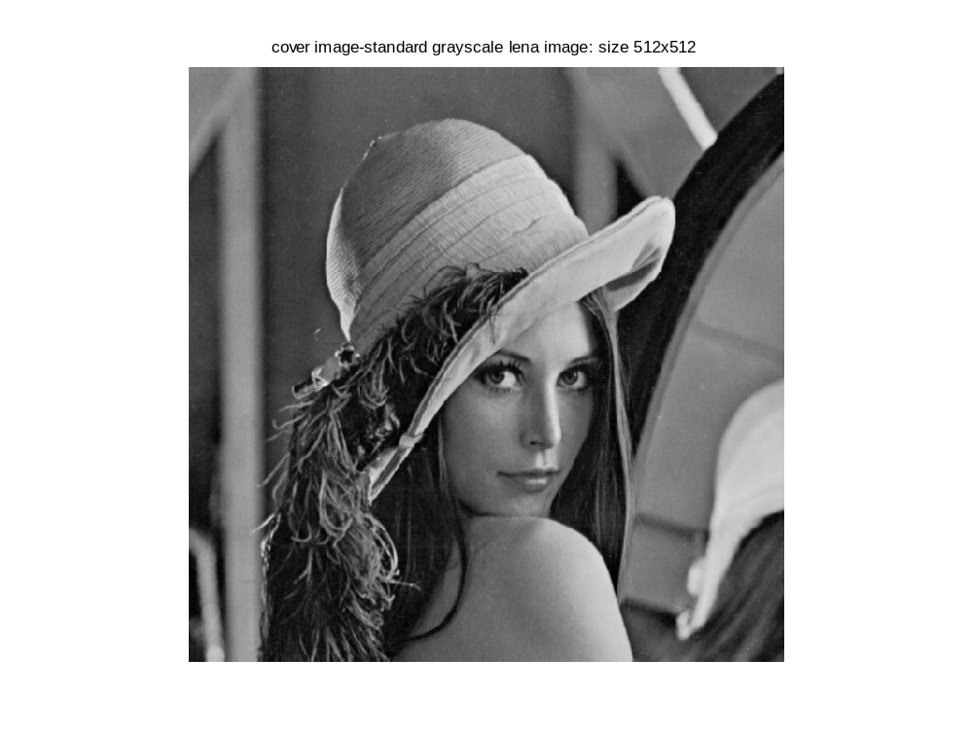
Figure 6: Original Cover Image: Size 512x512

Figure 7: Binary Watermark Image: Size 16x16

The watermarked image for an alpha value=0.1 is shown in figure 5. For such a low value of alpha, there is no perceptible difference between original and watermarked image.

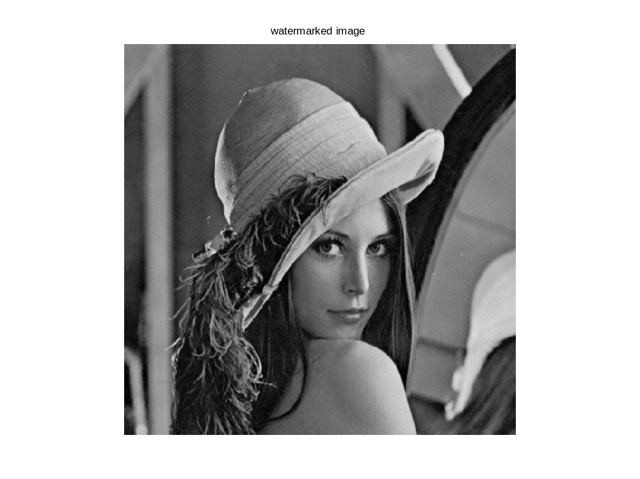

Figure 8: Watermarked Image for α=0.1

The reverse process of embedding was followed for extraction. The extracted watermark is given below:

Figure 9: Extracted Binary Watermark

The extracted watermark is same as the original watermark as the process is a lossless one.
We implemented the watermarking for a range of values of the scaling factor, α, i.e., 0.1 to 1.We have used two parameters compare the watermarked images obtained by varying α value:
  - Mean square error (MSE)

MSE =(1/n) 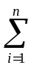(P_{i}-Q_{i})² …(32)

P_{i} = pixels of original image
Q_{i} = pixels of watermarked image
n = total no of pixels, in this case, 512x512

  - Peak signal to noise ratio (PSNR)

PSNR = 10log₁₀ (max_{i}(Pi)²/MSE) …(33)

It is observed that as α increases, the watermark becomes increasingly perceptible, MSE increases, and PSNR decreases. E.g.
For α =0.1, mse=1.56x10⁻⁴, psnr = 86.19 dB
For α =1, mse=1.5625, psnr = 46.19 dB.

We plotted the graph of increasing values of the scale factor alpha against the mean square errors calculated at each value.

The graph of α vs. mean square error is
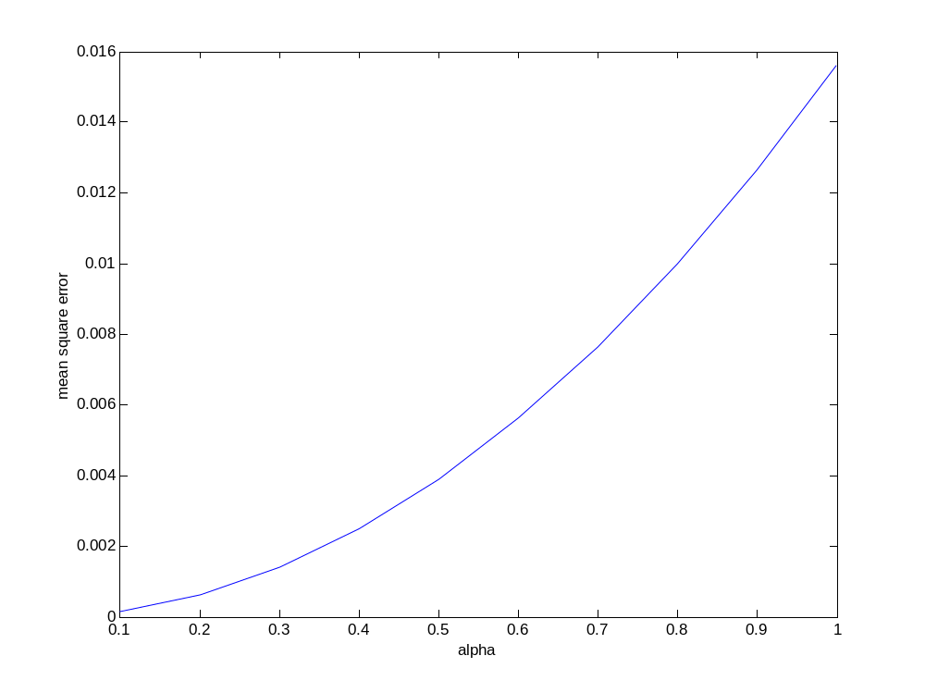
Figure 10: Alpha vs. Mean Square Error

The graph has a sharper rise after α>0.2 and a relatively smooth variation for the range α=0.1 to α=0.2. After that visible artefacts appear in the watermarked image.

For α.1, the image is very distorted as watermark dominates the watermarked image.

6. CONCLUSIONS AND FUTURE PLAN

In the course of the semester, we first started with a literature survey in which we studied the need for digital watermarking, its classification, features, and applications. The various attacks that an image can be subjected to were also seen.

The various methods of watermarking were next studied, mainly the transform domain techniques. We learnt various image transforms and also to implement them using MATLAB functions. Finally watermarking using two DCT based methods was implemented.

The watermarked image has to be tested for its resistance against various attacks like rotation, cropping and JPEG lossy compression.

Further, we plan to implement watermarking on color images, and experiment with various image types of both cover and watermark image, and strive to come up with innovative ideas for the same.

REFERENCES

[1] | Hidden Digital Watermarks In Images  Chiou-Ting Hsu; Ja-Ling Wu;  Image Processing, IEEE Transactions on , Volume: 8 Issue: 1 , Jan. 1999
[2] | Digital Watermarking: A Technology Overview  WHITE PAPER, WIPRO
[3] | Hiding Digital Watermarks Using Multiresolution Wavelet Transform  Ming-Shing Hsieh, Din-Chang Tseng, Member, IEEE, and Yong-Huai Huang. IEEE Transactions on Industrial Electronics, Vol. 48, No. 5, October 2001
[4] Data Compression: The Complete Reference, Third Edition, David Salomon

[5] | Attacks on Digital Watermarks: Classification, estimation based attacks, and benchmarks  Sviatolsav Voloshynovskiy, Shelby Pereira and Thierry Pun,  University of Geneva, IEEE Communications Magazine. August 2001

