Experiment : 01

Aim :

Program to Sort strings

CO 2:

Implement arrays and strings

Procedure

import java.util.Scanner;

public class CO_2sortstrings {

public static void main(String[] args) {

Scanner sc = new Scanner(System.in);

System.out.print("Enter the size of the Array :");

int l = sc.nextInt();

String str[] = new String[l];

int i;

System.out.println("Enter the String Elements");

for (i = 0; i < str.length; i++) {

str[i] = sc.next();

}

String temp;

int j;

for (i = 0; i < str.length; i++) {

for (j = i + 1; j < str.length; j++) {

if (str[i].compareTo(str[j]) > 0) {

temp = str[i];

str[i] = str[j];

str[j] = temp;

}

}

}

System.out.println("The Sorted String order : ");

for (i = 0; i < str.length; i++) {

System.out.println(str[i]);

}

}

}

Output

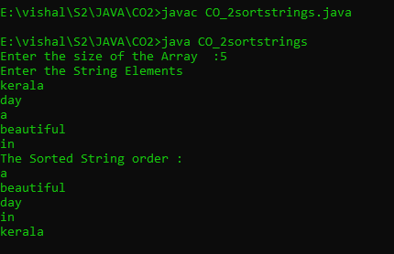

Experiment : 02

Aim :

Search an element in an array.

CO 2:

Implement arrays and strings

Procedure

import java.util.Scanner;

public class Search_Array

{

public static void main(String[] args)

{

Scanner sc=new Scanner(System.in);

System.out.println("Enter the limit");

Integer size=sc.nextInt();

int arr[]=new int[size];

int i,flag=0;

System.out.println("Enter the elements");

for(i=0;i<arr.length;i++)

{

arr[i]=sc.nextInt();

}

System.out.println("Enter item to be searched");

Integer item=sc.nextInt();

for(i=0;i<arr.length;i++)

{

if(item==arr[i])

{

System.out.println("element found at loc "+i);

flag=1;

}

}

if(flag==0)

{

System.out.println("element not found");

}

}

}

Output

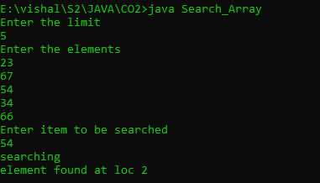

Experiment : 03

Aim :

Perform string manipulations

CO 2:

Implement arrays and strings

Procedure

import java.util.*;

public class string_manip{

public static void main(String[] args){

Scanner obj=new Scanner(System.in);

System.out.println("enter first string :");

String first=obj.nextLine();

System.out.println("enter second string :");

String second=obj.nextLine();

System.out.println(first.concat(second));

if(first == second)

{

System.out.println("two strings are same");

}

else

{

System.out.println("strings are not same");

}

System.out.println("the length of the first string is :"+first.length());

System.out.println("the length of the first string is :"+second.length());

System.out.println(first.equals(second));

int len1=first.length();

int len2=second.length();

if(len1==len2)

{

System.out.println("the length is same");

}

else

{

System.out.println("lengths are not same");

}

System.out.println(first.toUpperCase());

System.out.println(second.toUpperCase());

System.out.println(first.toLowerCase());

System.out.println(second.toLowerCase());

System.out.println("enter string to locate :");

String loc=obj.nextLine();

System.out.println(first.indexOf(loc));

System.out.println(first.substring(1,5));

}

}

Output

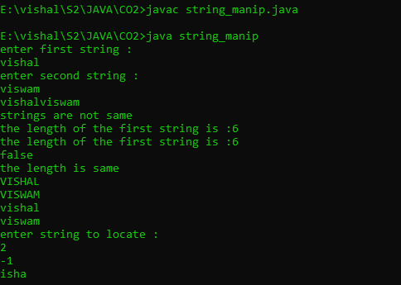

Experiment : 04

Aim :

Program to create a class for Employee having attributes eNo, eName eSalary. Read n employ information and Search for an employee given eNo, using the concept of Array of Objects.

CO 2:

Implement arrays and strings

Procedure

import java.util.*;

public class employee_search{

int eno;

String ename;

int salary;

public void get()

{

Scanner obj=new Scanner(System.in);

System.out.println("enter employee number :");

eno =obj.nextInt();

System.out.println("enter employee name :");

ename =obj.next();

System.out.println("enter employee salary :");

salary =obj.nextInt();

}

public void display()

{

System.out.println("employee number :"+eno);

System.out.println("employee name :"+ename);

System.out.println("employee salary :"+salary);

}

public static void main(String[] args)

{

int flag=0;

Scanner obj=new Scanner(System.in);

System.out.println("enter the size :");

int n=obj.nextInt();

employee_search e1[]= new employee_search[n];

for(int i=0;i<n;i++)

{

e1[i]=new employee_search();

e1[i].get();

}

for(int i=0;i<2;i++)

{

e1[i].display();

}

System.out.println("enter employee number to search for the employee details :");

int item=obj.nextInt();

for(int i=0;i<n;i++)

{

if(e1[i].eno ==item)

{

e1[i].display();

flag++;

break;

}

}

if(flag==0)

{

System.out.println("not found");

}

}

}

Output

