Experiment : 01

Aim :

Program to draw Circle, Rectangle, Line in Applet.

CO 5:

Develop applications to handle events using applets

Procedure

import java.applet.*;

import java.awt.*;

public class CO5_Q1 extends Applet

{

public void paint(Graphics g){

g.drawLine(20,20,200,20);

g.drawRect(20,60,200,40);

g.drawOval(20,120,200,160);

}

}

HTML

<HTML>

<HEAD>

</HEAD>

<BODY>

<div align="center">

<APPLET CODE="CO5_Q1.class" WIDTH="800" HEIGHT="500"></APPLET>

</div>

</BODY>

</HTML>

OUTPUT

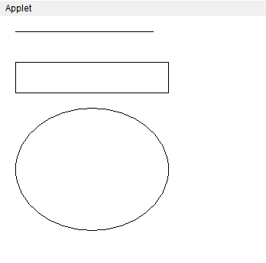

Experiment : 02

Aim :

Program to find maximum of three numbers using AWT

CO 5:

Develop applications to handle events using applets

Procedure

import java.awt.*;

import java.applet.*;

public class CO5Q2 extends Applet

{

TextField T1,T2,T3;

public void init(){

T1 = new TextField(10);

T2 = new TextField(10);

T3 = new TextField(10);

add(T1);

add(T2);

add(T3);

T1.setText("0");

T2.setText("0");

T3.setText("0");

}

public void paint(Graphics g){

int a, b, c,result;

String str;

g.drawString("Enter value to Check the Maximum of 3 ",10,50);

str=T1.getText();

a=Integer.parseInt(str);

str=T2.getText();

b=Integer.parseInt(str);

str=T3.getText();

c=Integer.parseInt(str);

g.setColor(Color.blue);

if (a>b) {

if (a>c)

result=a;

else

result=c;

}

else{

if (b>c)

result=b;

else

result=c;

}

g.drawString("Maximum of 3 No is "+result,10,70);

showStatus("MAXIMUM OF 3 NUMBERS");

}

public boolean action(Event e, Object o){

repaint();

return true;

}

}

HTML

<HTML>

<HEAD>

</HEAD>

<BODY>

<div align="center">

<APPLET CODE="CO5Q2.class" WIDTH="800" HEIGHT="500"></APPLET>

</div>

</BODY>

</HTML>

Output

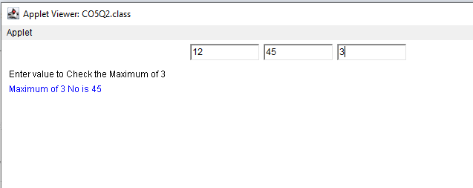

Experiment : 03

Aim :

Find the percentage of marks obtained by a student in 5 subjects. Display a happy face if he secures above 50% or a sad face if otherwise.

CO 5:

Develop applications to handle events using applets

Procedure

import java.applet.*;

import java.awt.*;

import java.awt.event.*;

public class CO5_Q3 extends Applet implements ActionListener {

TextField tb1,tb2,tb3,tb4,tb5,tb6;

Button newbutton;

public void init(){

Color color1 = new Color (244, 224, 172);

setBackground (color1);

tb1 = new TextField(10);

tb2 = new TextField(10);

tb3 = new TextField(10);

tb4 = new TextField(10);

tb5 = new TextField(10);

tb6 = new TextField(15);

newbutton = new Button(" final score ");

newbutton.setBounds(50,250,90,30);

add(tb1);

add(tb2);

add(tb3);

add(tb4);

add(tb5);

add(tb6);

add(newbutton);

newbutton.addActionListener(this);

}

public void actionPerformed(ActionEvent e){

int mark1, mark2,mark3, mark4,mark5,percent;

mark1= Integer.parseInt(tb1.getText());

mark2= Integer.parseInt(tb2.getText());

mark3= Integer.parseInt(tb3.getText());

mark4= Integer.parseInt(tb4.getText());

mark5= Integer.parseInt(tb5.getText());

percent=((mark1+mark2+mark3+mark4+mark5)*100)/500;

tb6.setText(String.valueOf(percent));

repaint();

}

public void paint(Graphics g){

int demopercent;

demopercent = Integer.parseInt(tb6.getText());

if(demopercent > 50.0) {

g.drawOval(10,40,200,200);

g.drawOval(50,100,40,20);

g.drawOval(130,100,40,20);

g.drawArc(95,150,50,20,200,150);

}

else {

g.drawOval(10,40,200,200);

g.drawOval(50,100,40,20);

g.drawOval(130,100,40,20);

g.drawArc(95,150,50,20,15,150);

}

}

}

HTML

<HTML>

<BODY>

<APPLET CODE="CO5_Q3.class" width="700" height="700"> </APPLET>

</BODY>

</HTML>

OUTPUT

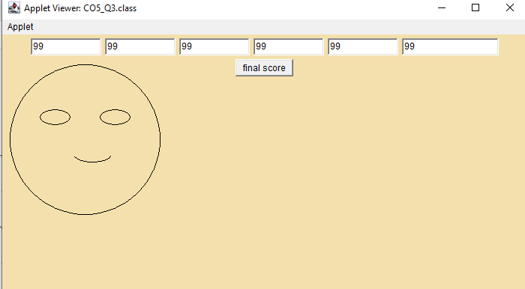

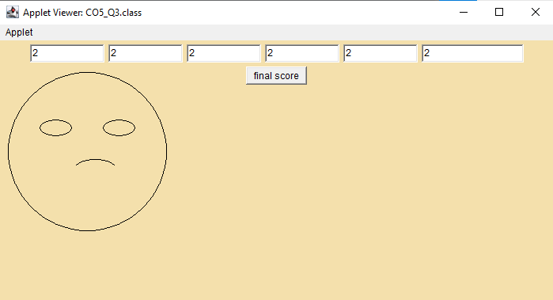

Experiment : 04

Aim :

Using 2D graphics commands in an Applet, construct a house. On mouse click event, change the color of the door from blue to red.

CO 5:

Develop applications to handle events using applets

Procedure

import java.awt.*;

import java.awt.event.*;

public class CO5_Q4 extends Frame {

public Color doorColor;

public CO5_Q4() {

doorColor = Color.BLUE;

setTitle("Vishal Constructions");

setSize(400, 400);

addWindowListener(new WindowAdapter() {

public void windowClosing(WindowEvent we) {

System.exit(0);

}

});

addMouseListener(new MouseAdapter() {

public void mouseClicked(MouseEvent me) {

if (me.getButton() == MouseEvent.BUTTON1) {

if (doorColor == Color.BLUE) {

doorColor = Color.RED;

} else {

doorColor = Color.BLUE;

}

repaint();

}

}

});

}

public void paint(Graphics g) {

g.setColor(Color.YELLOW);

g.fillRect(100, 100, 200, 200);

int[] xPoints = {100, 200, 300};

int[] yPoints = {100, 50, 100};

g.setColor(Color.GREEN);

g.fillPolygon(xPoints, yPoints, 3);

g.setColor(doorColor);

g.fillRect(160, 175, 80, 120);

}

public static void main(String[] args) {

CO5_Q4 house = new CO5_Q4();

house.setVisible(true);

}

}

OUTPUT

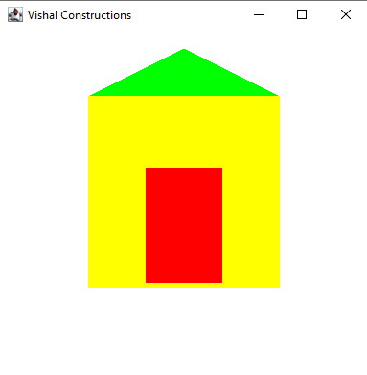

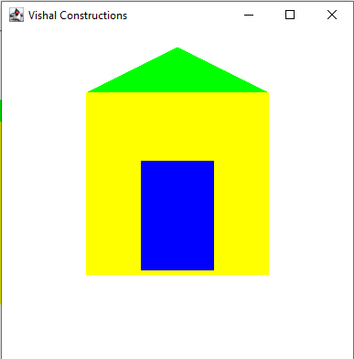

import java.applet.Applet;

import java.awt.Color;

import java.awt.Graphics;

import java.awt.event.MouseAdapter;

import java.awt.event.MouseEvent;

public class CO5_4 extends Applet {

private Color doorColor;

public void init() {

doorColor = Color.BLUE;

addMouseListener(new MouseAdapter() {

public void mouseClicked(MouseEvent e) {

if (doorColor == Color.BLUE) {

doorColor = Color.RED;

} else {

doorColor = Color.BLUE;

}

repaint();

}

});

}

public void paint(Graphics g) {

g.setColor(Color.GRAY);

g.fillRect(100, 100, 200, 200);

g.setColor(Color.RED);

int[] xPoints = {100, 200, 300};

int[] yPoints = {100, 50, 100};

g.fillPolygon(xPoints, yPoints, 3);

g.setColor(doorColor);

g.fillRect(160, 240, 80, 60);

}

}

Html

<HTML>

<BODY>

<APPLET CODE="CO5_4.class" width="400" height="400"> </APPLET>

</BODY>

</HTML>

Experiment : 05

Aim :

Implement a simple calculator using AWT components.

CO 5:

Develop applications to handle events using applets

Procedure

import java.awt.*;

import java.awt.event.*;

class Calculator extends Frame implements ActionListener {

TextField tInput;

Panel panel;

String btnString[] = {"7", "8", "9", "+",

"4", "5", "6", "-",

"1", "2", "3", "*",

"C", "0", "=", "/"};

Button btn[] = new Button[16];

int num1 = 0, num2 = 0, result = 0;

char op;

public Calculator() {

Font f = new Font("Cambria", Font.BOLD, 18);

tInput = new TextField(10);

tInput.setFont(f);

panel = new Panel();

add(tInput, "North");

add(panel, "Center");

panel.setLayout(new GridLayout(4, 4));

for (int i = 0; i < 16; i++) {

btn[i] = new Button(btnString[i]);

btn[i].setFont(f);

btn[i].addActionListener(this);

panel.add(btn[i]);

}

addWindowListener(new WindowAdapter() {

public void windowClosing(WindowEvent we) {

System.exit(0);

}

});

}

public void actionPerformed(ActionEvent ae) {

String str = ae.getActionCommand();

if (str.equals("+")) {

op = '+';

if (!tInput.getText().isEmpty()) {

num1 = Integer.parseInt(tInput.getText());

}

tInput.setText("");

} else if (str.equals("-")) {

op = '-';

if (!tInput.getText().isEmpty()) {

num1 = Integer.parseInt(tInput.getText());

}

tInput.setText("");

} else if (str.equals("*")) {

op = '*';

if (!tInput.getText().isEmpty()) {

num1 = Integer.parseInt(tInput.getText());

}

tInput.setText("");

} else if (str.equals("/")) {

op = '/';

if (!tInput.getText().isEmpty()) {

num1 = Integer.parseInt(tInput.getText());

}

tInput.setText("");

} else if (str.equals("=")) {

if (!tInput.getText().isEmpty()) {

num2 = Integer.parseInt(tInput.getText());

}

switch (op) {

case '+':

result = num1 + num2;

break;

case '-':

result = num1 - num2;

break;

case '*':

result = num1 * num2;

break;

case '/':

result = num1 / num2;

break;

}

tInput.setText(String.valueOf(result));

num1 = result;

} else if (str.equals("C")) {

tInput.setText("");

num1 = 0;

num2 = 0;

result = 0;

} else {

tInput.setText(tInput.getText() + str);

}

}

public static void main(String[] args) {

Calculator calc = new Calculator();

calc.setSize(300, 300);

calc.setVisible(true);

}

}

Output

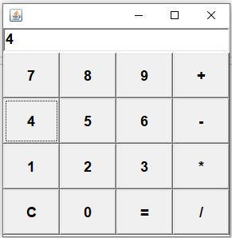

Experiment : 06

Aim :

Develop a program that has a Choice component which contains the names of shapes such as rectangle, triangle, square and circle. Draw the corresponding shapes for given parameters as per user’s choice.

CO 5:

Develop applications to handle events using applets

Procedure

import java.awt.*;

import java.applet.*;

import java.awt.event.ItemEvent;

import java.awt.event.ItemListener;

import java.awt.Graphics;

public class Q6try extends Applet implements ItemListener

{

Choice newchoice;

int selected;

public void init()

{

Label newlabel;

newlabel=new Label("hi choose the one you want to try :");

add(newlabel);

newchoice = new Choice();

newchoice.addItem("Default");

newchoice.addItem("Circle");

newchoice.addItem("Rectangle");

newchoice.addItem("Traingle");

newchoice.addItem("Square");

newchoice.addItemListener(this);

add(newchoice);

}

public void paint(Graphics g1)

{

if(selected==0)

{

g1.drawString("You Haven't selected Any",270,80);

}

if(selected==1)

{

g1.drawOval(400, 300, 150, 175);

}

if(selected==2)

{

g1.drawRect(50, 50, 200, 100);

}

if(selected==3)

{

int[] x = {150, 50, 250};

int[] y = {50, 150, 150};

g1.drawPolygon(x,y,3);

}

if(selected ==4)

{

g1.drawRect(100,100,100,100);

}

}

public void itemStateChanged (ItemEvent n1)

{

selected= newchoice.getSelectedIndex();

repaint();

}

}

Html

<html>

<body>

<applet code ="Q6try.class" width="700" height="700"></applet>

</body>

</html>

Output

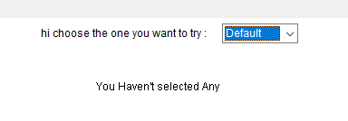



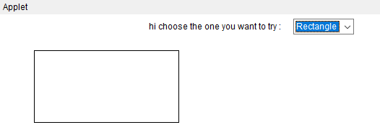

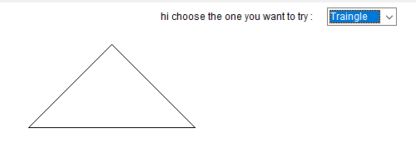

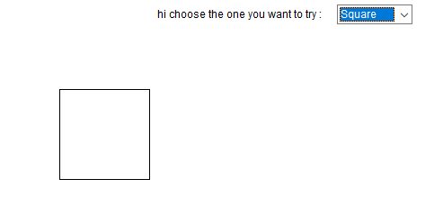

Experiment : 07

Aim :

Develop a program to handle all mouse events and window events

CO 5:

Develop applications to handle events using applets

Procedure

Experiment : 08

Aim :

Develop a program to handle Key events.

CO 5:

Develop applications to handle events using applets

Procedure

import java.awt.FlowLayout;

import java.awt.Frame;

import java.awt.Label;

import java.awt.TextField;

import java.awt.event.KeyEvent;

import java.awt.event.KeyListener;

public class CO5Q8 implements KeyListener

{

Label lb1, lbl2, lb;

TextField tf1;

Frame fr;

String s;

CO5Q8()

{

fr = new Frame("KeyEventListener Example");

lb1= new Label(" Key Events will be displayed based on the actions", Label.CENTER);

lbl2= new Label();

lb= new Label();

tf1 = new TextField(20);

fr.setLayout(new FlowLayout());

fr.add(lb1);

fr.add(tf1);

fr.add(lbl2);

tf1.addKeyListener(this);

fr.setSize(460,250);

fr.setVisible(true);

}

public void keyPressed(KeyEvent ev)

{

lbl2.setText(" Key pressed");

}

public void keyReleased(KeyEvent ev)

{

lbl2.setText("Released");

}

public void keyTyped(KeyEvent ev)

{

lbl2.setText("Key is typed");

fr.setVisible(true);

}

public static void main(String[] args)

{

new CO5Q8();

}

}

Output

