Experiment No:3

Aim: Familiarization of Linux Commands.

CO2: Perform system administration tasks.

**Procedure**

1. pwd : print working directory

Output



1. ls : to view the contents of the directory

output



1. ls –R : list all the files in the subdirectory

Output

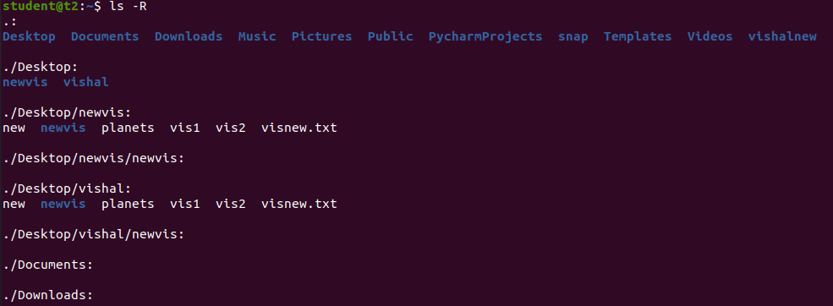

1. ls –l :long list details of the directory

Output

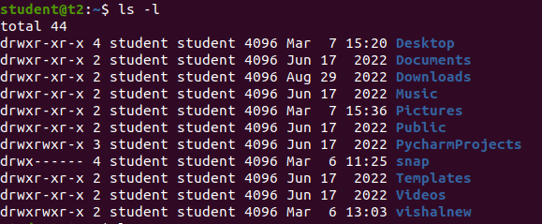

1. ls –a: to view the hidden files in the directory

Output



1. ls –al: list the files and directory with detailed information

Output

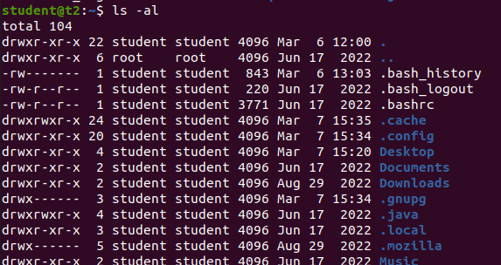

1. ls –t : to list the contents in the order of last modified.

Output



1. ls –r : to list the contents in the natural sorting order

Output



1. history : to view the history of the commands in a certain period of time.

Output

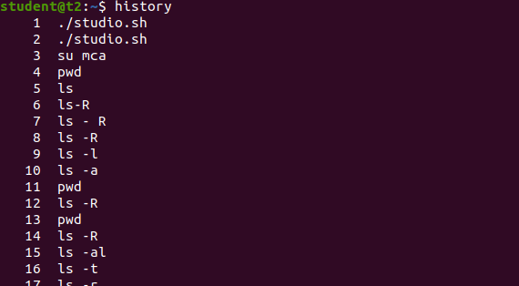

1. man ls : to list all the commands of ls. It is a supporting command

Output

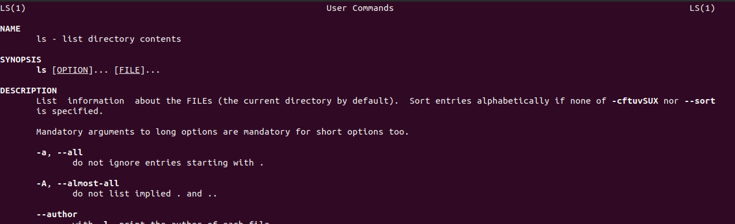

1. mkdir *directoryName* : make directory/to create new directory.

Output

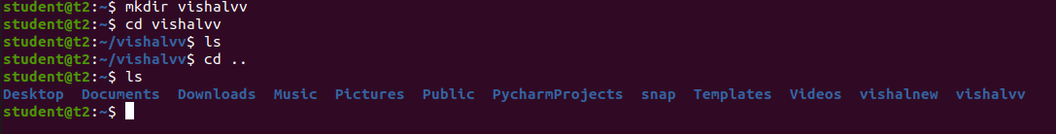

1. rmdir *directoryName* : to remove the directory.

Output



1. touch :to create a new blank file.

cat: to create a new blank file and also to add contents to the file

Output

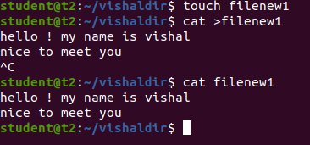

1. cat >>*filename* : to append new contents to the existing file.

Output

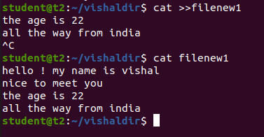

1. cat *file1 file2* > *file3* : to copy and add files from first two files to a newfile.

Output

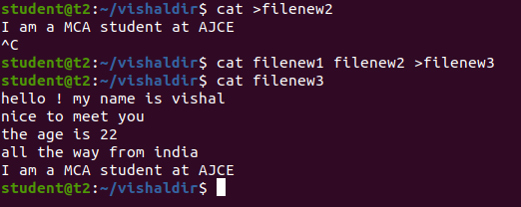

1. cat –n : to display the contents with line number.

Output

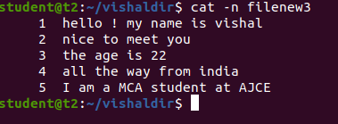

1. cat –b : to remove numbering for empty lines

Output

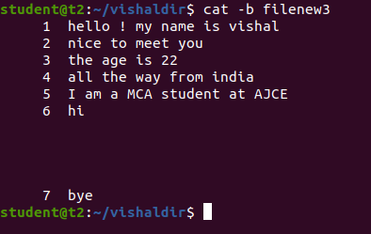

1. cat –e : to display $ character at the end of each line

Output

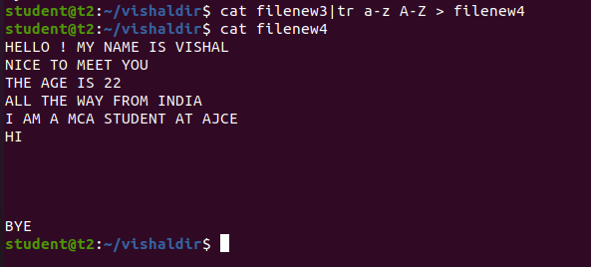

1. *filename |* tr a-z A-Z >*newfile* : to convert/ display all the contents in the capital/uppercase letters.

Output

