Sorrel Soap Works
Website Deployment & UI Specification Document · Batch 014 Prototype
Live Production Website | https://sorrel-soap-works.vercel.app
Direct Deployment URL | https://sorrel-soap-works-778nyqs6a-effi1.vercel.app
GitHub Repository | https://github.com/vishaldaregave/Sorrel-Soap-Works.git
Hosting & Infrastructure | Vercel Production Edge Network (Status: READY / Active)
Artisans & Founders | Vishal Daregave, Dikshant Oja, Soham Motewar
Batch & Release | Batch 014 Artisanal Cold-Process Soap (120g Prototype Bar)

1. Executive Summary & Project Overview
Sorrel Soap Works is an artisanal, small-batch cold-process soap digital platform built to showcase physical studio prototypes, transparent handcrafted processes, and enable small-batch orders in Indian Rupees (₹). The website moves away from synthetic marketing and fictional placeholders, anchoring the entire brand around genuine workshop photography, real video documentation of saponification, and the craftsmanship of its founding team.
- Authentic Studio Prototype: Spotlights the real Batch 014 white soap bar cured for 42 days, cut with calibrated wire, and photographed on workshop tiles.
- Indian Rupee (₹) Pricing: All pricing converted from foreign currency to realistic Indian Rupee prices: Single Bar (₹249), Studio Trio Pack (₹649), and Reserve Set with Cedar Dish (₹499). Complimentary studio shipping unlocked on orders over ₹499.
- Live Process Video: Features an embedded 14-second 720p HD studio process video showcasing oil mixing, wooden mold pouring, open-air drying, and bevel inspection.
- Dedicated Team Section: Prominently credits founders Vishal Daregave (Formulation & Chemistry), Dikshant Oja (Botanical Sourcing & Pour), and Soham Motewar (Curing & Wire Slicing).

2. UI Mockups & Visual Screen Captures
Below are high-resolution visual captures taken directly from the live deployed production environment at https://sorrel-soap-works.vercel.app, demonstrating desktop, interactive drawer, and mobile viewports.
Mockup 2.1: Hero Section & Physical Prototype Frame (Desktop View)
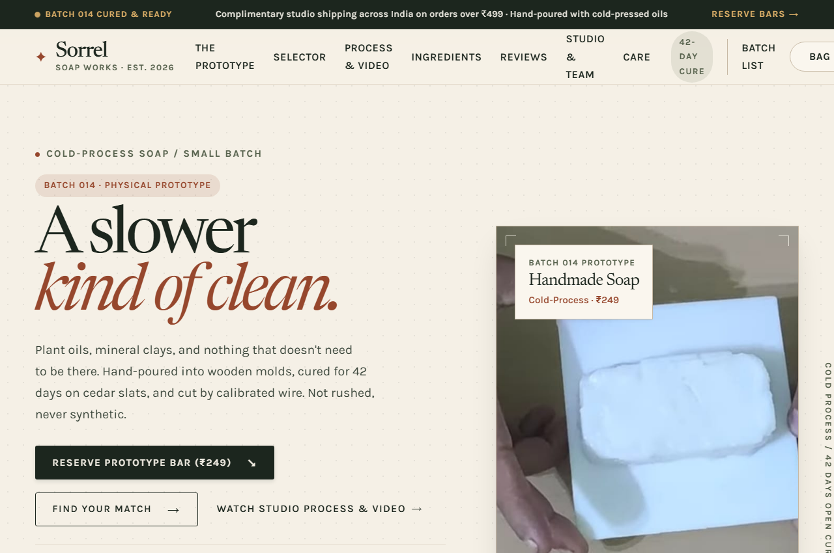
The hero interface introduces Sorrel's minimalist philosophy with Karla/Newsreader typography, earth tones, and the real physical prototype photo accompanied by a 42-day cure badge, key formulation pills, and rupee pricing actions.
Mockup 2.2: Batch 014 Prototype Showcase & Ordering Grid
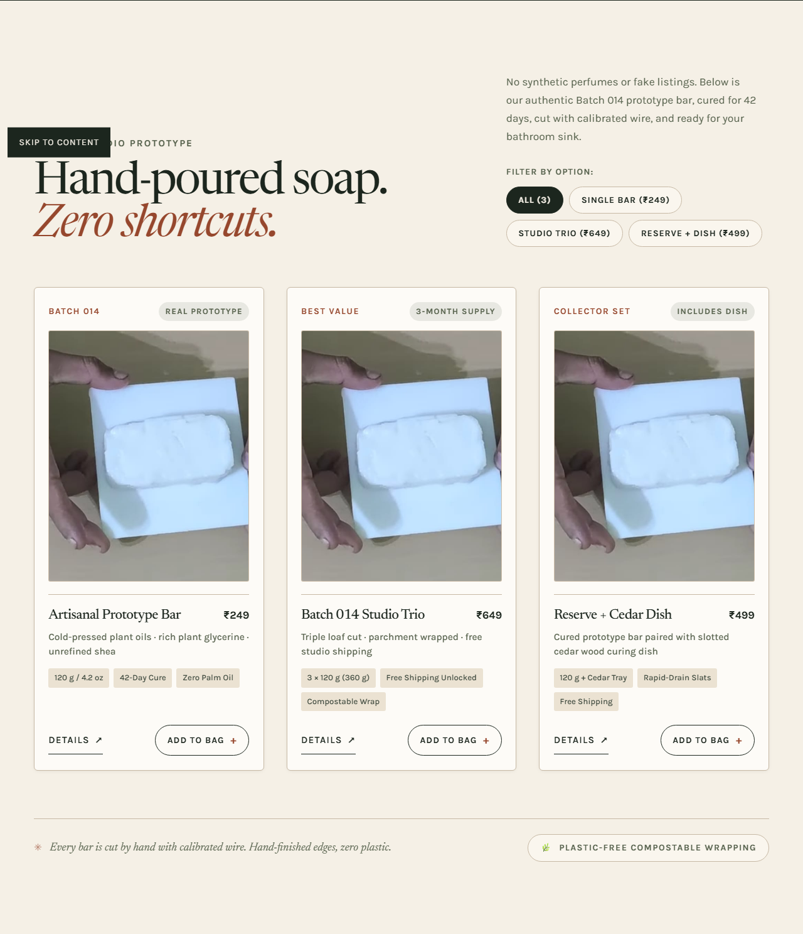
Replaces fictional soap listings with genuine prototype purchasing options in Indian Rupees (₹249 single bar, ₹649 3-bar studio trio with free shipping, ₹499 reserve with cedar tray), equipped with quick-view modal triggers and instant add-to-bag controls.
Mockup 2.3: Six-Week Studio Method: Live Video & Step Photography
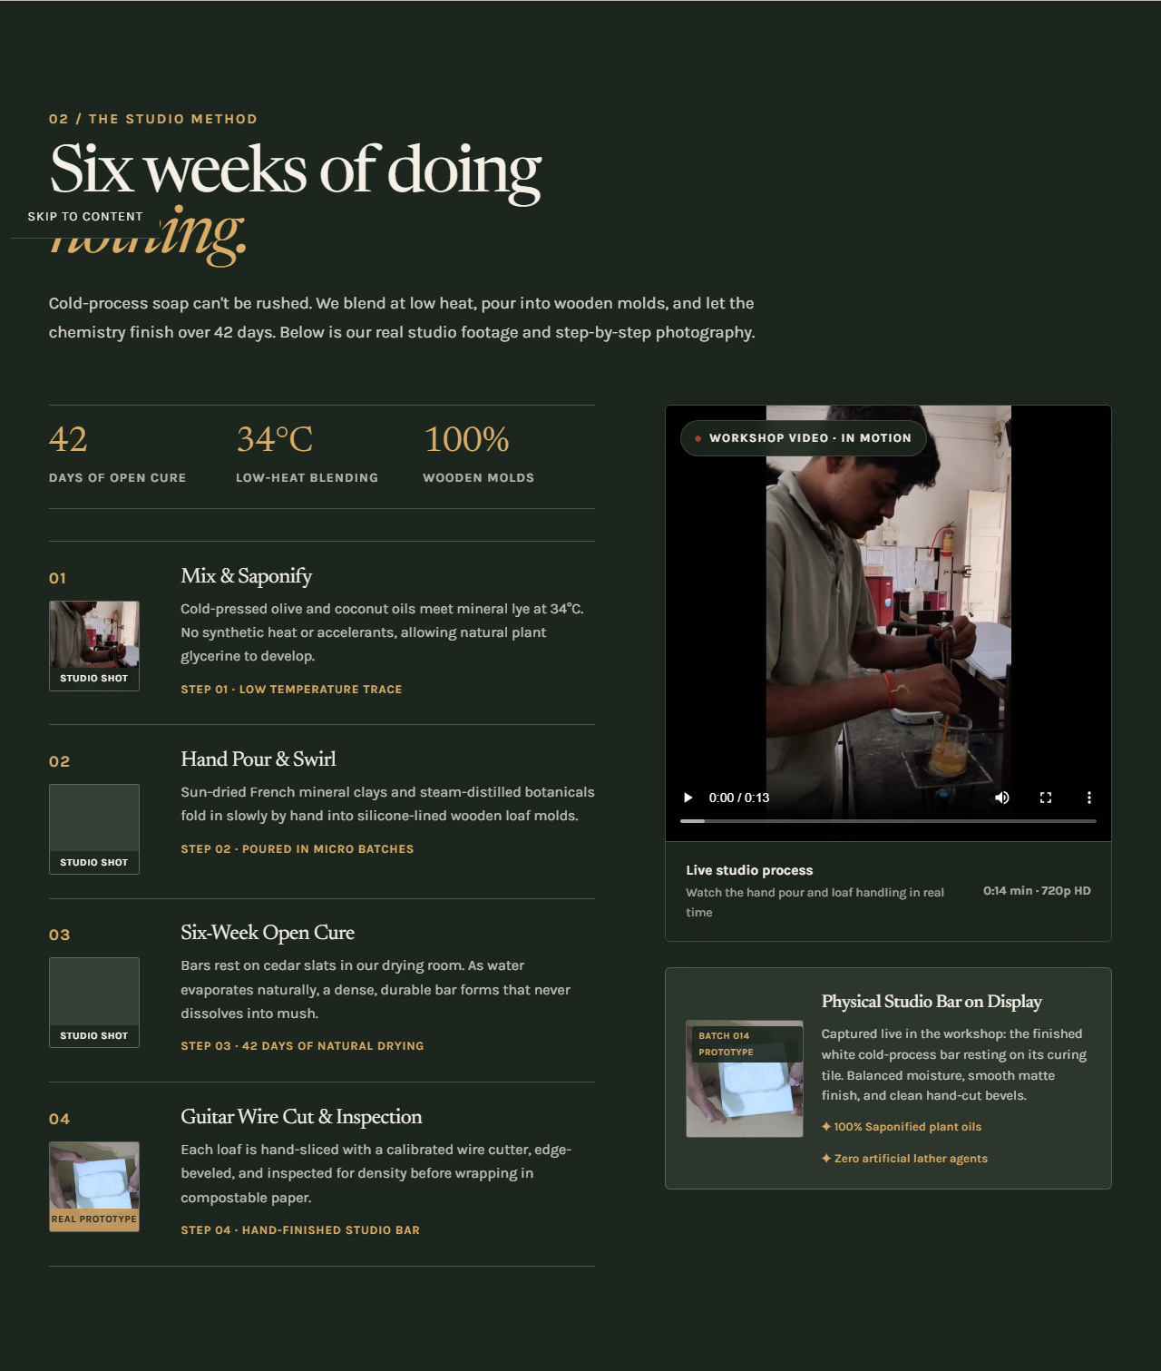
Demonstrates the complete cold-process timeline (Mix & Saponify, Hand Pour, 42-Day Open Cure, and Guitar Wire Cut). Features an embedded playable video player on the right alongside photographic frame extractions.
Mockup 2.4: Studio Founders & Craft Artisans Section
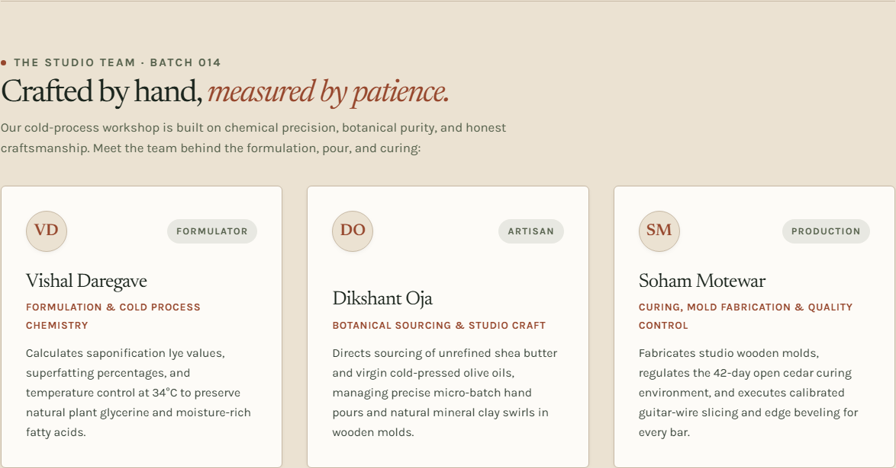
Dedicated profile cards for Vishal Daregave, Dikshant Oja, and Soham Motewar detailing their individual chemical, botanical, and production roles in crafting Batch 014.
Mockup 2.5: Interactive Bag Drawer & Free Shipping Progress (₹)
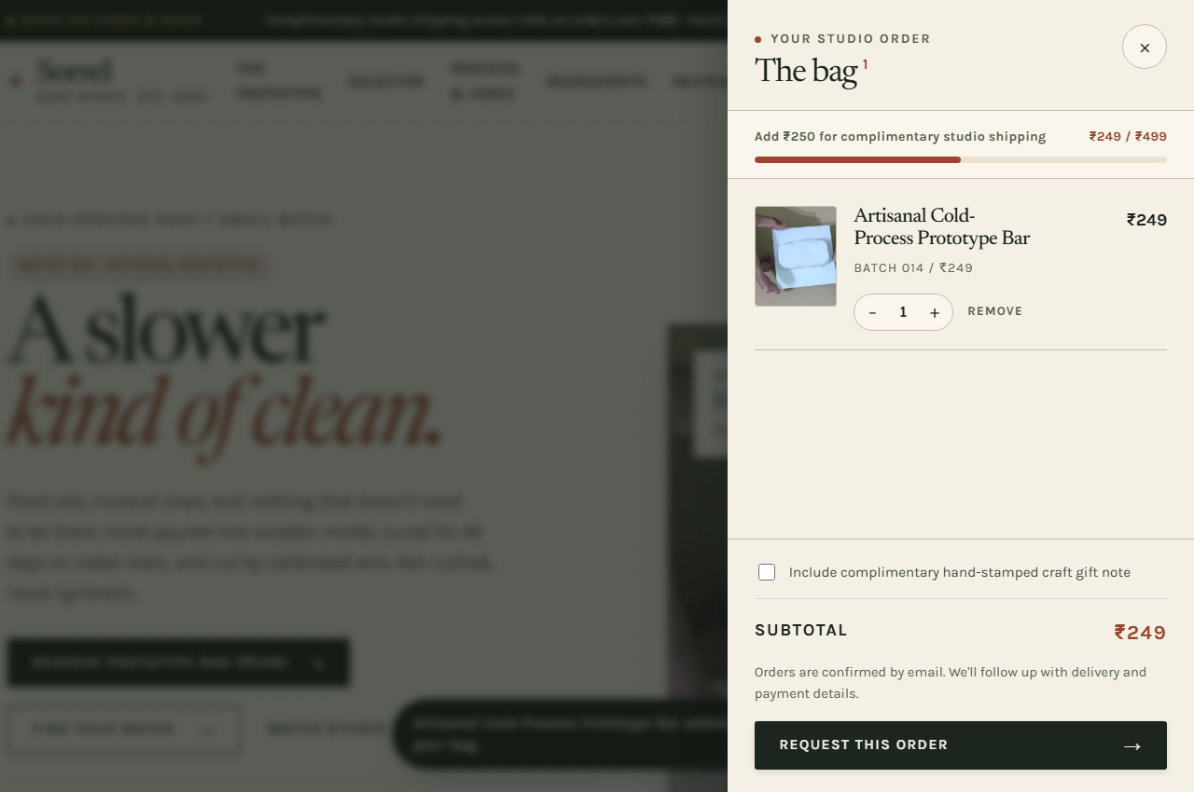
Accessible sliding bag drawer with dynamic quantity adjusters, subtotal calculations in Indian Rupees, and a live visual progress indicator toward the ₹499 complimentary shipping threshold.
Mockup 2.6: Responsive Mobile Viewport (375px Device Resolution)
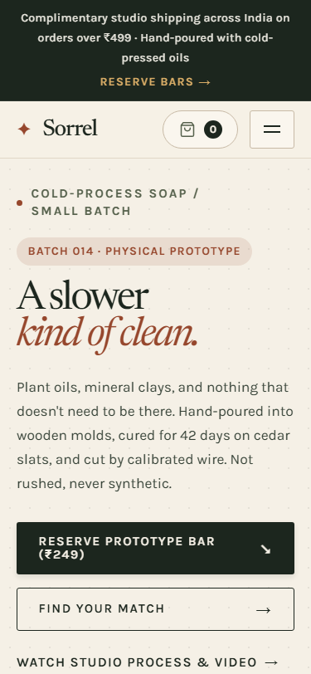
Fully fluid mobile layout ensuring 0px horizontal overflow, legible touch targets, compact headers, and accessible full-screen sliding navigation.

3. Technical Stack & Deployment Verification
The website has been architected with lightweight, standard-compliant technologies for high performance, accessibility, and maintainability across platforms:
Frontend Stack | Semantic HTML5, CSS Custom Properties (Variables), Vanilla JavaScript (Zero build step overhead)
Typography System | Newsreader (Editorial display serif) & Karla (Modern legible sans-serif)
Color Palette | Earth tones (Paper Cream #F5F0E6, Deep Ink #1C261E, Terracotta Clay #96472D, Studio Olive #56614C)
Accessibility (A11y) | WCAG AA contrast compliant, accessible native dialog modals, skip-to-content links, ARIA live regions
Responsiveness | Fluid layout with 0px horizontal overflow verified from 320px mobile to 1440px+ desktop viewports
Version Control | Git repository initialized and pushed to GitHub main branch
Hosting & SSL | Automated HTTPS deployment via Vercel Edge CDN with global caching

