* **@Jitendr** : Panel should collapsible

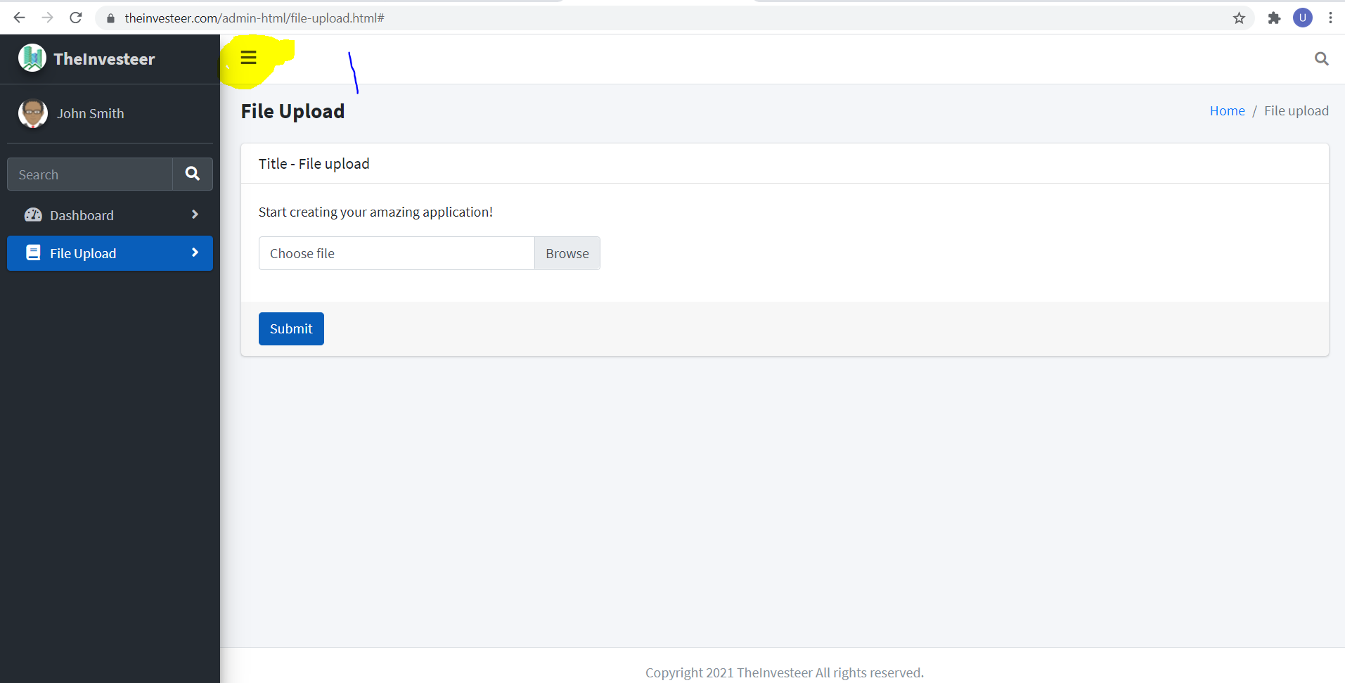

* **@Jitendr** : Logout button should be there

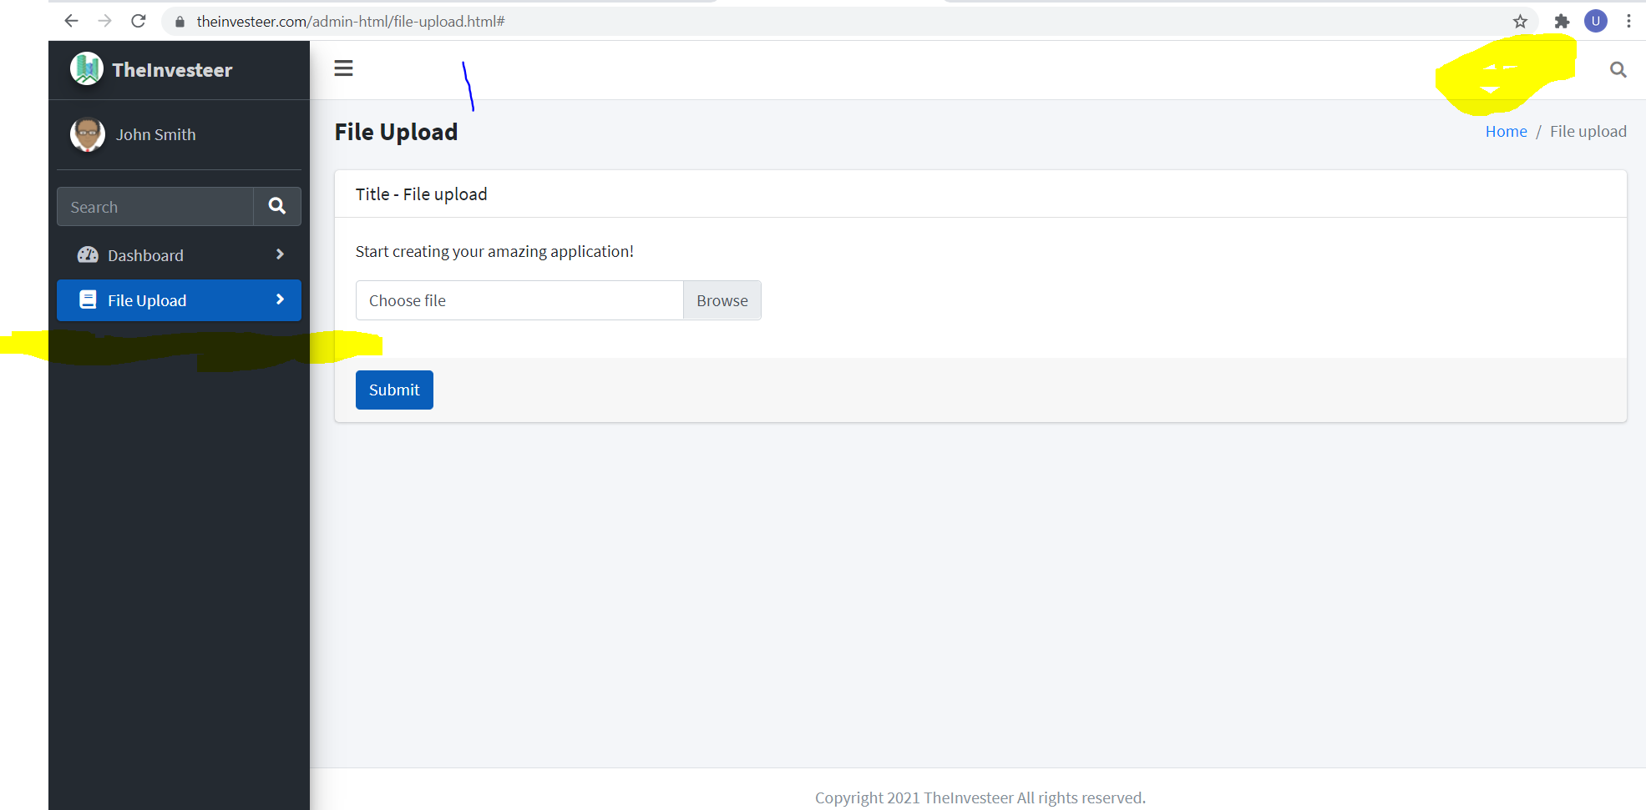

* **@Jitendr:** When Choosing file using file upload selected file path/name should be display in pace of “Choose File”

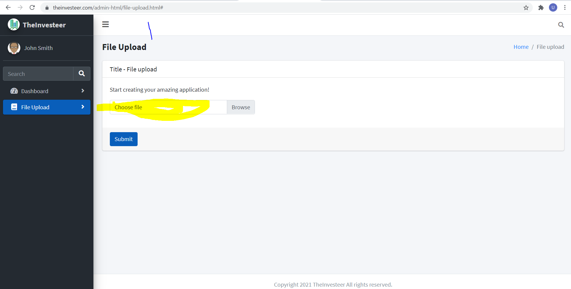

* **@Paras Shah**: We have shame name for multiple column. Can you suggest how need to manage that column.

