On Improved Approaches for Dynamic Lightpath Establishment in Translucent WDM Optical Networks

Abstract- In translucent WDM optical networks, a subset of the nodes are capable of 3R-regeneration and are called regenerators where an optical signal undergoes re-shaping, re-timing and re-amplification to maintain its quality of transmission. In this paper we study the problem of minimizing the utilization of resources at regenerators during dynamic establishment of lightpaths in translucent optical networks. We first propose an Integer Linear Program to show, how minimization of the number of regenerations occurring at regenerators can be achieved during dynamic establishment of lightpaths. We then propose two heuristic routing approaches. In the first approach RNRR (Reducing Number of Regenerations at Regenerators), the objective is to route each arriving connection in a way that reduces the number of regenerations that takes place at regenerators to the extent possible. In the second approach FSR-RNRR (Fewest Stages of Regeneration with Reduced Number of Regenerations at Regenerators), the objective is to find the route of each connection so that it passes through as few stages of regeneration as possible and in addition, the number of regenerations that takes place at regenerators is also reduced. Performance comparisons with an existing approach show that the proposed heuristics provide a significant improvement in connection blocking performance.

Keywords – translucent, optical networks, dynamic routing, wavelength assignment, 3R-regeneration, lightpaths

1. Introduction

In all-optical networks, also known as transparent networks, data communication takes place entirely in the optical domain without Optical-Electronic-Optical (O-E-O) conversion [1]. But Physical Layer Impairments (PLI) introduce factors such as optical noise, chromatic dispersion, nonlinear effects, polarization mode dispersion (PMD) and cross-talk [2], [3] due to which the Quality of Transmission (QoT) of an optical signal degrades as it propagates through a fiber. Optical signals usually have an optical reach a distance (ranging from 800 to 300 km or from 500 to 2000 miles depending on the technology used), such that transmission beyond this distance causes its quality to degrade to an unacceptable level [4]. This degradation in QoT necessitates re-amplification, re-shaping and re-timing (a process known as 3R-regeneration) [2]. Thus optical signals that travel beyond the optical reach need to undergo regeneration at some node(s) in its path from source to destination in order to maintain the required QoT.

In translucent optical networks, introduced by Yang et al. [5], only a subset of the nodes can have regeneration facility as 3R-regeneration is costly. We shall henceforth refer to such nodes capable of 3R-regeneration as regenerators. In optical networks that employ Wavelength Division Multiplexing (WDM), a lightpath established between two end-nodes serve as optical communication link or channel for data communication. A lightpath must be assigned a wavelength in each fiber that it traverses in its path from source to destination. A lightpath established beyond the optical reach must undergo 3R-regeneration at the regenerators. We shall hereafter refer to lightpaths that undergo 3R-regeneration as translucent lightpaths. A translucent lightpath may consist of two or more transparent (all-optical) lightpaths. We shall hereafter refer to such transparent part of a translucent lightpath as segment. In a translucent lightpath exactly one segment is between the source and a regenerator, exactly one segment is between a regenerator and the destination and the rest, if any, are between two regenerators as shown in Fig.1. The total length of fibers involving a segment should not surpass the optical reach.

Nodes without 3R regenerators
Source
Nodes with 3R regenerators
Destination
R₁
R₂
Transparent lightpaths
Fibers

Fig.1 Translucent lightpath consisting of transparent segments routed through regenerators

According to the work [3], it may be difficult to obtain chromatic dispersion and other PLI factors in real time and so optical reach can be considered as an approximation of almost all PLI factors. The two most important problems in translucent optical WDM networks that have attracted research attention are the Regenerator Placement (RP) problem [2]-[12] and the Routing with Regenerators (RR) problem [4], [20-22]. In the RP problem, given a physical topology G=(V,E), the length of fibers for each e∈E and the optical reach, the problem is to find the minimum number of regenerators and their locations so that every pair of nodes i.e. source(s) and destination(d) can establish either a transparent lightpath (not exceeding optical reach) or a translucent lightpath. In the RR problem, given a physical topology G=(V,E), the length of fibers for each e∈E and the location of the regenerators, the problem is to find a lightpath route for every (s, d) pair that will need the least number of regenerations.

In this paper we address the problem of routing for dynamic lightpath establishment in translucent optical networks and in a way similar to [22], we consider optical reach to approximate all PLI factors. The authors [22] made an important observation that solutions to the RR problem [4], [20] and [21] may lead to computation of translucent lightpath routes having unavoidable cycles. This is a possibility, as for certain (s, d) pairs no lightpath route may exist without the ones containing a cycle because route computation occurs in the presence of fixed regenerator locations. Route of a translucent lightpath can thus have overlapping segments and in such a case, the same wavelength cannot be used for assignment in the two segments that overlap. Thus it is important to identify translucent lightpath routes with overlapping segments. The manner in which wavelength assignment is carried out while addressing the RR problem thus becomes extremely important. This is because segments in a route that overlap (traverses common fiber(s)) have to be assigned distinct wavelengths. We will call this problem of identifying routes with overlapping segments and then assigning appropriate wavelengths to such segments the Overlapping Segments Sub-Problem (OSSP). Individual segments in route need not contain overlapping fibers. We provide an example from [22] in Fig.2 to illustrate the problem.

In Fig.2 the network has a single regenerator, node D. If the optical reach is 2000 miles, then communication between nodes A and H can only be established via the translucent lightpath whose route is A→B→C→D→F→G→B→C→H, with the optical signal getting regenerated at D. This route contains two segments S₁: A→B→C→D and S₂: D→F→G→B→C→H which overlaps (have a common fiber B→C). If only a single wavelength w₁ is available in every link of the network then this lightpath cannot be established at all. However, if two wavelengths w₁ and w₂ are available in all the links then establishment of this lightpath is possible by assigning w₁ to S₁ and w₂ to S₂. This wavelength assignment is possible as wavelength conversion is available at regenerator D due to O-E-O conversion. In this paper, our approaches for dynamic lightpath establishment consider OSSP.

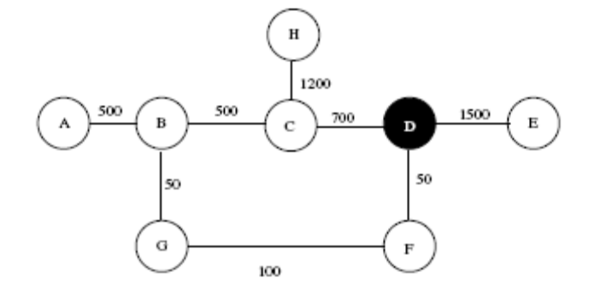
Fig.2 8-node network from [22]

Since regeneration of an optical signal requires O-E-O conversion, the process is costly and so for any solution to the RR problem the objective is primarily to reduce this cost i.e. minimize the total number of regenerations that takes place in the network for serving the requested connections between all (s, d) pairs. It is also important to perform 3-R regeneration of an optical signal as sparingly as possible since regeneration can introduce both delay and Bit Error Rates (BER) because of O-E-O conversion [21]. But providing service to connections in a way performed in the works [4], [20-22] can result in increasing cost of regeneration at some regenerators arbitrarily. This is because the objective in these works is to route connections through minimum stages of regeneration.

The sole objective of minimizing the regeneration stages to address the RR problem can cause regeneration resources to decrease appreciably at some regenerators, while at others resources can remain underutilized. This unbounded increase of regeneration cost at regenerators is a critical issue because regeneration resources being expensive are sparsely deployed at regenerators. For regenerating an optical signal, at least a transmitter and a receiver are required at a regenerator [5]. Thus non-uniform utilization of regeneration resources at regenerators can have serious consequences such as increasing the blocking probability of future connections. Thus the objective of any solution to the RR problem should not be just to route the requested connections through minimum stages of regeneration, but also to route connections in a way so that the number of regenerations that takes place at regenerators is minimized.

The problem of minimizing the cost of regeneration at a regenerator becomes even more important in a dynamic scenario, where connections to be served are not known in advance but arrive continuously. In this paper, we first address the problem of dynamic lightpath establishment focusing on the sole objective of minimizing the number of regenerations that takes place at regenerators. We next address the problem with the objective of routing connections through minimum stages of regeneration and in a way that reduces the number of regenerations that takes place at regenerators to the extent possible. To the best of our knowledge, this work is the first to address establishment of lightpaths in translucent optical networks to minimize the stages of regeneration of each connection subjected to reducing the number of regenerations that takes place at regenerators in a dynamic scenario taking into account OSSP.

It is important to note that works on Physical Layer Impairment aware Routing and Wavelength Assignment (PLI-RWA) such as [16], [17], [23] and those that addresses the RR problem such as [20] and [21] which considers various factors of physical layer impairments (PLIs) separately during establishment of lightpaths cannot be directly compared with our proposed approaches as we model the entire factors of PLIs as optical reach. In translucent networks, wavelength conversion is possible at the regenerators due to O-E-O conversion. So though the entire translucent lightpath route is not constrained to follow wavelength continuity, the individual segments in the route must use a single wavelength. The RWA problem is known to be NP-Complete [28]. So the RR problem which can be solved only through RWA of lightpaths is also NP-Complete. Efficient heuristics are thus needed to provide solutions to the RR problem. The heuristics proposed in this paper are designed to provide efficient solution to the RR problem.

The rest of the paper is organized as follows. In sec.2 we discuss the related works, in sec.3 we mention the contributions of our work, in sec.4 we provide the Integer Linear Program formulation for addressing our objective, in sec.5 we provide the heuristics, in sec.6 we include performance comparisons and provide the result analysis and finally in sec.7 we conclude with a summary of this work.

2. Related works

The authors [13] provide a comprehensive survey of various PLIs, their effects and a survey of various PLI-RWA algorithms. The work [14] provides a survey of PLI-RWA algorithms and the impact of wavelength conversion on these algorithms. An economic analysis of PLI-RWA problem to justify the concept of translucent optical networks is provided in [15]. In [16], the authors investigate the problems of RWA in transparent optical networks that can support unicast and multicast applications taking into consideration the PLIs. BER performance estimation is performed by authors [17] in connection with PLI-RWA to investigate the role of regeneration and wavelength conversion in optical networks. Given, a network topology, the number of available wavelengths and a traffic matrix, authors [18] focus on the offline PLI-RWA problem and propose an algorithm that selects the regenerators for a given set of connection requests solving the RP problem. The work [19] too proposes offline PLI-RWA iterative heuristics where RP is carried out based on RWA of connection requests to minimize lightpath blocking and regenerator equipment cost.

Schemes for finding a route with fewest stages of regenerations between (s, d) pairs by enumerating a large number of routes between s and d is proposed in [4]. The work [20] proposes dynamic routing strategies for allocation, advertisement and discovery of regeneration resources to facilitate transmitter-receiver sharing between regeneration and access functions. An intra-domain routing algorithm [21], for dynamic allocation of regeneration resources is proposed considering many optical layer constraints such as chromatic dispersion, polarization mode dispersion, amplified spontaneous emission noise, cross talk etc to address routing in a single domain. The authors [22] observe that the works [4], [20] and [21] may lead to computation of infeasible translucent lightpath routes between certain (s, d) pairs if segments have overlapping fibers leading to OSSP. An ILP for solving the dynamic RR problem and an efficient heuristic for large networks is proposed in [22] that considers OSSP.

The problem of RWA of connections within a single domain and inter-domain connections so that the QoT of each connection is satisfied and blocking probability is minimized is considered [23]. Recently, the authors [24] addressed the problem of static impairment-aware multicast routing and wavelength assignment for transparent WDM metro area networks considering a number of PLIs. A case study of regenerator placement and regenerator assignment through dynamic calls and performance analysis of call blocking probability of a number of algorithms for OFDM based flexible grid Elastic Optical Networks (EONs) appeared recently in [25]. The authors [26] recently, considered the joint problem of Virtual Elastic Regenerator (VER) placement and Routing and Spectrum Assignment (RSA) and proposed a Binary Real Coded Firefly (BRCFF) algorithm to solve the problem in EONs.

To the best of our knowledge, these papers have not addressed the problem of minimizing the stages of regeneration that a requested connection passes through, subjected to reducing the number of regenerations that takes place at regenerators during dynamic establishment of lightpaths in translucent optical networks, taking into consideration OSSP.

3. Illustration of the need to conserve regeneration resources and our contributions

A transmitter (T) at the source (s) and a receiver (R) at the destination (d) is necessary to establish a transparent lightpath between s and d. A (T, R) pair is also a minimum requirement at a regenerator for 3R-regeneration of a translucent lightpath [5]. We illustrate that regeneration resources can be sparsely available at regenerators with a simple example. Let us assume that node A is the source whereas node B is the destination of m and n transparent lightpaths respectively established due to the arrival of (m + n) requests for connection. The m lightpaths that start at A and the n lightpaths that terminate at B consumes m number of Ts and n number of Rs at A and B respectively. Let us assume that nodes A and B are also regenerators in a translucent optical network which were initially deployed with x number of transceivers or (T, R) pairs. Then the number of Ts and Rs that are now available at A are x – m and x respectively whereas at B the number of Ts and Rs is now x and x – n respectively. It may be noted that though both A and B were initially deployed with x number of (T, R) pairs, only x – m and x – n of them are now available at A and B respectively to regenerate translucent lightpaths that may need 3R-regeneration at these regenerators in future. Thus regeneration resources are always sparsely available at regenerators. So efficient routing schemes are needed for the connections that require establishment of translucent lightpaths so that (T, R) pairs are conserved at regenerators to reduce blocking probability for future translucent lightpaths.

Thus it is important to minimize the number of regenerations that occurs at individual regenerators to conserve the scarce resources. This conservation further becomes extremely important in a dynamic scenario where connections to be served are not known in advance but arrive one at a time continuously. The sole objective of routing dynamic connections through fewest stages of regeneration in the works [4], [20-22] can definitely minimize the total number of regenerations for the requested connections but cannot guarantee conservation of resources at regenerators. To address this issue we propose two heuristic routing schemes. In the first scheme, the objective is to route lightpaths for connections in a way that will reduce the number of regenerations at individual regenerators to the extent possible. In the second scheme, the objective is to route lightpaths for connections using as few regeneration stages as possible with reduction in resource utilization at regenerators to the extent possible. We contribute by

1) proposing an Integer Linear Program (ILP) to show how dynamic lightpath allocation can be performed to minimize the regenerations that takes place at regenerators.

2) proposing two heuristic routing schemes to address the said issue in a dynamic scenario for large networks taking into consideration OSSP and

3) a) studying the effect of number of segments in a translucent lightpath route on the connection blocking probability with fixed number of regeneration resources b) studying the effect of number of regeneration resources on the connection blocking probability with a given number of allowable segments in translucent lightpath routes and c) studying the effect of other network resources such as number of wavelengths in links on the connection blocking probability.

4. Formulation for routing to establish dynamic lightpaths

In this section we present an Integer Linear Program (ILP) formulation for addressing the problem of routing for dynamic establishment of lightpaths in translucent optical networks. Our ILP formulation shows how translucent lightpaths can be routed to minimize the cost of regeneration (the number of regenerations) at regenerators in a scenario where requests for connection arrive one at a time continuously and are not known in advance. Specifying the number of allowable segments in a translucent lightpath route is essential as optical signals should be regenerated sparingly to prevent introduction of delay and BER [21]. It may be noted that paths of individual segments (representing transparent lightpaths) in a translucent lightpath route will not contain a cycle but a translucent lightpath route can have unavoidable cycles leading to OSSP.

a) Notations used in the formulation

V: the set of nodes of the physical topology.
E: the set of all pairs of nodes (i, j) such that i→j is a link in the physical topology.
l_{ij}: the length of the link i→j in the physical topology.
d: the distance signifying optical reach.
R: the set of all regenerators in the network whose locations are known.
s: a constant that denotes the number of allowable segments in a translucent lightpath route.
W: the set of all wavelengths available in a physical link.
N_{i}: an integer representing the number of regenerations that has occurred at regenerator i∈R so far.
θ_{i}: a binary variable for node i∈V defined as follows.
θ_{i} = 1, if node i is a regenerator.
= 0, otherwise.
A^{w}_{ij}: a binary variable indicating whether wavelength w is available in link i→j, defined as follows.
A^{w}_{ij} = 1, if wavelength w has already been assigned to an existing lightpath route on link i→j.
= 0, otherwise.
C^{k}_{w}: a binary variable indicating whether wavelength w is consumed by the k^{th} segment of a new lightpath, defined as follows.
C^{k}_{w} = 1, if the k^{th} segment of a new lightpath consumes wavelength w.
= 0, otherwise.
T^{k}_{ij}: a binary variable indicating whether the k^{th} segment of a new lightpath traverses link i→j, defined as follows.
T^{k}_{ij} = 1, if the k^{th} segment of the new lightpath traverses link i→j.
= 0, otherwise.
b) ILP formulation for minimizing the number of regenerations at a regenerator

Given 1) the physical topology, G=(V,E) 2) the length of fibers (l_{ij}) for each (i, j)∈E 3) the optical reach, d 4) the set of all wavelengths (W) available in a physical link 5) the number of allowable segments (s) in a translucent lightpath route 6) the location of all regenerators in R and 7) the number of regenerations (N_{i}) that has taken place at a regenerator i∈R so far, the ILP formulation presented below determines the route of a new lightpath for communication between any source S and any destination D, in a way such that the regenerations at the regenerators are minimized.

Objective: minimize N_{i} + ^{s}∑_{k=1}∑_{j: (i, j)∈E} T^{k}_{ij}, ∀i where θ_{i} = 1,

subjected to the following constraints (1-11).

Constraints:

1. The first segment in the route must originate at S. This can be expressed as follows.
∑_{j:(S, j)∈E} T¹_{Sj} = 1

2. No segment in the route is allowed to enter S. This can be expressed as follows.
^{s}∑_{k=1}∑_{j:(j, S)∈E} T^{k}_{jS} = 0

3. Only one segment in the route is allowed to enter D. This can be expressed as follows.
^{s}∑_{k=1}∑_{j:(j, D)∈E} T^{k}_{jD} = 1

4. No segment in the route is allowed to leave D. This can be expressed as follows.
^{s}∑_{k=1}∑_{j:(D, j)∈E} T^{k}_{Dj} = 0

5. The last segment in the route must terminate at D. This can be expressed as follows.
∑_{j:(j, D)∈E} T^{s}_{jD} = 1

6. Every segment in the route that traverses a non-regenerator node must pass through it i.e. enter as well as leave the node. This can be expressed as follows.
∑_{j:(i, j)∈E} T^{k}_{ij} – ∑_{j:(j, i)∈E} T^{k}_{ji} = 0, ∀i where θ_{i} =0, ∀k, 1 ≤ k ≤ s.

7. For every regenerator and for any two successive segments (k^{th} and (k+1)^{th}) in the route, the k^{th} segment must terminate and the (k+1)^{th} must originate at the regenerator. This can be expressed as follows.
∑_{j:(i, j)∈E} T^{k+1}_{ij} – ∑_{j:(j, i)∈E} T^{k}_{ji} = 0, ∀i where θ_{i} =1, ∀k, 1 ≤ k ≤ s.

8. The length of individual segment in the route should not exceed the optical reach. This can be expressed as follows.
∑_{(i, j)∈E} T^{k}_{ij} . l_{ij} ≤ d, ∀k, 1 ≤ k ≤ s.

9. Every segment in the route must be assigned a single wavelength. This can be expressed as follows.
∑_{w∈W} C^{k}_{w} = 1, ∀k, 1 ≤ k ≤ s.

10. The wavelength assigned to a segment must be available on all physical links traversed by the route. This can be expressed as follows.
∀ w∈W, A^{w}_{ij} . T^{k}_{ij} + C^{k}_{w} ≤ 1, ∀(i, j) ∈ E, ∀k, 1 ≤ k ≤ s.

11. Two segments in the route that overlap and share a physical link (fiber) cannot be assigned the same wavelength. This is required for addressing OSSP and can be expressed as follows.
∀ w∈W, T^{s1}_{ij} + T^{s2}_{ij} + C^{s1}_{w} + C^{s2}_{w} ≤ 3, ∀(i, j)∈E, ∀s₁,1 ≤ s₁ ≤ s, ∀s₂,1 ≤ s₂ ≤ s.

V. Heuristics for dynamic lightpath establishment

We provide the proposed heuristic routing algorithms RNRR (Reducing Number of Regenerations at Regenerators) and FSR-RNRR (Fewest Stages of Regeneration with Reduced Number of Regenerations at Regenerators). These heuristics are compared with the one presented in [22]. We first discuss about the common data structures and schemes used in both the heuristics.

a) Data structures and schemes used in the heuristics

The set P_{ab} = {p₁, p₂, …, p_{k}} represents the set of k paths between two nodes a, b ∈V such that ∀p_{i} ∈P_{ab}, 1 ≤ i ≤ k, the length of p_{i} ≤ d (the optical reach). It may be noted that there can be fewer than k paths in P_{ab}, if all k paths does not exist in the physical topology G = (V, E). P_{set} represents the set of all such path sets P_{ab}, |P_{set}| = n.(n – 1) where |V| = n. The set w_{ij} represents the set of all wavelengths currently available in link i→j. W_{set} represents the set of all such wavelength sets w_{ij}, |W_{set}| = |E|. The set R⊃V, represents the set of regenerators in the network whose locations are known. A variable c_{i} is associated with every regenerator i ∈R, which represents the cost of regeneration (the number of regenerations) at i so far. The variable c_{i} is initially 0, but is incremented for every connection that gets regenerated at i. The value of c_{i} at any instant represents the number of (T, R) pairs that have been consumed at i for 3R-regeneration. A hash-map regCost = {<c_{e}, e>, <c_{f}, f>,…,<c_{m}, m>} of size |R|, maps regenerators to their corresponding cost values. Each member of regCost is of the form <c_{i}, i> where c_{i} is the cost of regeneration at regenerator i so far. The cost matrix is an n × n matrix such that cost[i][j], gives the value l_{ij}, the length of the fiber link i→j in the physical topology. If no link is present between nodes i and j cost[i][j] = ∞.

In both heuristics we employ A*, a well-known best-first search [29] to find the route of a new connection requested between source S and destination D that satisfies the required objective. The search space SP consists of pairs (a, P), where a ∈V and P is the set of transparent paths determined by the search such that node a can be reached from S using the paths in P. For wavelength assignment to segments in a lightpath route, we use the well-known First-Fit (FF) policy [20] for simplicity. The heuristics identify overlapping segments in a translucent lightpath route to address OSSP. If two segments in a route overlap due to common fiber(s) then they are assigned distinct wavelengths. Addressing OSSP becomes possible as wavelength conversion is available at the regenerators. We next provide the heuristic RNRR.

b) Reducing Number of Regenerations at Regenerators (RNRR)

The heuristic RNRR attempts to find a route for the requested connection (S, D) in a way that will reduce the number of regenerations (or cost of regeneration) at the regenerators to the extent possible. The details of the heuristic are shown in Fig.3.

Input: The inputs to algorithm are 1) S, the source of the requested connection 2) D, the destination of the requested connection 3) d, the distance representing optical reach 4) s, the number of allowable segments 5) R, the set of regenerators 6) P_{set}, the set of path sets 7) W_{set}, the set of wavelength sets 8) the matrix cost and 9) the hash-map regCost.

Output: The output is the pair (P, regCost), where P is the set of transparent paths determined by the heuristic using which it will be possible to reach D from S and regCost is the updated hash-map after serving the new connection.

Method: The algorithm works as follows. Initially the search space SP contains the pair (S, φ). The procedure findBest() is used to obtain the best pair (a, P) presently available in SP, such that the paths in P will lead to establishment of a lightpath from source S to D not exceeding the specified number of segments s subjected to reducing the cost of regeneration at the regenerators (line 4). If a = null which indicates that no pair (a, P) exists in SP with |P| ≤ s, the connection is considered to be blocked and the pair (φ, regCost) is returned (line 6). If a ≠ null then there can be two possibilities, either D can be reached using the paths in P or D cannot be reached.

If D can be reached i.e. if a = D (line 7), then the paths in P can be used to establish a lightpath from S to D and so procedure updateCost() is called to update the cost at the regenerators in the route from S to D that can be formed by the paths in P. The procedure updateCost() returns the updated hash-map regCost. The procedure findOverlaps() is called to obtain OS_{set}, the set of paths in P that overlaps. The procedure assignWav() is then used to assign wavelengths to segments (paths in P) in a way that addresses OSSP as explained earlier in this section. The path set P and regCost is returned and the heuristic stops (line 11).

If D cannot be reached using the paths in P i.e. if a ≠ D, then the algorithm calls procedure findPathSet() (line 13) to obtain P_{aD}, from P_{set}. The algorithm next proceeds to check whether cost[a][D] i.e. l_{aD} is within the optical reach d or not. If l_{aD} ≤ d, then the paths in P_{aD} are added to a temporary path set P_{temp} (line 15). If l_{aD} > d, then ∀i ∈R, procedure findPathSet() is used to find P_{ai}, from P_{set}. The paths in sets P_{ai}, ∀i ∈R are then added to P_{temp}. Finally the paths in P_{aD} are added to P_{temp} (line 22). New pairs are then added to SP in the following manner. The procedure findLastNode() is used to find the last node x in a path p in P_{temp}. For each path p ∈P_{temp} a new pair (x, P’) is added to SP (line 29) where P’ = P ∪ p (line 28). The process repeats itself until the required pair (a, P) is obtained from SP such that a = D.

Procedure updateCost():The inputs to the procedure are P and regCost. This procedure is used to update the cost associated with the regenerators in the lightpath route 𝓡_{SD} from S to D formed by the paths in P determined by the search. The procedure increments the values of c_{i} in every <c_{i}, i> in regCost if 𝓡_{SD} undergoes regeneration at regenerator i. For example, if P consists of three transparent paths{S→q→r→t, t→u→v→w, w→x→y→z→D}, then 𝓡_{SD} is the route S→q→r→t→u→v→w→x→y→z→D formed by the concatenation of the transparent paths. The values of c_{t} in <c_{t}, t> and c_{w} in <c_{w}, w> in regCost are incremented to represent the updated cost of regeneration at regenerators t and w. The updated hash-map regCost is returned by the procedure.

Procedure findBest(): This procedure is used to obtain the best pair (a, P) presently available in SP, such that the paths in P will lead to establishment of a lightpath route from S to D with the allowable number of segments s in a way that the cost of regeneration at the regenerators will be reduced. The inputs to the procedure are SP, s and regCost. The details of findBest() is shown in Fig.4. The procedure works as follows.

Heuristic RNRR (S, D, d, s, R, P_{set}, W_{set}, cost, regCost)
begin
1 SP ← (S, φ);
2 P_{temp} ← φ;
3 repeat
4 ((a, P), SP) ← findBest(SP, s, regCost);
5 if (a = null) then
6 return (φ, regCost);
7 if (a = D) then
8 regCost ← updateCost(P, regCost);
9 OS_{set} ← findOverlaps(P);
10 P ← assignWav(OS_{set}, P, W_{set});
11 return (P, regCost);
12 else
13 P_{aD} ← findPathSet(P_{set}, a, D);
14 if (cost[a][D] ≤ d) then
15 P_{temp} ← P_{temp} ∪ P_{aD};
16 else
17 for each i ∈R do
18 begin
19 P_{ai} ← findPathSet(P_{set}, a, i);
20 P_{temp} ← P_{temp} ∪ P_{ai};
21 end for
22 P_{temp} ← P_{temp} ∪ P_{aD};
23 end if
24 end if
25 for each p ∈ P_{temp} do
26 begin
27 x ← findLastNode(p);
28 P’ ← P ∪ p;
29 SP ←SP ∪ {(x, P’)};
30 end for
31 forever
end heuristic

Fig. 3 Heuristic RNRR

Procedure findBest(SP, s, regCost)
begin
1 found ← false;
2 sort the <c_{i}, i> in regCost in increasing order of c_{i} values;
3 for each (a, P)∈ SP with |P| ≤ s
4 begin
5 found ← true;
6 regList ← getRegList(P);
// regList contains u, v, w,…and z, the regenerators
// involved in the translucent lightpath route that can be
// formed by the transparent segments in P
7 (<c_{u}, u>, <c_{v}, v>,…, <c_{z}, z>) ← makeSeq(regCost, regList);
// c_{u}, c_{v},… and c_{z} are the cost of regenerations
// at u, v, w,…and z respectively
8 (c_{u}, c_{v},…, c_{z}) ← removReg((<c_{u}, u>, <c_{v}, v>,…, <c_{z}, z>));
9 add [(c_{u}, c_{v},…, c_{z}), (a, P)] to seqMap;
10 end for
11 if (found = true) then
12 seqMap ← sortMap(seqMap);
13 get (a₁, P₁), the pair corresponding to the first member in
seqMap;
14 SP ← SP – {(a₁, P₁)};
15 return ((a₁, P₁), SP);
16 else
17 return ((null, φ), SP);
18 end if
end procedure

Fig.4. Procedure findBest

The procedure begins by initializing the variable found to false. If at least a pair (a, P) is available with |P| ≤ s, then found will be set to true else it remains false. First, the members <c_{i}, i> in regCost are sorted in increasing order of c_{i} values. Then ∀(a, P)∈ SP having |P| ≤ s the following operations take place. The procedure getRegList() (line 6) is used to obtain regList, the list of regenerators that are involved in the translucent path formed by the segments in P. The procedure makeSeq() (line 7) is then used to obtain a sequence of the form (<c_{u}, u>, <c_{v}, v>,…, <c_{z}, z>) of length (s – 1) or less, by copying the members in the order in which they appear in the sorted regCost corresponding to regenerators u, v,…, z present in regList. The procedure removReg() (line 8) is used to delete regenerator i from every member <c_{i}, i> of the sequence. Thus the sequence (<c_{u}, u>, <c_{v}, v>,…, <c_{z}, z>) gets modified to (c_{u}, c_{v},…, c_{z}). The member [(c_{u}, c_{v},…, c_{z}), (a, P)] is then added to seqMap. The hash-map seqMap is defined to map each sequence to its corresponding pair (a, P). It is important to note that sequences will vary in length as its length depends on the number of transparent segments present in P of (a, P) from which it has been derived.

The procedure sortMap() (line 12) is then used to sort seqMap. In the sorted seqMap, for any two consecutive members [(x₁, x₂, …, x_{k}), (a_{x}, P_{y})] and [(y₁, y₂,…, y_{l}), (a_{y}, P_{y})] the relation [(x₁, x₂, …, x_{k}), (a_{x}, P_{y})] < [(y₁, y₂,…, y_{l}), (a_{y}, P_{y})] implies x_{k} < y_{l} or (x_{k} = y_{l} and x_{k-1} < y_{l-1}) or (x_{k} = y_{l}, x_{k-1} = y_{l-1} and x_{k-2} < y_{l-2}) and so on. The pair (a₁, P₁) that corresponds to the first member in sorted seqMap is chosen as the best. The procedure also removes (a₁, P₁) from SP. The pair (a₁, P₁) and the updated SP are returned by the procedure. If none of the pairs (a, P) in SP has |P| ≤ s i.e. if found is false, then the request is considered to be blocked and the procedure returns (null, φ) and SP.

We do not include the details of the procedures findPathSet(), findLastNode(), findOverlaps(), assignWav(), getRegList(), makeSeq(), removReg() and sortMap() as they are simple to understand. We next discuss the heuristic FSR-RNRR.

c) Fewest Stages of Regeneration with Reduced Number of Regenerations at Regenerators (FSR-RNRR)

The heuristic FSR-RNRR attempts to find a route for the requested connection (S, D) in a way that the route passes through as few stages of regeneration as possible and in addition, the number of regenerations (or cost of regeneration) at the regenerators is also reduced to the extent possible. The inputs, outputs and the method is the same as that of RNRR except that the findBest() procedure in line 4 of RNRR is replaced by the procedure getBest() whose working is discussed next.

Procedure getBest():This procedure is used to obtain the best pair (a, P) presently available in SP having |P| ≤ s, such that the paths in P will lead to establishment of a lightpath route from S to D satisfying the objective of FSR-RNRR. The inputs to the procedure are SP, s, regCost and cost. Then every pair (a, P) ∈ SP with |P| ≤ s, is associated with a cost which is calculated as follows. The cost of reaching node a from S by the paths in P is |P| - 1. The estimated cost eCost, of reaching D from a is ⎡cost[a][D]/d⎤. The net cost associated with every (a, P) having |P| ≤ s is (|P| - 1 + eCost). The best pair (a, P) is chosen as the one whose net cost is minimum.

If two or more pairs have the same net cost then the tie is broken by choosing the one which will lead to reduction of the cost of regeneration at the regenerators. This is done by forming sequences out of all pairs (a, P) involved in the tie, modifying the sequences by removing the regenerators from every member <c_{i}, i>, generating seqMap to map sequences to their corresponding pairs, sorting seqMap and finally selecting the pair (a₁, P₁) that corresponds to the first member in the sorted seqMap in exactly the same way as described in procedure findBest() (sec.V.b). The procedure further removes the chosen best pair (a₁, P₁) from SP. The pair (a₁, P₁) and the updated SP are returned. If no pair (a, P)∈ SP has |P| ≤ s, then the request is considered to be blocked and the procedure returns (null, φ) and SP.

VI. Performance comparisons

The work [22] is closest to our approach as the authors consider optical reach to approximate all PLI factors. So we compare our heuristics RNRR and FSR-RNRR with the heuristic presented in [22] which we name as FSR (Fewest Stages of Regeneration). Comparisons are carried out with programs written in ANSI C++, executed using Ubuntu 16.04 LTS 64-bit operating system in Intel Core i3 CPU M 380 @ 2.53GHz × 4 processor with 3GB RAM. We use the 14-node NSF network shown in Fig.5 and the 20-node ARPANET shown in Fig.6 for the simulation experiments. The results from simulation experiments are also compared with the optimal values obtained by solving the ILP. The ILP is solved using ILOG CPLEX 10.0.

The k paths in P_{ab} for ∀a, b∈V were computed using Yen’s algorithm [27]. We computed 5 paths (k = 5) within optical reach between every node pair. The length of a fiber link in the two networks used for simulation where varied randomly between 200 and 1200 miles. The optical reach is assumed to be 1500 miles. Approximately 33 % of the nodes in each network were randomly chosen as regenerators in a way similar to [22]. We assume that all fiber links have the same number of wavelengths and (T, R) pairs are the only resources available at regenerators for 3R-regeneration of an optical signal in a way similar to [18].
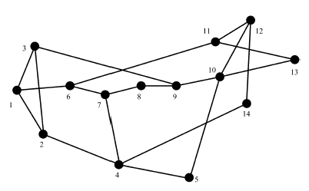

Fig.5 14-node NSF network
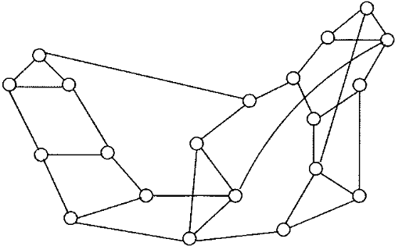

Fig.6 20-node ARPANET

We first compare the maximum number of regenerations (M) at a regenerator, computed by RNRR with that of the ILP using Fig.7 and Fig.8. The figures show the comparison of the values of M in NSF network and ARPANET respectively, for different number of dynamic connections and wavelengths in links. To ensure that connections do not block due to want of wavelengths we provided enough wavelengths in links for every experiment. For each set size 20, 40, 60, 80 we conducted 10 set of experiments in each network and reported the average value rounded off to the nearest integer. In all these experiments if the value of M computed by RNRR differed with that of the optimal, it differed by at most 1. The results show that RNRR is able to compute near optimal values of M.

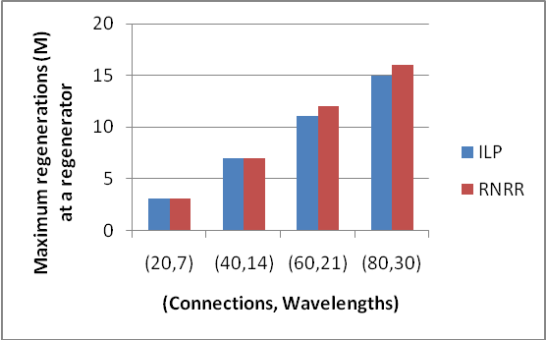

Fig. 7 Comparison of maximum number of regenerations (M) at a regenerator obtained using RNRR and ILP for different experiments in NSF network.

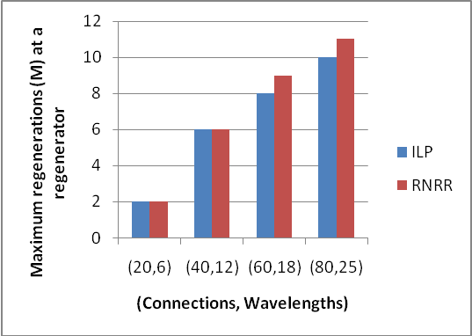

Fig. 8 Comparison of maximum number of regenerations (M) at a regenerator obtained using RNRR and ILP for different experiments in ARPANET.

Comparison of total execution time required for RNRR and the ILP is shown in Fig.9 and Fig.10 for the two networks. The figures show that the heuristic is able to compute near-optimal solutions in a small fraction of time needed to compute the optimal solutions by the ILP.

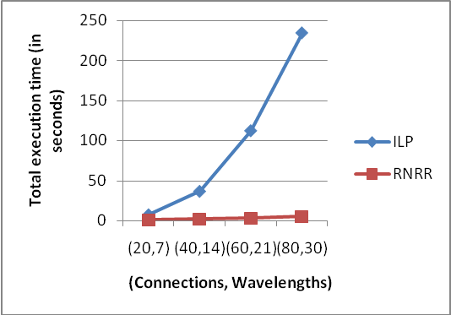

Fig. 9 Comparison of total execution time taken by RNRR and ILP in NSF network.

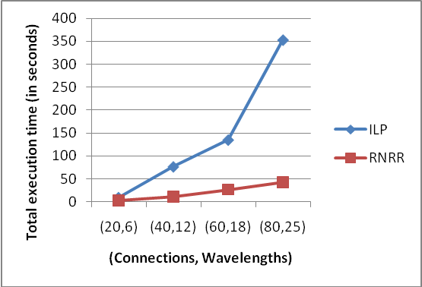

Fig. 10 Comparison of total execution time taken by RNRR and ILP in ARPANET.

For set size of 100 or more connections, CPLEX failed to respond within a reasonable time and since we report here an average value of 10 experiments conducted for each set size, we compare the performance of the heuristics. We thus compare the performance of the three heuristic FSR, FSR-RNRR and RNRR for connections of set size 100, 200, 300, 400 and 500 in the two networks.

Comparison of total number of regenerations (T) in non-blocking condition obtained in different experiments by using the three heuristics is shown in Fig.11 and Fig.12 for the two networks. The figures show that in each experiment only a small increase in T value resulted by using the proposed heuristics in comparison to FSR. In fact, the average (maximum) increase in T values using FSR-RNRR and RNRR in comparison to FSR over all experiments in NSF network are 1.5 (3.58) and 3.07 (6.15) respectively whereas in ARPANET these values are 1.8 (3) and 4.8 (8) respectively. These results reveal that the objective of minimizing number of regenerations at regenerators may not necessarily result in a substantial increase in total number of regenerations in the network.

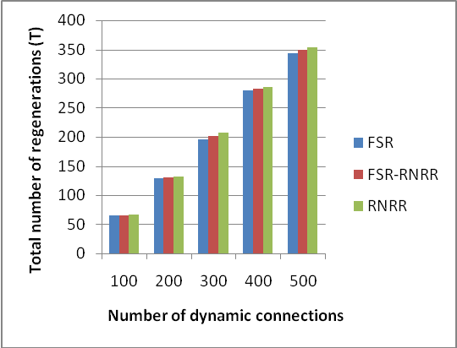

Fig. 11 Comparison of total number of regenerations (T) computed by the three heuristics in NSF network.

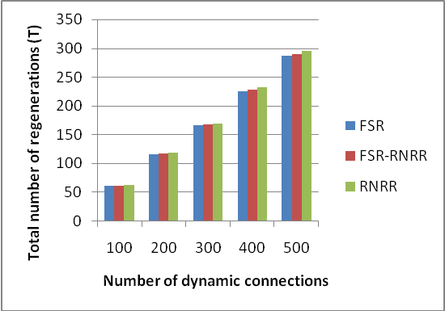

Fig. 12 Comparison of total number of regenerations (T) computed by the three heuristics in ARPANET.

Comparisons of maximum number of regenerations (M) at a regenerator computed by the three heuristics in non-blocking conditions for different experiments in the two networks are shown in Fig.13 and Fig.14. The figures show that in each experiment a substantial decrease in M value resulted by using the proposed heuristics in comparison to FSR. In fact, the average (maximum) decrease in M values using FSR-RNRR and RNRR in comparison to FSR over all experiments in NSF network are 21.08 (26.37) and 26.08 (30.87) respectively whereas in ARPANET these values are 13.6 (18) and 16.6 (23) respectively. The results further show that the proposed heuristics are able to reduce the number of regenerations at the regenerators by an appreciable amount with only a small increase in total number of regenerations (T).

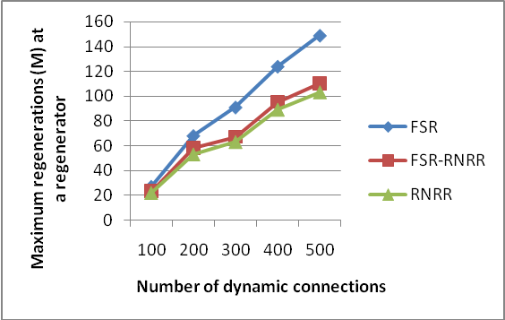

Fig. 13 Comparison of maximum number of regenerations (M) at a regenerator computed by the three heuristics in NSF network.

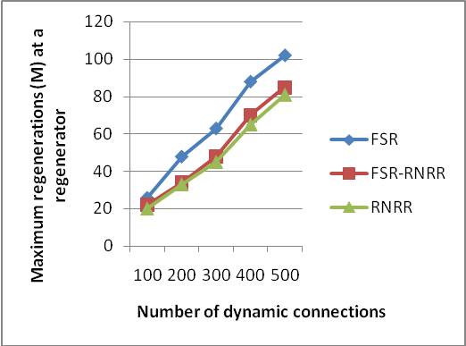

Fig. 14 Comparison of maximum number of regenerations (M) at a regenerator computed by the three heuristics in ARPANET.

Table 1 and Table 2 compare the standard deviation (S.D) of the values of regenerations that occurred at the regenerators in the two networks. The results show that the proposed heuristics perform better than FSR. The low value of S.D. in every experiment signifies that regenerations occurred more uniformly at the regenerators in our heuristics than that of FSR. RNRR however outperforms the others.

Table 1. Standard deviation of the values of regenerations at regenerators in NSF network

No of connections | S.D of RNRR | S.D. of FSR-RNRR | S.D. of FSR
100 | 4.5 | 5.2 | 9.9
200 | 8.9 | 9.2 | 22.6
300 | 8.87 | 10.3 | 30.5
400 | 9.3 | 11.87 | 38
500 | 11.85 | 12.6 | 43

Table 2. Standard deviation of the values of regenerations at regenerators in ARPANET

No of connections | S.D of RNRR | S.D. of FSR-RNRR | S.D. of FSR
100 | 5.7 | 5.95 | 7.58
200 | 9.8 | 11 | 14.3
300 | 12.5 | 13.6 | 19
400 | 16.6 | 17.5 | 26.5
500 | 20.1 | 22.6 | 32.2

In Fig.15 and Fig.16, the effect of number of wavelengths (W) in links on connection blocking probability (CBP) is compared with 100 connections in the two networks. The proposed heuristics provide much superior blocking performance compared to FSR. The maximum percentage decrease in CBP using FSR-RNRR and RNRR over FSR is 42.85 % and 52.38 % respectively in NSF network and 36.36 % and 45.45 % respectively in ARPANET. This occurs at the highest value of W, i.e. for W = 50 in NSF network and W = 40 in ARPANET. This is because connections that were blocked due to lesser number of wavelengths in links are now routed successfully with increase in number of wavelengths. The proposed RNRR outperforms others in terms of CBP for every experiment that is conducted. This is because employing RNRR results in computation of paths between every S and D in a way that balance the number of times regeneration occurs at a regenerator and hence results in a balanced traversal of the links that leads to a regenerator.

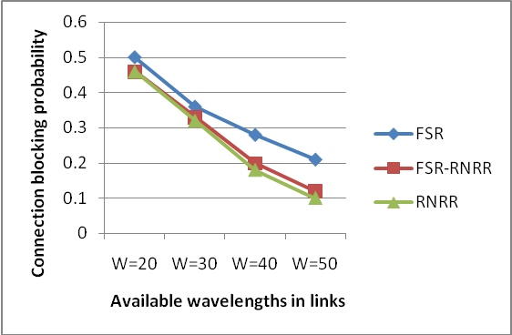

Fig. 15 Comparison of the effect of number of wavelength in links on connection blocking probability with 100 connections in NSF network.

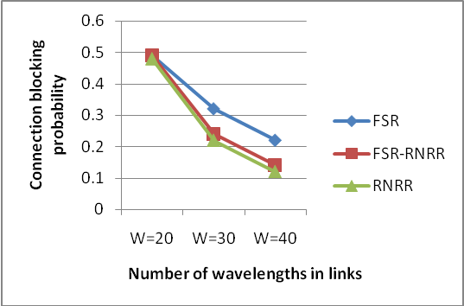

Fig. 16 Comparison of the effect of number of wavelength in links on connection blocking probability with 100 connections in ARPANET.

In Fig.17 and Fig.18, the effect of regeneration resources on CBP is compared with 500 connections in both the networks and with a fixed number (s = 2) of allowable segments in lightpath route. The same is compared for the two networks in Fig.19 and Fig.20 with 500 connections and with a fixed (s = 3) number of allowable segments. For s =2, the maximum percentage decrease in CBP using FSR-RNRR and RNRR over FSR is 19.35 % and 22.58 % respectively in NSF network and 31.25 % and 31.25 % respectively in ARPANET. For s =3, the maximum percentage decrease in CBP using FSR-RNRR and RNRR over FSR is 40 % and 45 % respectively in NSF network and 33.33 % and 41.66 % respectively in ARPANET. This maximum decrease in CBP occurs when the number of regeneration resources (N) allocated at the regenerators is the highest, i.e. for N = 80 in both NSF network and ARPANET. This is because translucent lightpaths that failed to undergo regeneration and blocked consequently are now successfully regenerated due to the high value of N. The results show that a considerable lowering of CBP was achieved using the proposed heuristics with RNRR outperforming others.

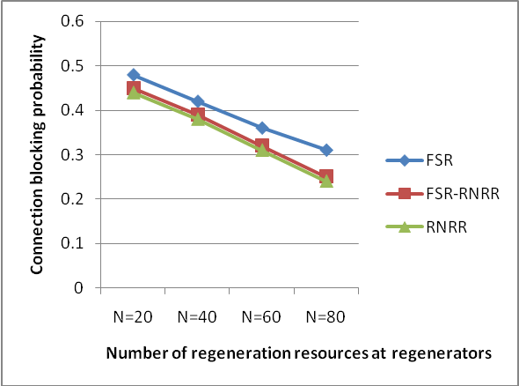

Fig. 17 Comparison of the effect of regeneration resources on connection blocking probability with 500 connections in NSF network and with two allowable segments (s = 2) in lightpath route.

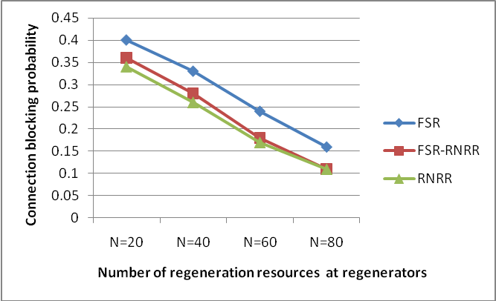

Fig. 18 Comparison of the effect of regeneration resources on connection blocking probability with 500 connections in ARPANET and with two allowable segments (s = 2) in lightpath route.

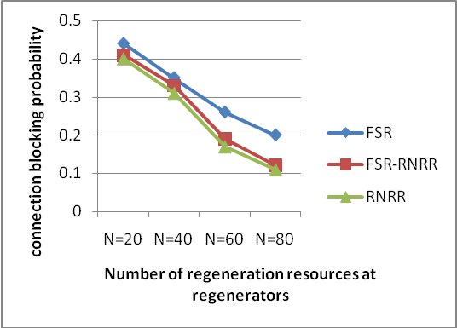

Fig. 19 Comparison of the effect of regeneration resources on connection blocking probability with 500 connections in NSF network and with three allowable segments (s = 3) in lightpath route.

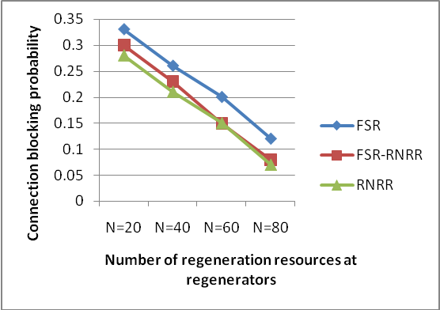

Fig. 20 Comparison of the effect of regeneration resources on connection blocking probability with 500 connections in ARPANET and with three allowable segments (s = 3) in lightpath route.
In Fig.21 and Fig.22, the effect of the number of segments (s) in a lightpath route on CBP is compared with 500 connections in both the networks and with a given number (N = 40) of regeneration resources at regenerators. The same is compared for the two networks in Fig.23 and Fig.24 with 500 connections and with a given (N = 80) number of regeneration resources at every regenerator. For N = 40, the maximum percentage decrease in CBP using FSR-RNRR and RNRR over FSR is 12.12 % and 15.15 % respectively in NSF network and 21.73 % and 26.08 % respectively in ARPANET. For N =80, the maximum percentage decrease in CBP using FSR-RNRR and RNRR over FSR is 50 % and 55.55 % respectively in NSF network and 40 % and 40 % respectively in ARPANET. The maximum decrease in CBP was obtained when the number of segments (s) was allowed to be 4 in both networks. This is because with increase in the value of s more translucent lightpaths routes could be established without the need of additional regeneration resources. The results show that a significant lowering of CBP in this case too was achieved using the proposed heuristics. Heuristic RNRR in this case too outperformed others.

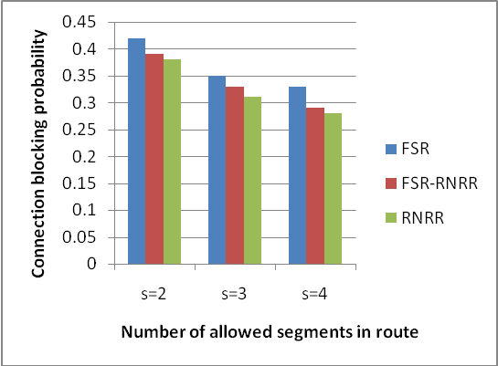

Fig. 21 Comparison of the effect of segments in lightpath routes on call blocking probability with 500 connections in NSF network and with 40 regeneration resources (N = 40) at regenerators.

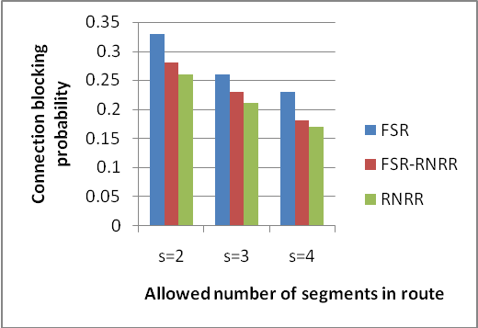

Fig. 22 Comparison of the effect of segments in lightpath routes on connection blocking probability with 500 connections in ARPANET and with 40 regeneration resources (N = 40) at regenerators.

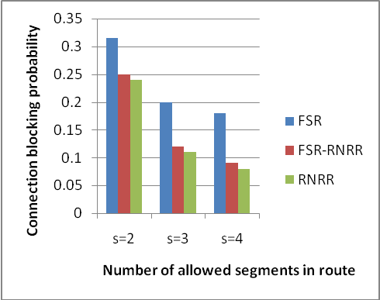

Fig. 21 Comparison of the effect of segments in lightpath routes on connection blocking probability with 500 connections in NSF network and with 80 regeneration resources (N = 80) at regenerators.

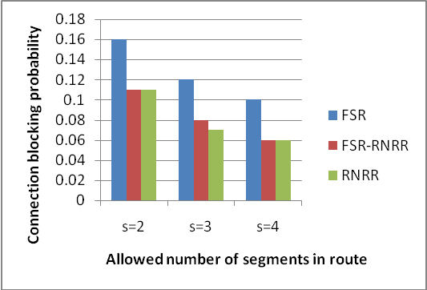

Fig. 22 Comparison of the effect of segments in lightpath routes on connection blocking probability with 500 connections in ARPANET and with 80 regeneration resources (N = 80) at regenerators.

VII. Conclusion

In this paper, we study the problem of minimizing the number of regenerations (or cost of regeneration) at regenerators during dynamic allocation of lightpaths in translucent optical networks, taking into account OSSP. To the best of our knowledge this problem was not addressed earlier though authors have addressed the problem of dynamic RWA of connections by allocating lightpaths through minimum stages of regeneration. We have proposed an ILP formulation to show how the problem can be addressed and then proposed two efficient heuristics for the problem. The proposed heuristics outperformed an existing heuristic in every experiment that was performed. Our heuristic RNRR was able to provide the best results with an extremely small increase in total number of regenerations in the network. Connection blocking probability was studied extensively through simulation experiments. At first, blocking probability was studied by varying the number of wavelengths in links, it was then studied by keeping the number of allowable segments fixed while varying the number of regeneration resources at regenerators and it was studied further by varying the number of segments with a given number of regeneration resources at regenerators. In every experiment where connection blocking probability was studied, our heuristics outperformed the existing one. The results of this work, show that minimizing the number of regenerations at regenerators can be a better choice of objective to address the problem of dynamic establishment of lightpaths in presence of fixed regenerator locations than focusing on minimizing the stages of regeneration that a lightpath route passes through. If the objective is primarily to minimize stages of regeneration in lightpath routes, this work shows how it should be carried out by proposing FSR-RNRR to improve blocking performance.

References

1. S. Bandyopadhyay, “Dissemination of Information in Optical Networks”, Springer, 2008.

2. G. Shen and R.S. Tucker, “Translucent optical networks: the way forward”, IEEE Communications Magazine vol.45 no.2, 2007, pp. 48-54.

3. J. Simmons, “On determining the optimal optical reach for a long-haul network,” Journal of Lightwave Technology, vol.23, no.3, 2005, pp. 1039-1048.

4. J. Simmons, “Network design in realistic all-optical backbone networks”, IEEE Communications Magazine vo.44, no.11, 2006, pp. 88-94.

5. X. Yang and B. Ramamurthy, “Sparse regeneration in translucent wavelength routed optical networks: architecture, network design and wavelength routing,” Photonic Network Communication., vol.10, no.1, 2005, pp. 39-53.

6. A. Sen, S. Murthy and S. Bandyopadhyay, “On sparse placement of regenerator nodes in translucent optical network”, Proc. IEEE Global Telecommunications Conference (IEEE GLOBECOM 2008), 2008, pp. 1-6.

7. S. Chen, I. Ljubic and S. Raghavan, “The regenerator location problem”, Networks, Wiley-Interscience New York, USA, vol.55, no.3, 2010, pp. 205-220.

8. A. Sen, S. Banerjee, P. Ghosh, S. Murthy and H. Ngo, “Brief announcement: On regenerator placement problems in optical networks”, Proc. ACM Symposium on Parallelism in algorithms and architectures (SPAA, 2010), 2010, pp. 178-180.

9. D. Lucerna, N. Gatti, G. Maier and A. Pattavina, “On the efficiency of a game theoretic approach to sparse regenerator placement in WDM networks”, Proc. IEEE Global Telecommunications Conference (IEEE GLOBECOM 2009), 2009, pp. 1-6.

10. Y. Zhu, X. Gao, W. Wu, and J.P. Jue, “Efficient impairment-constrained 3R regenerator placement for light-trees in optical networks”, IEEE/OSA Journal of Optical Communications and Networking, vol.3, no.4, 2011, pp. 359-371.

11. M. Flammini, A. Marchetti-Spaccamela, G. Monaco, L. Moscardelli, and S. Zaks, “On the complexity of the regenerator placement problem in optical networks”, IEEE/ACM Transactions on Networking, vol.19, no.2, 2011, pp. 498-511.

12. Q. Rahman, Y. Aneja, S. Bandyopadhyay and A. Jaekel, “Optimal regenerator placement in survivable translucent networks”, Proc. of International Conference on Design of Reliable Communication Networks (DRCN 2014), 2014, pp. 1-7.

13. C.V. Saradhi and S. Subramaniam, “Physical layer impairment aware routing (PLIAR) in WDM optical networks: issues and challenges”, IEEE Communications Surveys and Tutorials, vol.11, no.4, 2009, pp. 109-130.

14. S. Azodolmolky, M. Klinkowski, E. Marin, D. Careglio, J.S. Pareta and I. Tomkos, “A survey on physical layer impairments aware routing and wavelength assignment algorithms in optical networks”, Computer Networks, vol. 53, no.7, 2009, pp. 926-944.
15. M. Gagnaire and S. Zahr, “Impairment-aware routing and wavelength assignment in translucent networks: State of the art, IEEE Communications Magazine”, vol. 47, no. 5, 2009, pp. 55-61.

16. S. Azodolmolky, M. Angelou, I. Tomkos, T. Panayiotou, G. Ellinas and N. Antoniades, “Impairment-aware optical networking: A survey”, WDM Systems and Networks, Optical Networks, Springer, 2011, pp. 443-479.

17. C. Politi, V. Anagnostopoulos and A. Stavdas, “Pli-aware routing in regenerated mesh topology optical networks”, Journal of Lightwave Technology, vol.30, no.12, 2012, pp. 1960-1970.

18. K. Manousakis, K. Christodoulopoulos, E. Kamitsas, I. Tomkos, and E.A. Varvarigos, “Offline impairment-aware routing and wavelength assignment algorithms in translucent WDM optical networks”, Journal of Lightwave Technology, vol.27, no.12, 2009, pp. 1866-1877.

19. B. Garcia-Manrubia, P. Pavon-Marino, R. Aparicio-Pardo, M. Klinkowski and D. Careglio, “Offline impairment-aware RWA and regenerator placement in translucent optical networks”, Journal of Lightwave Technology, vol.29, no.3, 2011, pp. 265-277.

20. X. Yang and B. Ramamurthy, “Dynamic routing in translucent WDM optical networks”, IEEE International Conference on Communications (IEEE ICC 2002), 2002, vol.5, pp. 2796-2802.

21. X. Yang and B. Ramamurthy, “Dynamic routing in translucent WDM optical networks: the intradomain case”, Journal of Lightwave Technology vol.23, no.3, 2005, pp. 955-971.

22. S. Bandyopadhyay, Q. Rahman, S. Banerjee, S. Murthy, and A. Sen, “Dynamic lightpath allocation in translucent WDM optical networks,” Proc. IEEE International Conference on Communications (IEEE ICC 2009), 2009, pp. 1-6.

23. J. Zhao, S. Subramaniam and M. Brandt-Pearce, “Intradomain and interdomain QoT aware RWA for translucent optical networks”, IEEE/OSA Journal of Optical Communications and Networking, vol.6, no.6, 2014, pp. 536-548.

24. T. Panayiotou, K. Manousakis, G. Ellinas, “Static impairment-aware multicast session provisioning in metro optical networks”, Proc. of 18th Mediterranean Electrotechnical Conference 2016 (MELECON 2016), Cyprus, 2016, pp. 1-6.

25. D. A. R. Chaves, M. A. Cavalcante, H. A. Pereira and R. C. A. Jr, “A case study of regenerator placement and regenerator assignment in dynamic translucent elastic optical networks”, Proc. of International Conference on Transparent Optical Networks 2016 (ICTON 2016), pp. 1-4.

26. K. Yamazaki, H. Matsushita and M. Jinno, “Virtualized-elastic-regenerator placement by firefly algorithm for translucent elastic optical networks”, 2016 IEEE Congress on Evolutionary Computation (IEEE CEC 2016), pp. 2866-2872.

27. J.Y. Yen, “Finding the k shortest loopless paths in a network”, Management Science, vol. 17 no. 11, 1971, pp.712-716.

28. I. Chlamtac, A. Ganz and G. Karmi, “Lightnets: Topologies for high speed optical networks”, Journal of Lightwave Technology, vol.11, no.5, pp. 951-961.

29. E. Rich and K. Knight, “Artificial Intelligence”, McGraw Hill, New York, 2nd Edition, 2009.

