|  |
| --- |
| Experiment No.4 |
| Create a child process in Linux using the fork system call. |
| Date of Performance:12/02/2024 |
| Date of Submission:19/02/2024 |

**Aim:** Create a child process in Linux using the fork system call. From the child process obtain the process ID of both child and parent by using getpid and getppid system call.

**Objective:** The purpose of fork() is to create a new process, which becomes the child process of the caller. After a new child process is created, both processes will execute the next instruction following the fork() system call.

**Theory:**

A system call is the programmatic way in which a [computer program](https://en.wikipedia.org/wiki/Computer_program) requests a service from the [kernel](https://en.wikipedia.org/wiki/Kernel_(computing)) of the [operating system](https://en.wikipedia.org/wiki/Operating_system) it is executed on. This may include hardware-related services (for example, accessing a [hard disk drive)](https://en.wikipedia.org/wiki/Hard_disk_drive), creation and execution of new [processes,](https://en.wikipedia.org/wiki/Process_(computing)) and communication with integral [kernel services](https://en.wikipedia.org/wiki/Kernel_service) such as [process scheduling.](https://en.wikipedia.org/wiki/Process_scheduling) System calls provide an essential interface between a process and the operating system.

System call **fork()** is used to create processes. It takes no arguments and returns a process ID. The purpose of **fork()** is to create a **new** process, which becomes the child process of the caller.

* If **fork()** returns a negative value, the creation of a child process was unsuccessful.
* **fork()** returns a zero to the newly created child process.
* **fork()** returns a positive value, the **process ID** of the child process, to the parent. The returned process ID is of type **pid_t** defined in **sys/types.h**. Normally, the process ID is an integer. Moreover, a process can use function **getpid()** to retrieve the process ID assigned to this process.

If the call to **fork()** is executed successfully, Unix will make two identical copies of address spaces, one for the parent and the other for the child.

**getpid, getppid - get process identification**

* **getpid()** returns the process ID (PID) of the calling process. This is often used by routines that generate unique temporary filenames.
* **getppid()** returns the process ID of the parent of the calling process. This will be either the ID of the process that created this process using fork().

**Result:**

#include <stdio.h>

#include <sys/types.h>

#include <unistd.h> #include <fcntl.h> int main() { pid_t p, p1, p2;

int num1 = 10, num2 = 20, num3 = 15;

int largest, smallest; // Find largest number

if (num1 >= num2 && num1 >= num3)

largest = num1;

else if (num2 >= num1 && num2 >= num3)

largest = num2;

else

largest = num3; // Find smallest number

if (num1 <= num2 && num1 <= num3)

smallest = num1;

else if (num2 <= num1 && num2 <= num3)

smallest = num2;

else

smallest = num3; printf("The largest number is %d\n", largest); printf("The smallest number is %d\n", smallest);

fork(); fork(); fork(); p = getpid(); p1 = getppid(); printf("Current process id is %d and its parent id is %d \n", p, p1); p2 = getuid(); printf("The real user id of the calling process is %d \n", p2); p2 = geteuid(); printf("The effective user id of the calling process is %d \n", p2); p2 = getgid(); printf("The real group id of the calling process is %d \n", p2); p2 = getegid(); printf("The effective group id of the calling process is %d \n", p2);

int fd;

char buffer[80]; static char message[ ] = "Comparison done"; fd = open("abc.txt", O_RDWR);

if (fd != -1) { printf("abc.txt opened with read/write access \n"); write(fd, message, sizeof(message));

lseek(fd, 0, 0); read(fd, buffer, sizeof(message)); printf("%s - was written to abc.txt\n", buffer);

close(fd); } else { printf("Failed to open abc.txt\n");

}

return 0; }

**OUTPUT**

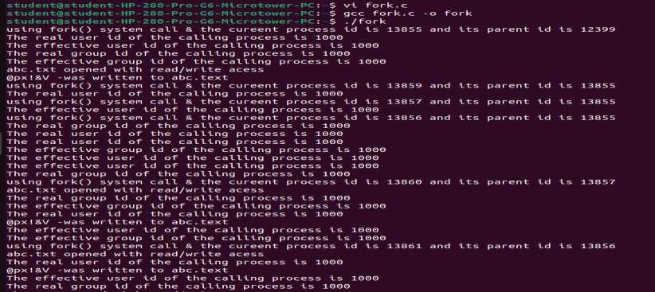

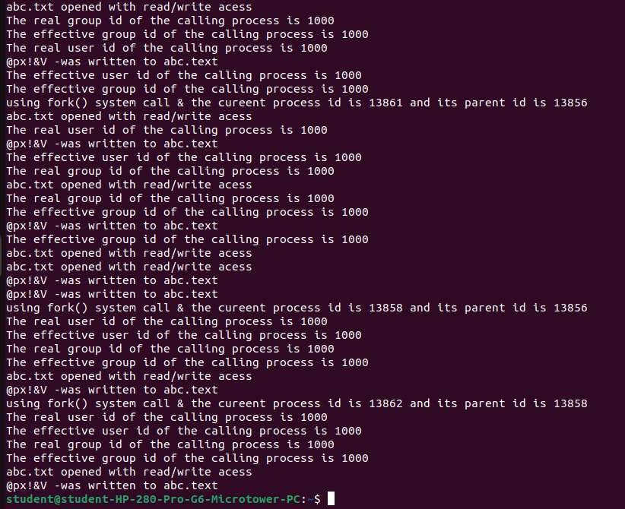

**Conclusion:** In Unix-like operating systems, the `fork()` system function duplicates the current process to start a new one. It is utilized for concurrency, isolation, parallel processing, parallel execution, and process formation. Programs may execute tasks concurrently thanks to `fork()}, effectively splitting workloads. It makes it possible to build concurrent and multitasking processes, each with its own memory and resources. Furthermore, `fork()} is necessary for networking applications that leverage forking servers and the creation of background processes.