|  |
| --- |
| Experiment No.5 |
| Explore the system calls in Linux. |
| Date of Performance:19/2/2024 |
| Date of Submission:26/02/2024 |

**Aim:**  Explore the system calls open, read, write, close, getuid, getgid, getegid, geteuid of Linux.

**Objective:** When a program in user mode requires access to RAM or a hardware resource, it must ask the kernel to provide access to that resource. This is done via a system call.

**Theory:**

**getuid, geteuid** - get user identity **getgid, getegid** - get group identity

* **getuid**() returns the real user ID of the calling process.
* **geteuid**() returns the effective user ID of the calling process.
* **getgid()** returns the real group ID of the calling process.
* **getegid()** returns the effective group ID of the calling process.

All four functions shall always be successful and no return value is reserved to indicate an error.[Unix-like](https://en.wikipedia.org/wiki/Unix-like) operating systems identify a user within the [kernel](https://en.wikipedia.org/wiki/Kernel_(computing)) by a value called a **user identifier**, often abbreviated to **user ID** or **UID**. The UID, along with the [group identifier](https://en.wikipedia.org/wiki/Group_identifier) (GID) and other access control criteria, is used to determine which system resources a user can access.

# Effective user ID

The effective UID (euid) of a process is used for most access checks. It is also used as the owner for files created by that process. The effective GID (egid) of a process also affects access control and may also affect file creation, depending on the semantics of the specific kernel implementation in use and possibly the mount options used.

**Open**: Used to Open the file for reading, writing or both. Open() returns file descriptor **3** because when main process created, then fd **0, 1, 2** are already taken by **stdin**, **stdout** and **stderr**. So first unused file descriptor is **3** in file descriptor table.

int open(const char *pathname, int flags);

# Parameters

* **Path :** path to file which you want to use
* use absolute path begin with “/”, when you are not work in same directory of file.
* Use relative path which is only file name with extension, when you are work in same directory of file.
* **flags :** How you like to use
* **O_RDONLY**: read only, **O_WRONLY**: write only, **O_RDWR**: read and write, **O_CREAT**: create file if it doesn’t exist

**Close:** Tells the operating system you are done with a file descriptor and Close the file which pointed by fd. int close (int fd);

**Parameter**

* **fd :**file descriptor

# Return

* **0** on success.
* **-1** on error.

**read:** Read data from one buffer to file descriptor, Read **size** bytes from the file specified by fd into the memory location.

size_t read (int fd, void* buf, size_t cnt);

# Parameters

* **fd:** file descripter
* **buf:** buffer to read data from
* **cnt:** length of buffer

# Returns: How many bytes were actually read

* return Number of bytes read on success
* return 0 on reaching end of file
* return -1 on error
* return -1 on signal interrupt

**Write:** Write data from file descriptor into buffer, Writes the bytes stored in **buf** to the file specified by **fd**. The file needs to be opened for write operations size_t write (int fd, void* buf, size_t cnt);

# Parameters

* **fd:** file descripter
* **buf:** buffer to write data to
* **cnt:** length of buffer

# Returns: How many bytes were actually written

* return Number of bytes written on success
* return 0 on reaching end of file
* return -1 on error
* return -1 on signal interrupt

**Result:**

#include <stdio.h>

#include <sys/types.h>

#include <unistd.h> #include <fcntl.h> int main(void) {

pid_t p, p1, p2; fork(); p = getpid(); p1 = getppid(); printf("Using fork() system call & the current process id is %d and parent id is %d \n", p, p1); p2 = getuid(); printf("The real id for calling process is %d \n", p2); p2 = geteuid(); printf("The effective user id for calling process is %d \n", p2); p2 = getgid(); printf("The real group id for calling process is %d \n", p2); p2 = getegid(); printf("The effective group id for calling process is %d \n", p2);

int fd;

char buffer[80];

// Changed to an array of three integers static int numbers[] = {10, 20, 30};

fd = open("adc.txt", O_RDWR | O_CREAT, 0644); // Added O_CREAT flag to create the file if it doesn't exist if (fd != -1) { printf("adc.txt opened with read/write access \n");

// Write the numbers to the file write(fd, numbers, sizeof(numbers)); lseek(fd, 0, SEEK_SET); // Reset the file pointer to the beginning

// Read the numbers back into the buffer read(fd, buffer, sizeof(numbers));

// Convert the buffer back to integers for comparison

int num1 = (int)&buffer[0]; int num2 = (int)&buffer[4]; int num3 = (int)&buffer[8]; // Find the greatest and smallest numbers int greatest = num1, smallest = num1; if (num2 > greatest) greatest = num2; if (num3 > greatest) greatest = num3; if (num2 < smallest) smallest = num2; if (num3 < smallest) smallest = num3;

// Print the results

printf("The greatest number is %d\n", greatest); printf("The smallest number is %d\n", smallest);

close(fd); }

return 0;

}

# OUTPUT:-

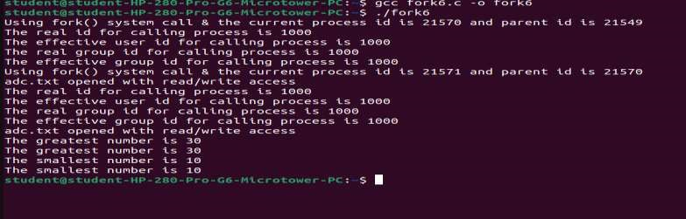

**Conclusion:** System calls are an important API for user space code to execute privileged kernel actions. Calling a system call from user space involves adding the correct arguments to registers, and trapping into the kernel. Normally this is taken care of by functions in the C library.