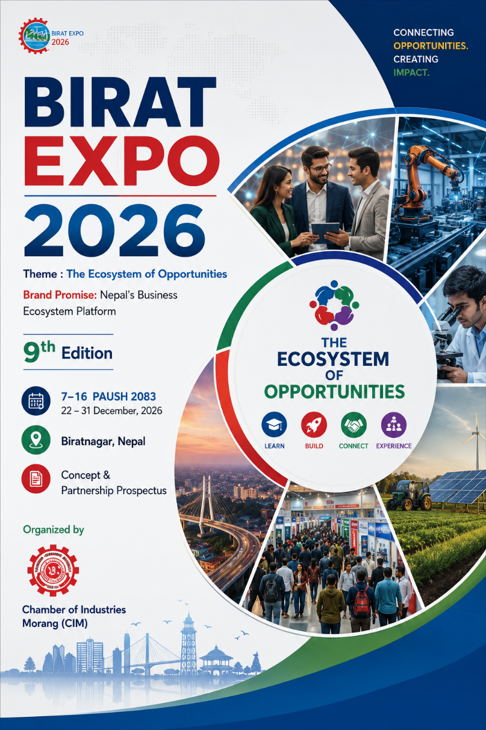
BIRAT EXPO 2026

Theme : The Ecosystem of Opportunities

Brand Promise: Nepal's Business Ecosystem Platform
9th Edition
7–16 Poush 2083
22 – 31 December, 2026
Biratnagar, Nepal
Concept & Partnership Prospectus

Organized by
Chamber of Industries Morang (CIM)

"Opportunities do not emerge in isolation. They are created when ideas, people, enterprises, investment and innovation come together. Birat Expo exists to make those connections possible."

1. Birat Expo at a Glance
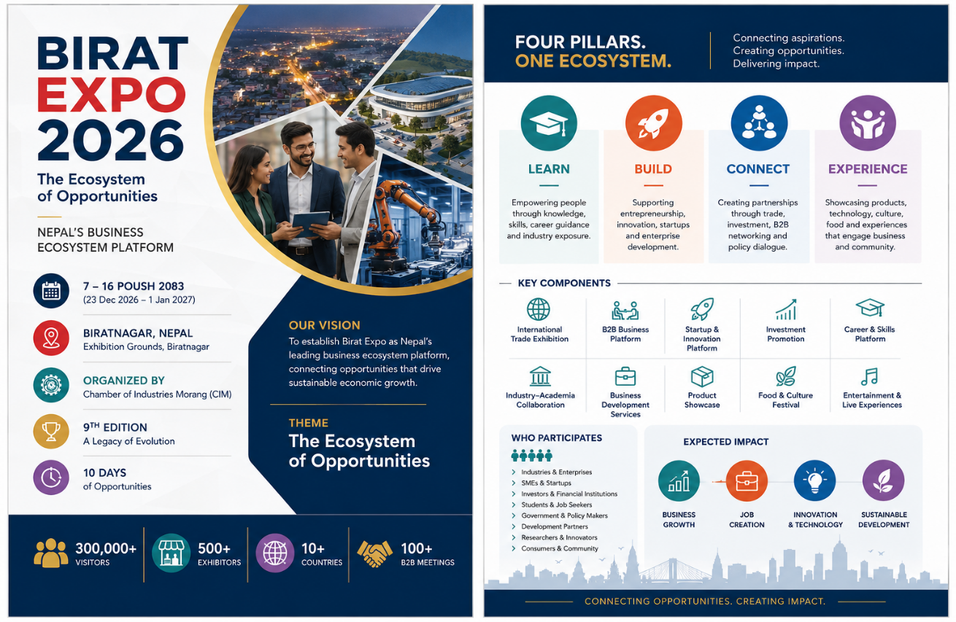

4.

2.The Evolution of Birat Expo

For nearly three decades, Birat Expo has evolved alongside the economic transformation of Eastern Nepal. Organized by the Chamber of Industries Morang (CIM), the Expo has continuously adapted to meet the changing aspirations of industries, entrepreneurs, businesses and society.
The journey began in 2053 B.S. with Koshi Mahotsav, creating a new platform to promote trade, local industries and regional economic activity.
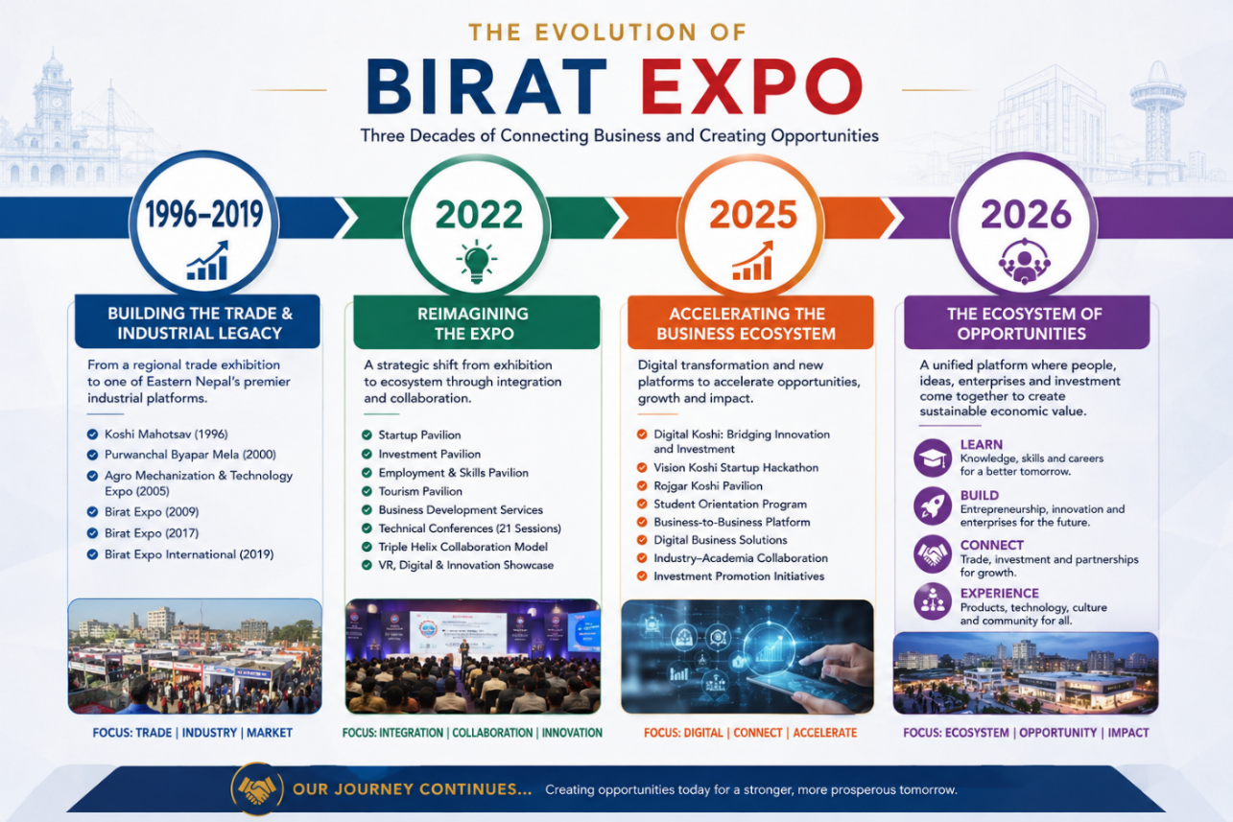
Over the years, this vision expanded through Purwanchal Byapar Mela, the Agro Mechanization & Technology Exhibition, and successive editions of Birat Expo, each contributing to the promotion of industry, commerce, agriculture, technology and investment.
The first six editions established Birat Expo as one of Eastern Nepal's premier trade and industrial exhibitions, strengthening business networking, industrial promotion and regional economic cooperation.
The 7th Edition (2022) marked a strategic transformation. Birat Expo expanded beyond product exhibition by introducing integrated platforms for startups, investment, employment, skills, tourism, business development services, technical conferences and the Triple Helix collaboration model. The Expo became a place where industries, entrepreneurs, academia and government interacted to address broader economic challenges.
Building upon this transformation, the 8th Edition (2025) embraced the theme "Digital Koshi: Bridging Innovation and Investment." It further strengthened the ecosystem approach by introducing the Vision Koshi Startup Hackathon, Rojgar Koshi Pavilion, Student Orientation Program, Business-to-Business Platform, Business Development Services and Digital Business Solutions. These initiatives demonstrated that an expo could actively connect education, entrepreneurship, employment, innovation and investment.
Today, Birat Expo enters its 9th Edition with a broader purpose. It is no longer defined simply by exhibitions or business transactions. It is defined by the opportunities it creates. The Ecosystem of Opportunities

3. The Ecosystem of Opportunities
Economic growth is not created through isolated initiatives. It is created through ecosystems.
An ecosystem where businesses collaborate rather than compete in isolation. Where students connect with industries. Where entrepreneurs meet investors. Where innovation reaches markets. Where policy meets practice. Where partnerships create impact. This philosophy defines Birat Expo 2026. Every participant enters the Expo seeking a different opportunity.
A student seeks learning. A job seeker seeks employment. A startup seeks investment. An entrepreneur seeks partnerships. An MSME seeks new markets. An industry seeks technology and talent. A policymaker seeks dialogue. A development partner seeks collaboration. A consumer seeks quality and innovation. Birat Expo connects these aspirations through four strategic pillars.

LEARN: Knowledge, Skills, Career, Education and Industry Exposure.

BUILD : Entrepreneurship, Innovation, Startups, Enterprise Development.

CONNECT: Trade, Investment, Business Networking, Policy Dialogue, Strategic Partnerships.

EXPERIENCE: Products, Technology, Culture, Food, Entertainment, Community.

4. Birat Expo 2026 Creating Opportunities Through an Integrated Business Ecosystem

Introduction
Birat Expo 2026 is designed around a simple yet powerful belief:
Every visitor comes to the Expo in search of an opportunity.
Some seek knowledge.
Some seek employment.
Some seek business growth.
Some seek investment.
Some seek partnerships.
Some seek innovation.
Some seek inspiration.
Rather than organizing a conventional exhibition around products and pavilions, Birat Expo 2026 is organized around Opportunity Ecosystems—integrated platforms that bring together people, institutions, industries, services and ideas to create meaningful economic and social outcomes.
Each Opportunity Ecosystem is designed to address the unique aspirations of a specific stakeholder while creating connections across the wider business community.
Together, these interconnected ecosystems transform Birat Expo from an exhibition into Nepal's Business Ecosystem Platform.

🎓 Opportunity to Learn
For Students & Future Talent
Connecting education with industry through career guidance, skills development, TVET, industry exposure and entrepreneurship awareness.

💼 Opportunity to Work
For Job Seekers & Professionals
Connecting talent with employers through recruitment, career counselling, internships, apprenticeships and employment services.

🚀 Opportunity to Build
For Startups & Entrepreneurs
Supporting innovation, incubation, mentorship, business coaching and startup development.

📈 Opportunity to Grow
For SMEs
Helping small and medium enterprises strengthen competitiveness through business advisory, digital transformation, branding and market development.

🏭 Opportunity to Expand
For Industries
Creating opportunities for industrial growth through technology adoption, market expansion, exports and strategic partnerships.

🤝 Opportunity to Connect
For Businesses & Traders
Facilitating business networking, B2B meetings, buyer–seller interactions, trade partnerships and collaboration.

💰 Opportunity to Invest
For Investors
Connecting capital with innovation through startup investment, industrial projects, financial institutions and investment-ready enterprises.

🏛 Opportunity to Influence
For Government & Development Partners
Encouraging public–private dialogue, policy consultation, business facilitation and collaborative solutions for economic development.

🛍 Opportunity to Discover
For Consumers
Introducing new products, technologies, brands, services and innovations while promoting local enterprises.

🎭 Opportunity to Experience
For Everyone
Creating memorable experiences through food, culture, technology, entertainment and community engagement.

The Birat Expo Opportunity Model
These ten Opportunity Ecosystems are not independent activities. They are interconnected pathways that enable visitors to discover, connect and create value.
To make these opportunities accessible and practical, Birat Expo organizes them into six integrated Opportunity Zones, where related ecosystems come together to provide a seamless visitor experience.
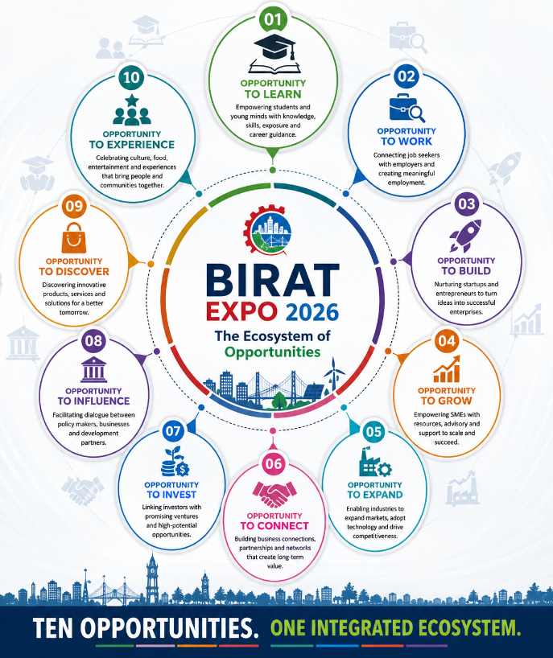

Opportunity Platforms

Where Opportunities Come to Life

From Concept to Experience
Birat Expo 2026 is not organized around exhibition halls alone. It is designed around Opportunity Platforms—integrated environments where people, businesses, institutions, services and ideas come together to create meaningful economic value.
Each Opportunity Platform combines exhibitions, networking, business services, knowledge sharing, live demonstrations and collaboration within a single ecosystem. Rather than visiting isolated stalls, participants experience complete opportunity pathways that help them learn, connect, build, grow and succeed.
These platforms translate the ten Opportunity Ecosystems into practical and engaging experiences throughout the Expo.
Together, they make Birat Expo more than an exhibition—they make it Nepal's Business Ecosystem Platform.

1. Learn & Work Platform

Preparing Talent for the Future
Every successful economy begins with skilled people.
The Learn & Work Platform connects students, job seekers, industries, educational institutions and training providers to bridge the gap between education and employment.
Designed as a complete talent development ecosystem, this platform enables young people to explore career pathways, understand industry expectations and connect directly with employment opportunities.

Major Components
- Career Guidance & Counselling
- Career Aptitude Assessment
- CV Writing Clinic
- Walk-in Interviews
- Job Matching Services
- Internship & Apprenticeship Opportunities
- TVET & Skills Showcase
- Industry Experience Sessions
- Live Skill Demonstrations
- Inspiration Talks
- Future Career Sessions
- JobBriz Career Platform

Target Participants
- Students
- Job Seekers
- Schools & Colleges
- Universities
- TVET Institutions
- Industries
- HR Professionals
- Parents

2. Build Platform

From Ideas to Enterprises
Innovation begins with ideas, but growth requires mentorship, investment and collaboration.
The Build Platform is designed for startups, entrepreneurs and innovators seeking to transform ideas into sustainable businesses.
It creates an environment where entrepreneurship is nurtured through incubation, mentoring, networking and investment readiness.

Major Components
- Startup Pavilion
- Vision Koshi Startup Challenge
- Pitch Competition
- Incubation Support
- Mentor Connect
- Investor Meet
- Angel Investment Network
- Innovation Showcase
- Business Coaching
- Startup Networking

Target Participants
- Startups
- Entrepreneurs
- Innovators
- Incubators
- Investors
- Banks & Financial Institutions
- Development Partners

3. Connect Platform

Growing Businesses Through Strategic Connections
Business growth depends on relationships.
The Connect Platform helps businesses expand through networking, collaboration and market access.
It brings together industries, SMEs, traders, service providers and business support organizations to strengthen partnerships and unlock new opportunities.

Major Components
- Business-to-Business (B2B) Meetings
- Business Matchmaking
- Buyer–Seller Meet
- Business Advisory Services
- Digital Business Platforms
- Export Promotion Desk
- Branding & Marketing Support
- Business Clinic
- Dealer & Distributor Networking
- Business Networking Lounge

Target Participants
- Industries
- SMEs
- Traders
- Exporters
- Importers
- Business Associations
- Service Providers

4. Expand & Discover Platform

Showcasing Products, Services and Innovation
This is the largest exhibition platform within Birat Expo.
It provides businesses with opportunities to showcase products, services, technologies and innovations while enabling consumers and buyers to discover new solutions and market trends.

Major Components
- National Product Exhibition
- International Pavilion
- Industrial Showcase
- SME Pavilion
- Made in Nepal Pavilion
- Technology Showcase
- Product Launches
- Live Demonstrations
- Consumer Experience
- Business Promotion

Target Participants
- Industries
- SMEs
- National Exhibitors
- International Exhibitors
- Buyers
- Consumers
- Trade Visitors

5. Experience Platform

Celebrating Business, Culture and Community
Business exhibitions are also places where communities connect, celebrate and experience innovation together.
The Experience Platform creates a vibrant atmosphere that blends commerce with culture, food, tourism and entertainment, making Birat Expo an engaging destination for families and visitors of all ages.
Unlike other platforms, the Experience Platform extends across the entire Expo venue, enriching every visitor's journey.

Major Components
- Food Festival
- Cultural Performances
- Entertainment Programs
- Family Activities
- Live Demonstrations
- Tourism Promotion
- Interactive Experiences
- Evening Events

Target Participants
- Families
- Youth
- Visitors
- Tourists
- Consumers
- Communities

6. Influence Platform

Shaping Policies. Strengthening Partnerships.
A competitive economy requires constructive dialogue between the public and private sectors.
The Influence Platform serves as a collaborative space where government agencies, policymakers, business leaders, development partners and academia come together to discuss policy priorities, address business challenges and identify practical solutions for sustainable economic growth.

Major Components
- Policy Dialogue Sessions
- Business Clinic
- Government Service Desk
- Public–Private Dialogue
- Roundtable Discussions
- Development Partner Forum
- Business Leaders Forum
- Policy Research Showcase
- White Paper Launches

Target Participants
- Government Agencies
- Policymakers
- Private Sector
- Development Partners
- Business Associations
- Academic Institutions
- Think Tanks
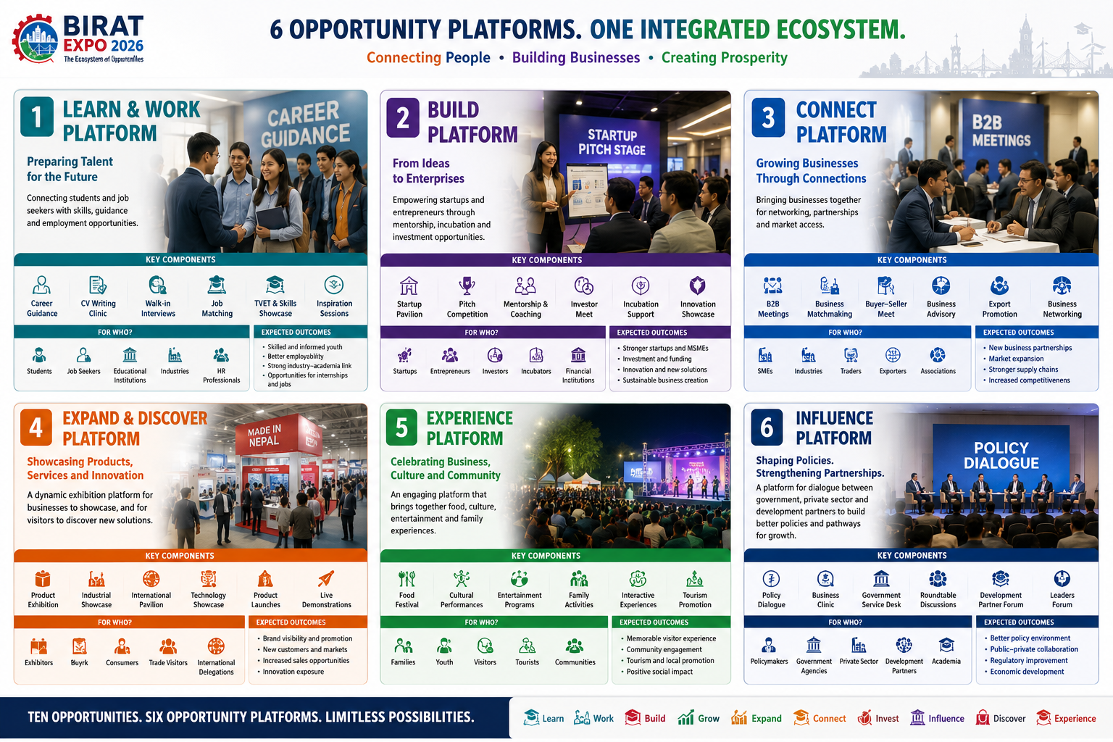

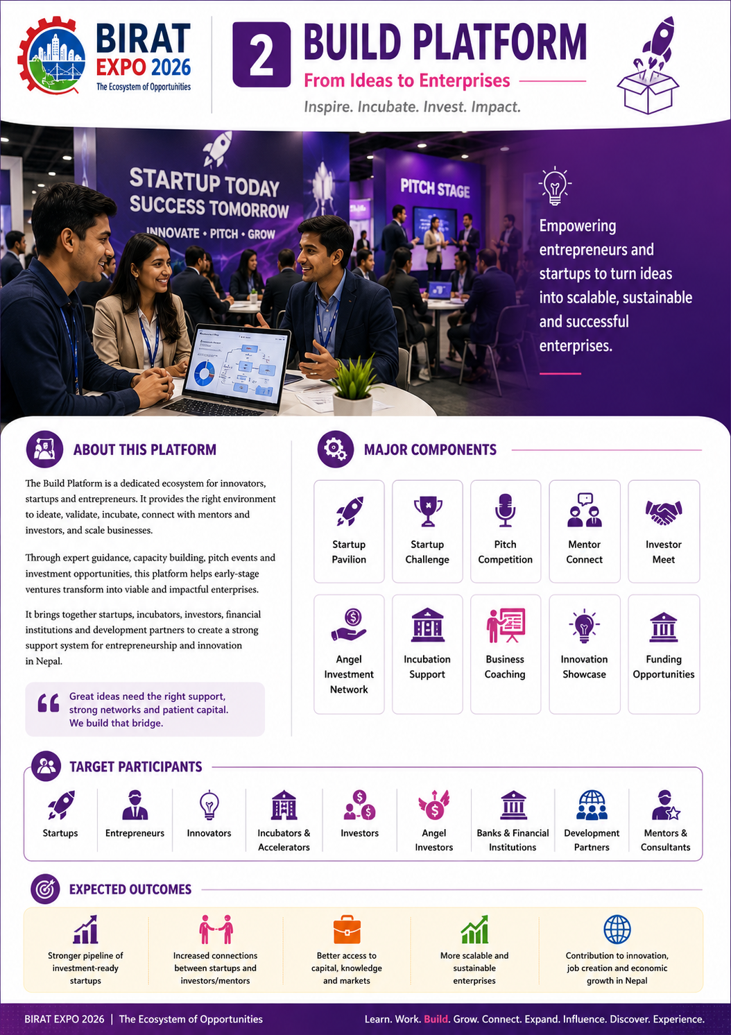

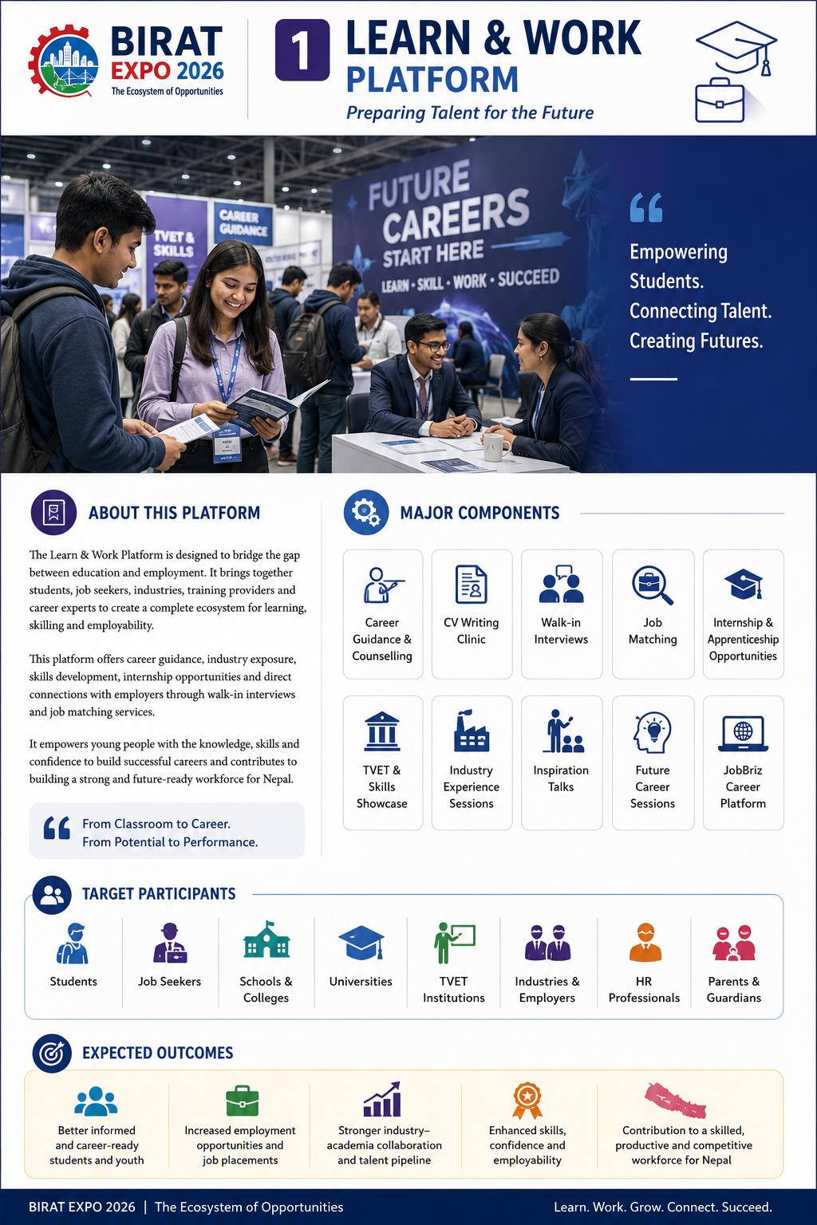

Signature Programs

Powering the Ecosystem of Opportunities

Introduction
The vision of Birat Expo 2026 – The Ecosystem of Opportunities is translated into action through CIM's flagship platforms.
Rather than creating temporary activities for the Expo, Birat Expo integrates proven year-round platforms that already support entrepreneurship, business growth, talent development, digital commerce, startup incubation and policy advocacy.
By bringing these platforms together within one integrated event, Birat Expo creates greater visibility, wider participation and stronger impact, while providing every stakeholder with meaningful opportunities to learn, connect, build and grow.

Birat Business Summit

A New Leadership Platform
A premier business forum introduced through Birat Expo 2026, bringing together business leaders, policymakers, entrepreneurs and development partners to discuss emerging economic opportunities, industrial competitiveness and the future of business.
Focus: Leadership • Economy • Investment • Innovation • Policy

BiratBazaar

Official B2B & Business Matchmaking Platform
BiratBazaar powers the Expo's business networking ecosystem by facilitating B2B meetings, buyer–seller connections, business matchmaking and digital business opportunities.
Focus: B2B • Matchmaking • Business Networking • Digital Trade

Future Talent Forum

Career, Skills & Employment Platform
Integrating Business at School, JobBriz, Skill Festival and Career Guidance initiatives, the Future Talent Forum connects students, job seekers, industries and training providers to strengthen Nepal's future workforce.
Focus: Career • Skills • Employment • Industry Connect

Vision Koshi Startup Challenge

Startup & Innovation Platform
Powered by the Biratnagar Incubation Center and the Biratnagar Angel Investors Network, this platform supports startups through mentorship, incubation, investor engagement and innovation showcases.
Focus: Startups • Innovation • Mentorship • Investment

Business Clinic LIVE

Policy & Business Facilitation Platform
An interactive platform connecting businesses, government agencies and experts to address business challenges, improve the business environment and strengthen public–private dialogue.
Focus: Policy Dialogue • Business Facilitation • Advocacy • Collaboration

The Impact

Opportunities Created
👥 250,000+
People Connected
🎓 10,000+
Learning Opportunities
💼 1,000+
Career Opportunities
🤝 500+
Business Opportunities
🚀 100+
Startup Opportunities
💰 100+
Investment Opportunities
🏭 250+
Industrial Opportunities
🌍 International Opportunities
🏛 Policy Opportunities
🎭 Community Experiences
Notice the subtle difference.
We are not counting activities.
We are counting opportunities created.

Expected Outcomes

Beyond the Exhibition
Birat Expo 2026 aims to create measurable outcomes that contribute to Nepal's economic and social development.

Business Outcomes
- Increased business transactions
- New market linkages
- Stronger supply chains
- Expanded trade partnerships
- Improved business competitiveness

Entrepreneurship Outcomes
- Stronger startup ecosystem
- Increased investment readiness
- Higher innovation adoption
- Business creation and expansion

Employment Outcomes
- Better industry–academia linkage
- Improved employability
- Increased workforce awareness
- Stronger talent pipeline

Investment Outcomes
- Investment-ready enterprises
- New investment partnerships
- Greater access to finance
- Increased investor engagement

Institutional Outcomes
- Stronger collaboration
- Public–private partnerships
- Industry–government dialogue
- Regional business cooperation

Community Outcomes
- Promotion of local products
- Increased tourism visibility
- Community participation
- Stronger regional identity

