# Mulesoft secure properties encryption with the cluster master key

Some of the properties holding secret information are encrypted with the cluster master key. You can find the master key in Keepass under Mulesoft folder.

There is a java jar file used to encrypt/decrypt.

Here is the jar file attached:

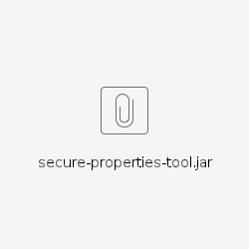

To encrypt a secure property you will need:

* java installed on the machine you are working on
* download the jar file secure-properties-tool.jar
* value of the property to be encrypted
* the master cluster encryption key, separate for PRD and STG, you can find it in Keepass

Encryption of a property example:

java -cp ./secure-properties-tool.jar com.mulesoft.tools.SecurePropertiesTool string encrypt Blowfish CBC CLUSTER_MASTER_KEY_NO_QUOTES "VALUE_TO_BE_ENCRYPTED"

Decryption of a property example: (you can use this to validate that the encrypted property added to the build is correct, by trying to decrypt it)

java -cp ./secure-properties-tool.jar com.mulesoft.tools.SecurePropertiesTool string decrypt Blowfish CBC CLUSTER_MASTER_KEY_NO_QUOTES "ALREADY_ENCRYPTED_VALUE"

**NOTE: If the password has "!" in it, you will need to type "set +H" on the terminal before you try to encrypt or decrypt.**