CBSE Science Chapter 11 Electricity: 1 – mark questions.
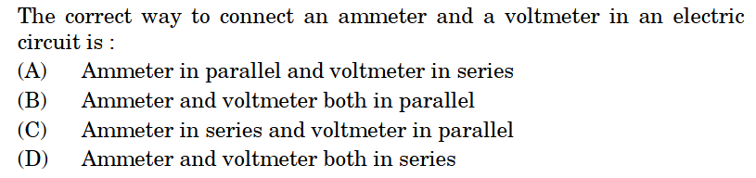
1)

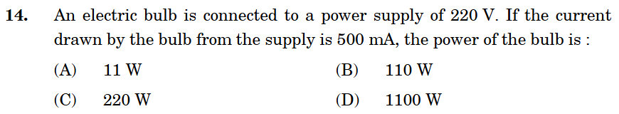
2)

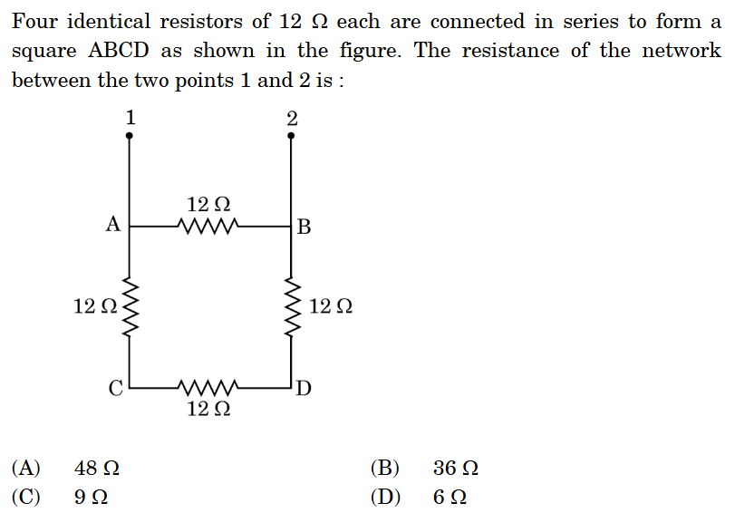
3)

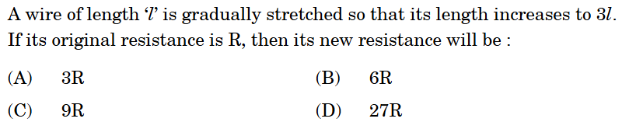
4)

5) A piece of wire of resistance 'R' is cut lengthwise into three identical parts. These parts are then connected in parallel. If the equivalent resistance of this combination is R', then the value of R/R' is:
(a) 1/9 (b) 1/3 (c) 3 (d) 9
6) An electric bulb is rated 220 V; 11W. The resistance of its filament when it glows with a power supply of 220 V is:
(a) 4400 Ω (b) 440 Ω (c) 400 Ω (d) 20 Ω
7) The minimum number of identical bulbs of rating 4V; 6W, that can work safely with desired brightness, when connected in series with a 240 V mains supply is:
(a) 20 (b) 40 (c) 60 (d) 80
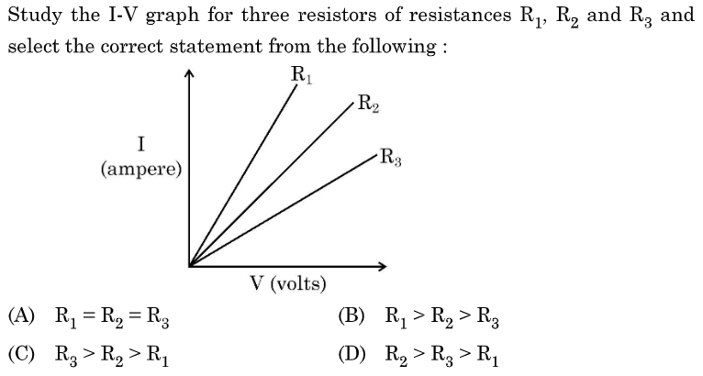
8)

9) The maximum resistance of a network of five identical resistors of 1/5 Ω each can be:
(a) 1 Ω (b) 0.5 Ω (c) 0.25 Ω (d) 0.1 Ω
10) In case of four wires of same material, the resistance will be minimum if the diameter and length of the wire respectively are:
(a) D/2 and L/4 (b) D/4 and 4L (c) 2D and L (d) 4D and 2L
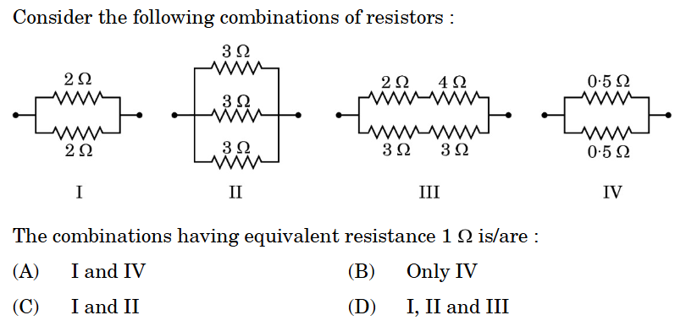
11)

12) An electric iron of resistance 20 Ω draws a current of 5 A. The heat developed in the iron in 30 seconds is:
(a) 15000 J (b) 6000 J (c) 1500 J (d) 3000 J
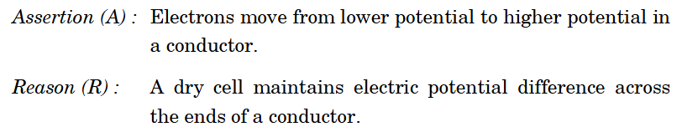
13)

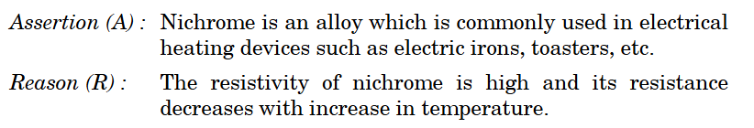
14)

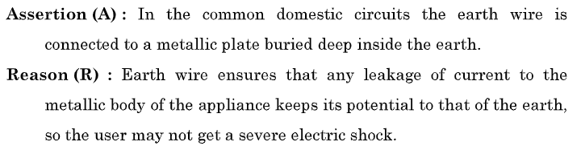
15)

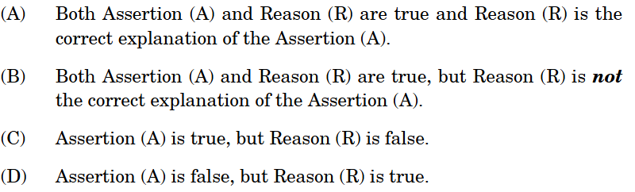

16) At the time of short circuit, the electric current in the circuit:
(a) varies continuously (b) does not change (c) reduces substantially (d) increases heavily
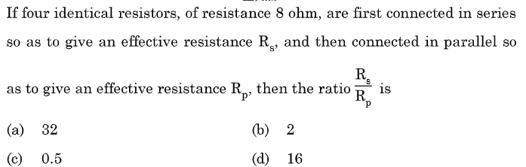
17)

18) In domestic electric circuits the wiring with 15 A current rating is for the electric devices which have
(a) higher power ratings such as geyser. (b) lower power ratings such as fan.
(c) metallic bodies and low power ratings. (d) non-metallic bodies and low power ratings.
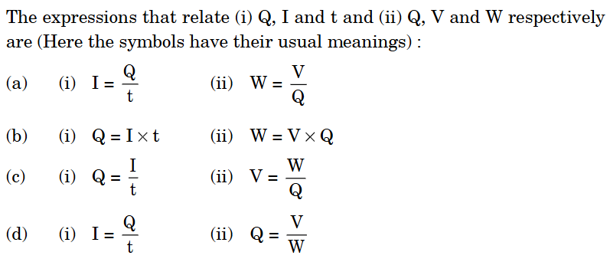
19)

20) An electric kettle consumes 1 kW of electric power when operated at 220 V. The minimum rating of the fuse wire to be used for it is:
(a) 1 A (b) 2 A (c) 4 A (d) 5 A
21) A current of $0.5\text{ A}$ is drawn by a filament of an electric bulb for $10\text{ minutes}$. Find the amount of electric charge that flows through the circuit.
22) Calculate the number of electrons passing through a cross-section of a conductor in $1\text{ second}$ if a current of $1\text{ A}$ flows through it.
23) A potential difference of $6\text{ V}$ is applied across an electrical component, and a current of $0.5\text{ A}$ flows through it. Find the resistance of the component.
24) An electric bulb is rated $220\text{ V}$, $100\text{ W}$. Calculate the resistance of its filament.
25) A wire of resistance $R$ is cut into 5 equal parts. These parts are then connected in parallel. If the equivalent resistance of this combination is $R'$, find the ratio $R/R'$.
26) Calculate the heat produced in joules when a current of $2\text{ A}$ flows through a resistor of $4 Ω$ for $10\text{ seconds}$.
27) Define current and its Unit.
28) Define voltage and its Unit.
29) State ohm’s law & write its expression
30) Define Electric Power and write is unit.
31) State joules law of heating.
32) How much is 1 commercial unit of energy i.e. 1 UNIT is equal to SI unit of energy i.e. joules.
33) If you doubled a wire’s length and doubled its thickness (cross-section), what happens to its resistance?
34) Why does a bulb glow but its connecting wire doesn’t, though the same current flows through both?
35) If one fairy light fuses and the whole string goes dark, what does that say about how they’re connected?
36) If electrons flow from negative to positive, why do we say current flows the opposite way?
37) You pay the electricity bill. What exactly are you paying for, if not electrons?
38) Two bulbs on the same 220 V line draw very different currents. What does that tell you about them?
39) Why does a “kilowatt hour” measure energy and not power, despite having “watt” in its name?
40) If the potential difference across a resistor is halved, what happens to the heat produced per second?

