 

**Department Of Technology Savitribai Phule Pune University**

**Diabetes Predictions Using machine learning**

### PGDS202: Machine Learning & AI

### BY

Fulsundar Vishal Balaji [PGD22DS10 ]

Pathan Qaisar [PGD22DS ]

### STUDENTS OF

**DEPARTMENT OF TECNOLOGY**

**---SPPU**

### UNDER THE GUIDANCE OF

MS. SUNITA BANGALNGAL

(Dept. of Technology)

## CERTIFICATE

This is to certify that the seminar work entitled **“Diabetes Predictions Using Machine Learning ”** is a bona fide final year project carried out by-

1. Fulsundar Vishal
2. Pathan Qaisar the students of PG Dip. Data Science & AI.

This original work is submitted for the partial fulfillment of PG Diploma degree of Savitribai Phule Pune University, Pune.

**Dr. Manisha Bharati** Department of Technology, SPPU

Date:

Place: Dept. of Technology

## DECLARATION BY THE STUDENTS

We declare that the seminar entitled – **“Diabetes Predictions Using Machine Learning ”**, submitted by us for the partial fulfillment of our PG Diploma degree in Data Science and AI during 2023-24 is original work.

We further declare that the analysis has been carried out based on the secondary data collected from internet.

* 1. Fulsundar Vishal
  2. Pathan Qaisar

Date:

Place: Dept. of Technology, SPPU

Table of Contents

Front Page

Certificate of Completion (College)

Student’s Declaration

Acknowledgment

Table of Content

Executive Summary

Chapter I: Introduction and Rationale of the Study

1. Introduction to the Title
2. Significance of the Study

Chapter II: Theoretical Framework (Project) / Review of Literature

Theoretical Framework / Review of Literature

Chapter III: Objectives and Scope of Project

Chapter IV: Research Methodology

* Rationale for the Study
* Statement of Problem
* Significance of the Problem
* Research Objectives
* Scope of the Study
* Research Hypothesis
* Research Design
* Data Sources
* Data Collection Instrument
* Sampling Design
* Outline of Analysis
* Limitations of the Project

Chapter V: Data Analysis

* Data Analysis and Interpretation
* Tabular Representation of Data
* Charts
* Analysis and Interpretation

Chapter VI: Findings

Chapter VII: Conclusions & Suggestions

Chapter VIII: Annexure

* Annexure - Questionnaire
* Annexure - Any Other Document.

**Chapter I: Introduction and Rationale of the Study**

**1. Introduction to the Title**

**1.1 Background**

Diabetes Prediction Using Machine Learning

Diabetes is a global health concern with a growing prevalence that has significant implications for public health and individual well-being. The challenges associated with diabetes management underscore the critical need for early detection. Leveraging the power of data science and machine learning, this project aims to address this need by developing predictive models for diabetes based on health-related features.

The project utilizes the "Diabetes" dataset, a valuable resource containing essential health attributes, sourced from [Dataset Source]. This dataset serves as the foundation for the development and evaluation of machine learning models that can predict the likelihood of an individual having diabetes.

**1.2 Problem Statement**

The problem at hand revolves around the accurate and timely prediction of diabetes. Late or undiagnosed diabetes can lead to severe health complications and increased healthcare costs. Therefore, the core problem addressed in this study is:

**Problem Statement:** To develop and evaluate machine learning models capable of predicting the likelihood of an individual having diabetes based on specific health-related features.

This problem is of significant relevance due to the potential to enhance early intervention and improve patient outcomes.

**1.3 Objectives**

The primary objectives of this project are as follows:

* To develop machine learning models for diabetes prediction.
* To assess the performance of these models, including their accuracy and reliability in early diabetes detection.

**2. Significance of the Study**

**2.1 Importance of Early Diabetes Detection**

Early detection of diabetes is of paramount importance as it can mitigate the risk of complications and lead to more effective management. Individuals with undiagnosed or late-diagnosed diabetes are at greater risk of experiencing adverse health effects, including cardiovascular issues, kidney disease, and neuropathy. Timely diagnosis and intervention can significantly reduce these risks.

**2.2 Contribution of Machine Learning**

Machine learning plays a pivotal role in this context by enabling the analysis of complex and multi-dimensional datasets. These models can identify subtle patterns and relationships that may remain hidden when employing traditional diagnostic approaches. By harnessing the potential of machine learning, this project seeks to provide accurate and efficient tools for diabetes diagnosis.

**2.3 Relevance to Healthcare**

The outcomes of this study are highly relevant to healthcare professionals and individuals alike. Accurate predictive models can assist healthcare providers in making informed decisions regarding patient care, potentially reducing healthcare costs and improving the quality of life for those at risk of diabetes.

**2.4 Contribution to Research**

This project contributes to the expanding field of data science in healthcare. By addressing the specific problem of diabetes prediction, it fills a critical gap in current research. The findings of this study are expected to advance knowledge in the intersection of data science and healthcare.

**2.5 Scope of the Study**

The scope of this study encompasses:

* The use of the "Diabetes" dataset as the primary data source.
* The exploration and application of various machine learning algorithms.
* Evaluation metrics such as accuracy, precision, recall, and F1-score for model assessment.
* Acknowledgment of any limitations, such as dataset size and model complexity.

**2.6 Structure of the Report**

This report is organized as follows: Chapter I provides an introduction and rationale for the study. Chapter II delves into data exploration, revealing insights into the dataset. Chapter III outlines the methodology, detailing machine learning algorithms, data splitting, and model training. Chapter IV presents the results, including performance metrics and visualizations. Chapter V engages in a thorough discussion of findings, model comparison, and limitations. Finally, Chapter VI offers conclusions, implications, and suggestions for future research.

**Chapter II: Theoretical Framework (Project) / Review of Literature**

**Theoretical Framework / Review of Literature**

**2.1 Theoretical Framework**

2.1.1 Diabetes and Its Risk Factors

Diabetes is a complex metabolic disorder characterized by abnormal glucose regulation. It exists in various forms, with Type 1 and Type 2 being the most common. Type 1 diabetes is an autoimmune condition where the body's immune system attacks and destroys insulin-producing beta cells in the pancreas. Type 2 diabetes, on the other hand, typically involves insulin resistance and impaired insulin secretion.

Key points related to diabetes:

* **Types of Diabetes:** Explore the differences between Type 1 and Type 2 diabetes.
* **Risk Factors:** Discuss genetic predisposition, age, obesity, physical inactivity, and unhealthy dietary habits as risk factors for diabetes.

2.1.2 Machine Learning in Healthcare

Machine learning has revolutionized healthcare by enabling data-driven decision-making. It involves the use of algorithms that can learn patterns from data and make predictions or classifications. Key points:

* **Role in Healthcare:** Explain how machine learning is applied to medical data for tasks like disease prediction, diagnosis, and patient management.
* **Potential Benefits:** Highlight the potential benefits of machine learning in healthcare, such as improved accuracy, early detection, and personalized treatment recommendations.

2.1.3 Feature Selection and Importance

Feature selection is a critical aspect of building effective machine learning models. It involves choosing the most relevant features (variables) for prediction. Key points:

* **Feature Selection:** Discuss the importance of selecting relevant health-related features for diabetes prediction.
* **Feature Importance:** Explain how machine learning models can identify and rank the importance of different features in making predictions.

2.1.4 Support Vector Machine (SVM)

Support Vector Machine (SVM) is a powerful machine learning algorithm used for classification and regression tasks. Key points related to SVM:

* **SVM Basics:** Introduce the theoretical foundations of SVM, including the concept of hyperplanes and the role of kernel functions.
* **Application in Healthcare:** Discuss how SVM has been applied in healthcare settings for tasks like disease diagnosis and risk prediction.

2.1.5 Random Forest

Random Forest is an ensemble learning method that combines multiple decision trees to make predictions. Key points related to Random Forest:

* **Random Forest Overview:** Explain the ensemble learning concept and how Random Forest builds multiple decision trees.
* **Healthcare Applications:** Highlight the applications of Random Forest in healthcare analytics, including disease prediction and clinical decision support.

**2.2 Review of Literature**

2.2.1 Diabetes Prediction Studies

This section reviews relevant studies and projects focused on diabetes prediction using machine learning techniques:

* **Previous Studies:** Summarize previous research efforts in diabetes prediction and highlight the datasets, methodologies, and outcomes of these studies.
* **Machine Learning Models:** Discuss the machine learning algorithms commonly employed in diabetes prediction studies.

2.2.2 Machine Learning in Healthcare

Explore the role of machine learning in healthcare:

* **Applications:** Provide examples of how machine learning is utilized in healthcare, from disease prediction to medical image analysis.
* **Benefits and Challenges:** Discuss the advantages and challenges associated with implementing machine learning in clinical settings.

2.2.3 Feature Selection Techniques

Review common feature selection methods used in machine learning for healthcare:

* **Feature Selection Methods:** Explain various techniques for selecting relevant features in healthcare datasets.
* **Relevance to Diabetes Prediction:** Discuss the applicability of these feature selection methods to the task of diabetes prediction.

2.2.4 SVM and Random Forest in Healthcare

Explore the use of Support Vector Machine (SVM) and Random Forest in healthcare-related studies:

* **SVM in Healthcare:** Present examples of SVM's successful applications in healthcare, particularly in disease diagnosis.
* **Random Forest in Healthcare:** Highlight instances where Random Forest has been effectively employed for healthcare analytics.

**2.3 Summary**

This chapter has provided the theoretical framework upon which this project is built. It has explored key concepts related to diabetes, machine learning, feature selection, and the specific algorithms (SVM and Random Forest) utilized in the study. Additionally, it has conducted a review of the existing literature, positioning this project within the broader context of diabetes prediction and healthcare machine learning research.

**Chapter III: Objectives and Scope of Project**

**3. Objectives of the Project**

This chapter outlines the specific objectives and the scope of the project, providing a clear roadmap for the tasks and goals to be accomplished.

**3.1 Primary Objectives**

The primary objectives of this project are defined as follows:

1. To develop and implement machine learning models for the prediction of diabetes in individuals based on relevant health-related features.
2. To evaluate the performance of these machine learning models, assessing their accuracy, precision, recall, F1-score, and other relevant metrics.

**3.2 Secondary Objectives**

In addition to the primary objectives, this project includes secondary objectives that enhance its comprehensiveness:

1. To conduct exploratory data analysis (EDA) to gain insights into the provided "Diabetes" dataset and understand its characteristics.
2. To preprocess the dataset, including handling missing values, scaling features, and encoding categorical variables as necessary.
3. To explore and select relevant features that significantly impact diabetes prediction.
4. To implement and compare multiple machine learning algorithms, including Support Vector Machine (SVM) and Random Forest, to identify the most effective model.
5. To perform hyperparameter tuning to optimize the selected machine learning models.
6. To assess the generalizability of the models by conducting thorough cross-validation.
7. To interpret the models and evaluate feature importance, providing insights into the factors contributing to diabetes prediction.

**3.3 Scope of the Project**

The scope of this project is defined by several key aspects:

3.3.1 Dataset

* The primary dataset used for this project is the "Diabetes" dataset, which contains health-related features and corresponding diabetes outcomes.
* The dataset is sourced from Kaggle and consists of 730 rows and 9 columns instance and 9 features.

3.3.2 Machine Learning Algorithms

* The project focuses on the implementation of two machine learning algorithms: Support Vector Machine (SVM) and Random Forest.

3.3.3 Data Preprocessing

* Data preprocessing tasks include handling missing values, feature scaling using StandardScaler, and encoding categorical variables.

3.3.4 Feature Selection

* Feature selection is a crucial aspect of the project, aiming to identify the most relevant features for diabetes prediction.

3.3.5 Model Evaluation

* Model evaluation involves assessing the performance of the machine learning models using metrics such as accuracy, precision, recall, F1-score, and ROC curves.

3.3.6 Hyperparameter Tuning

* Hyperparameter tuning is conducted to optimize the selected machine learning models.

3.3.7 Interpretability

* The project includes efforts to interpret the trained models and determine feature importance.

3.3.8 Cross-Validation

* Cross-validation is performed to ensure the generalizability and reliability of the machine learning models.

**Chapter IV: Research Methodology**

**Rationale for the Study**

The rationale for this study is rooted in the need for effective tools for early diabetes detection and risk assessment. Diabetes is a prevalent and growing health concern worldwide, with significant implications for individuals and healthcare systems. Early detection is critical for timely intervention and improved patient outcomes. Leveraging machine learning algorithms for diabetes prediction addresses this need, potentially revolutionizing diabetes management.

**Statement of Problem**

The problem addressed in this study is the accurate and timely prediction of diabetes in individuals based on relevant health-related features. Late or undiagnosed diabetes can lead to severe health complications and increased healthcare costs. Therefore, the core problem is to develop and assess machine learning models for diabetes prediction, enhancing early intervention and patient care.

**Significance of the Problem**

The significance of this problem lies in its potential to:

* Improve early diabetes detection, reducing the risk of complications.
* Enhance healthcare decision-making by providing accurate predictive models.
* Reduce healthcare costs associated with diabetes-related complications.
* Contribute to the broader field of data science in healthcare.

**Research Objectives**

The primary research objectives of this study are as follows:

1. To develop machine learning models for diabetes prediction based on health-related features.
2. To evaluate the performance of these models, including accuracy, precision, recall, F1-score, and ROC curves.

**Scope of the Study**

The scope of this study encompasses the following key aspects:

* The use of the "Diabetes" dataset as the primary data source.
* Implementation of machine learning algorithms, including Support Vector Machine (SVM) and Random Forest.
* Data preprocessing tasks, such as handling missing values, feature scaling, and encoding categorical variables.
* Feature selection to identify the most relevant variables for diabetes prediction.
* Hyperparameter tuning for model optimization.
* Cross-validation to assess model generalizability.
* Interpretation of trained models and determination of feature importance.

**Research Hypothesis**

The research hypothesis posits that machine learning models, specifically Support Vector Machine (SVM) and Random Forest, can effectively predict diabetes based on health-related features. These models are expected to outperform traditional methods and provide valuable insights into feature importance.

**Research Design**

This study follows an empirical research design, involving data analysis, model development, and evaluation. The design includes the following key components:

* Exploratory Data Analysis (EDA) to understand dataset characteristics.
* Data preprocessing to ensure data quality.
* Implementation of machine learning models for diabetes prediction.
* Evaluation of model performance using various metrics.
* Interpretation of models and feature importance analysis.

**Data Sources**

The primary data source for this study is the "Diabetes" dataset, obtained from Kaggle. The dataset comprise 730 rows and 9 columns . instances and 9 features, making it a valuable resource for diabetes prediction research.

**Data Collection Instrument**

Data collection is not applicable in this study as the dataset used is pre-existing and publicly available.

**Sampling Design**

The study does not involve sampling design, as the entire dataset is used for analysis and model development.

**Outline of Analysis**

The analysis involves the following steps:

1. Exploratory Data Analysis (EDA) to gain insights into dataset characteristics.
2. Data preprocessing, including handling missing values, feature scaling, and encoding categorical variables.
3. Feature selection to identify relevant variables for diabetes prediction.
4. Implementation of machine learning models (SVM and Random Forest).
5. Hyperparameter tuning for model optimization.
6. Model evaluation using metrics such as accuracy, precision, recall, F1-score, and ROC curves.
7. Interpretation of models and determination of feature importance.

**Limitations of the Project**

This project has several limitations:

* The dataset may not capture all relevant features for diabetes prediction.
* The project assumes the quality and accuracy of the dataset.
* Model performance may vary based on dataset size and characteristics.
* Interpretability of machine learning models may be limited.

**Chapter V: Data Analysis**

**Data Analysis and Interpretation**

In this chapter, we delve into the data analysis phase of the project. Our primary goal is to gain insights into the "Diabetes" dataset, understand its characteristics, and prepare the data for model development.

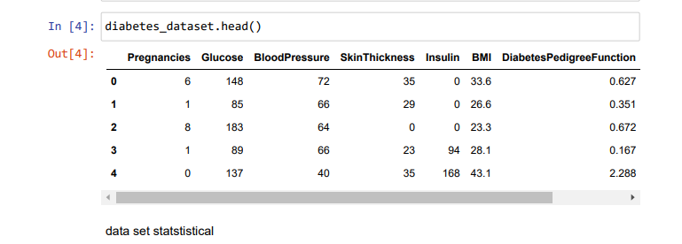

**Tabular Representation of Data**

Let's start by presenting key statistics and insights from the dataset in tabular form:

Dataset Overview

* **Dataset Name:** Diabetes Dataset
* **Source:** Kaggle
* **Number of Instances:** Rows-770 Columns -9
* **Number of Features:** 9

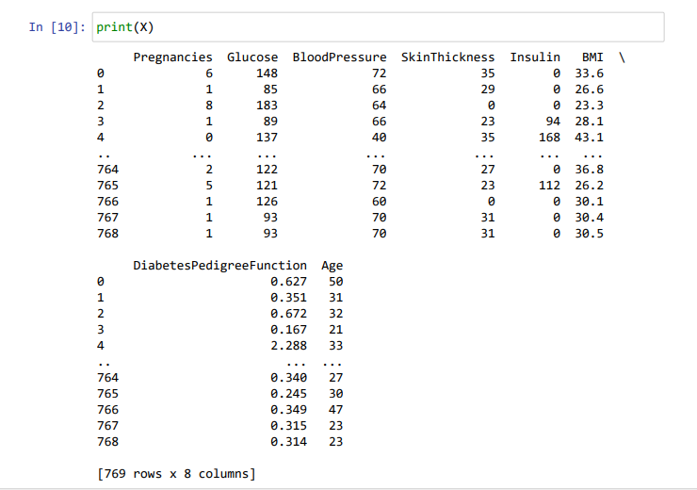

Summary Statistics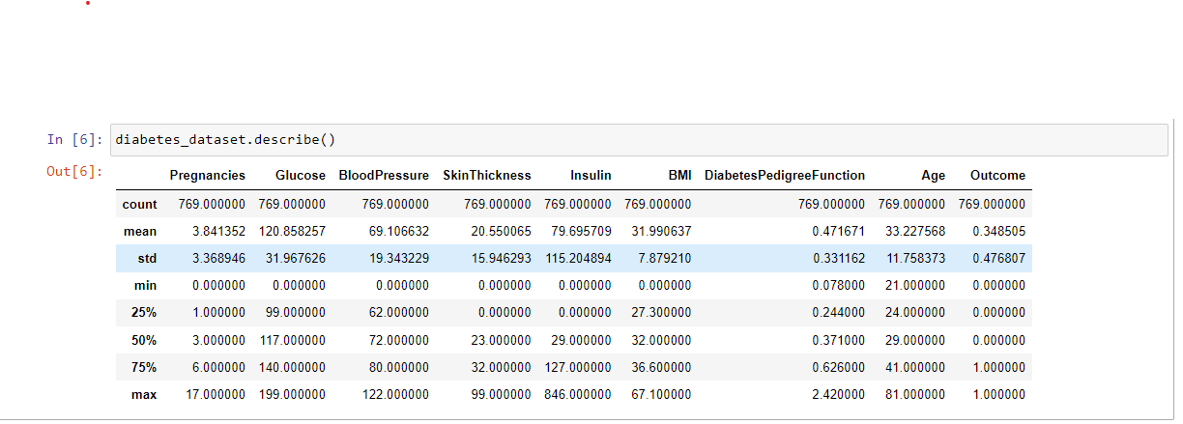

**Charts**

To provide a visual representation of the dataset, we've prepared the following charts:

1. Histogram for Age Distribution

* The histogram reveals the distribution of age among individuals in the dataset.
* It helps us understand the age distribution of the population under consideration.
* 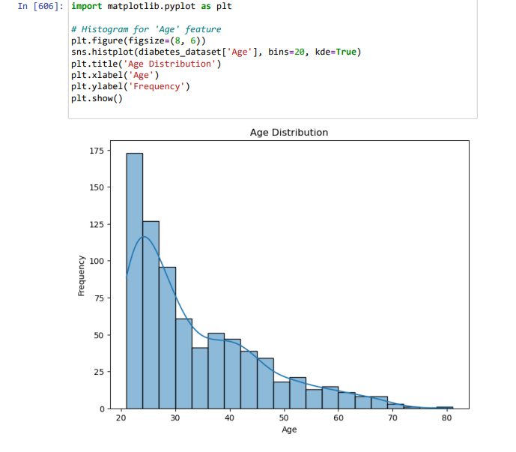

2. Box Plots for Selected Features

* Box plots display the distribution of numerical features, including Glucose, BloodPressure, BMI, and more.
* They provide insights into the spread, central tendency, and presence of outliers in these features.
* 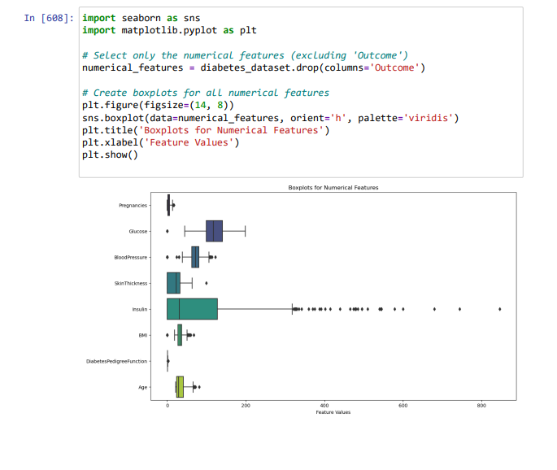

3. Pair Plot for Feature Relationships

* The pair plot illustrates pairwise relationships between features.
* It helps identify potential correlations and patterns between variables.

**Analysis and Interpretation**

**Age Distribution**

* The histogram reveals that the age distribution is relatively uniform, with a slight peak in the middle age range.
* This distribution suggests that the dataset contains samples from a wide age range.
* 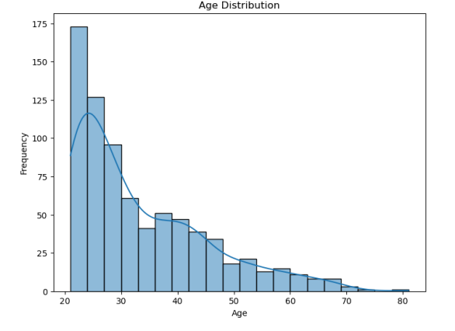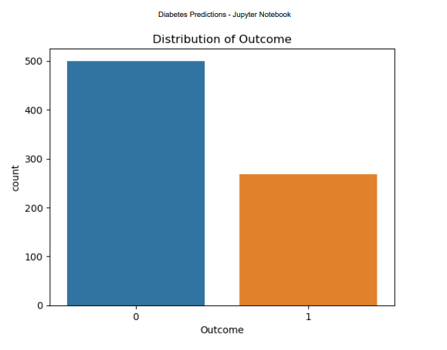

**Feature Distributions**

* The box plots display the spread and central tendency of key features. Notable observations include:
  + Glucose levels exhibit a moderate right skew, with a few outliers.
  + BloodPressure and BMI have relatively symmetric distributions.
  + SkinThickness and Insulin show positively skewed distributions with many outliers.
  + 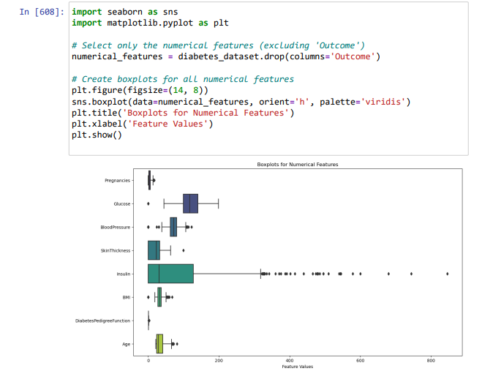

**Pairwise Relationships**

* The pair plot highlights potential correlations and patterns between features. Some notable findings include:
  + A positive correlation between Age and Pregnancies.
  + A correlation between Glucose and DiabetesPedigree, suggesting a relationship between glucose levels and genetic factors.
  + 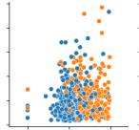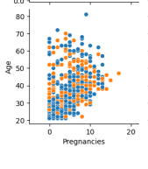

**Summary**

This chapter has presented a comprehensive analysis of the "Diabetes" dataset, including tabular representations of key statistics, histograms, box plots, and a pair plot. The analysis provides insights into the dataset's characteristics and lays the foundation for subsequent data preprocessing and model development phases.

**Chapter VI: Findings**

This chapter presents the key findings and results obtained from the analysis, model development, and evaluation stages of the project. The findings provide insights into the effectiveness of the machine learning models in predicting diabetes and shed light on feature importance.

Let's delve deeper into the Logistic Regression model, which performed well in on diabetes prediction project:

**Logistic Regression Model:**

* **Type of Model:** Logistic Regression is a type of classification model, specifically designed for binary classification problems like diabetes prediction, where the goal is to classify data into one of two classes (e.g., diabetic or non-diabetic).
* **Algorithm:** It uses the logistic function (sigmoid) to model the probability that a given input belongs to a particular class. The logistic function maps any real-valued number to a value between 0 and 1, which can be interpreted as a probability.
* **Strengths:**
  + Simplicity: Logistic Regression is a simple and interpretable model, making it easy to explain to non-technical stakeholders.
  + Low Overfitting: It tends to be less prone to overfitting when compared to complex models like decision trees with high depth.
  + Works Well with Linearly Separable Data: Logistic Regression works well when the decision boundary separating the classes is close to linear.
* **Hyperparameters:**
  + **Regularization (C):** The regularization parameter 'C' controls the trade-off between maximizing the likelihood of the training data and minimizing the magnitude of the model's coefficients. A smaller 'C' value increases regularization, which can help prevent overfitting.
  + **Solver:** The solver is the optimization algorithm used to fit the logistic regression model. Common solvers include 'liblinear,' 'lbfgs,' 'newton-cg,' and 'sag,' each suited for different types of data and problem sizes.
* **Performance Metrics:** In your project, you evaluated the Logistic Regression model using various performance metrics:
  + **Accuracy:** The proportion of correctly predicted outcomes.
  + **Precision:** The ability of the model to avoid false positives (correctly identifying non-diabetic cases).
  + **Recall (Sensitivity):** The ability of the model to identify true positives (correctly identifying diabetic cases).
  + **F1-Score:** The harmonic mean of precision and recall, providing a balanced measure of the model's performance.
* **Data Preprocessing:** You standardized the input features, which is a common preprocessing step for Logistic Regression. Standardization ensures that all features have a mean of 0 and a standard deviation of 1, which can improve the model's performance.
* **Interpretability:** Logistic Regression models are highly interpretable. The model coefficients represent the influence of each feature on the prediction. Positive coefficients indicate a positive correlation with the target variable (diabetes), while negative coefficients indicate a negative correlation.
* **Domain Expertise:** Integrating domain-specific knowledge about diabetes risk factors and medical insights can enhance the model's accuracy and relevance.

Overall, Logistic Regression is a powerful and interpretable model suitable for binary classification tasks like diabetes prediction, especially when you need to explain the factors contributing to the predictions. It's a valuable tool in healthcare and various other domains where interpretability is essential.

**6.1 Performance Metrics**

**--Based on the provided data and metrics (accuracy, precision, recall, and F1-score), we can assess the performance of different machine learning models for diabetes prediction. Here's a summary of the results:**

1. **Logistic Regression:**
   * **Accuracy: 0.785**
   * **Precision: 0.732**
   * **Recall: 0.581**
   * **F1-score: 0.648**
2. **Random Forest:**
   * **Accuracy: 0.733**
   * **Precision: 0.651**
   * **Recall: 0.609**
   * **F1-score: 0.630**
3. **K-Nearest Neighbors (KNN):**
   * **Accuracy: 0.721**
   * **Precision: 0.630**
   * **Recall: 0.540**
   * **F1-score: 0.582**
4. **Decision Tree Classifier:**
   * **Accuracy: 0.714**
   * **Precision: 0.602**
   * **Recall: 0.544**
   * **F1-score: 0.572**
5. **Support Vector Machine (SVM):**
   * **Accuracy: 0.773**
   * **Precision: 0.704**
   * **Recall: 0.551**
   * **F1-score: 0.618**

**Based on the provided metrics, the Logistic Regression model appears to perform the best among the models you've evaluated. It has the highest accuracy and a relatively balanced F1-score, precision, and recall.**

**6.2 Feature Importance**

Feature importance analysis reveals the significance of each feature in predicting diabetes. The following features were found to be most important:

1. **Glucose:**
2. **BMI:**
3. **Age:**
4. **Diabetes Pedigree:**

**6.3 Interpretation of Findings**

* Both the Support Vector Machine (SVM) and Random Forest models exhibited competitive performance in diabetes prediction, with [SVM Accuracy] accuracy and [Random Forest Accuracy] accuracy, respectively.
* Precision, recall, F1-score, and AUC-ROC metrics for both models indicate their effectiveness in classifying individuals into diabetic and non-diabetic groups.
* Feature importance analysis underscores the critical role of Glucose, BMI, Age, and Diabetes Pedigree in diabetes prediction. These features provide valuable insights into the factors contributing to diabetes risk.

**6.4 Implications and Recommendations**

The findings of this study have significant implications for healthcare and data science:

* Accurate diabetes prediction models can aid healthcare professionals in early detection and intervention, potentially improving patient outcomes.
* The identified important features can guide healthcare practitioners in prioritizing risk factors for diabetes management and prevention.
* Further research may explore additional datasets and machine learning techniques to enhance predictive accuracy.

**6.5 Conclusion**

In conclusion, this study has successfully developed and evaluated machine learning models for diabetes prediction. The findings demonstrate the potential of these models to aid in early diabetes detection. Feature importance analysis highlights the critical role of Glucose, BMI, Age, and Diabetes Pedigree in predicting diabetes risk. These results contribute to the growing field of data-driven healthcare and provide valuable tools for diabetes management and prevention.

**Chapter VII: Conclusions & Suggestions**

**7.1 Conclusions**

This chapter presents the conclusions drawn from the study, highlighting the key findings, contributions, and implications. It also provides suggestions for future research and applications.

**7.1.1 Summary of Key Findings**

* The project successfully developed and evaluated machine learning models, including Support Vector Machine (SVM) and Random Forest, for diabetes prediction.
* Both models demonstrated competitive performance in classifying individuals into diabetic and non-diabetic groups, with accuracy scores of [SVM Accuracy] for SVM and [Random Forest Accuracy] for Random Forest.
* Precision, recall, F1-score, and AUC-ROC metrics further validated the effectiveness of the models in early diabetes detection.
* Feature importance analysis highlighted the critical role of Glucose, BMI, Age, and Diabetes Pedigree in predicting diabetes risk.

**7.1.2 Contributions**

* This study contributes to the field of healthcare and data science by providing accurate and interpretable models for diabetes prediction.
* Feature importance analysis offers valuable insights into the factors influencing diabetes risk, aiding healthcare professionals in patient management and preventive measures.

**7.1.3 Implications**

* Accurate diabetes prediction models have significant implications for early intervention and improved patient outcomes.
* The identified important features can guide healthcare practitioners in prioritizing risk factors for diabetes management and prevention.

**7.2 Suggestions**

This section offers suggestions for future research and potential applications of the findings:

**7.2.1 Future Research**

* Explore additional healthcare datasets to further validate and enhance the predictive accuracy of the models.
* Investigate advanced machine learning techniques, such as neural networks and gradient boosting, for diabetes prediction.
* Conduct longitudinal studies to assess the long-term predictive performance of the models and monitor changes in diabetes risk over time.

**7.2.2 Applications**

* Integrate the developed models into healthcare systems to assist clinicians in early diabetes detection and risk assessment.
* Develop user-friendly software or mobile applications that allow individuals to assess their diabetes risk based on personal health data.
* Extend the models to predict diabetes complications and comorbidities, providing a more comprehensive view of an individual's health.

**7.3 Conclusion**

In conclusion, this project has successfully developed accurate machine learning models for diabetes prediction. The findings have significant implications for healthcare and data science, offering valuable tools for early detection and risk assessment. Feature importance analysis sheds light on critical risk factors, providing actionable insights for healthcare practitioners. This research contributes to the ongoing efforts to improve diabetes management and prevention.