Instructions:

After installing the package, please perform below steps:

1. Change contact layout to add button(Quick Action) ‘Set as Primary Contact’

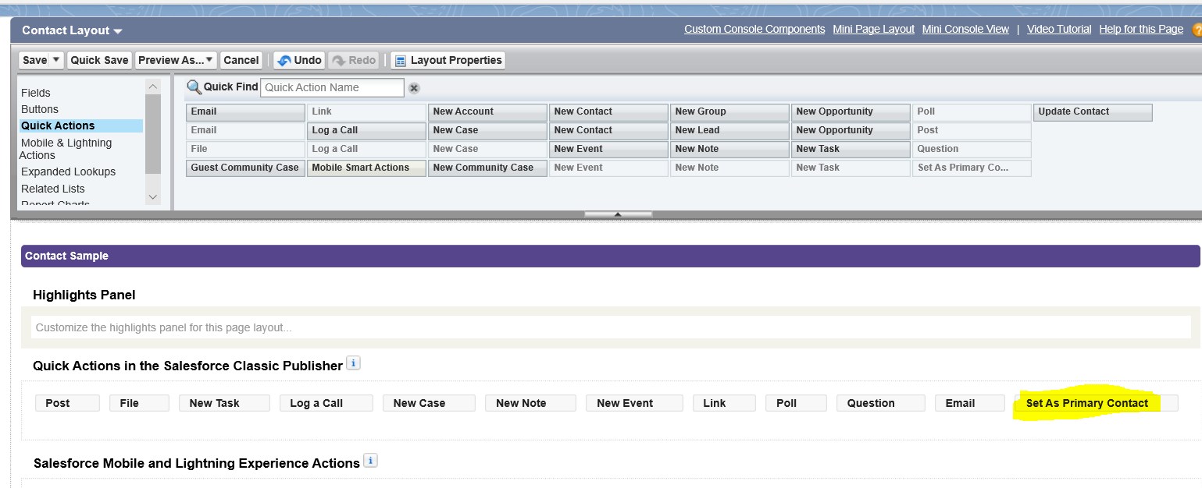

1. Open the Custom_Contact lightning record pages under Contact object and assign to profiles accordingly. If you mark as Org default, You’ll see the Account information in right hand size corner.

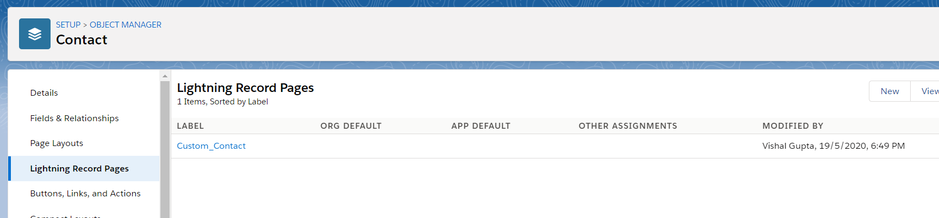

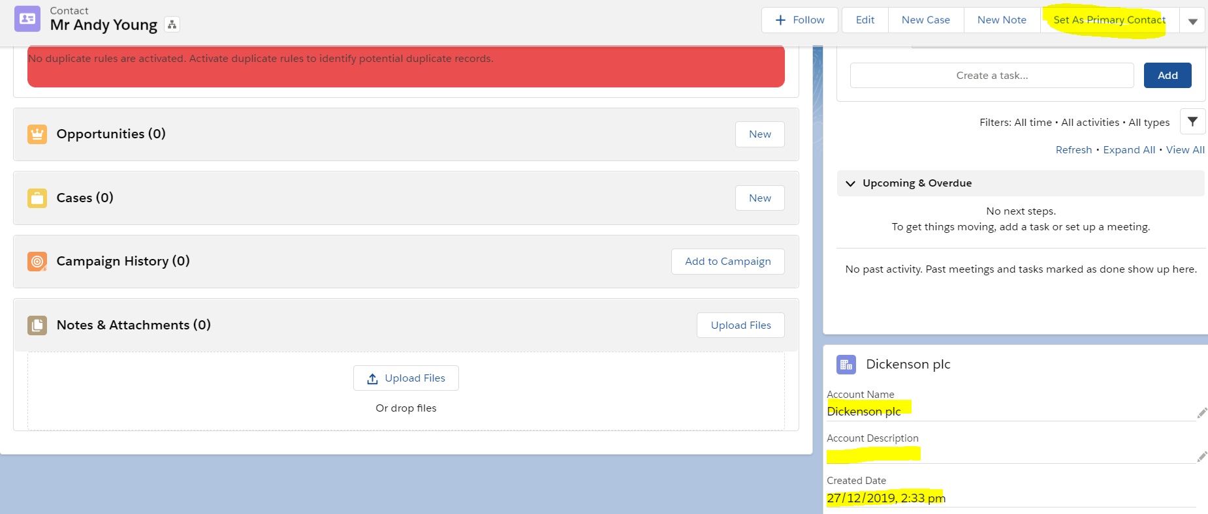

1. Use button ‘Set as Primary Contact’ to mark as Primary contact.
2. If an Account has already 1 primary contact, it will throw error on the screen as below:

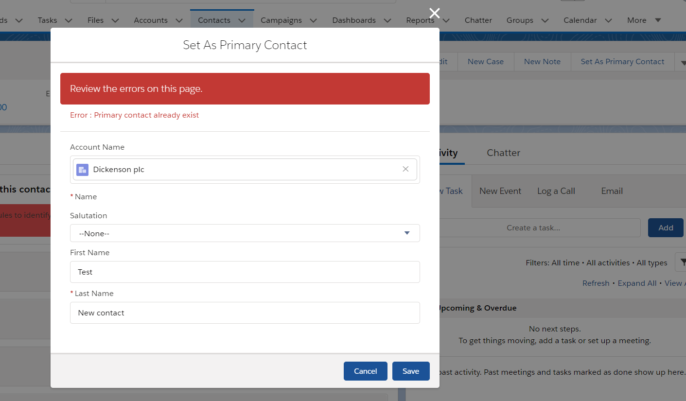

Components used in the solution:

Lightning Page: Custom_Contact

Aura Component: Account_CustomLayout

Apex Class: ContactTrigger, ContactTrigger_Test

Trigger : ContactTriggerHandler

Action : Set As Primary Contact

Custom field: Primary__c (Contact)