AWS Practical Assignment Documentation

📌 Overview
This project demonstrates a web application built using AWS services. It allows users to manage categories (add, view, delete) through a simple frontend UI. The architecture follows best practices for security, scalability, and cost-efficiency.

🏗️ Architecture
User (Browser)
↓
EC2 (Frontend)
↓
API Gateway
↓
Lambda (Backend Logic)
↓
RDS PostgreSQL (Private Database)

⚙️ AWS Services Used
Amazon EC2 – Hosts frontend
Amazon API Gateway – Exposes APIs
AWS Lambda – Backend logic
Amazon RDS – PostgreSQL database
Amazon VPC – Network isolation

✨ Features
Add new category
Fetch all categories
Delete category
Secure backend with private database

🔐 Security Design
RDS is placed in a private subnet (not publicly accessible)
Lambda runs inside VPC to access RDS securely
Security Groups restrict access (only Lambda → RDS)
API Gateway acts as controlled public entry point
SSH access restricted to personal IP only
VPC: Private subnet for RDS and Lambda.
Public subnet for EC2, API Gateway for internet access.
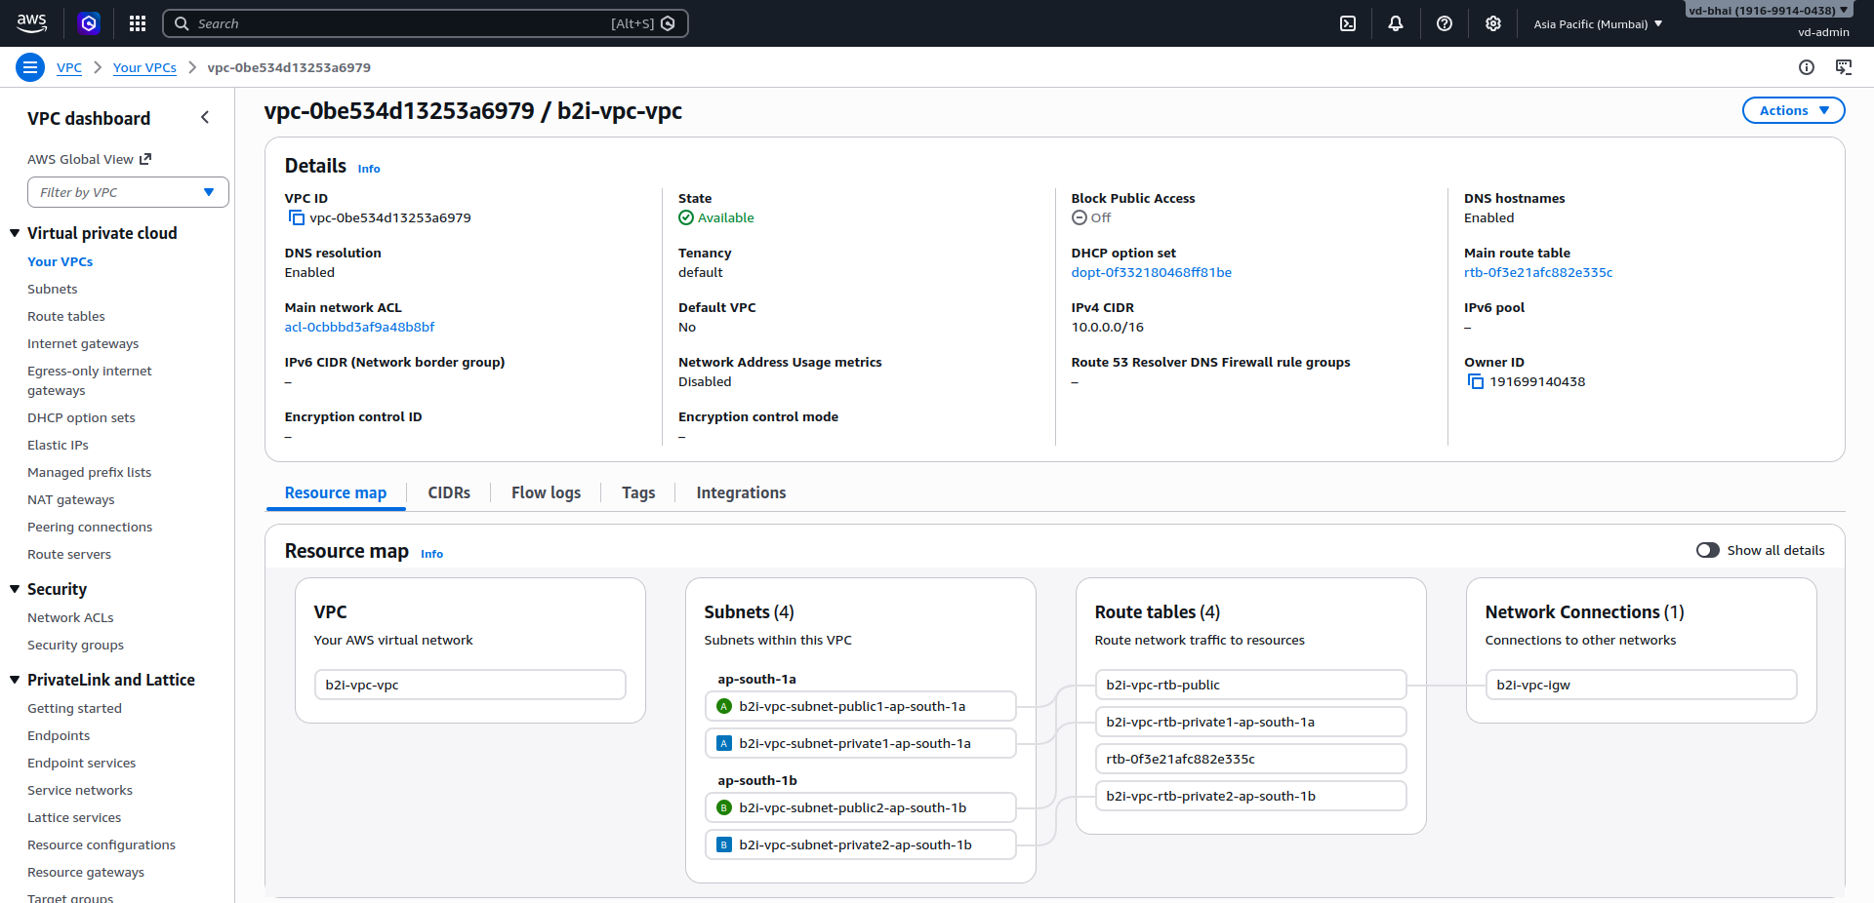
Security Groups:
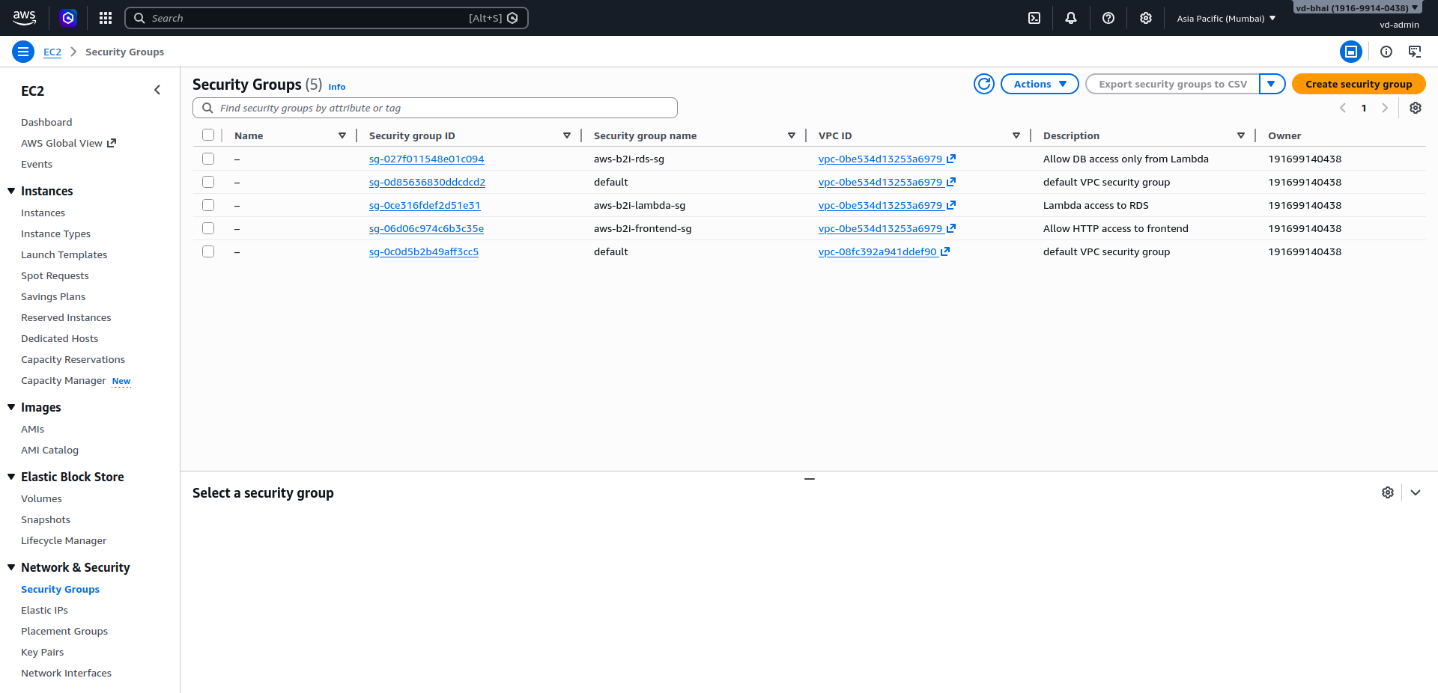

🔗 API Endpoints
GET /categories – Fetch all categories
POST /categories – Add new category
DELETE /categories – Delete category
API Gateway:
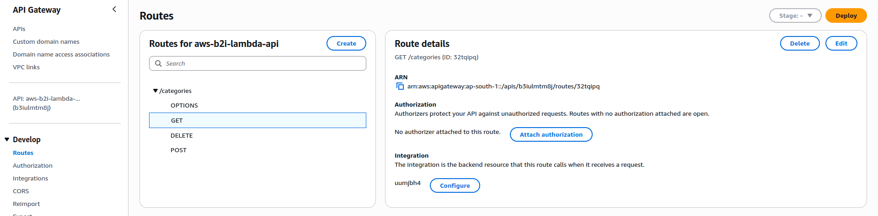
Postman:
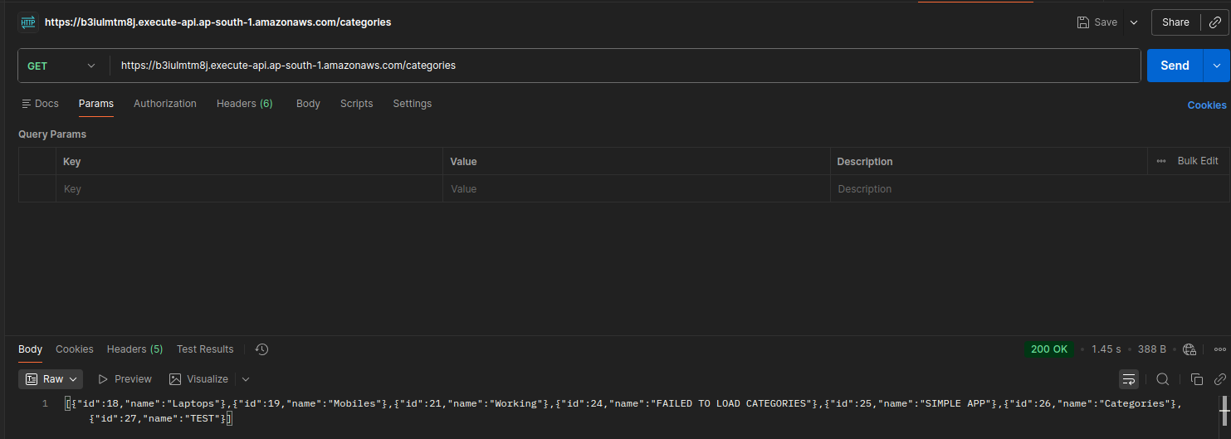
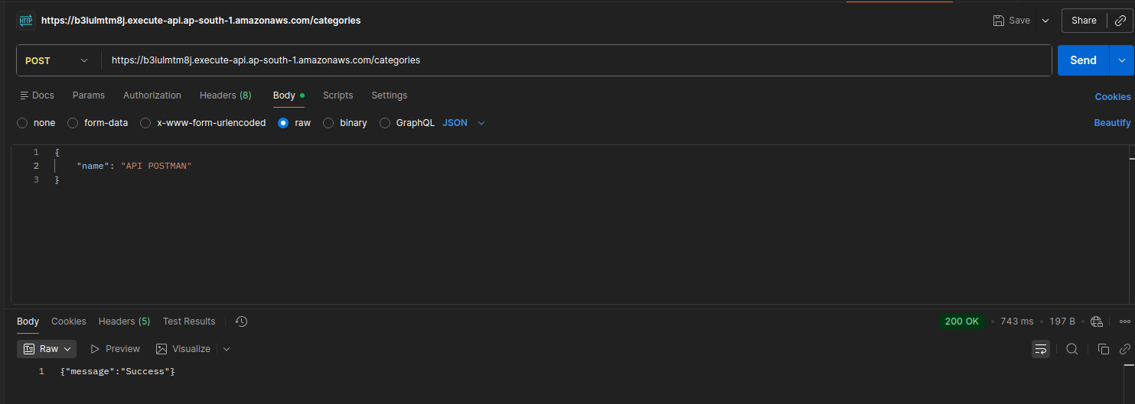

🖥️ Frontend
The frontend is hosted on EC2 and built using static HTML and JavaScript. It communicates with backend APIs via API Gateway.
EC2 Instance:
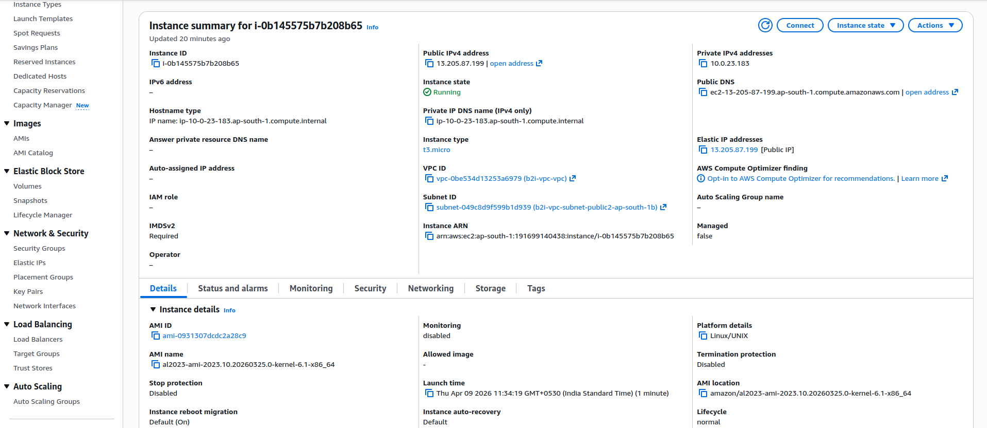
Frontend app:
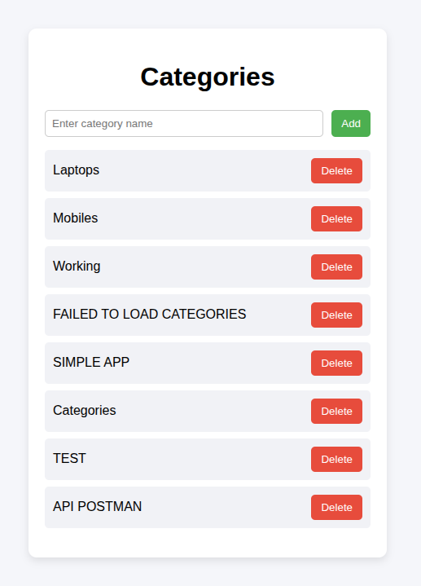

🗄️ Database
PostgreSQL database hosted on RDS. Contains a 'categories' table used for storing data.
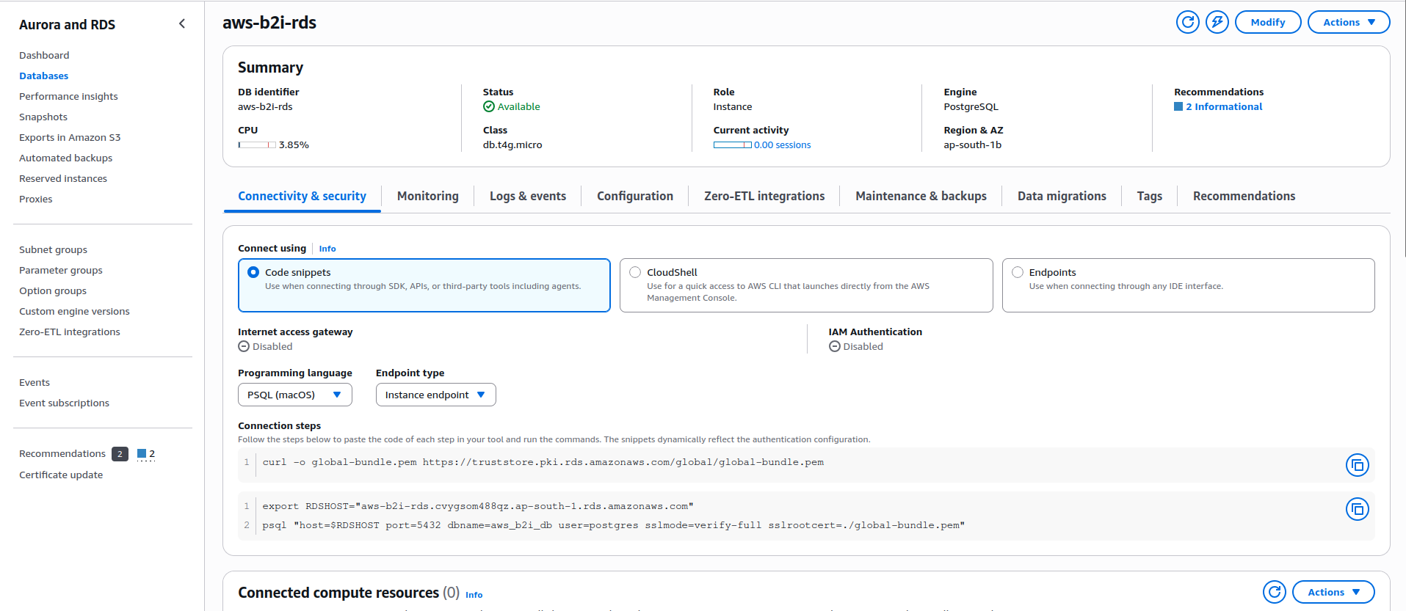
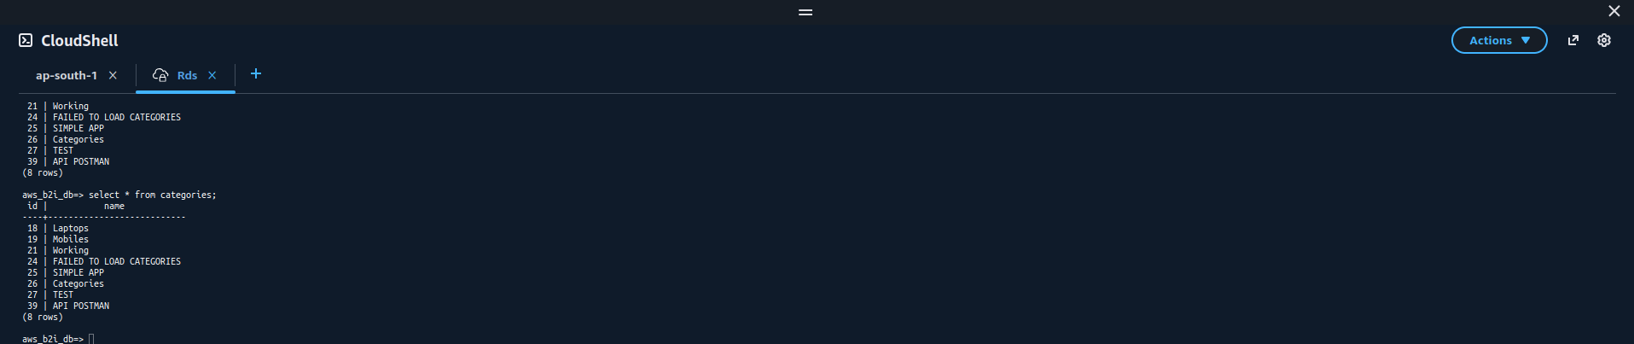

🚀 Application Workflow
1. User interacts with frontend (EC2)
2. Frontend calls API Gateway
3. API Gateway triggers Lambda
4. Lambda processes request and interacts with RDS
5. Response is returned to frontend

📌 Conclusion
This project successfully demonstrates a secure and scalable AWS architecture using EC2, API Gateway, Lambda, and RDS with proper VPC and security group configurations.

