**Anudip Foundation**

A

PROJECT REPORT ON

**“EMPLOYEE MANAGEMENT”**

SUBMITTED BY

**StudentId:AF04957030**

**Student Name : GOSWAMI VISHAL**

UNDER GUIDENCE

**MISS.RAJSHRI C. THETE**

# ACKNOWLEDGMENT

I would like to thank the people who helped me in completion of this project and with deep content and pleasure I express my gratitude toward those people who have given me their precious time and guidance in developing project. It’s my privilege to express my sincere thanks and demo sense of gratitude to my guide Miss.Rajshri Thete for imparting me valuable guidance during the preparation of these papers. She helped me by suggesting me many references of emerge out with a perfect presentation.

Thanking You.

Sincerely

Vishal Goswami

## Index

|  |  |  |
| --- | --- | --- |
| Sr.no | Particular | Page No. |
| 1 | Introduction | 4 |
| 2 | Objectives | 5 |
| 3 | Proposed System | 6 |
| 4 | Fesiblity Study | 7 |
| 5 | Hardware Requirement | 8 |
| 6 | Software Requirement | 9 |
| 7 | System Design | 10 |
|  | * ER Diagram | 10 |
| 8 | DataBase | 11 |
| 9 | Screen Shots | 14 |
| 10 | Conclusion | 17 |
| 11 | Bibliography | 18 |
|  |  |  |
|  |  |  |
|  |  |  |

### INTRODUCTION

“The Employee Management System is a **Spring Boot-based web application** that allows organizations to manage employee information efficiently. It provides functionalities to **add, update, delete, and view employee records**. This system is designed to replace traditional manual record-keeping with a **digital, scalable, and secure solution**.reliable shopping experience across devices.”

### OBJECTIVES

1. **To provide a centralized database for all employee information.**
2. **To reduce manual paperwork and errors in employee record management.**
3. **To enable quick and easy access to employee data.**
4. **To support future enhancements like reporting, analytics, and web UI integration**

**Proposed System**

The proposed system is a **web-based application** that interacts with a **MySQL database** using **Spring Boot**. Employees’ data is managed via RESTful APIs, which makes it **scalable and extensible** for future integration with front-end frameworks like Angular or React.

**Advantages:**

* Real-time operations
* Secure and reliable
* Easy maintenance
* Minimal human intervention

**Feasibility Study**

**a) Technical Feasibility:**

* Using Spring Boot ensures fast and maintainable backend development.
* MySQL is reliable and widely supported for database management.

**b) Operational Feasibility:**

* The system is easy to operate by non-technical staff.
* Minimal training required.

**c) Economic Feasibility:**

* Low cost as it uses **open-source technologies** (Spring Boot, MySQL, Postman).

**Hardware Requirements**

| **Component** | **Minimum Requirement** |
| --- | --- |

|  |  |
| --- | --- |
| Processor | Intel Core i3 or above |

|  |  |
| --- | --- |
| RAM | 4 GB or above |

|  |  |
| --- | --- |
| Hard Disk | 250 GB or above |

|  |  |
| --- | --- |
| Monitor | 15-inch or above |

|  |  |
| --- | --- |
| Internet | Required for download and API testing |

|  |  |  |  |  |  |  |  |  |  |  |  |  |  |  |  |
| --- | --- | --- | --- | --- | --- | --- | --- | --- | --- | --- | --- | --- | --- | --- | --- |
| |  |  | | --- | --- | | **Software** | **Version/Specification** | | Operating System | Windows 11 | | IDE | IntelliJ IDEA | | Backend Framework | Spring Boot 3.x | | Database | MySQL 8.x | | API Testing Tool | Postman | | Java Development Kit | JDK 17 or above | |  |

**Software Requirements**

**ER-Diagram**

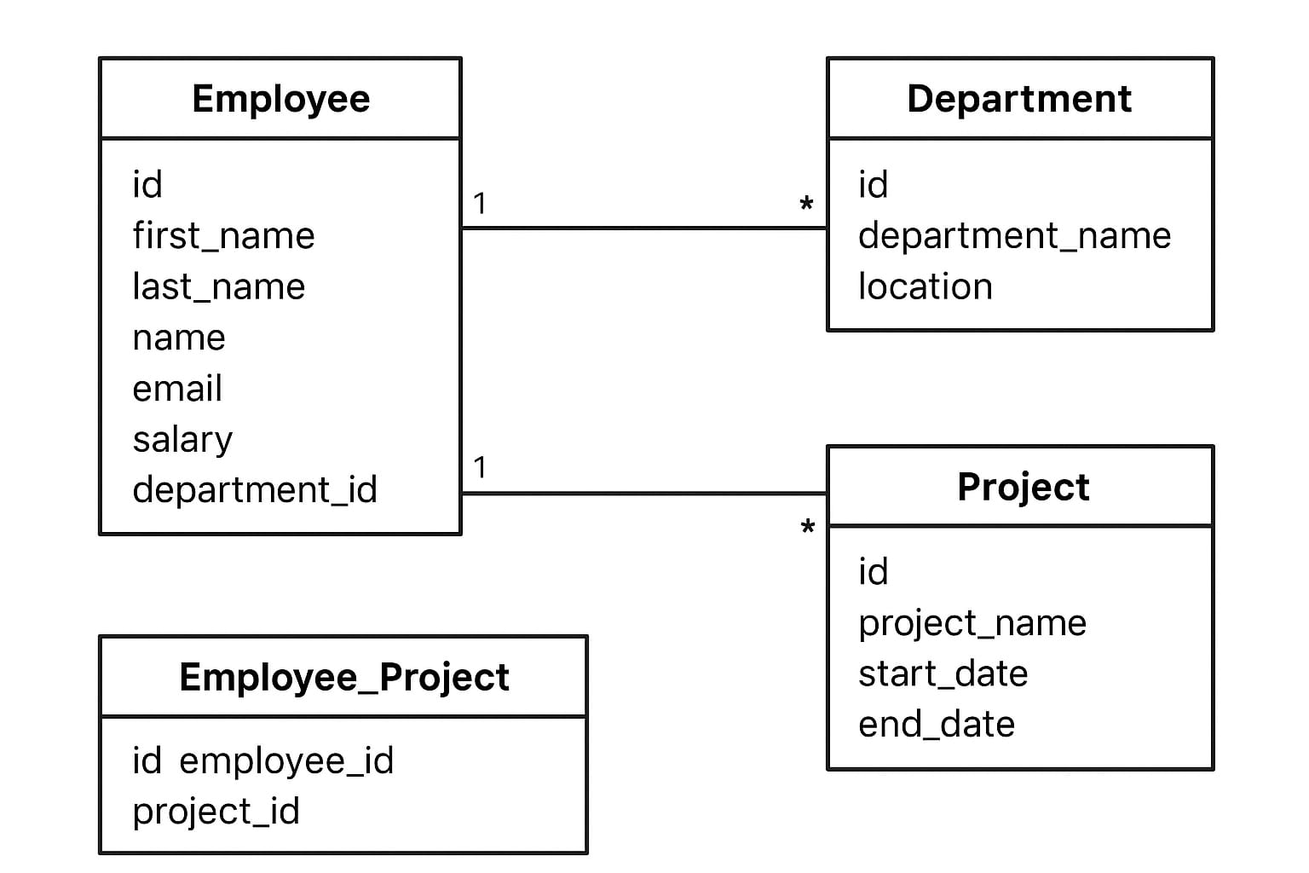

DATABASES

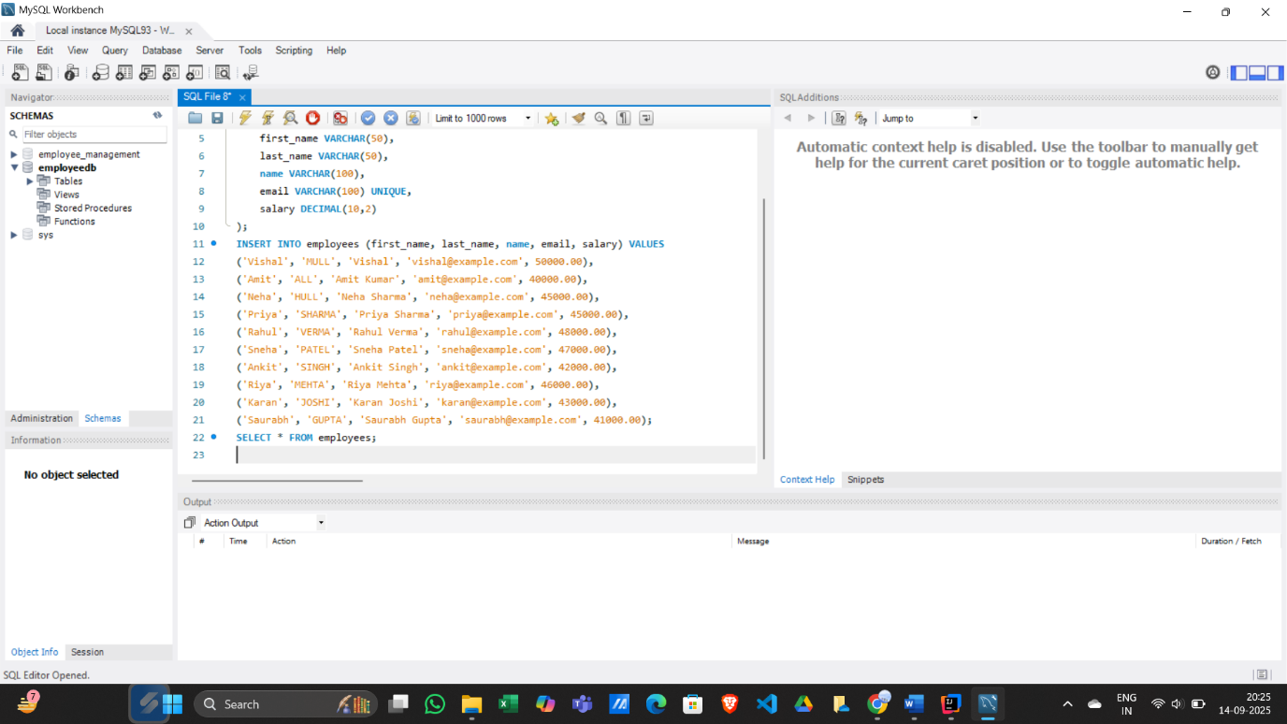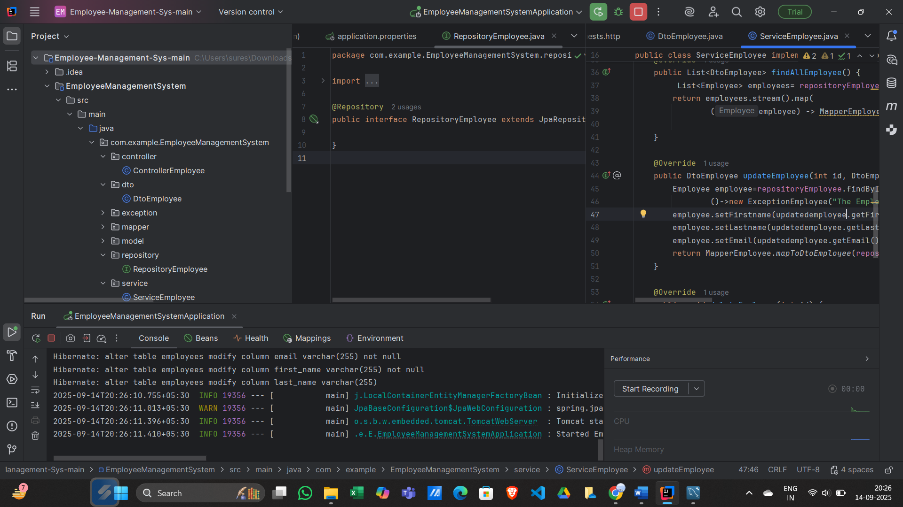

**Screen Shots**

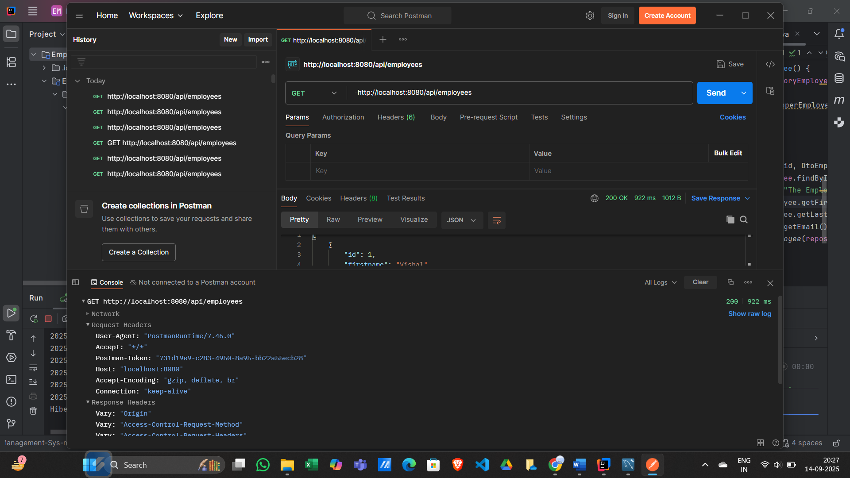

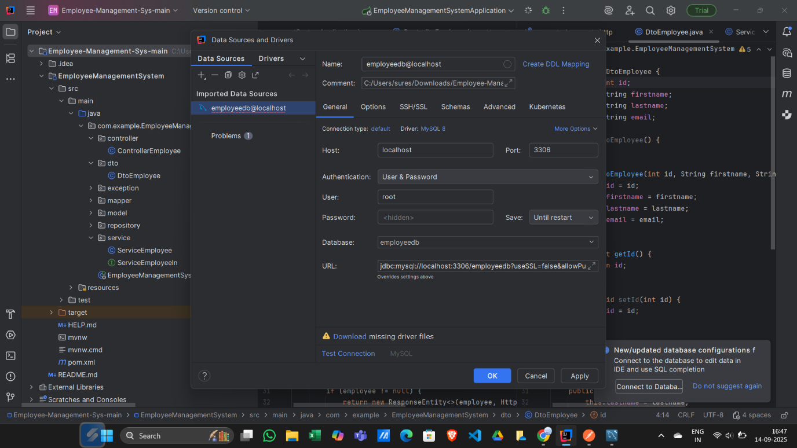

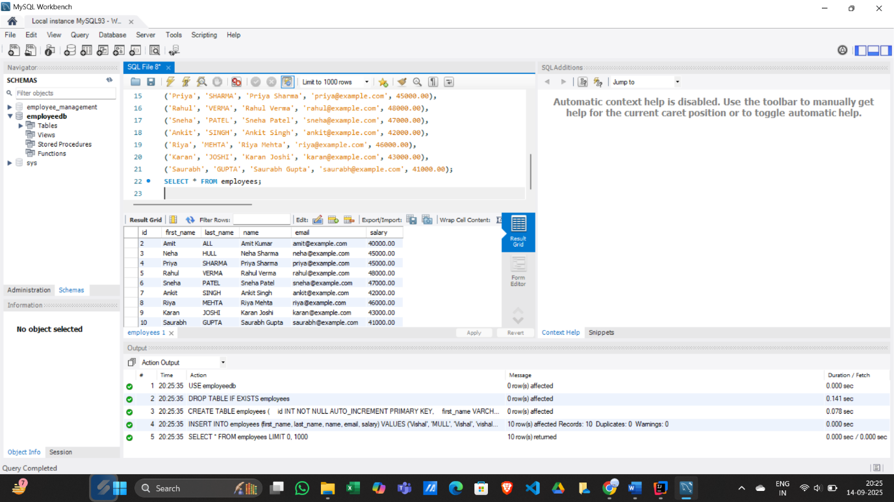

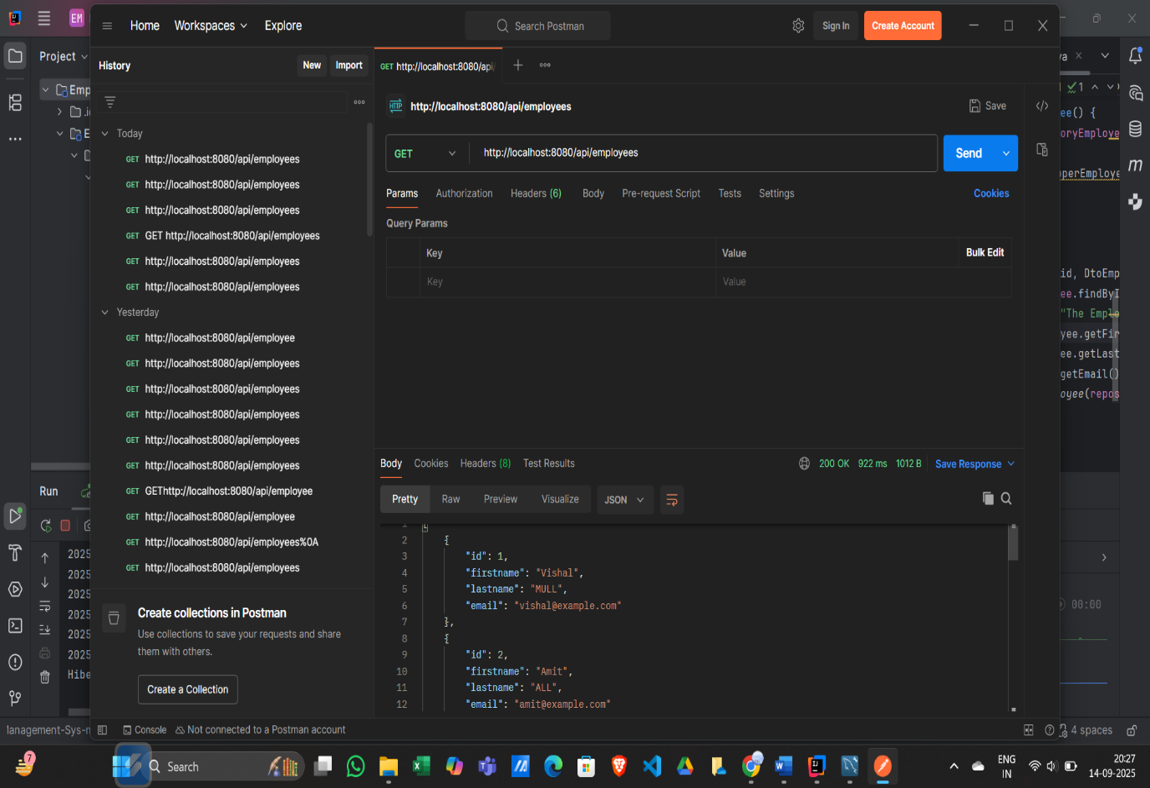

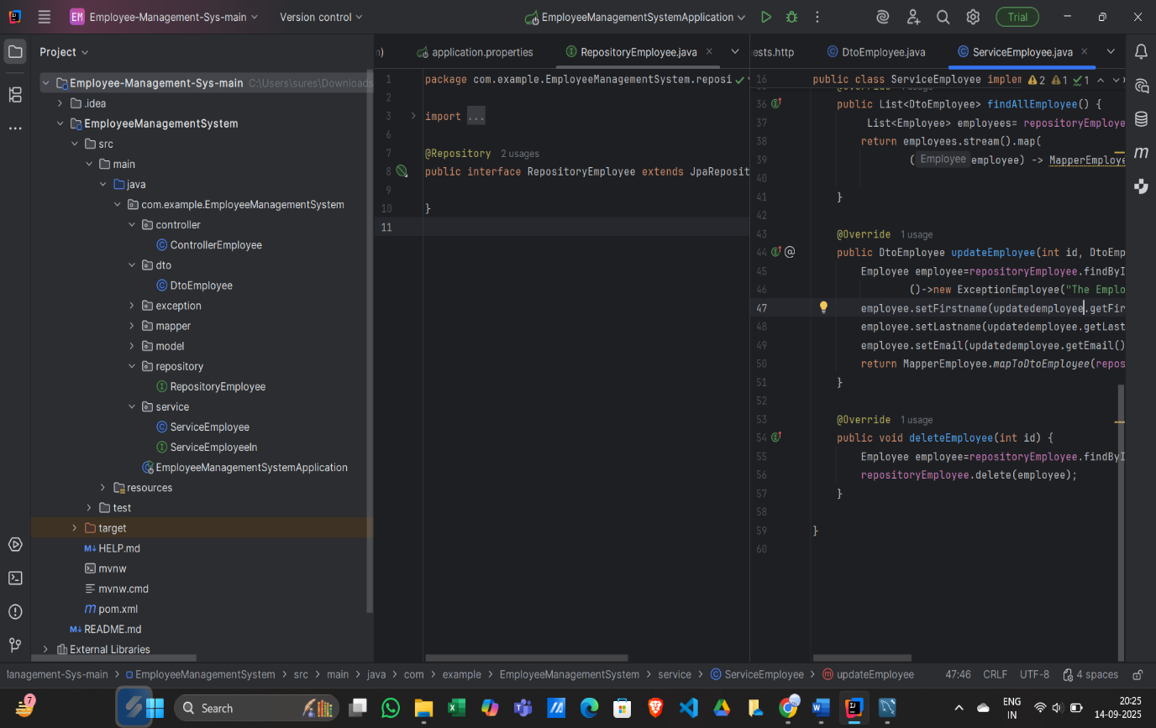

### CONCLUSION

### 

The Employee Management System project successfully demonstrates the automation and efficient handling of employee data within an organization. By implementing a user-friendly interface, structured database management, and secure backend operations, the system reduces manual effort, minimizes errors, and enhances productivity. The project highlights the integration of modern technologies such as Spring Boot, RESTful APIs, and MySQL, showcasing practical application in real-world business scenarios. Overall, this system serves as a reliable tool for managing employee information, ensuring streamlined operations, and providing a foundation for future enhancements such as analytics and reporting.

**BIBLIOGRAPHY**

1. Spring Boot Official Documentation: <https://spring.io/projects/spring-boot>
2. MySQL Official Documentation: https://dev.mysql.com/doc/
3. Postman API Tool: https://www.postman.com/
4. TutorialsPoint – Employee Management System in Java: https://www.tutorialspoint.com/java/java_web_projects.htm